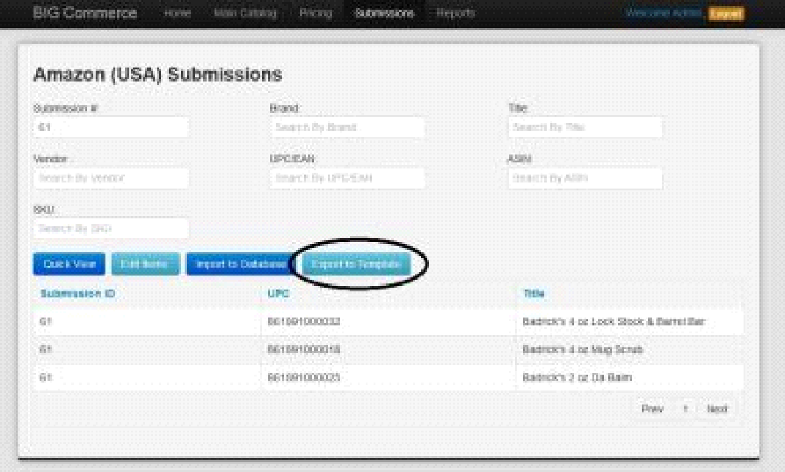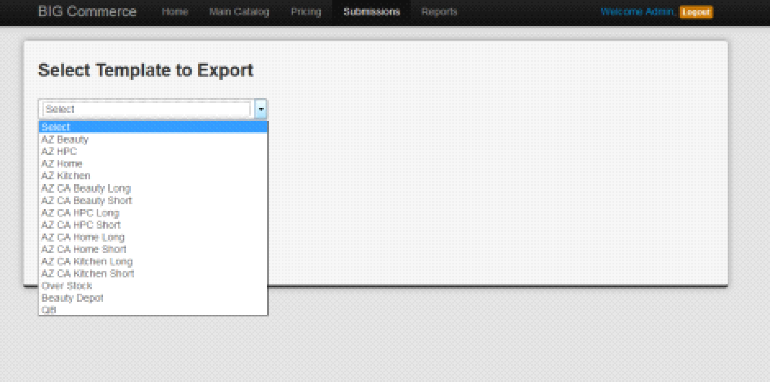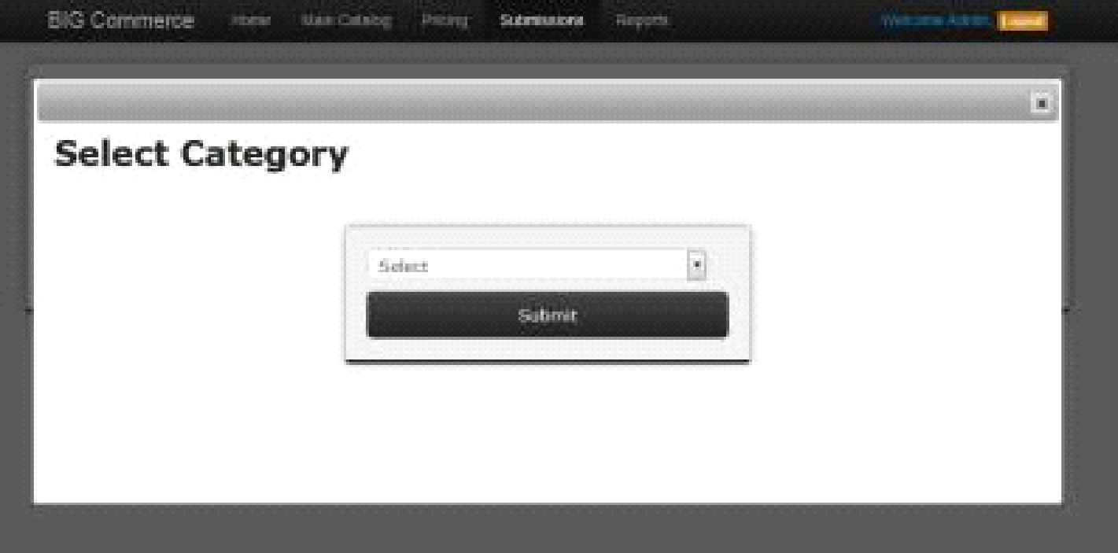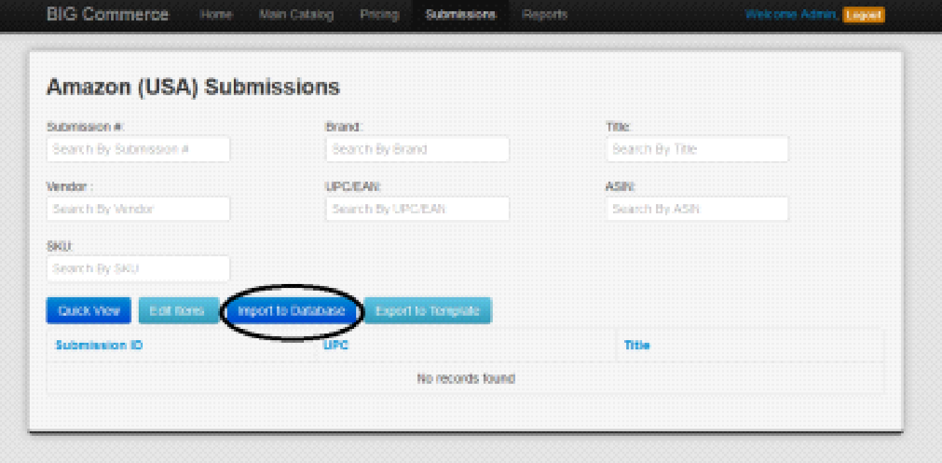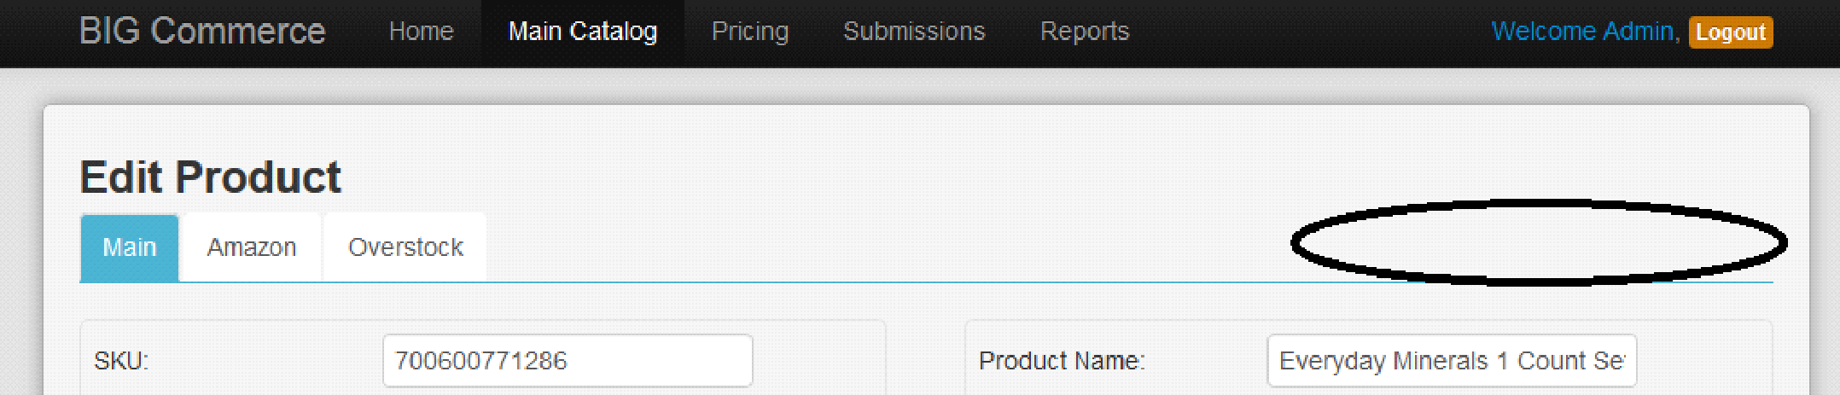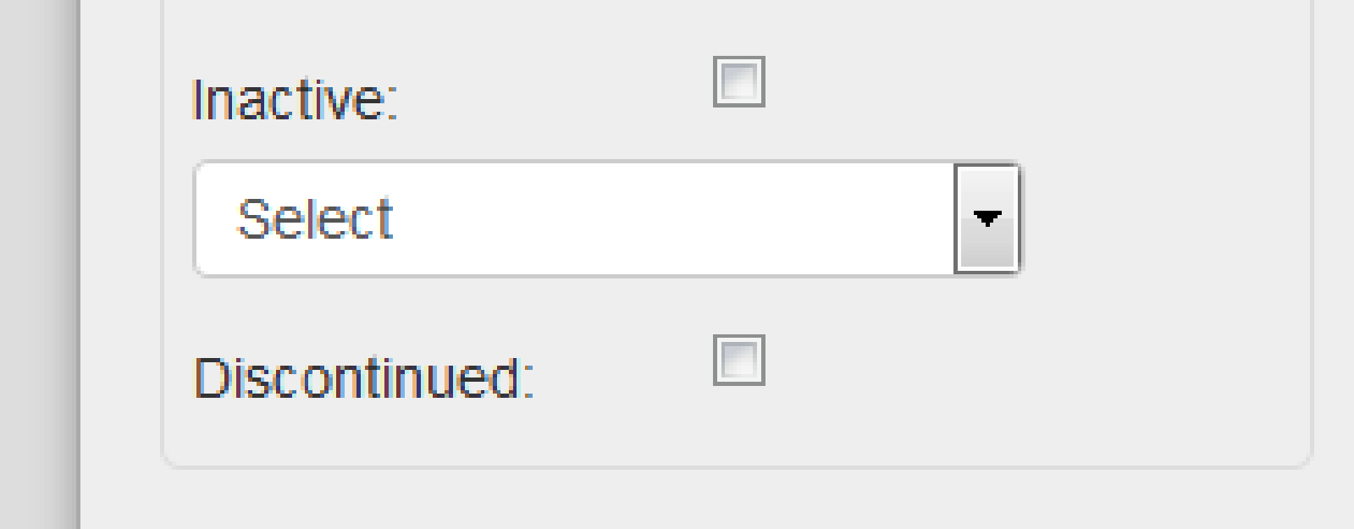**BIG Commerce- Maintenance**

* **Import Template:**
* Column, “Submit to AZ CA” mapping incorrectly
* Currently mapping to, “Submit to OS” field instead of “Submit to AZ CA” field
* Column, “Notes” not importing to catalog

**Correct**

* **Import:**
* Add a path that allows us to bypass the Pricing Page
* Suggestion-
* Change “Import Items” button (in Main Catalog) to “Import New Items”). This button should bring us to the Pricing Page (as it is currently doing)
* Add “Import Direct” next to “Import New Items” button. This button should allow us to bypass the Pricing Page & automatically import products into the Main Catalog
* NOTE: Fields in template should override fields in database, unless it is auto-calculated in database

This is the number one priority besides what is discussed in the emails

* Make field, “Submission ID”/”Sub. ID” editable so we can use/import our own IDs
* This field is currently automatically populated but we don’t need it to be
* **Pricing Page:**
* Add a “-5%” button next to the current “5%” button
* This should change the Prop. AZ Discount by increments of -5%
* Add a “Cancel” button next to the “Submit” button if we want to cancel importing products.
* Resize the “AZ”, “OS”, & “DNB” fields so it is smaller (we’d like to be able to view more without having to scroll side to side too much)
* When clicking “Submit”, pop up window confirming, “Are you sure you want to submit?”
* Add checkbox fields for “AZ CA” that fills in field, “Submit to AZ CA” in Main Catalog & maps from “Submit to AZ CA” column in upload template
* Add checkbox that performs “Select All” for “AZ”, “AZ CA”, “OS” & “DNB”
* After submitting, add # of products updated to message, “Products Updated Successfully”
* Ex: “# Product Updated Successfully”
* **Pricing (Maintenance):**
* Make “Pricing (Maintenance)” a drop-down in “Pricing”
* Add drop-down in “Pricing” for “OS Pricing”
* This should be the area we go to price products for OS
* Add drop-down in “Pricing” for “AZ Markdown”
* Add drop-down in “Pricing” for “OS Markdown”
* Add a “-5%” button next to the current “5%” button
* This should change the Prop. AZ Discount by increments of -5%

**Note : We will create OS pricing page and it will be designed based on Main Catalog page, it will just show product overstock details. This will come while you edit record.**

**Yes this sounds good**

* **Exporting Submissions:**
* Column, “Item Name” needs to pull data from field, “AZ Title”
* Currently pulling data from field, “Product Name”

* Make sure UPCs are exporting in the correct format
* Currently exporting as scientific notation

**Note: Please provide UPC number which has issue while exporting.**

Yes. It happens when exporting any Submission into our vendor templates. I've attached an example of an export I just did. Also note the file name needs to be changes

* **Submissions:**
* Add option to submit to QB in the Submissions dropdown
* When clicked, bring us to a QB section where we can select what products we want exported to QB
* Export products to QB template

Also have a query regarding Quickbook. Can we add new option in submission menu called "Quickbook" and it will have two sub option.   
  
1) "Submit to Quickbook"  this will add product to Quickbook.  
2) "Quickbook" this will have Quick View, Edit Items, Import to Database, & Export to Template functionality. like "Beauty Depot Submissions".

* Choosing Amazon (USA) or Amazon (CA)
* Doesn’t seem to actually affect anything in terms of filtering templates
* Can we have it do the following:
* Allow us to only view templates available for selected sites ONLY (ALL template choices are listed when we click “Export to Template”)







* When we click into Amazon (USA) or Amazon (CA), we are asked to select a category
* This doesn’t seem to affect anything at the moment so can we remove that step?

* When clicking “Edit Items” in any of the Submissions pages, BIG C should export the selected items to the new BIG Commerce Import Template
* It is currently exporting products onto the old import template

**Query : Please get this point confirmed with Brandon once as this is very big change.**

For this issue, please proceed with other changes and I will get back to you as soon as I get the go ahead from brandon.

* After editing items, we should be able to import the sheet back into the database by clicking “Import to Database” & uploading the same template we downloaded when editing (above note)



* **Product Page:**
* Add new categories in drop-down menu: “Electronics”, “Children”, “Apparel”, “Fragrance”, “Pets”
* Add new values for “Weight” drop-down: “Pounds”
* “Submit to” Date should be auto-populated with date the checkbox was clicked; UNLESS date is manually entered
* Can also be filled by importing data from template

* Add “In QB” checkbox next to “Professional Only” checkbox
* Once an item has been exported to be uploaded in QB, this box should be automatically checked
* Move “Inactive” checkbox, the Inactive dropdown list & “Discontinued” checkbox to the top right corner of product card



* **Main Catalog:**
* Add function that allows us to select (via checkbox) products & export them to an excel file (using import template to export)
* Include column for “AZ CA ASIN”
* “Search Product” should allow us to also search by “AZ ASIN”, “AZ CA ASIN”, “OS SKU”, “Sub. ID”, & “Keyword”

*Place these areas horizontally next to, or under, “Search Product” bar*

* Add to Search: “Vendor” drop-down
* Lists all vendors currently entered
* Once clicked, will filter for products under that vendor
* Add to Search “Category” drop-down
* Lists all categories entered
* Once clicked, will filter for products under that category
* Add to Search “Brand” drop-down
* Lists all brands entered
* Once clicked, will filter for products under that category
* From any filtered list/search, we should be able to click into a product, go to “Edit Product” page & be able to scroll/go to the next or previous product in that list
* Each column in Main Catalog should have the ability to sort the product list
* **Beauty Depot Submissions:**
* “Weight” column in template not exporting
* Currently exporting “0” value
* Need to export from “Weight” field in catalog
* Export function only exporting 20 items from a selected list
* Include Total Product count here so we can compare to # of items we need exported.
* **MSRP required validation when import template.**

**Note : We are still waiting for your answer for yellow background color.**