­­­­ Московский авиационный институт

(национальный исследовательский университет)

Институт № 8 «Информационные технологии и прикладная математика»

**Лабораторная работа №3**

**по курсу «Теоретическая механика и компьютерное моделирование»**

**Составление и численное решения дифференциальных уравнений движения системы и ее анимация.**

Выполнил студент группы М8О-207Б-20

Куценко Борис Дмитриевич

Преподаватель: Чекина Евгения Алексеевна

Оценка:

Дата: 27.12.2021

Москва, 2021

**Вариант № «16»**

**Задание:**

Необходимо составить и численно решить дифференциальные уравнения движения системы (уравнения Лагранжа второго рода), а затем реализовать анимацию движения механической системы используя язык программирования Python.

**Механическая система:**

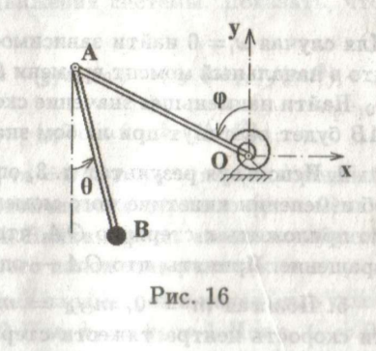

**Текст программы:**

**import numpy as np**

**import matplotlib.pyplot as plt**

**from matplotlib.animation import FuncAnimation**

**import matplotlib.patches as pat**

**import sympy as sp**

**from scipy.integrate import odeint**

**import math**

**def formY(y, t, fomega_phi, fomega_thetta):**

**y1, y2, y3, y4 = y**

**dydt = [y3, y4, fomega_phi(y1, y2, y3, y4), fomega_thetta(y1, y2, y3, y4)]**

**return dydt**

**#time**

**t_fin = 600**

**Steps = 10000**

**#constants**

**l = OA = AB = 5**

**R_Circle = l / 10**

**k1 = 5**

**k2 = 12**

**m = 10**

**c = 20**

**g = 9.81**

**#starting postion**

**phi0 = 2**

**thetta0 = 0**

**dphi0 = 1**

**dthetta0 = 1**

**t = sp.Symbol('t')**

**phi = sp.Function('phi')(t)**

**thetta = sp.Function('thetta')(t)**

**omega_phi = sp.Function('omega_phi')(t)**

**omega_thetta = sp.Function('omega_thetta')(t)**

**#1 defining the kinetic energy**

**Vb2 = ((l * omega_phi) ** 2) + ((l * omega_thetta) ** 2) - 2 * l * l * omega_phi * omega_thetta * sp.cos(phi - thetta)**

**K = m * Vb2 / 2**

**#2 defining the potential energy**

**Pmg = m * g * l * (sp.cos(phi + 3.14/2) - sp.cos(thetta))**

**P2 = c * phi * phi / 2**

**P = Pmg + P2**

**#Not potential force**

**Q1 = - k1 * omega_phi**

**Q2 = - k2 * omega_thetta**

**#Lagrange function**

**L = K - P**

**#equations**

**ur1 = sp.diff(sp.diff(L,omega_phi),t)-sp.diff(L,phi) - Q1**

**ur2 = sp.diff(sp.diff(L,omega_thetta),t)-sp.diff(L,thetta) - Q2**

**# isolating second derivatives(dV/dt and dom/dt) using Kramer's method**

**a11 = ur1.coeff(sp.diff(omega_phi, t), 1)**

**a12 = ur1.coeff(sp.diff(omega_thetta, t), 1)**

**a21 = ur2.coeff(sp.diff(omega_phi, t), 1)**

**a22 = ur2.coeff(sp.diff(omega_thetta, t), 1)**

**b1 = -(ur1.coeff(sp.diff(omega_phi, t), 0)).coeff(sp.diff(omega_thetta, t),**

**0).subs([(sp.diff(phi, t), omega_phi),**

**(sp.diff(thetta, t), omega_thetta)])**

**b2 = -(ur2.coeff(sp.diff(omega_phi, t), 0)).coeff(sp.diff(omega_thetta, t),**

**0).subs([(sp.diff(phi, t), omega_phi),**

**(sp.diff(thetta, t), omega_thetta)])**

**#we can check the result with:**

**# a11 = 1**

**# a12 = sp.cos(phi - thetta)**

**# a22 = 1**

**# a21 = sp.cos(phi - thetta)**

**# b1 = omega_thetta * omega_thetta*sp.sin(phi - thetta) + (g/l) * sp.sin(phi) - (c*phi + k1* omega_phi) / (m*l*l)**

**# b2 = -omega_phi*omega_phi*sp.sin(phi - thetta) - (g/l)*sp.sin(thetta) - k2*omega_thetta/(m*l*l)**

**print(b1)**

**print(b2)**

**detA = a11*a22-a12*a21**

**detA1 = b1*a22-b2*a12**

**detA2 = a11*b2-b1*a21**

**domega_phidt = detA1/detA**

**domega_thettadt = detA2/detA**

**Time = np.linspace(0, t_fin, Steps)**

**fomega_phi = sp.lambdify([phi, thetta, omega_phi, omega_thetta], domega_phidt, "numpy")**

**fomega_thetta = sp.lambdify([phi, thetta, omega_phi, omega_thetta], domega_thettadt, "numpy")**

**y0 = [phi0, thetta0, dphi0, dthetta0]**

**sol = odeint(formY, y0, Time, args=(fomega_phi, fomega_thetta))**

**Phi = sol[:, 0]**

**Thetta = sol[:, 1]**

**Omega_phi = sol[:, 2]**

**Omega_thetta = sol[:, 3]**

**X_A = sp.lambdify(phi, l * sp.cos(phi + 3.14/2))**

**Y_A = sp.lambdify(phi, l * sp.sin(phi + 3.14/2))**

**X_B = sp.lambdify([phi, thetta], l * sp.cos(phi + 3.14/2) + l * sp.sin(thetta))**

**Y_B = sp.lambdify([phi, thetta], l * sp.sin(phi + 3.14/2) - l * sp.cos(thetta))**

**XA = X_A(sol[:, 0])**

**YA = Y_A(sol[:, 0])**

**XB = X_B(sol[:, 0], sol[:, 1])**

**YB = Y_B(sol[:, 0], sol[:, 1])**

**Nv= 3**

**R1 = 0.001**

**R2 = l / 12**

**fig = plt.figure(figsize=(10,10))**

**ax = fig.add_subplot(1,1,1)**

**ax.axis('equal')**

**ax.set(xlim=[-l * 2 - R_Circle - l/10, l *2 + R_Circle + l/10], ylim=[-l*2 - R_Circle - l/10,l*2 + R_Circle + l/10])**

**V_B = sp.lambdify([phi, thetta, omega_phi, omega_thetta], sp.sqrt(((l * omega_phi) ** 2) + ((l * omega_thetta) ** 2) - 2 * l * l * omega_phi * omega_thetta * sp.cos(phi - thetta)))**

**VB = V_B(Phi, Thetta, Omega_phi, Omega_thetta)**

**alpha = np.linspace(0, Nv*6.283+Phi[0]+ 3.14/2, 100)**

**X_SpiralSpr = -(R1 + alpha * (R2 - R1) / alpha[-1]) * np.sin(alpha)**

**Y_SpiralSpr = (R1 + alpha * (R2 - R1) / alpha[-1]) * np.cos(alpha)**

**beta = np.linspace(0, 2*math.pi, 100)**

**X_Circle = R_Circle * np.cos(beta)**

**Y_Circle = R_Circle * np.sin(beta)**

**fig_for_graphs = plt.figure(figsize=[13, 7])**

**ax_for_graphs = fig_for_graphs.add_subplot(2, 2, 1)**

**ax_for_graphs.plot(Time, Phi, color='blue')**

**ax_for_graphs.set_title("Phi(t)")**

**ax_for_graphs.set(xlim=[0, 10])**

**ax_for_graphs.grid(True)**

**ax_for_graphs = fig_for_graphs.add_subplot(2, 2, 2)**

**ax_for_graphs.plot(Time, Thetta, color='red')**

**ax_for_graphs.set_title('Va(t)')**

**ax_for_graphs.set(xlim=[0, 10])**

**ax_for_graphs.grid(True)**

**ax_for_graphs = fig_for_graphs.add_subplot(2,2,3)**

**ax_for_graphs.plot(Time, Omega_phi * l, color='green')**

**ax_for_graphs.set_title("phi'(t) = omega_phi(t)")**

**ax_for_graphs.set(xlim=[0, 10])**

**ax_for_graphs.grid(True)**

**ax_for_graphs = fig_for_graphs.add_subplot(2, 2, 4)**

**ax_for_graphs.plot(Time, VB, color='black')**

**ax_for_graphs.set_title("Vb(t)")**

**ax_for_graphs.set(xlim=[0, 10])**

**ax_for_graphs.grid(True)**

**OX = ax.plot([-l * 2, l*2], [-l/10,-l/10], 'black', linestyle = '--')**

**Draw_Spring = ax.plot(X_SpiralSpr, Y_SpiralSpr, color='#666666')[0]**

**Draw_OA=ax.plot([0, XA[0]], [0, YA[0]], color='#808080')[0]**

**Draw_AB=ax.plot([XA[0], XB[0]], [YA[0], YB[0]], color='#808080' )[0]**

**PointB = ax.plot(XB[0], YB[0])[0]**

**PointA = ax.plot(XA[0], YA[0], color='#a0a0a0', marker='o')[0]**

**Draw_Circle = ax.plot(X_Circle + XB[0], Y_Circle + YB[0], color='black', linewidth=1)[0]**

**triangle = pat.Polygon([(0,0), (-l/10, -l/10), (l/10, -l/10)], color='#d3d3d3')**

**ax.add_patch(triangle)**

**def update(i):**

**PointB.set_data(XB[i],YB[i])**

**Draw_OA.set_data([0, XA[i]], [0, YA[i]])**

**PointA.set_data(XA[i], YA[i])**

**Draw_AB.set_data([XA[i], XB[i]], [YA[i], YB[i]])**

**Draw_Circle.set_data(X_Circle + XB[i], Y_Circle + YB[i])**

**alpha = np.linspace(0, Nv*6.28+Phi[i] + 3.14/2, 100)**

**X_SpiralSpr = -(R1 + alpha * (R2 - R1) / alpha[-1]) * np.sin(alpha - 1.57)**

**Y_SpiralSpr = (R1 + alpha * (R2 - R1) / alpha[-1]) * np.cos(alpha - 1.57)**

**Draw_Spring.set_data(X_SpiralSpr, Y_SpiralSpr)**

**return [PointB, Draw_OA, Draw_Spring, Draw_AB, PointA, Draw_Circle]**

**anima = FuncAnimation(fig, update, frames=Steps, interval=1)**

**plt.show()**

**Результат работы:**

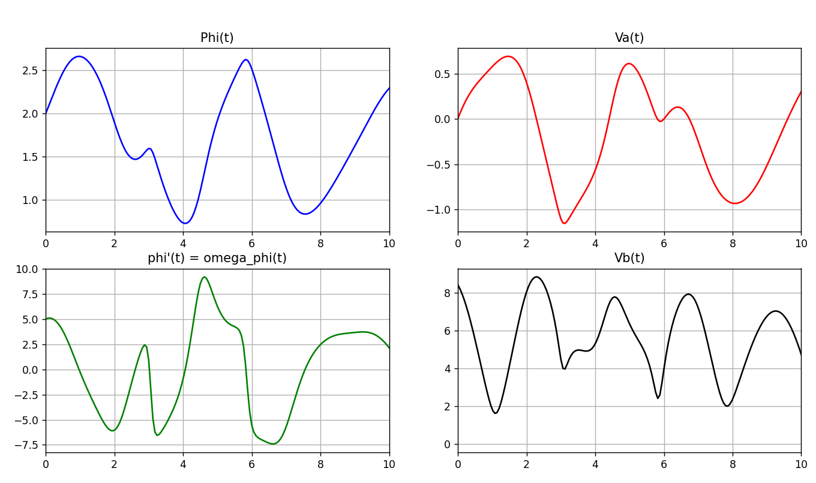

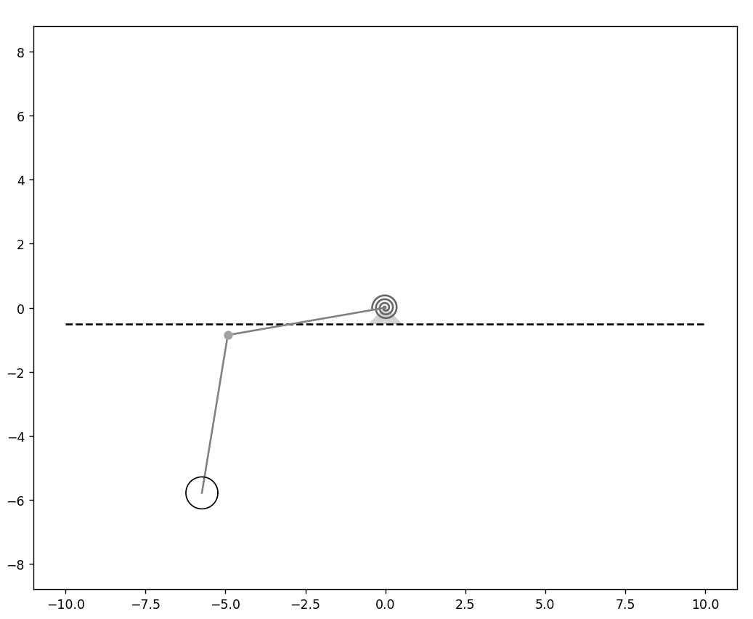 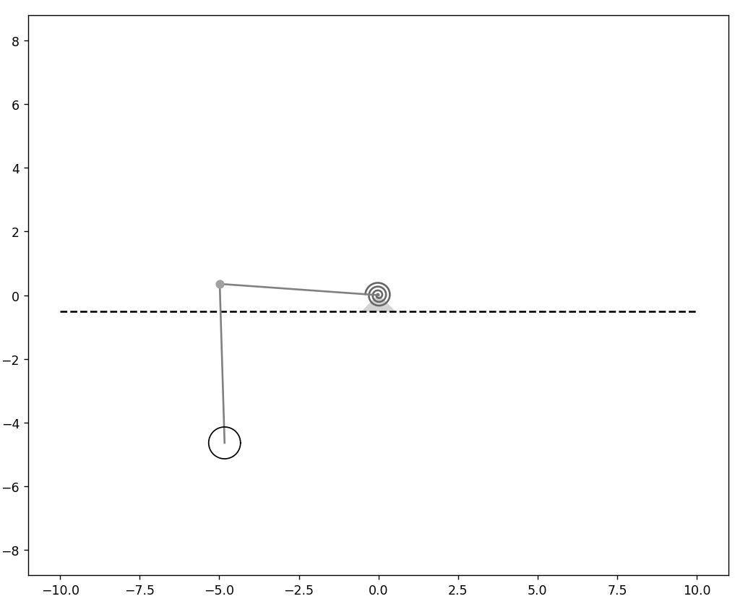

**Получение уравнения Лагранжа второго рода:**

