1. **Skrip**

Public Class calculator

Friend Hasil As Single = 0

Dim operasi As String = ""

Dim operasiHitung As Boolean = False

Private Sub cmbbutton0_Click(ByVal sender As System.Object, ByVal e As System.EventArgs) Handles cmbbutton0.Click

txtlayar.Text = txtlayar.Text & "0"

End Sub

Private Sub cmbbutton1_Click(ByVal sender As System.Object, ByVal e As System.EventArgs) Handles cmbbutton1.Click

If operasiHitung = True Or txtlayar.Text = "0" Then

txtlayar.Text = "1"

operasiHitung = False

Else

txtlayar.Text = txtlayar.Text + "1"

End If

End Sub

Private Sub cmbbutton2_Click(ByVal sender As System.Object, ByVal e As System.EventArgs) Handles cmbbutton2.Click

If operasiHitung = True Or txtlayar.Text = "0" Then

txtlayar.Text = "2"

operasiHitung = False

Else

txtlayar.Text = txtlayar.Text + "2"

End If

End Sub

Private Sub cmbbutton3_Click(ByVal sender As System.Object, ByVal e As System.EventArgs) Handles cmbbutton3.Click

If operasiHitung = True Or txtlayar.Text = "0" Then

txtlayar.Text = "3"

operasiHitung = False

Else

txtlayar.Text = txtlayar.Text + "3"

End If

End Sub

Private Sub cmbbutton4_Click(ByVal sender As System.Object, ByVal e As System.EventArgs) Handles cmbbutton4.Click

If operasiHitung = True Or txtlayar.Text = "0" Then

txtlayar.Text = "4"

operasiHitung = False

Else

txtlayar.Text = txtlayar.Text + "4"

End If

End Sub

Private Sub cmbbutton5_Click(ByVal sender As System.Object, ByVal e As System.EventArgs) Handles cmbbutton5.Click

If operasiHitung = True Or txtlayar.Text = "0" Then

txtlayar.Text = "5"

operasiHitung = False

Else

txtlayar.Text = txtlayar.Text + "5"

End If

End Sub

Private Sub cmbbutton6_Click(ByVal sender As System.Object, ByVal e As System.EventArgs) Handles cmbbutton6.Click

If operasiHitung = True Or txtlayar.Text = "0" Then

txtlayar.Text = "6"

operasiHitung = False

Else

txtlayar.Text = txtlayar.Text + "6"

End If

End Sub

Private Sub cmbbutton7_Click(ByVal sender As System.Object, ByVal e As System.EventArgs) Handles cmbbutton7.Click

If operasiHitung = True Or txtlayar.Text = "0" Then

txtlayar.Text = "7"

operasiHitung = False

Else

txtlayar.Text = txtlayar.Text + "7"

End If

End Sub

Private Sub cmbbutton8_Click(ByVal sender As System.Object, ByVal e As System.EventArgs) Handles cmbbutton8.Click

If operasiHitung = True Or txtlayar.Text = "0" Then

txtlayar.Text = "8"

operasiHitung = False

Else

txtlayar.Text = txtlayar.Text + "8"

End If

End Sub

Private Sub cmbbutton9_Click(ByVal sender As System.Object, ByVal e As System.EventArgs) Handles cmbbutton9.Click

If operasiHitung = True Or txtlayar.Text = "0" Then

txtlayar.Text = "9"

operasiHitung = False

Else

txtlayar.Text = txtlayar.Text + "9"

End If

End Sub

Private Sub cmbhapus_Click(ByVal sender As System.Object, ByVal e As System.EventArgs) Handles cmbhapus.Click

txtlayar.Text = ""

operasi = ""

End Sub

Private Sub cmbtambah_Click(ByVal sender As System.Object, ByVal e As System.EventArgs) Handles cmbtambah.Click

operasi = "tambah"

Hasil = Val(txtlayar.Text)

operasiHitung = True

End Sub

Private Sub cmbsamadengan_Click(ByVal sender As System.Object, ByVal e As System.EventArgs) Handles cmbsamadengan.Click

Select Case operasi

Case "tambah"

Hasil = Hasil + Val(txtlayar .Text)

Case "kurang"

Hasil = Hasil - Val(txtlayar.Text)

Case "kali"

Hasil = Hasil * Val(txtlayar.Text)

Case "pangkat"

Hasil = Hasil ^ 2

Case "bagi"

Hasil = Hasil / Val(txtlayar.Text)

End Select

txtlayar.Text = Hasil

operasiHitung = True

End Sub

Private Sub cmbkurang_Click(ByVal sender As System.Object, ByVal e As System.EventArgs) Handles cmbkurang.Click

operasi = "kurang"

Hasil = Val(txtlayar.Text)

operasiHitung = True

End Sub

Private Sub calculator_Load(ByVal sender As System.Object, ByVal e As System.EventArgs) Handles MyBase.Load

End Sub

Private Sub txtlayar_TextChanged(ByVal sender As System.Object, ByVal e As System.EventArgs) Handles txtlayar.TextChanged

End Sub

Private Sub cmbkali_Click(ByVal sender As System.Object, ByVal e As System.EventArgs) Handles cmbkali.Click

operasi = "kali"

Hasil = Val(txtlayar.Text)

operasiHitung = True

End Sub

Private Sub cmbpangkat_Click(ByVal sender As System.Object, ByVal e As System.EventArgs) Handles cmbpangkat.Click

operasi = "pangkat"

Hasil = Val(txtlayar.Text)

operasiHitung = True

End Sub

Private Sub cmbbagi_Click(ByVal sender As System.Object, ByVal e As System.EventArgs) Handles cmbbagi.Click

operasi = "bagi"

Hasil = Val(txtlayar.Text)

operasiHitung = True

End Sub

End Class

1. **Screenshoot**

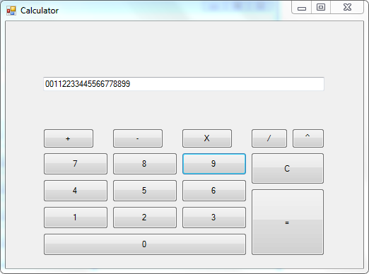

Tombol angka diatas 0-9

