# NBCC Flow Cytometry Guide

The Network Biology Collaborative Centre ([nbcc.lunenfeld.ca](https://nbcc.lunenfeld.ca)) offers a full complement of leading-edge instrumentation for cell sorting and analysis including the very latest imaging flow technology. This guide provides information on the flow cytometry capabilities we offer and the instrumentation that is available.

## I. Who we are

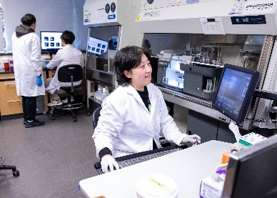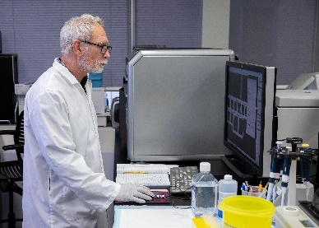The NBCC Flow Cytometry facility is overseen by Sinai Health’s Vice-President of Research and NBCC co-Director Dr. Anne-Claude Gingras who is an expert in cellular signaling. The facility is managed by Michael Parsons who has over 30 years’ experience in flow cytometry with a focus on operations, training, and image-based analysis. He works closely with flow cytometry specialist Annie Bang who has over 20 years' experience and expertise in cell sorting. The NBCC Director of Operations Dr. Karen Colwill provides administrative and logistical support. The facility provides service at two locations: 600 University Avenue, Room 980 and 25 Orde Street, Level 4, Room 421.

**Contact:** Michael Parsons ([parsons@lunenfeld.ca](mailto:parsons@lunenfeld.ca))

Room 980, Mount Sinai Hospital, Toronto)

**Website:** [nbcc.lunenfeld.ca/facilities/flow-cytometry](https://nbcc.lunenfeld.ca/facilities/flow-cytometry)

**Research Resource Identifier (RRID):** SCR_025384

## II. How we help

The NBCC supports a full range of flow cytometry needs from initial study concept and experimental design to manuscript preparation. Our services range from fully assisted analysis to comprehensive training leading to independent client-directed instrument operation. We start with an initial consultation to identify the best and most cost-effective approach to your project. Our services include advice on sample preparation, quality control, flow analysis, bioinformatics support and assistance with grant and publication writing related to the services we offer.

## III. Applications

### A. Cell Sorting

We support a variety of full-service cell sorting applications using either traditional or spectral detection for single cell plate-based indexed or tube-based bulk sorts. Our BD FACSDiscoverTM S8 allows for the inclusion of three additional imaging channels complexed with spectral detection to provide novel cell sorting parameters. Cell sorting applications include multi-colour sorts for bulk culture, indexed single cell sorts into 96-well plates, cell cycle phase sorting, and RNA/DNA analysis among many others. For clients wishing to perform their own sorts, we provide comprehensive cell-sort training on our Sony MA900 cell sorter.

### B. Cell Analysis

Our facilities have a full suite of conventional and image-based flow cytometry-based analyzers with high-throughput capability (see core instrumentation).

### C. Consultation and Training

For researchers who wish to perform their own flow experiments, we provide comprehensive consultation services that include in-depth theory review, experimental design recommendations, hands-on instrument training with follow-up troubleshooting, data analysis and reporting assistance.

### D. Software for Data Analysis

We provide data analysis software and computer workstations within our facility for users to analyze their own data. The software that we have includes:

**Amnis IDEAS:** We provide different versions of the image analysis software used to analyze imaging flow experiments generated on our Amnis ImageStream. *IDEAS 6.2* is a basic image analysis package freely provided to clients to perform instrument analysis on their own computer. *IDEAS 6.4* with a machine learning module is available on our workstation for those requiring more advanced image analysis. *Amnis AI*, available in our facility, is the most sophisticated image analysis software available from Amnis incorporating deep learning with convolutional neural network algorithms.

**FlowJo:** FlowJo is a comprehensive flow cytometry analysis tool. It includes a CellViewTM lens plugin for image analysis on our BD FACSDiscoverTM S8.

**Kaluza:** Kaluza is a basic flow cytometry analysis licensed software that is free for clients.

**ModFit:** ModFit LT is a DNA cotent cell cycle modeling software with automated analysis and cell tracking capability.

**FluoroFinder:** FluoroFinder is synched to our instrument configurations. It is an experimental design tool integrating panel design tools with spectral viewers, antibody search, and a fluorescent dye database.

## III. Core instrumentation

### Cell Sorters

We have three different cell sorters (FACS) available at the NBCC.

**BD FacsDiscoverTM S8:** The S8 is a new generation image-enabled cell-sorter at 25 Orde Street in room L420. This sorter performs high-parameter flow cytometry experiments where individual cells can be visualized in real time and sorted using both the flow cytometry signals and the microscopic images of each cell.

*Features:* 5 lasers (U/V/B/Y/R) – 78 color- full spectrum detection plus CellViewTM Imaging detection (3 fluorescence + light loss/forward and side scatter imaging).

**Beckman Coulter MoFlo Astrios EQ:** *Features:* 5 laser (U/V/B/Y/R) – 18 fluorescence conventional detectors + forward & side scatter.

**Sony MA900 cell sorter:** *Features:* 4 laser (B/Y/R/V) – 12 fluorescence detectors + forward and back scatter.

### B. Cell Analyzers

We have five different flow cytometers available at the NBCC.

**Amnis ImageStream MarkII:** *Features:* 5 laser (V/B/Y/G/R) – 10 fluorescence detectors + bright field and darkfield.

**BD Fortessa X-20 (HTS):** *Features:* 5 laser (U/V/B/Y/R) – 18 fluorescence detectors + forward and side scatter.

**BD Fortessa (HTS):** *Features:* 4 laser (V/B/Y/R) – 14 fluorescence + forward and side scatter.

**ThermoFisher Attune NxT (HTS):** *Features:* 4 laser (V/B/Y/R) – 16 fluorescence detectors + forward and side scatter.

**Beckman Coulter Gallios:** *Features:* 4 laser (V/B/Y/R) – 10 fluorescence detectors + forward and side scatter