**Jaba: Online tool for basic Java prigramming**

**User’s Manual**

By

Chanrich Andrew D. Mangco

|  |  |
| --- | --- |
| **Table of Contents** |  |
|  | **Page** |
| Title page | 1 |
| Table of Contsents | 2 |
| Abstract | 3 |
| Getting started with Jaba | 4 |
| Results | 8 |

**ABSTRACT**

Online learning systems offers a flexible time and location approach by changing the learning environment.  It enables learning to take place in a variety of different places, both physical and virtual. Students now have a choice and as a result increasingly wish to combine the options, choosing when and where they study and learn. Moreover, most schools today encourage the use of online quizzes as an alternate way of studying. It is because of this that the teachers found an easier way of teaching. It is with this thrust that the researcher developed Jaba: Online tool for basic Java programming. The study aims on simplifying the teachers work by providing an online environment for their lab activities. This study used descriptive research design to describe the data and characteristics of the subject being studied. The results reveal that the respondents find the system as an alternative tool for conventional method of teaching which implied that the respondents strongly agreed that Jaba helps the teachers by: reducing the time needed for them to check an activity, providing an online compiler, and gives teachers a repository for created activities; serves as an alternative tool for conventional method of teaching. In addition, the system provided a new method of checking laboratory activities and added unique features to lessen the time needed on answering, recording and submitting activities.

**Getting started with Jaba!**

**STEP 1:**

Guest interface is completely browser based. The interface works with any browser and any operating system.

* Open your browser.
* In the address bar type the URL for the administrator interface.
* To access the website you need to create an account.

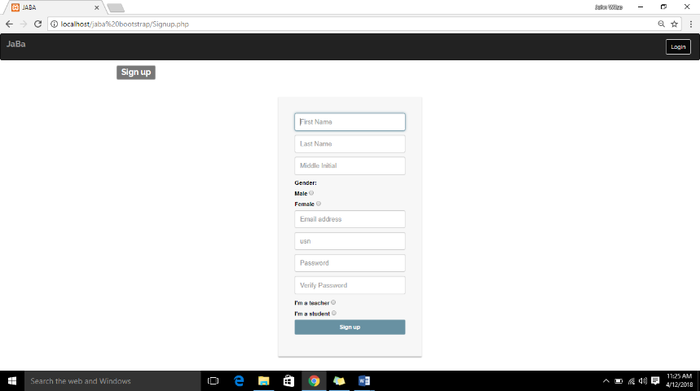

* Type in required information to register.

**STEP 2:**

* Click the login button on the upper right corner of the website.



* Choose between teacher and student login.

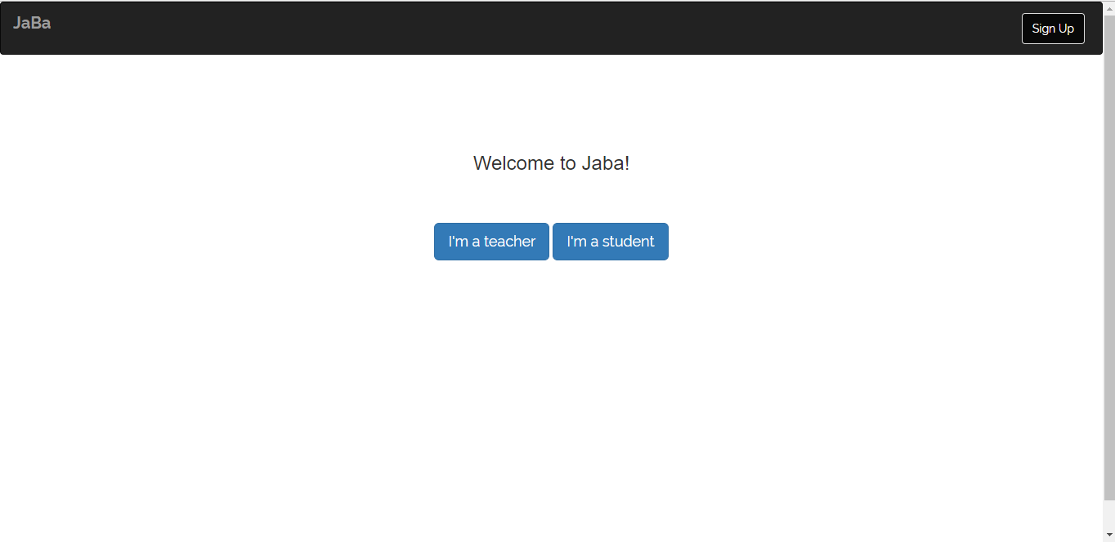

**STEP 3:**

* Input required information.

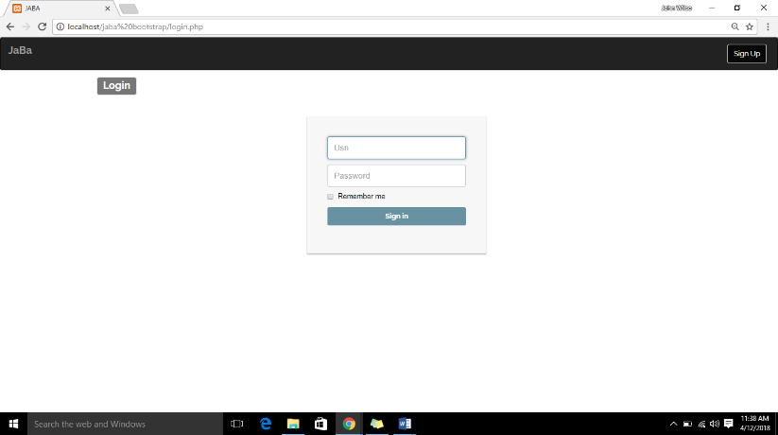

* Click sign in button. If student was previously selected proceed to step 6.

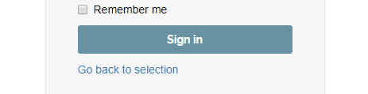

**STEP 4 (as teacher):**

* Click create button to create a new class.



* Input class name.

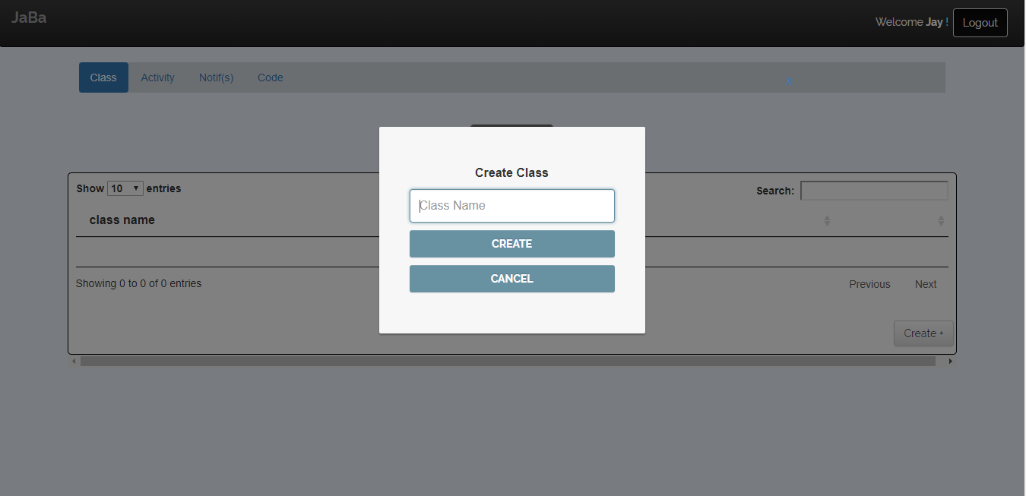

**STEP 5 (as teacher):**

* Click create button to create a new activity.



* Input required information.

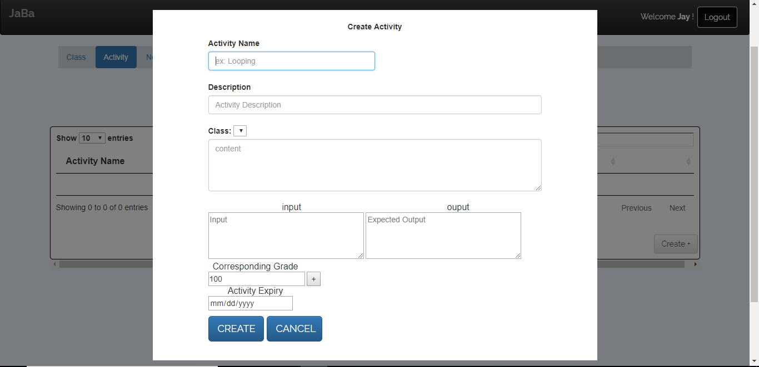

**STEP 6 (as student):**

* Home screen

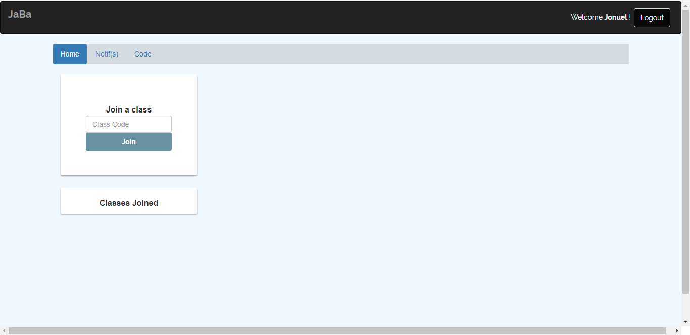

* Click join class.

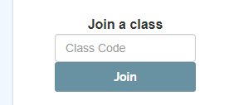

* Input class code to join a class.

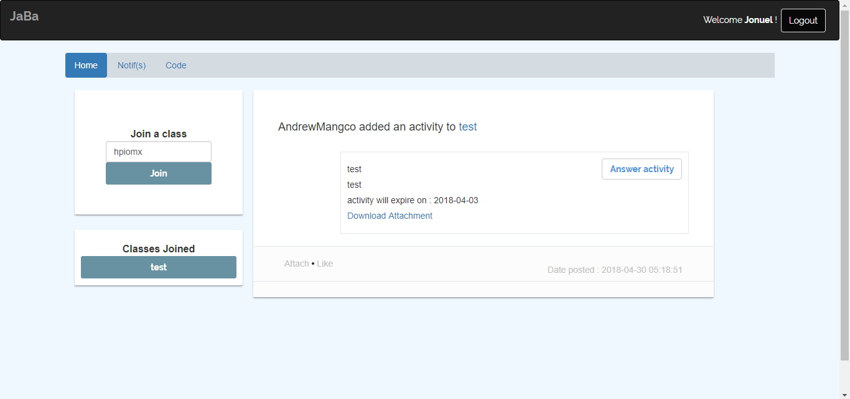

**STEP 7 (as student):**

* Click answer activity to open activity content.

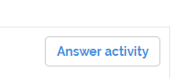

**STEP 8 (as student):**

* Fill the information needed to answer the activity.

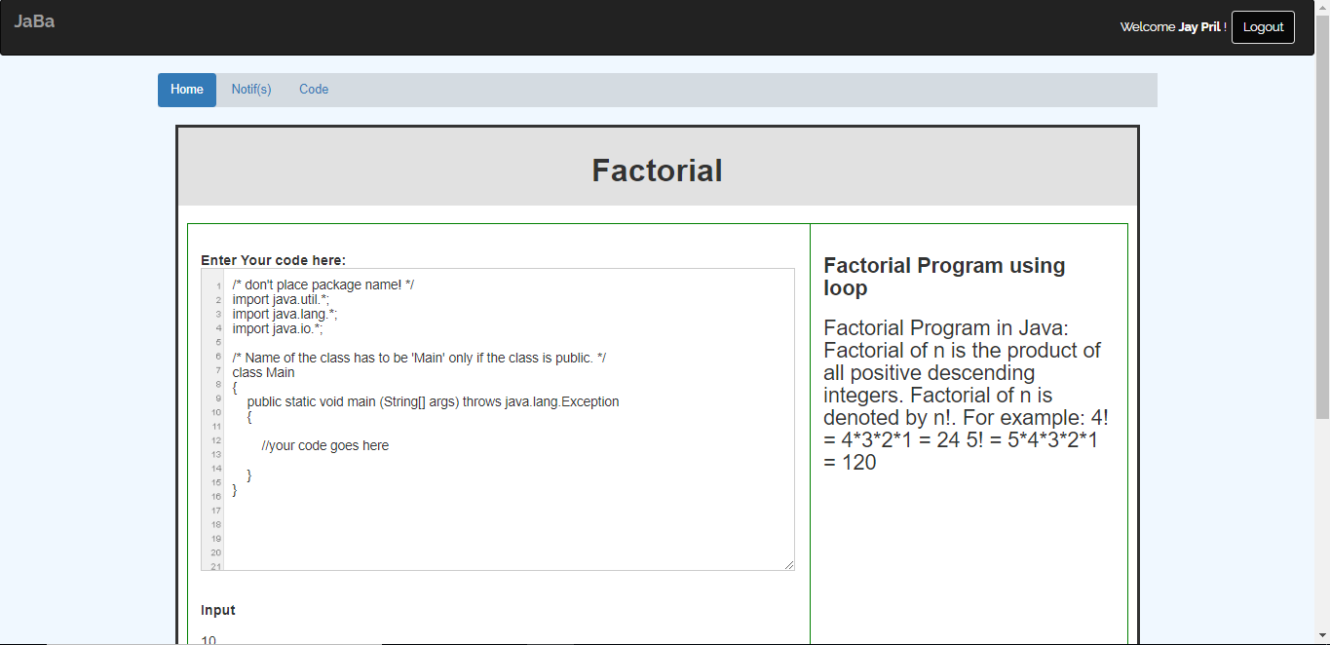

* Click run test to check if your code is running.

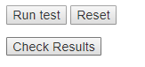

* Click check results to check if expected output has matched.
* Click submit button to submit answer.



**STEP 9:**

* Click code in nav bar to access the built in compiler.

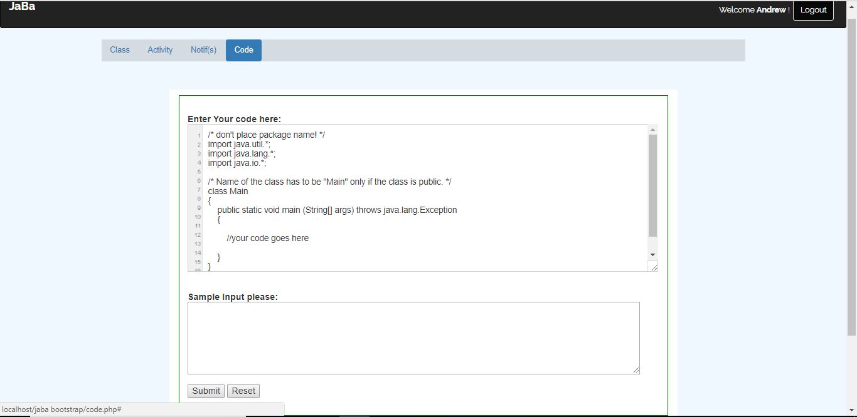

* Insert codes to run then click the submit button to run the program.