ModelIt! Coloring Sheet
Why Can We See Through Some Things?
1st Grade
Name: _______________________________ | Date: _______________

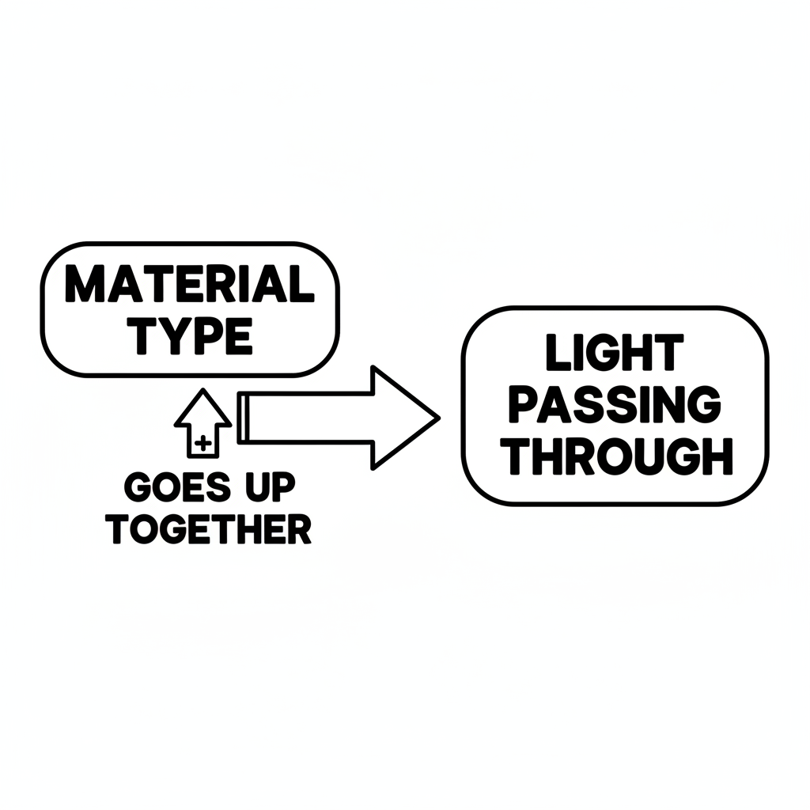

Color It!
A flashlight shining a beam of light at three objects in a row: a clear window (light goes through), a piece of wax paper (some light goes through with wavy lines), and a brick wall (light is blocked with an X).

Arrow Color Key:
Green arrow (+) = Go together (both go up!) Red arrow (-) = Go opposite (one up, one down!)

ModelIt! G01-L02

