ModelIt! Coloring Sheet
How Do Baby Animals Look Like Their Parents?
1st Grade
Name: _______________________________ | Date: _______________

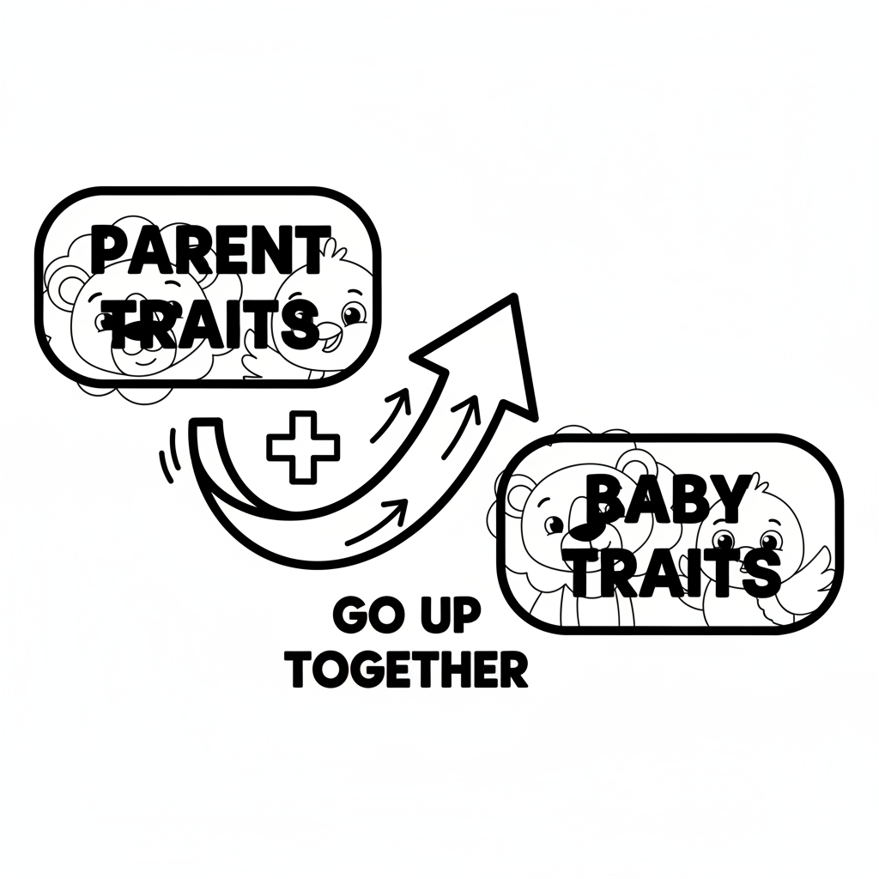

Color It!
A mama cat with spotted fur sitting next to two kittens — one has spots like mama and the other has slightly different spots. Arrows point from the mama's spots to the kittens' spots to show the trait was passed along.

Arrow Color Key:
Green arrow (+) = Go together (both go up!) Red arrow (-) = Go opposite (one up, one down!)

ModelIt! G01-L03

