ModelIt! Coloring Sheet
What Do Animals Need to Survive?
1st Grade
Name: _______________________________ | Date: _______________

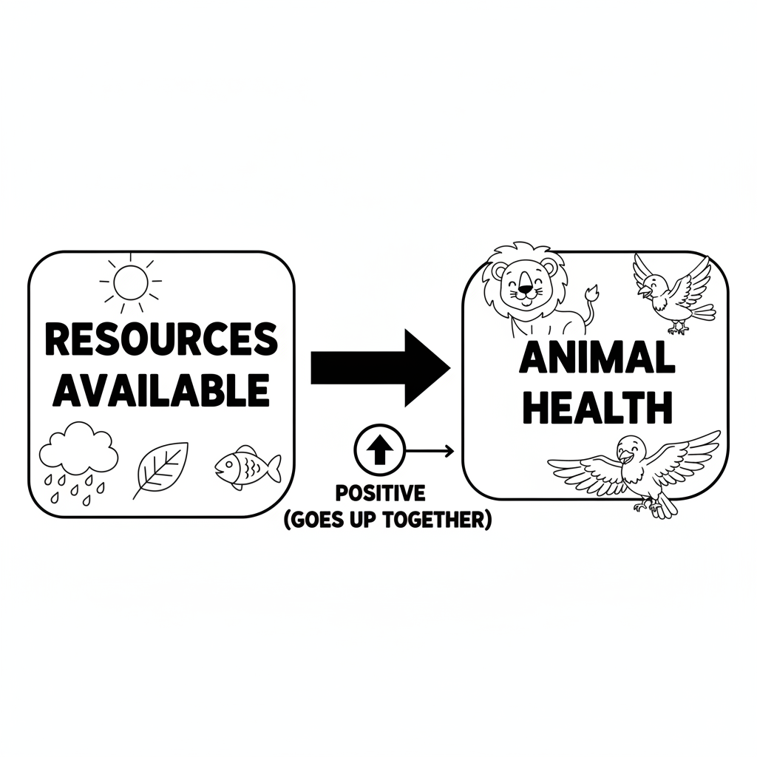

Color It!
A happy rabbit in a meadow surrounded by its four needs: a carrot (food), a little stream (water), clouds in the sky (air), and a burrow hole (shelter). Each need has a label with a dotted line connecting it to the rabbit.

Arrow Color Key:
Green arrow (+) = Go together (both go up!) Red arrow (-) = Go opposite (one up, one down!)

ModelIt! G01-L04

