ModelIt! Coloring Sheet
How Do Animals Use Their Body Parts?
1st Grade
Name: _______________________________ | Date: _______________

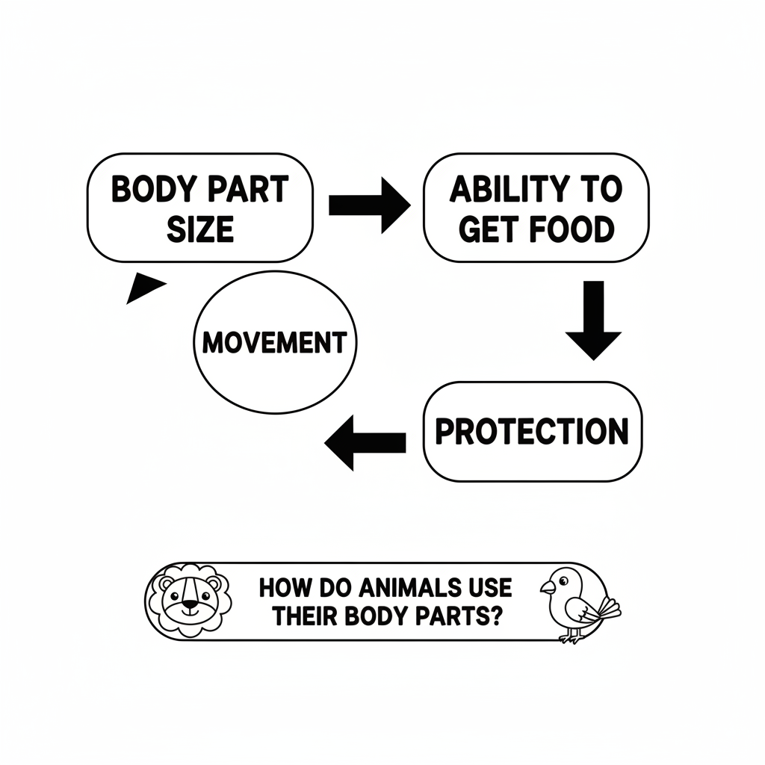

Color It!
Three birds sitting on a branch, each with a different beak shape: one long and thin reaching into a flower, one short and thick cracking a seed, and one wide and flat scooping a fish. Labels show each beak's job.

Arrow Color Key:
Green arrow (+) = Go together (both go up!) Red arrow (-) = Go opposite (one up, one down!)

ModelIt! G01-L05

