ModelIt! Coloring Sheet
Why Is It Dark at Night?
1st Grade
Name: _______________________________ | Date: _______________

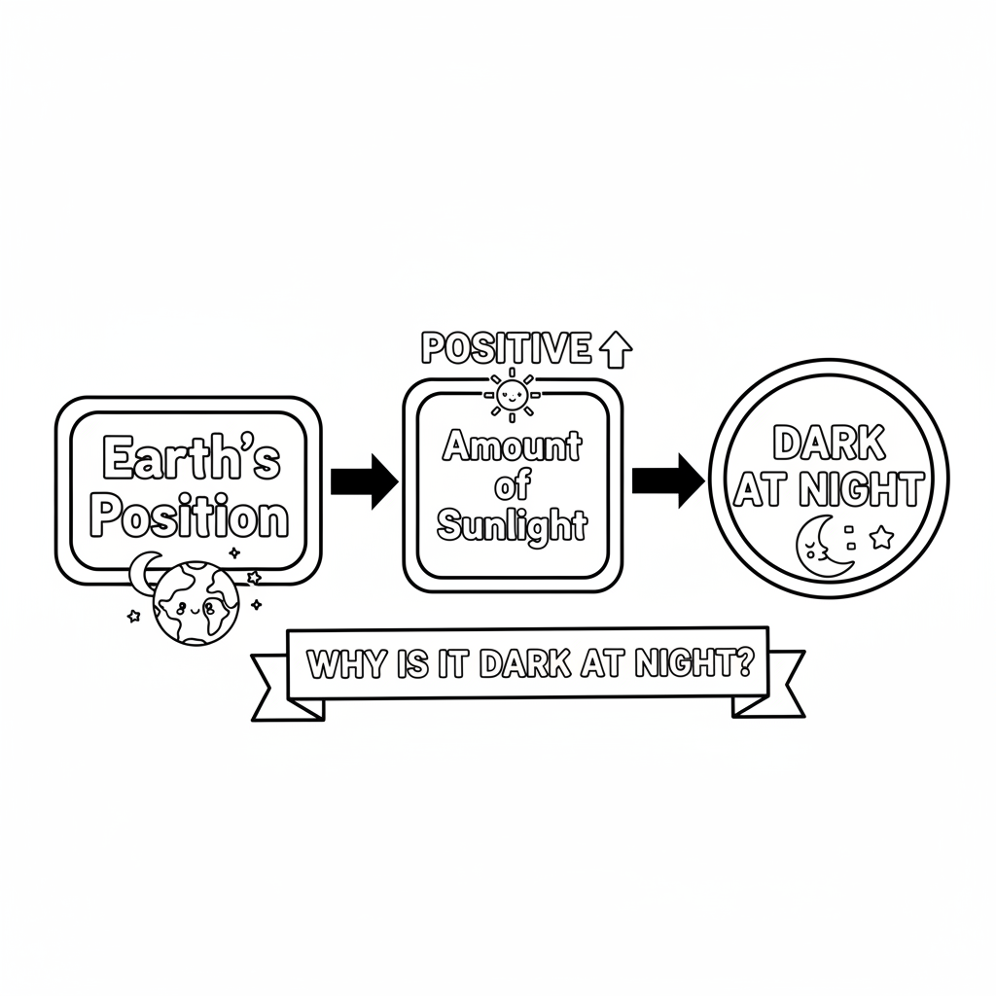

Color It!
The Earth shown as a big circle with the sun on one side. The side facing the sun is bright with a smiling child playing outside. The side facing away is dark with a sleeping child in bed with stars outside the window.

Arrow Color Key:
Green arrow (+) = Go together (both go up!) Red arrow (-) = Go opposite (one up, one down!)

ModelIt! G01-L06

