ModelIt! Coloring Sheet
How Do Seasons Change?
1st Grade
Name: _______________________________ | Date: _______________

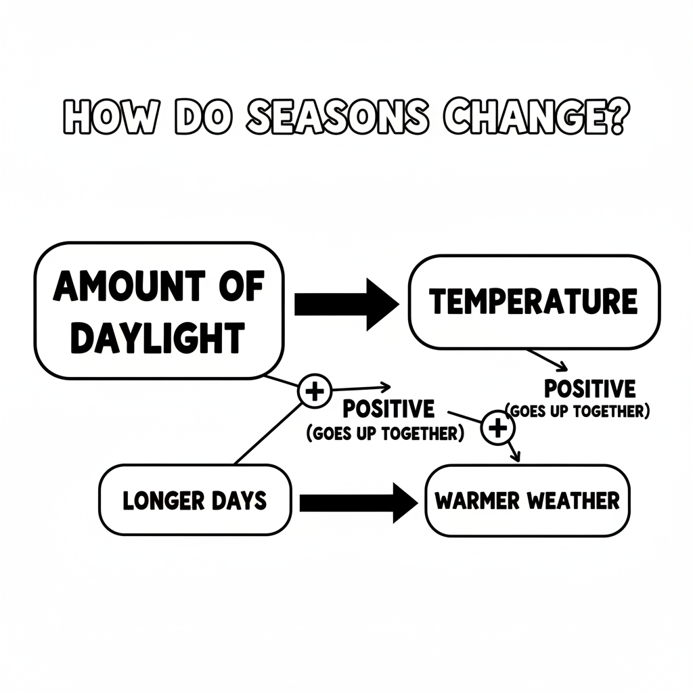

Color It!
Four boxes in a row showing the same tree in each season: spring with flowers and a small sun, summer with full leaves and a big bright sun, fall with orange leaves and a medium sun, winter with bare branches and a tiny sun. A thermometer next to each shows the temperature going up and then back down.

Arrow Color Key:
Green arrow (+) = Go together (both go up!) Red arrow (-) = Go opposite (one up, one down!)

ModelIt! G01-L07

