ModelIt! Coloring Sheet
Can You Send a Message with Light?
1st Grade
Name: _______________________________ | Date: _______________

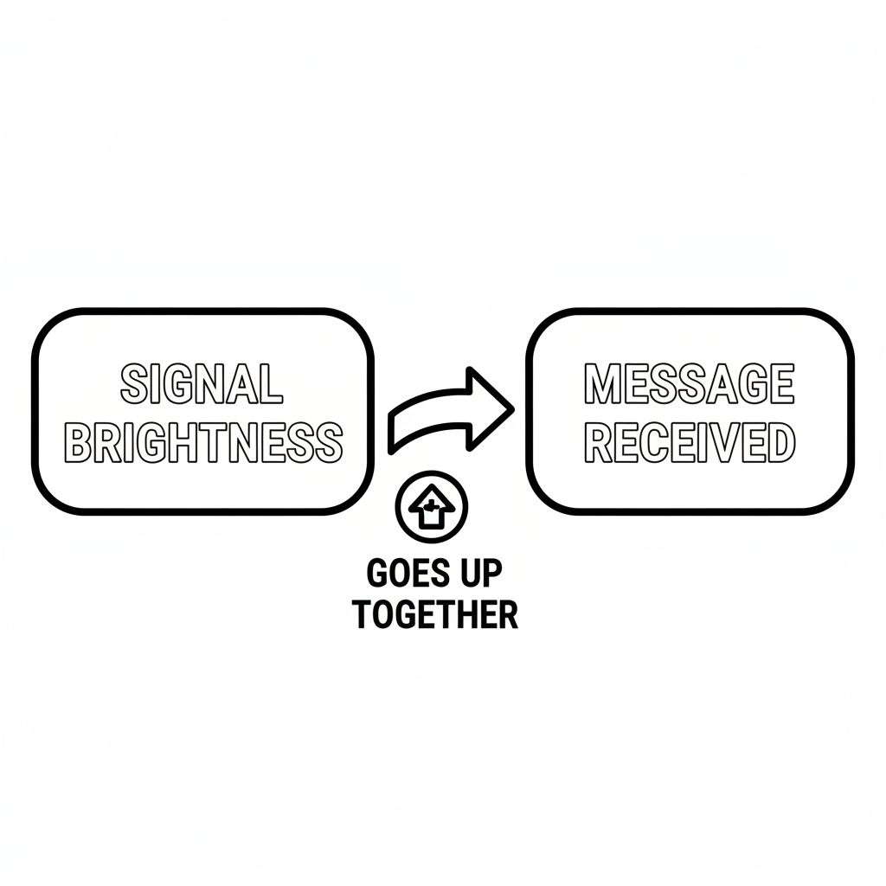

Color It!
Two children standing far apart — one holding a flashlight pointed at the other. Between them, dotted lines show the light traveling. The child receiving the signal has a big smile and is holding up a card that says the message. A lighthouse is in the background.

Arrow Color Key:
Green arrow (+) = Go together (both go up!) Red arrow (-) = Go opposite (one up, one down!)

ModelIt! G01-L08

