ModelIt! Coloring Sheet
How Do Plants Grow from Seeds?
1st Grade
Name: _______________________________ | Date: _______________

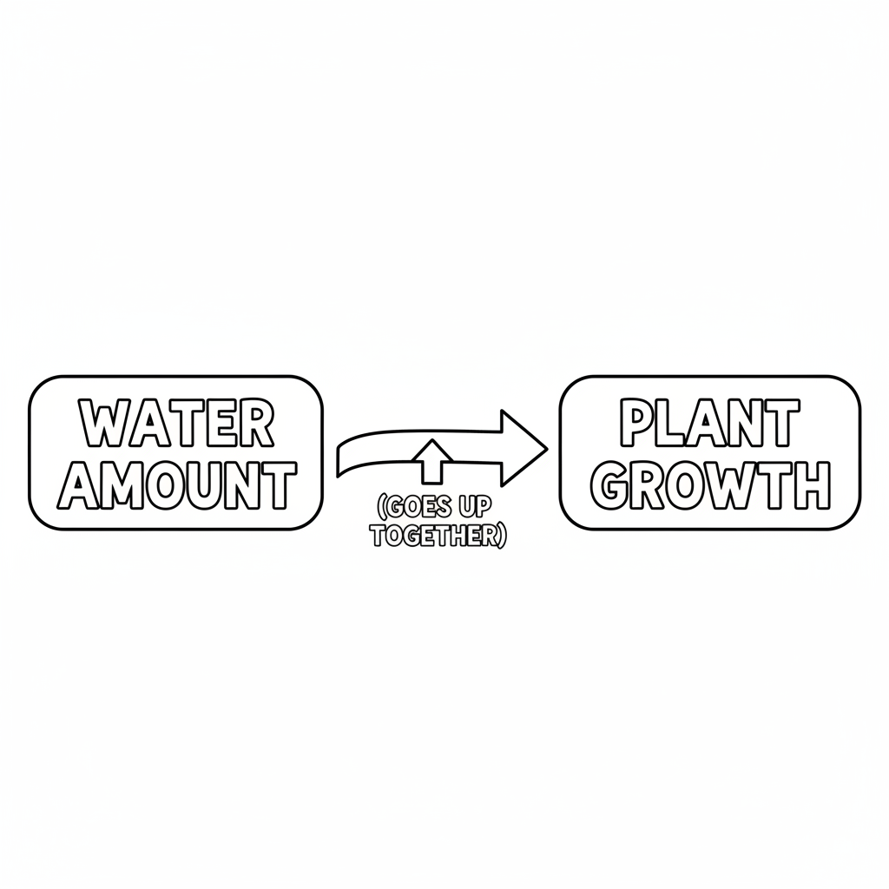

Color It!
A row of four cups showing the stages of a seed growing: Cup 1 has a seed buried in soil with a watering can above. Cup 2 shows a tiny sprout poking up. Cup 3 shows a small plant with two leaves. Cup 4 shows a tall plant with a flower on top. A smiling sun shines above all four cups.

Arrow Color Key:
Green arrow (+) = Go together (both go up!) Red arrow (-) = Go opposite (one up, one down!)

ModelIt! G01-L09

