ModelIt! Coloring Sheet
What Makes a Shadow?
1st Grade
Name: _______________________________ | Date: _______________

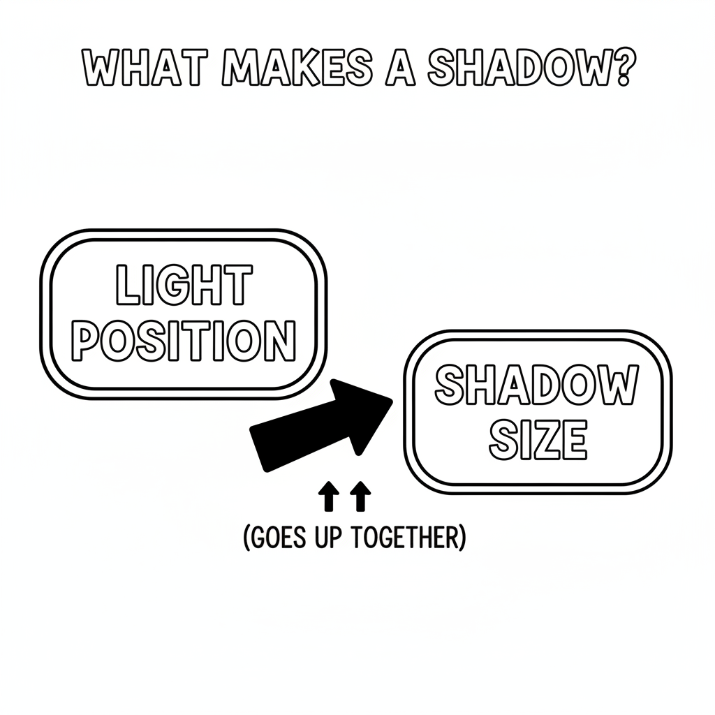

Color It!
A child holding a cardboard butterfly on a stick between a flashlight and a wall. On the wall, a big butterfly shadow appears. Dotted lines from the flashlight show how the light is blocked by the cardboard and creates the dark shadow behind it.

Arrow Color Key:
Green arrow (+) = Go together (both go up!) Red arrow (-) = Go opposite (one up, one down!)

ModelIt! G01-L10

