ModelIt! Coloring Sheet
Can Plants Grow Without Soil?
2nd Grade
Name: _______________________________ | Date: _______________

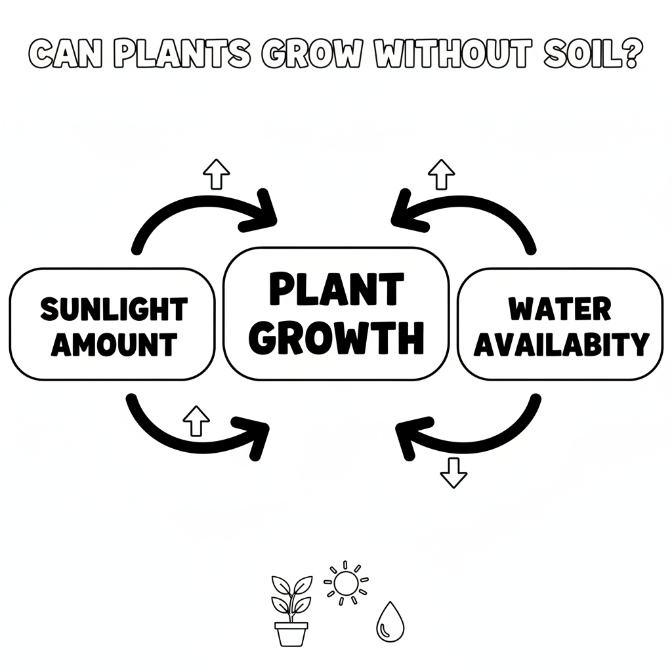

Color It!
Color each part of the system model! Color the Sunlight Amount box, the Water Availability box, and trace the arrows connecting them. Use green for arrows that mean 'goes up together' (+) and red for arrows that mean 'goes opposite' (-).

Arrow Color Key:
Green arrow (+) = Go together (both go up!) Red arrow (-) = Go opposite (one up, one down!)

ModelIt! G02-L04

