ModelIt! Coloring Sheet
Why Do Things Fall Down?
Kindergarten
Name: _______________________________ | Date: _______________

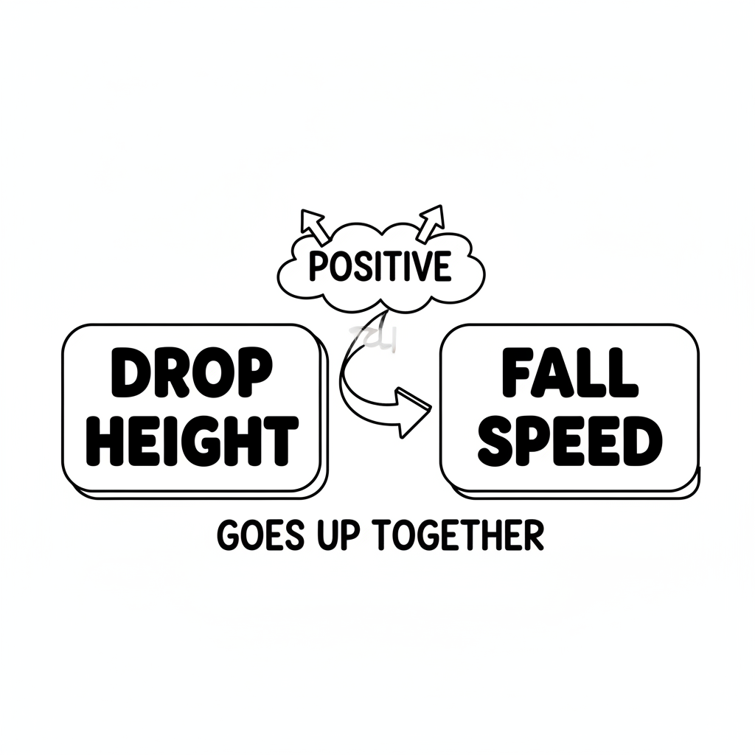

Color It!
Color the ball at the top of the picture and at the bottom. Trace the arrow showing gravity pulling the ball down!

Arrow Color Key:
Green arrow (+) = Go together (both go up!) Red arrow (-) = Go opposite (one up, one down!)

ModelIt! GK-L01

