ModelIt! Coloring Sheet
What Makes Things Move?
Kindergarten
Name: _______________________________ | Date: _______________

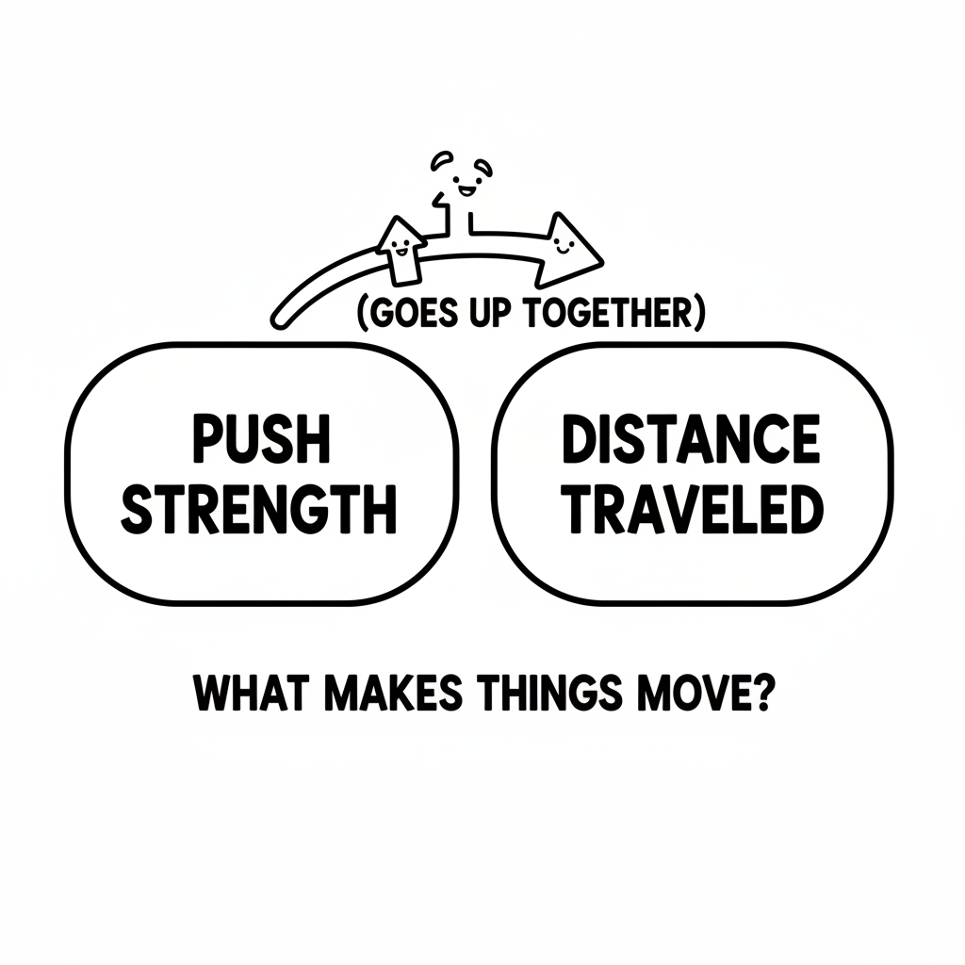

Color It!
Color the hand pushing the car. Color the car at the start and where it stops. Trace the arrow from the hand to the car!

Arrow Color Key:
Green arrow (+) = Go together (both go up!) Red arrow (-) = Go opposite (one up, one down!)

ModelIt! GK-L02

