ModelIt! Coloring Sheet
Does the Sun Warm Everything the Same?
Kindergarten
Name: _______________________________ | Date: _______________

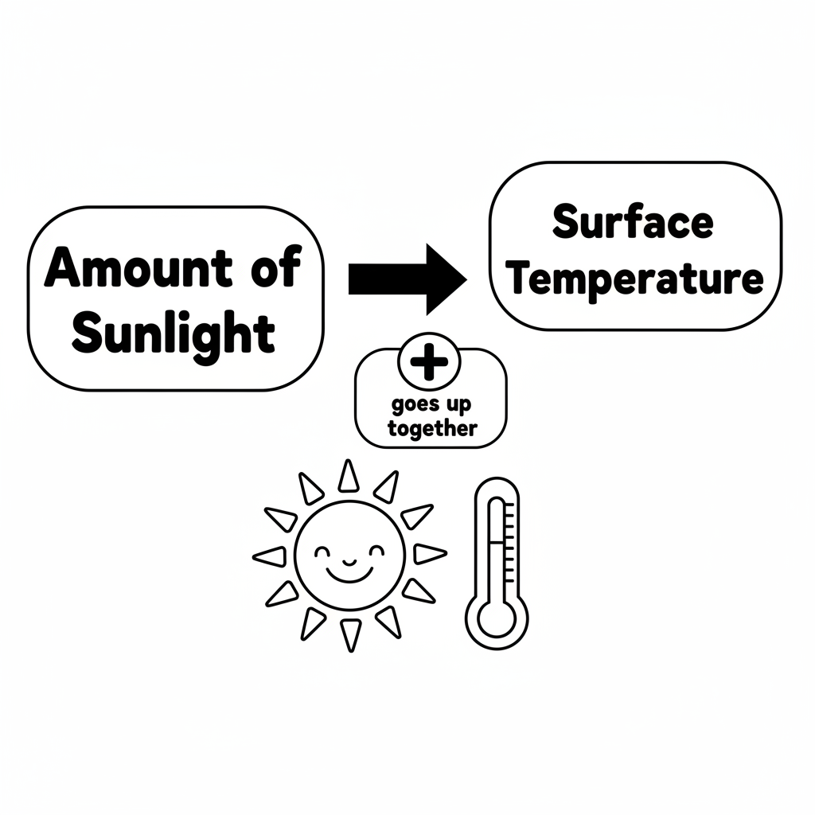

Color It!
Color the sun yellow. Color the sunny spot orange (warm) and the shady spot blue (cool). Draw a tree making the shade!

Arrow Color Key:
Green arrow (+) = Go together (both go up!) Red arrow (-) = Go opposite (one up, one down!)

ModelIt! GK-L03

