ModelIt! Coloring Sheet
What Do Plants Need to Grow?
Kindergarten
Name: _______________________________ | Date: _______________

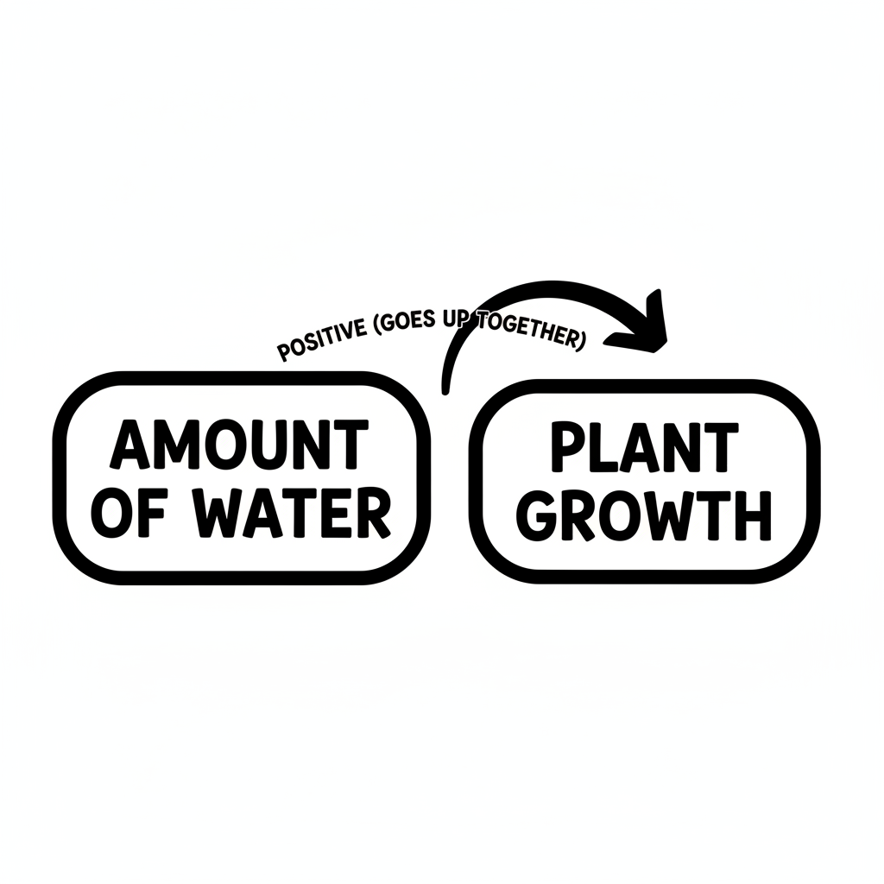

Color It!
Color the watering can blue. Color the tall plant green and the small plant light green. Draw water drops going into the soil!

Arrow Color Key:
Green arrow (+) = Go together (both go up!) Red arrow (-) = Go opposite (one up, one down!)

ModelIt! GK-L04

