ModelIt! Coloring Sheet
Where Do Animals Live?
Kindergarten
Name: _______________________________ | Date: _______________

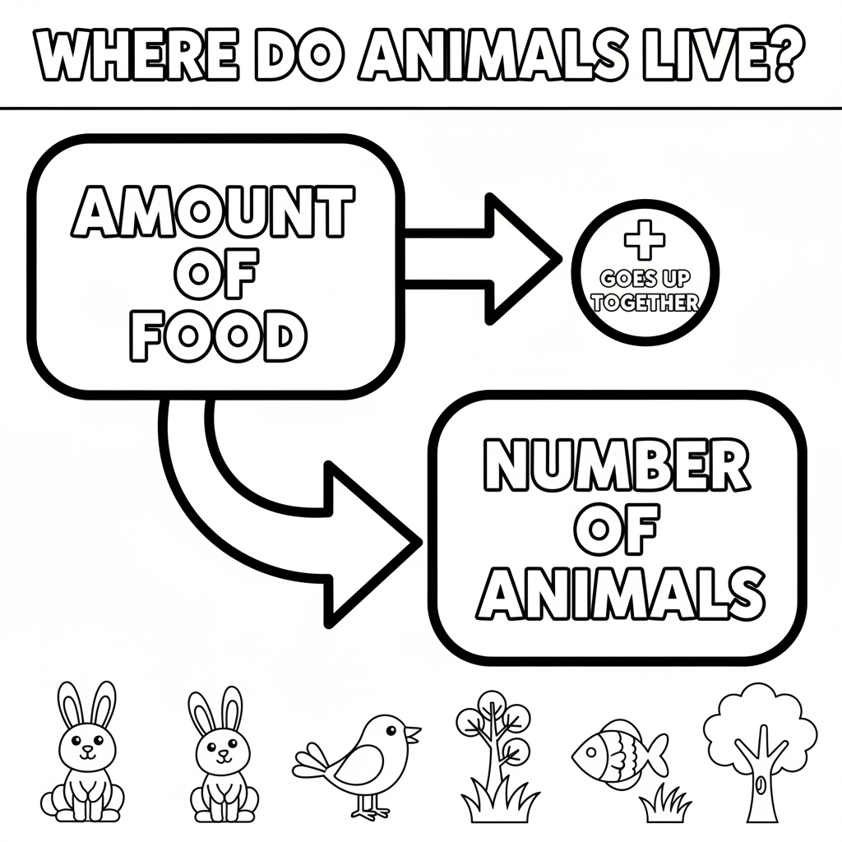

Color It!
Color the pond blue for water. Color the fish in the pond (food). Draw ducks on the pond and color a bush for shelter!

Arrow Color Key:
Green arrow (+) = Go together (both go up!) Red arrow (-) = Go opposite (one up, one down!)

ModelIt! GK-L05

