ModelIt! Coloring Sheet
What's the Weather Like Today?
Kindergarten
Name: _______________________________ | Date: _______________

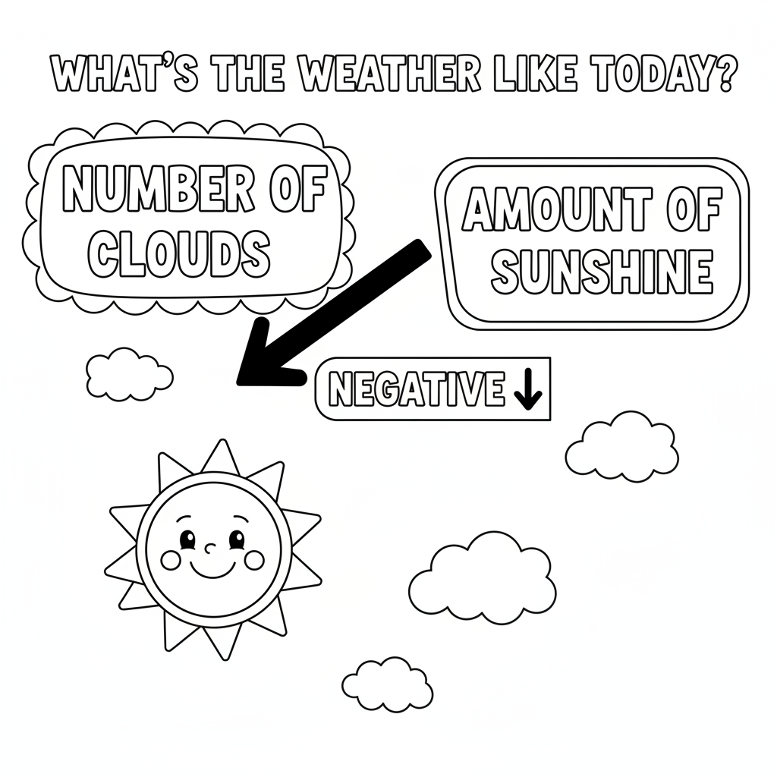

Color It!
Color a clear sky bright yellow with a big sun. Color a cloudy sky gray with clouds covering the sun. Circle which sky gives more sunshine!

Arrow Color Key:
Green arrow (+) = Go together (both go up!) Red arrow (-) = Go opposite (one up, one down!)

ModelIt! GK-L06

