ModelIt! Coloring Sheet
Can We Stop a Flood?
Kindergarten
Name: _______________________________ | Date: _______________

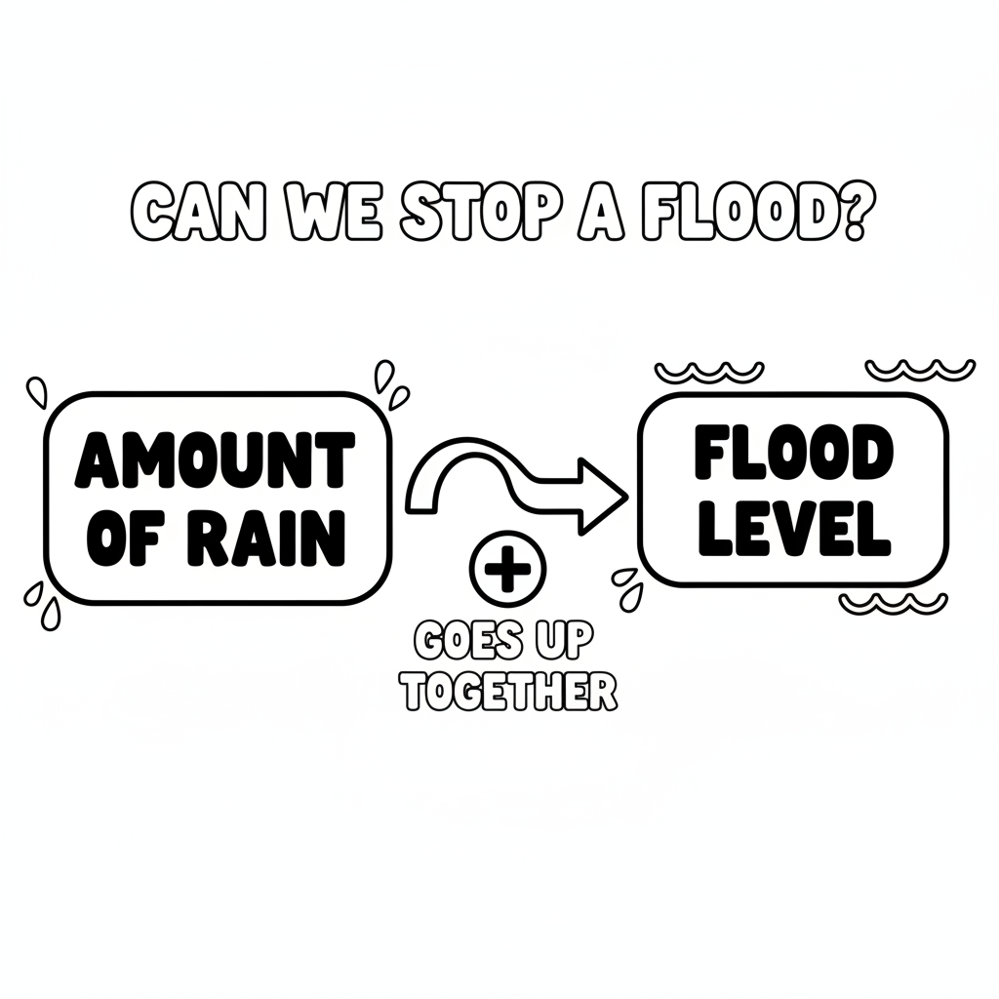

Color It!
Color the rain clouds dark gray. Color the water blue flooding toward the houses. Draw and color a barrier wall between the water and the houses!

Arrow Color Key:
Green arrow (+) = Go together (both go up!) Red arrow (-) = Go opposite (one up, one down!)

ModelIt! GK-L07

