ModelIt! Coloring Sheet
Where Does Rain Come From?
Kindergarten
Name: _______________________________ | Date: _______________

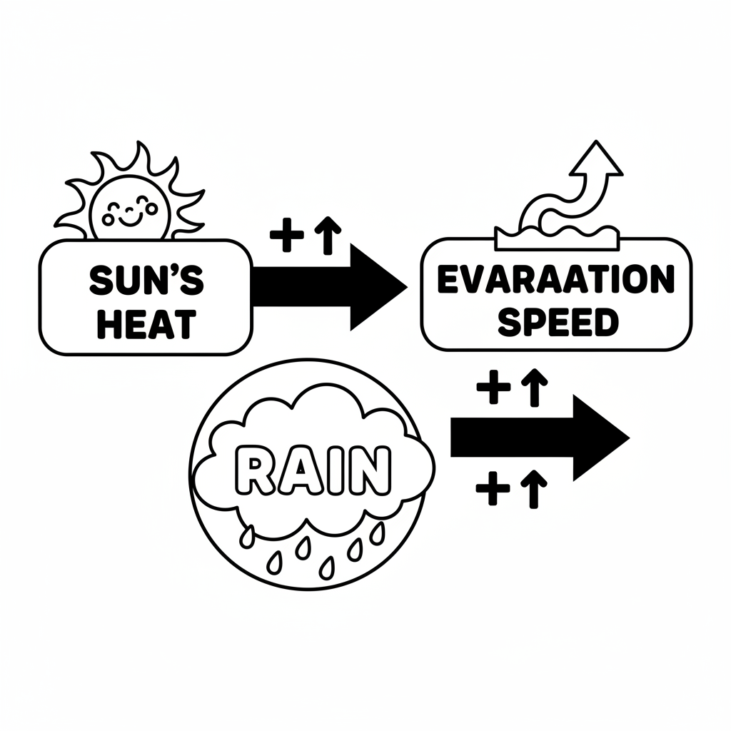

Color It!
Color the sun yellow at the top. Color the puddle blue at the bottom. Trace the arrows going UP from the puddle and DOWN from the cloud. Color the cloud white or gray!

Arrow Color Key:
Green arrow (+) = Go together (both go up!) Red arrow (-) = Go opposite (one up, one down!)

ModelIt! GK-L08

