ModelIt! Coloring Sheet
How Do We Take Care of Earth?
Kindergarten
Name: _______________________________ | Date: _______________

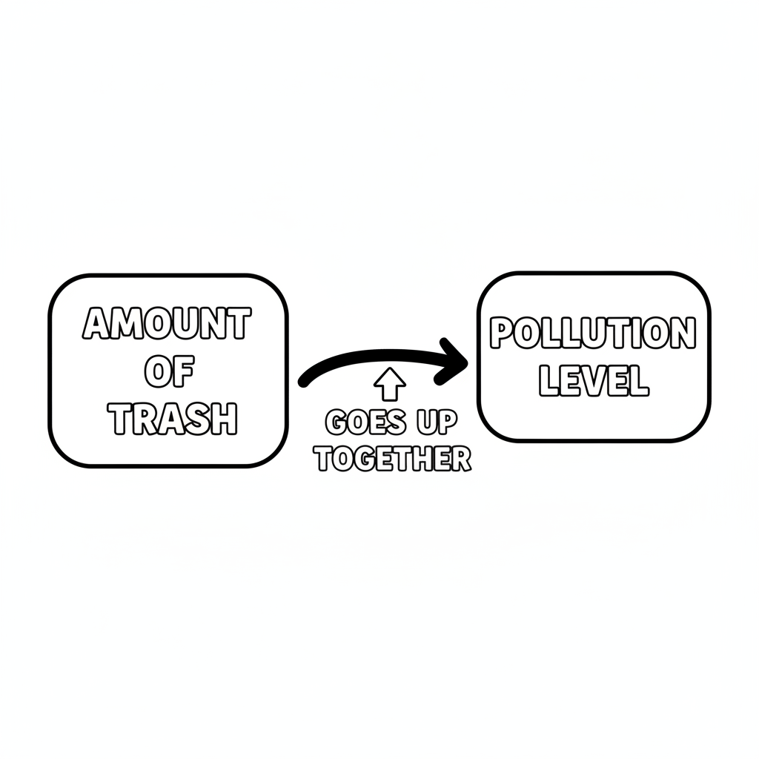

Color It!
Color the recycling bin green. Color the clean park with green grass and flowers. Draw yourself putting something in the recycling bin!

Arrow Color Key:
Green arrow (+) = Go together (both go up!) Red arrow (-) = Go opposite (one up, one down!)

ModelIt! GK-L09

