ModelIt! Coloring Sheet
What Happens When You Push Harder?
Kindergarten
Name: _______________________________ | Date: _______________

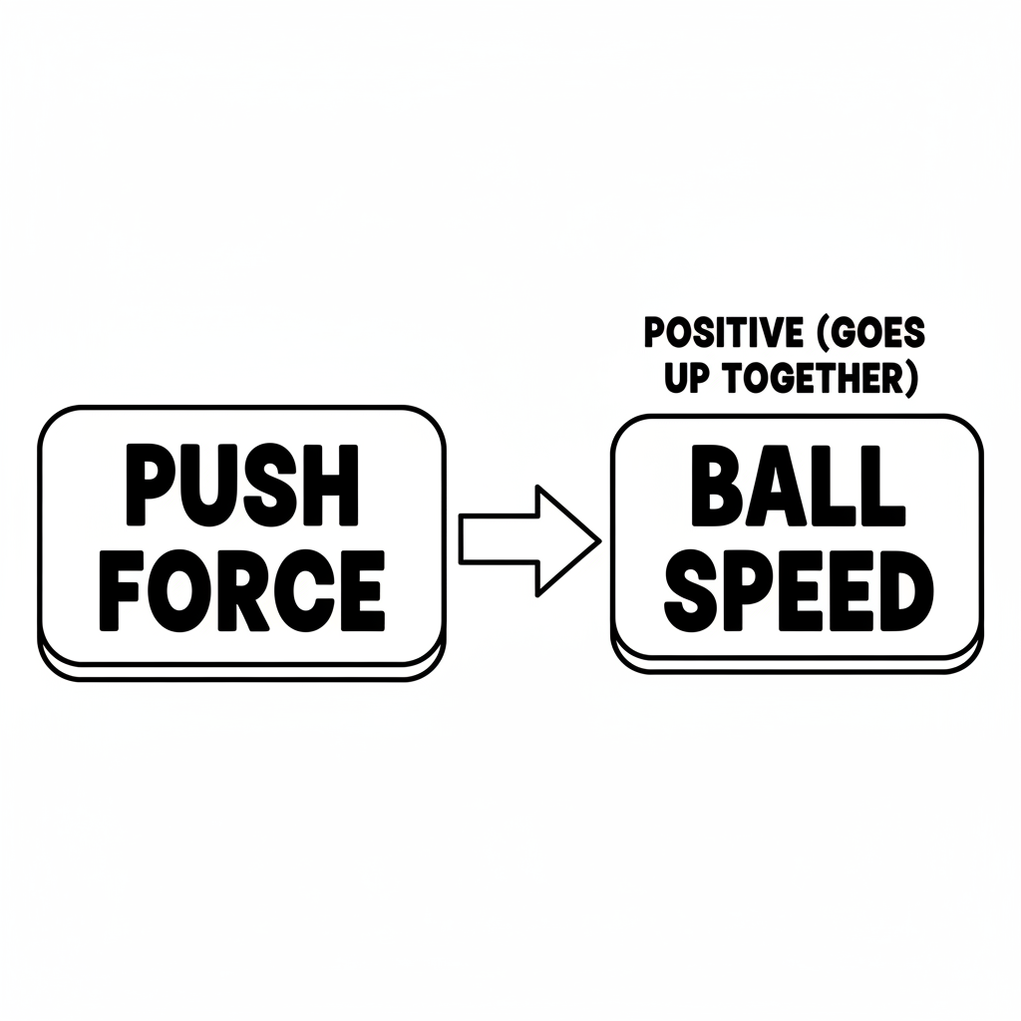

Color It!
Color the hand pushing the ball. Draw short arrows behind the slow ball and long arrows behind the fast ball. Color the bowling pins at the end!

Arrow Color Key:
Green arrow (+) = Go together (both go up!) Red arrow (-) = Go opposite (one up, one down!)

ModelIt! GK-L10

