**\*\* Import the script**

**\*\* Execute the script**

**\*\* Type the SQL statements for each questions below, and display the corresponding reporting output**

**Q-1. Write an SQL query to fetch “FIRST_NAME” from Worker table using the alias name as <WORKER_NAME>.**

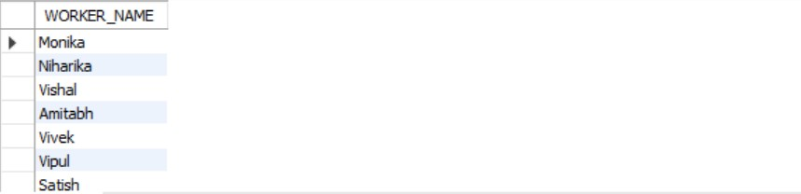

#### Q-2. Write an SQL query to fetch unique values of DEPARTMENT from Worker table.

#### 

#### Q-3. Write an SQL query to print the FIRST_NAME and LAST_NAME from Worker table into a single column COMPLETE_NAME. A space char should separate them.

#### 

#### Q-4. Write an SQL query to print all Worker details from the Worker table order by FIRST_NAME Ascending.

#### 

#### Q-5. Write an SQL query to print all Worker details from the Worker table order by FIRST_NAME Ascending and DEPARTMENT Descending.

#### 

#### Q-6. Write an SQL query to print details for Workers with the first name as “Vipul” and “Satish” from Worker table.

#### 

#### Q-7. Write an SQL query to print details of workers excluding first names, “Vipul” and “Satish” from Worker table.

#### 

#### Q-8. Write an SQL query to print details of Workers with DEPARTMENT name as “Admin”.

#### 

#### Q-9. Write an SQL query to print details of the Workers whose FIRST_NAME contains ‘a’.

#### 

#### Q-10. Write an SQL query to print details of the Workers whose FIRST_NAME ends with ‘a’.

#### 

#### Q-11. Write an SQL query to print details of the Workers whose FIRST_NAME ends with ‘h’ and contains six alphabets.

#### 

#### Q-12. Write an SQL query to print details of the Workers whose SALARY lies between 100000 and 500000.

#### 

#### Q-13. Write an SQL query to fetch the count of employees working in the department ‘Admin’.

#### 

#### Q-14. Write an SQL query to fetch worker names with salaries >= 50000 and <= 100000.

#### 

#### Q-15. Write an SQL query to print details of the Workers who are also Managers.

#### 

#### Q-16. Following MySQL query returns the current date and time:

#### 

#### Q-17. Write an SQL query to show the top n (say 10) records of a table.

#### 