Supplementary Information
Decoding Bispecific Antibody Developability: Design Rules and Predictive Models from a 160-Member Library

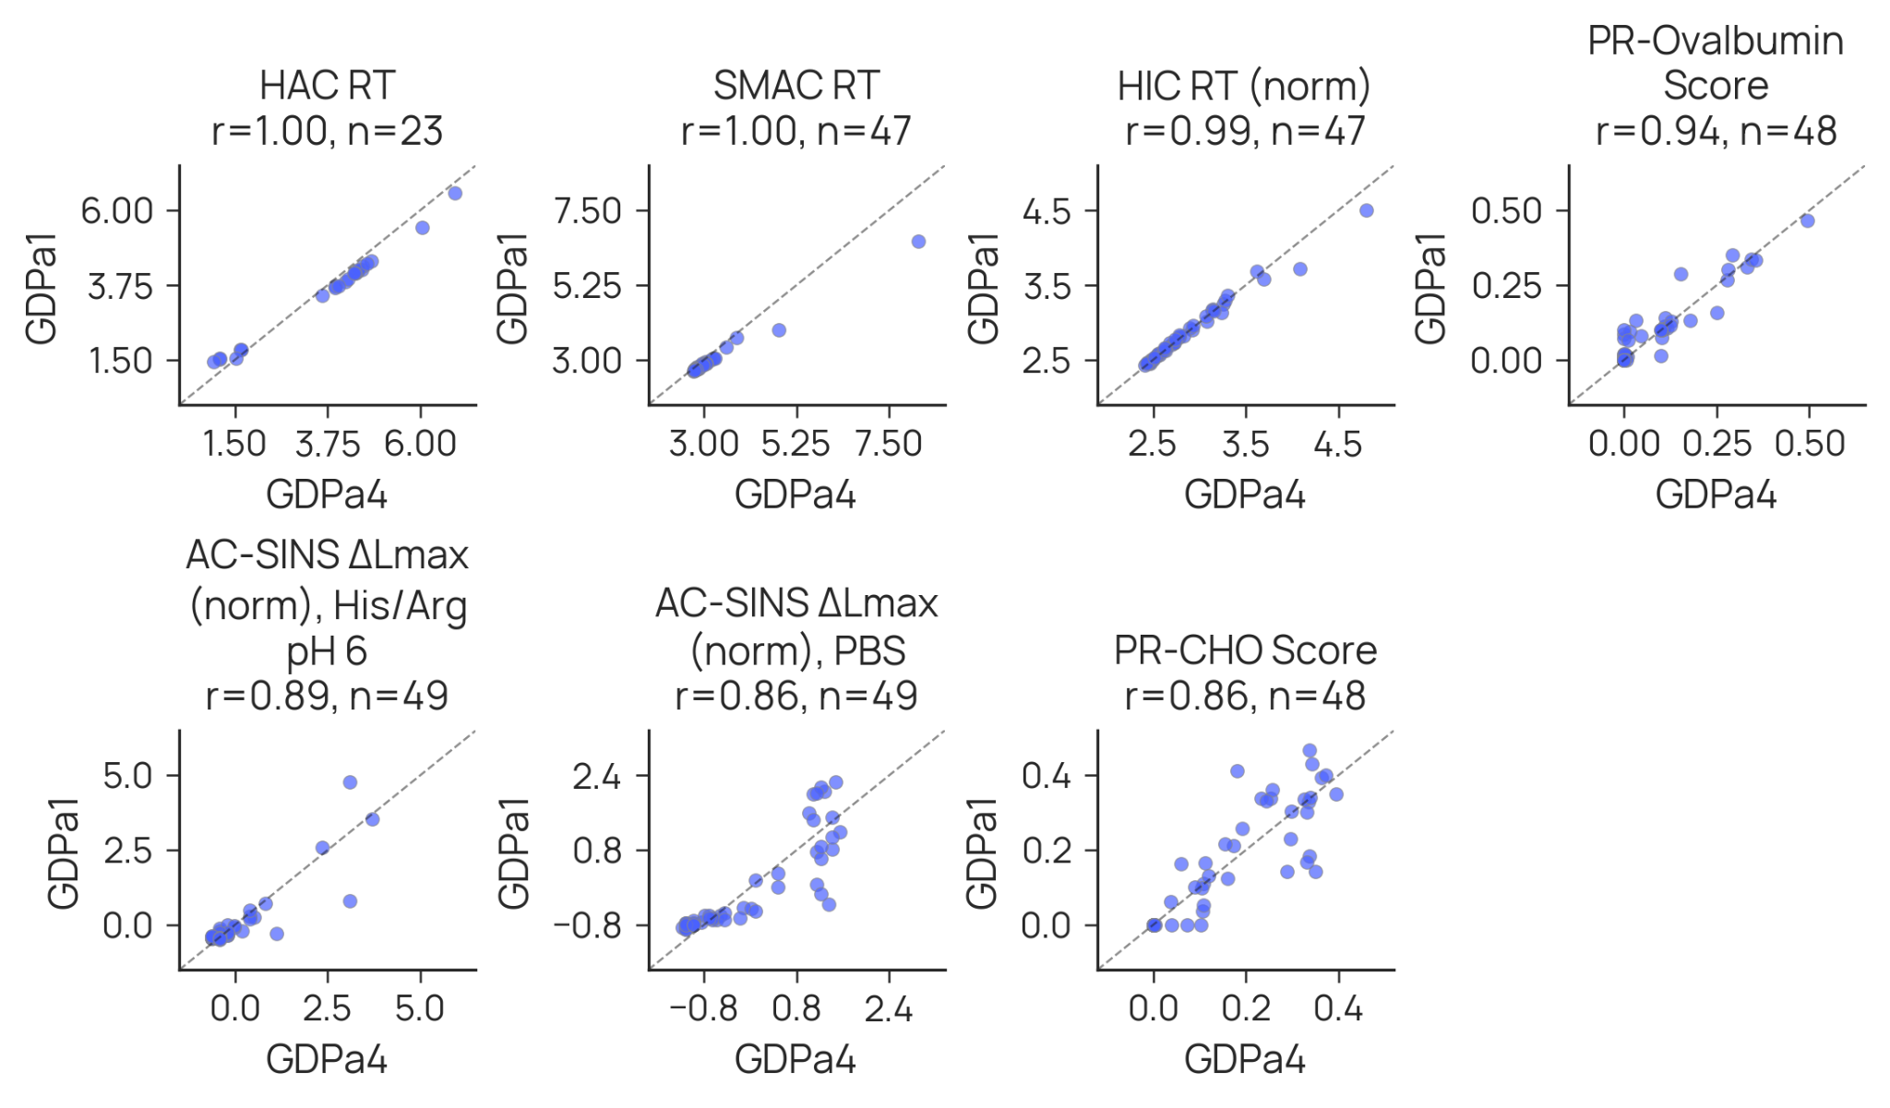
Supplementary Figure 1. Reproducibility of antibody developability property profiling. Antibodies from this study (GDPa4; all reformatted as IgG1) are compared to the GDPa1 antibodies reported by Arsiwala et al. (2025). Of note, a method change was implemented for AC-SINS since the prior publication, resulting in elevated measures for this campaign.

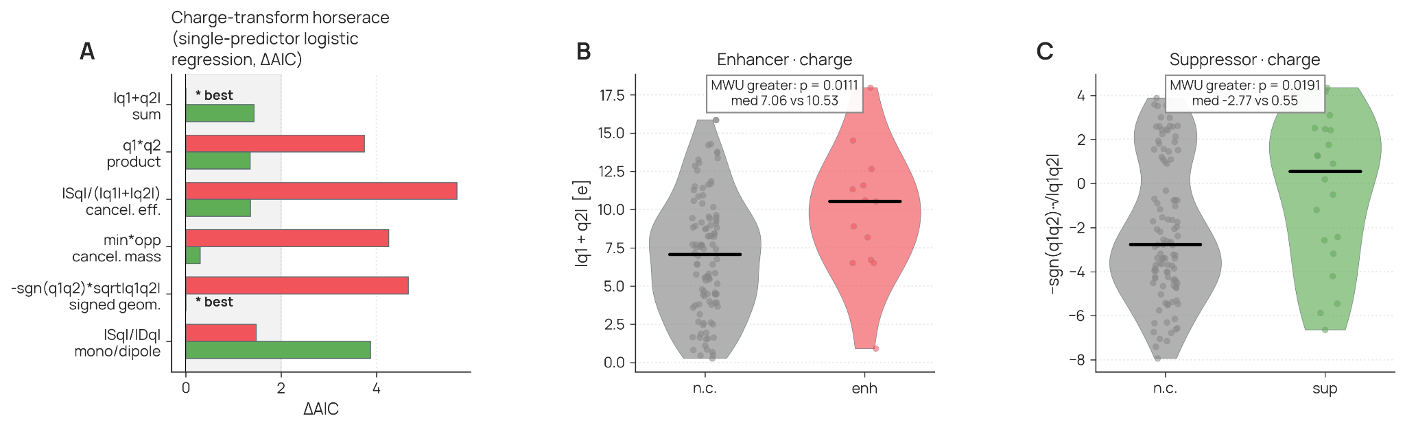
Supplementary Figure 2. AC-SINS self-association in PBS pH 7.4. (A) Single-predictor logistic-regression horserace over six charge transforms, ranked by ΔAIC. Each transform is fitted twice, once as a predictor of enhancer status (red bars) and once as a predictor of suppressor status (green bars), and ΔAIC is reported relative to the best-performing transform within each of those two classes. The shaded band marks ΔAIC < 2, within which a transform is not statistically distinguishable from the best. Because the winning transform in each class has ΔAIC = 0 by definition, its bar has zero length and does not render: this is why |q1+q2| sum, the best enhancer transform, shows only its green suppressor bar, and why the signed geometric mean, the best suppressor transform, shows only its red enhancer bar. Both are marked with an asterisk. (B) Distribution of |q1+q2|, the best enhancer transform, for enhancers (red) against bispecifics that were not classified as outliers (grey); medians 10.53 and 7.06, one-sided Mann-Whitney U p = 0.0111. (C) Distribution of the signed geometric mean, the best suppressor transform, for suppressors (green) against non-classified bispecifics (grey); medians 0.55 and −2.77, one-sided Mann-Whitney U p = 0.0191. In (B) and (C) each point is one bispecific, the violin shows the kernel density, and the horizontal bar is the median.

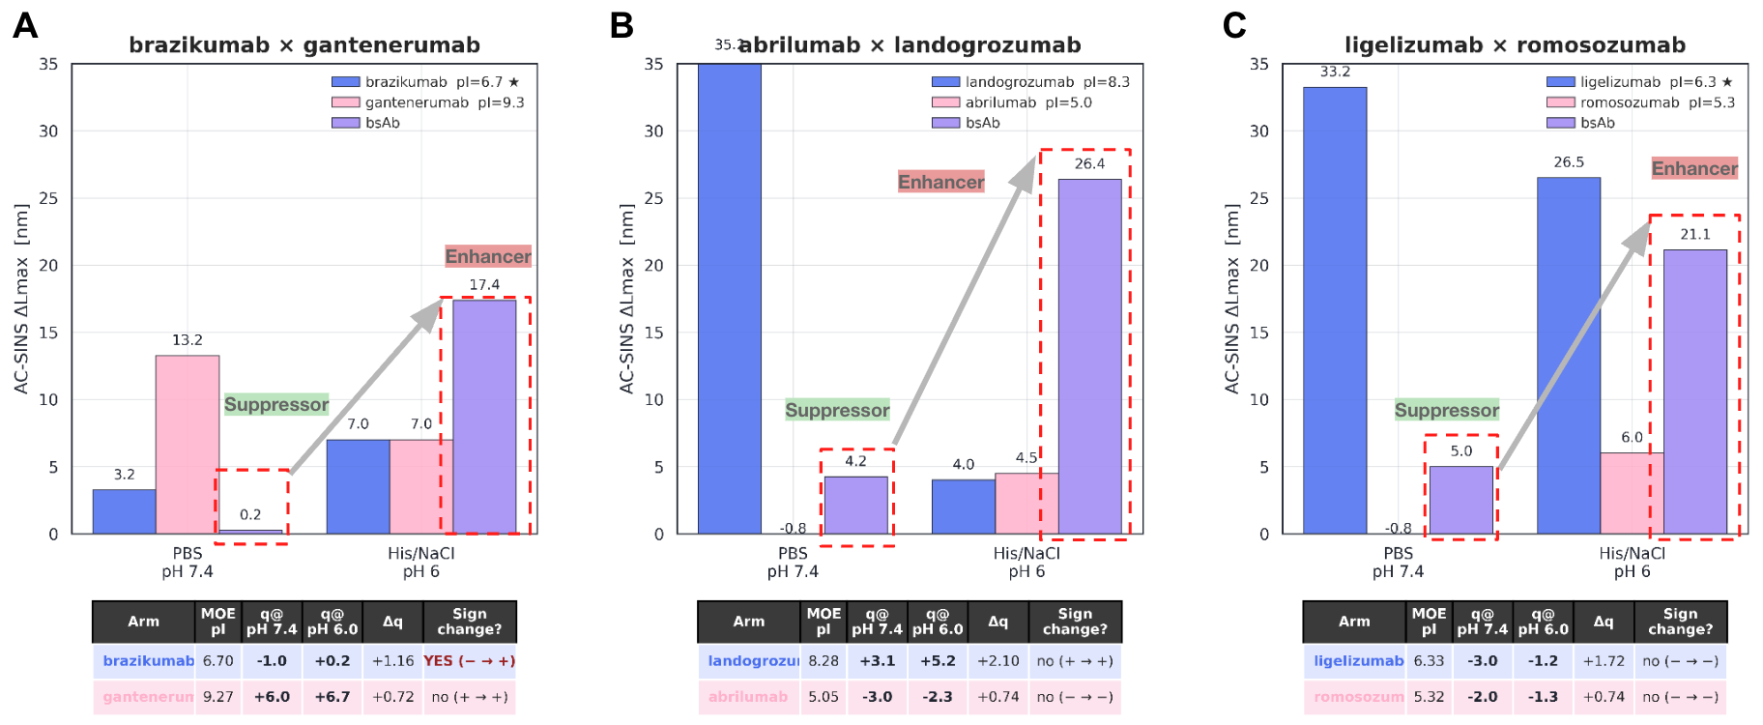
Supplementary Figure 3. Emergent enhancer behavior by buffer context for AC-SINS. Expanding from analysis on a single buffer, emergence is presented in the context of 3 bispecific antibodies. (A) Bispecific antibody built of brazikumab and gantenerumab exhibits a large increase in AC-SINS signal when moving to pH6 in His/NaCl buffer, whereas the average for the constituent mAbs lowers. (B) Bispecific antibody built of abrilumab and landogrozumab exhibits large increase in AC-SINS signal despite dramatic decrease in average for each constituent mAb. (C) Bispecific antibody built of ligelizumab and romosozumab exhibits increase, potentially providing an example of the loss of suppressor behavior from the pair under context shift.

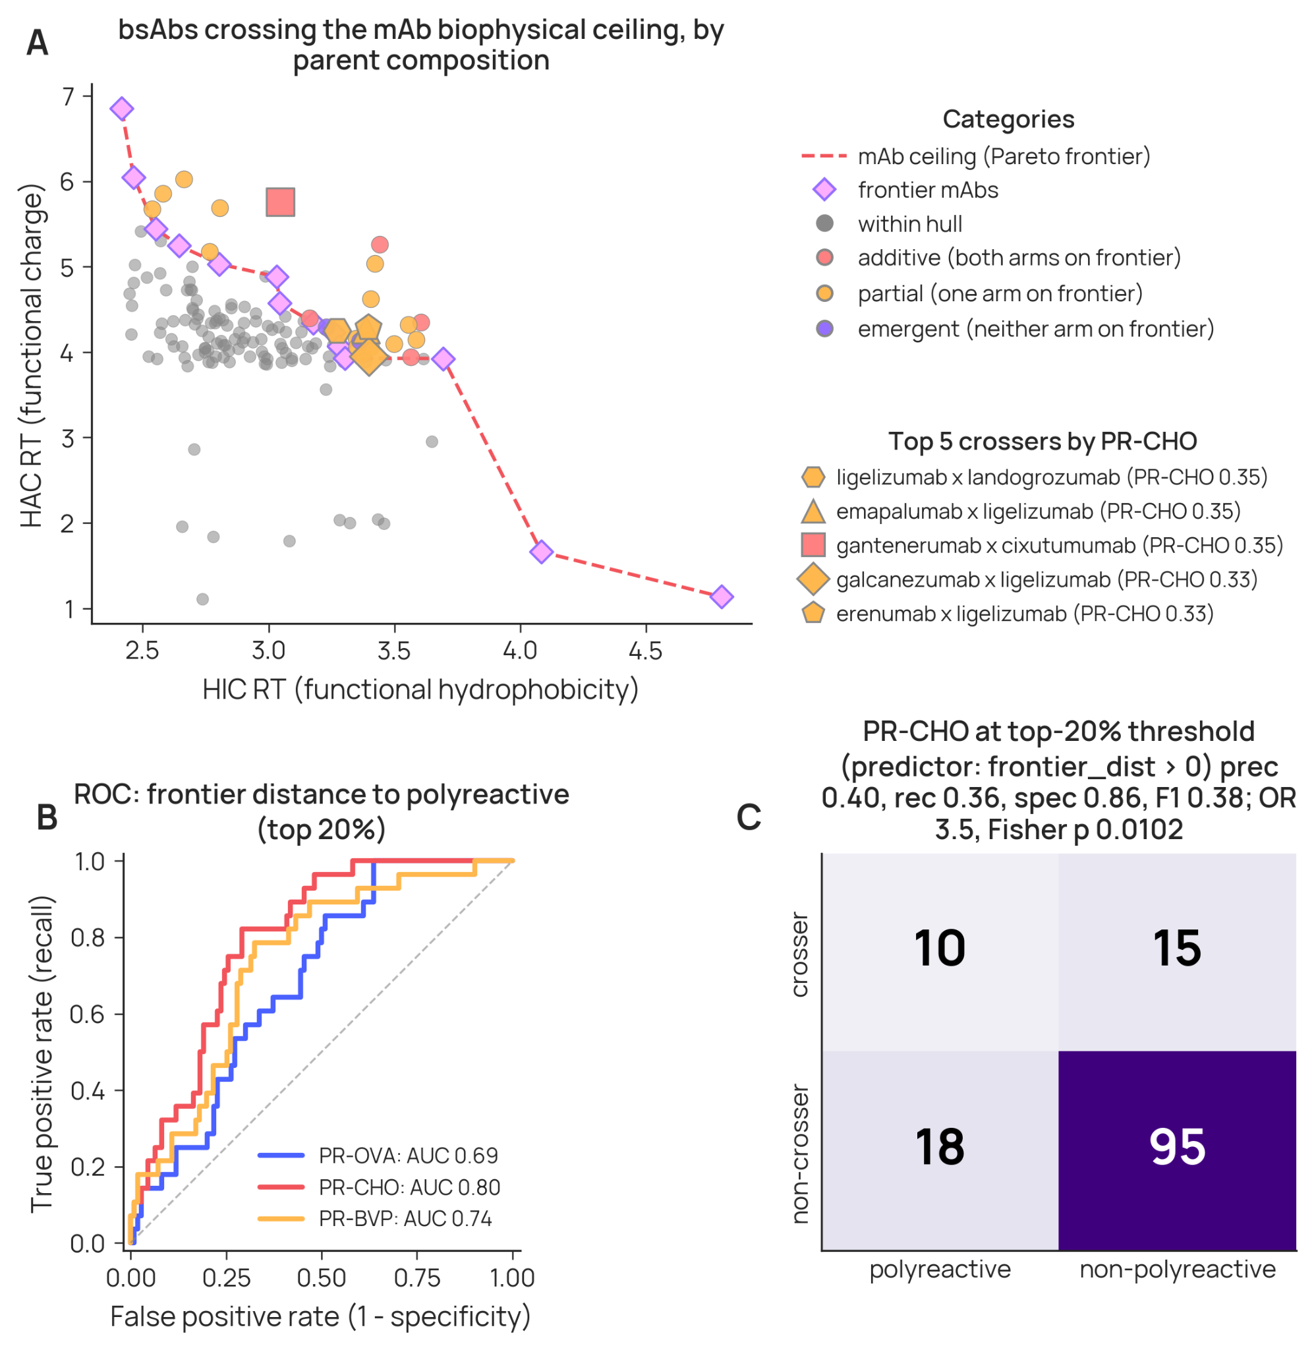
Supplementary Figure 4. HIC x HAC frontier analysis. (A) Assessment of bispecific antibodies when mapped against the Pareto-frontier providing predictive assessment of PR-CHO. (B) Distance to this front, across polyreactivity assays, provides a measurable signal predictive of having elevated polyreactivity. (C) Bispecifics with parents that fall on the front and that exhibit crossing of the front are significantly more likely to be polyreactive.

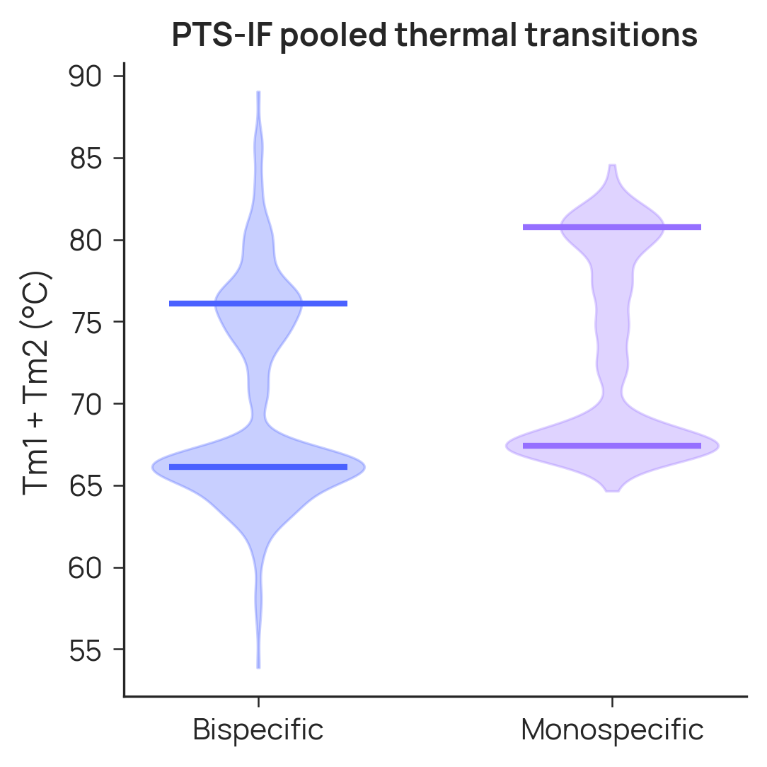
Supplementary Figure 5. Distributions of pooled measured thermal transitions. The dominant transitions, modes 67.4 and 80.8 °C for mAbs, and 66.1 76.1 °C for bsAbs, marked as horizontal bars.

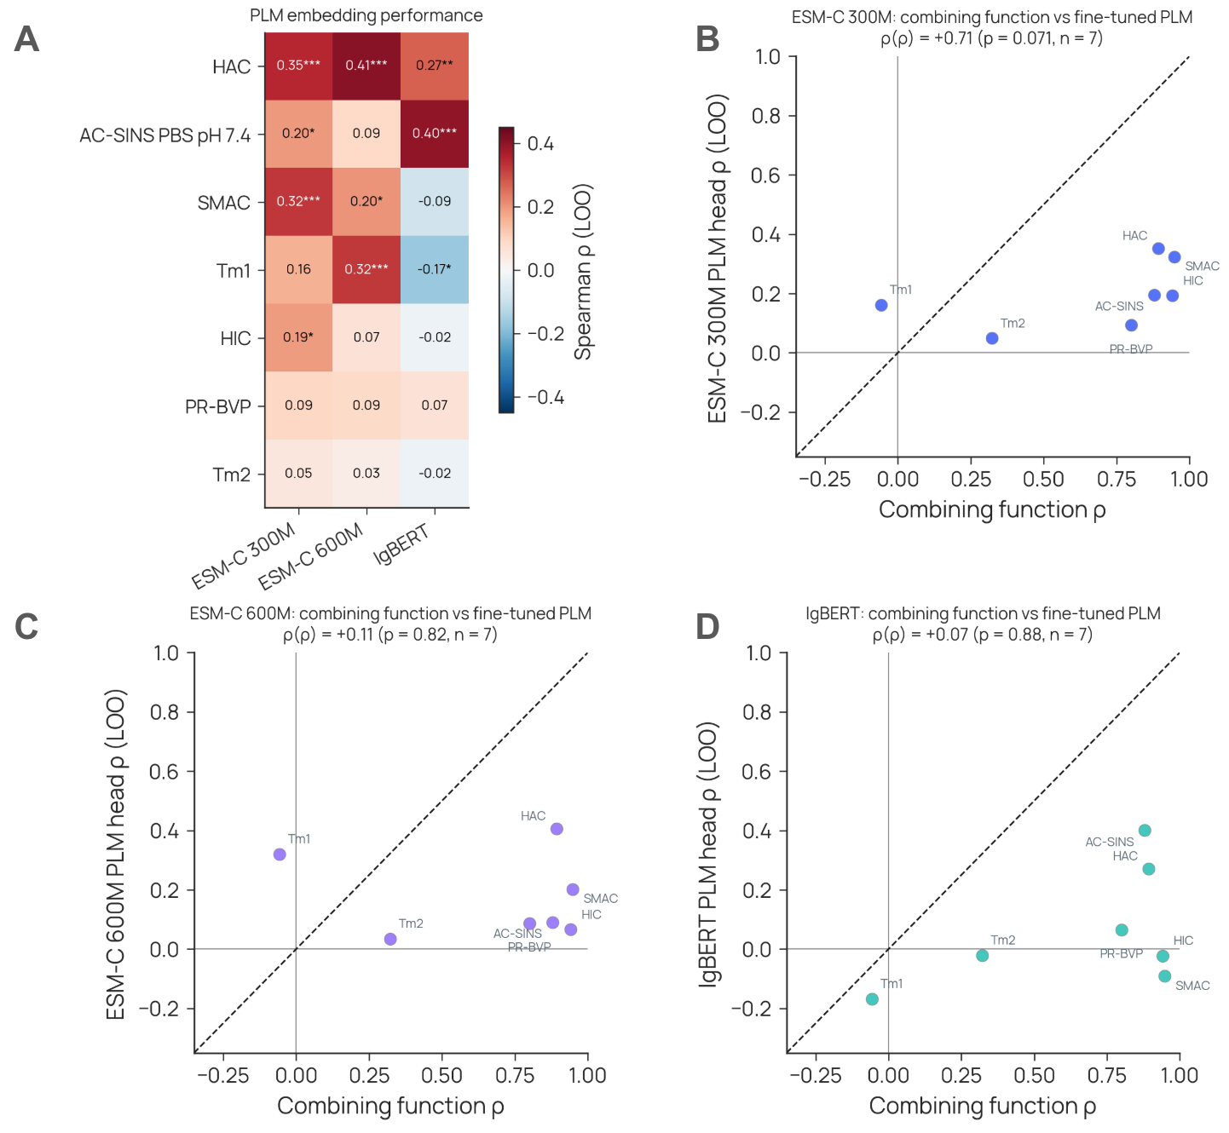
Supplementary Figure 6. PLM embedding performance. Each bsAb readout was predicted with a two-layer MLP head over the concatenation of both parent mAbs' variable-region PLM embeddings and their measured same-assay mAb readouts, using three encoders: ESM-C 300M and ESM-C 600M (VH and VL embedded separately and averaged) and IgBERT (VH+VL embedded as a pair). Performance is leave-one-out Spearman ⍴ between held-out bsAb predictions and measurements under a parent-disjoint split, so no training bsAb shares an arm with the held-out molecule (n = 107–141 bsAbs per readout, limited to those with both parent readouts available). Cells give ⍴ for each readout × encoder over the reported assay subset, ordered by best result (A), with asterisks marking p < 0.05 (*), p < 0.01 (**), and p < 0.001 (***). Correlation of correlations comparing the simple combining functions of parental mAb values to the performance of the three PLMs used: (B) ESMC-300M; (C) ESMC-600M; (D) IgBERT.

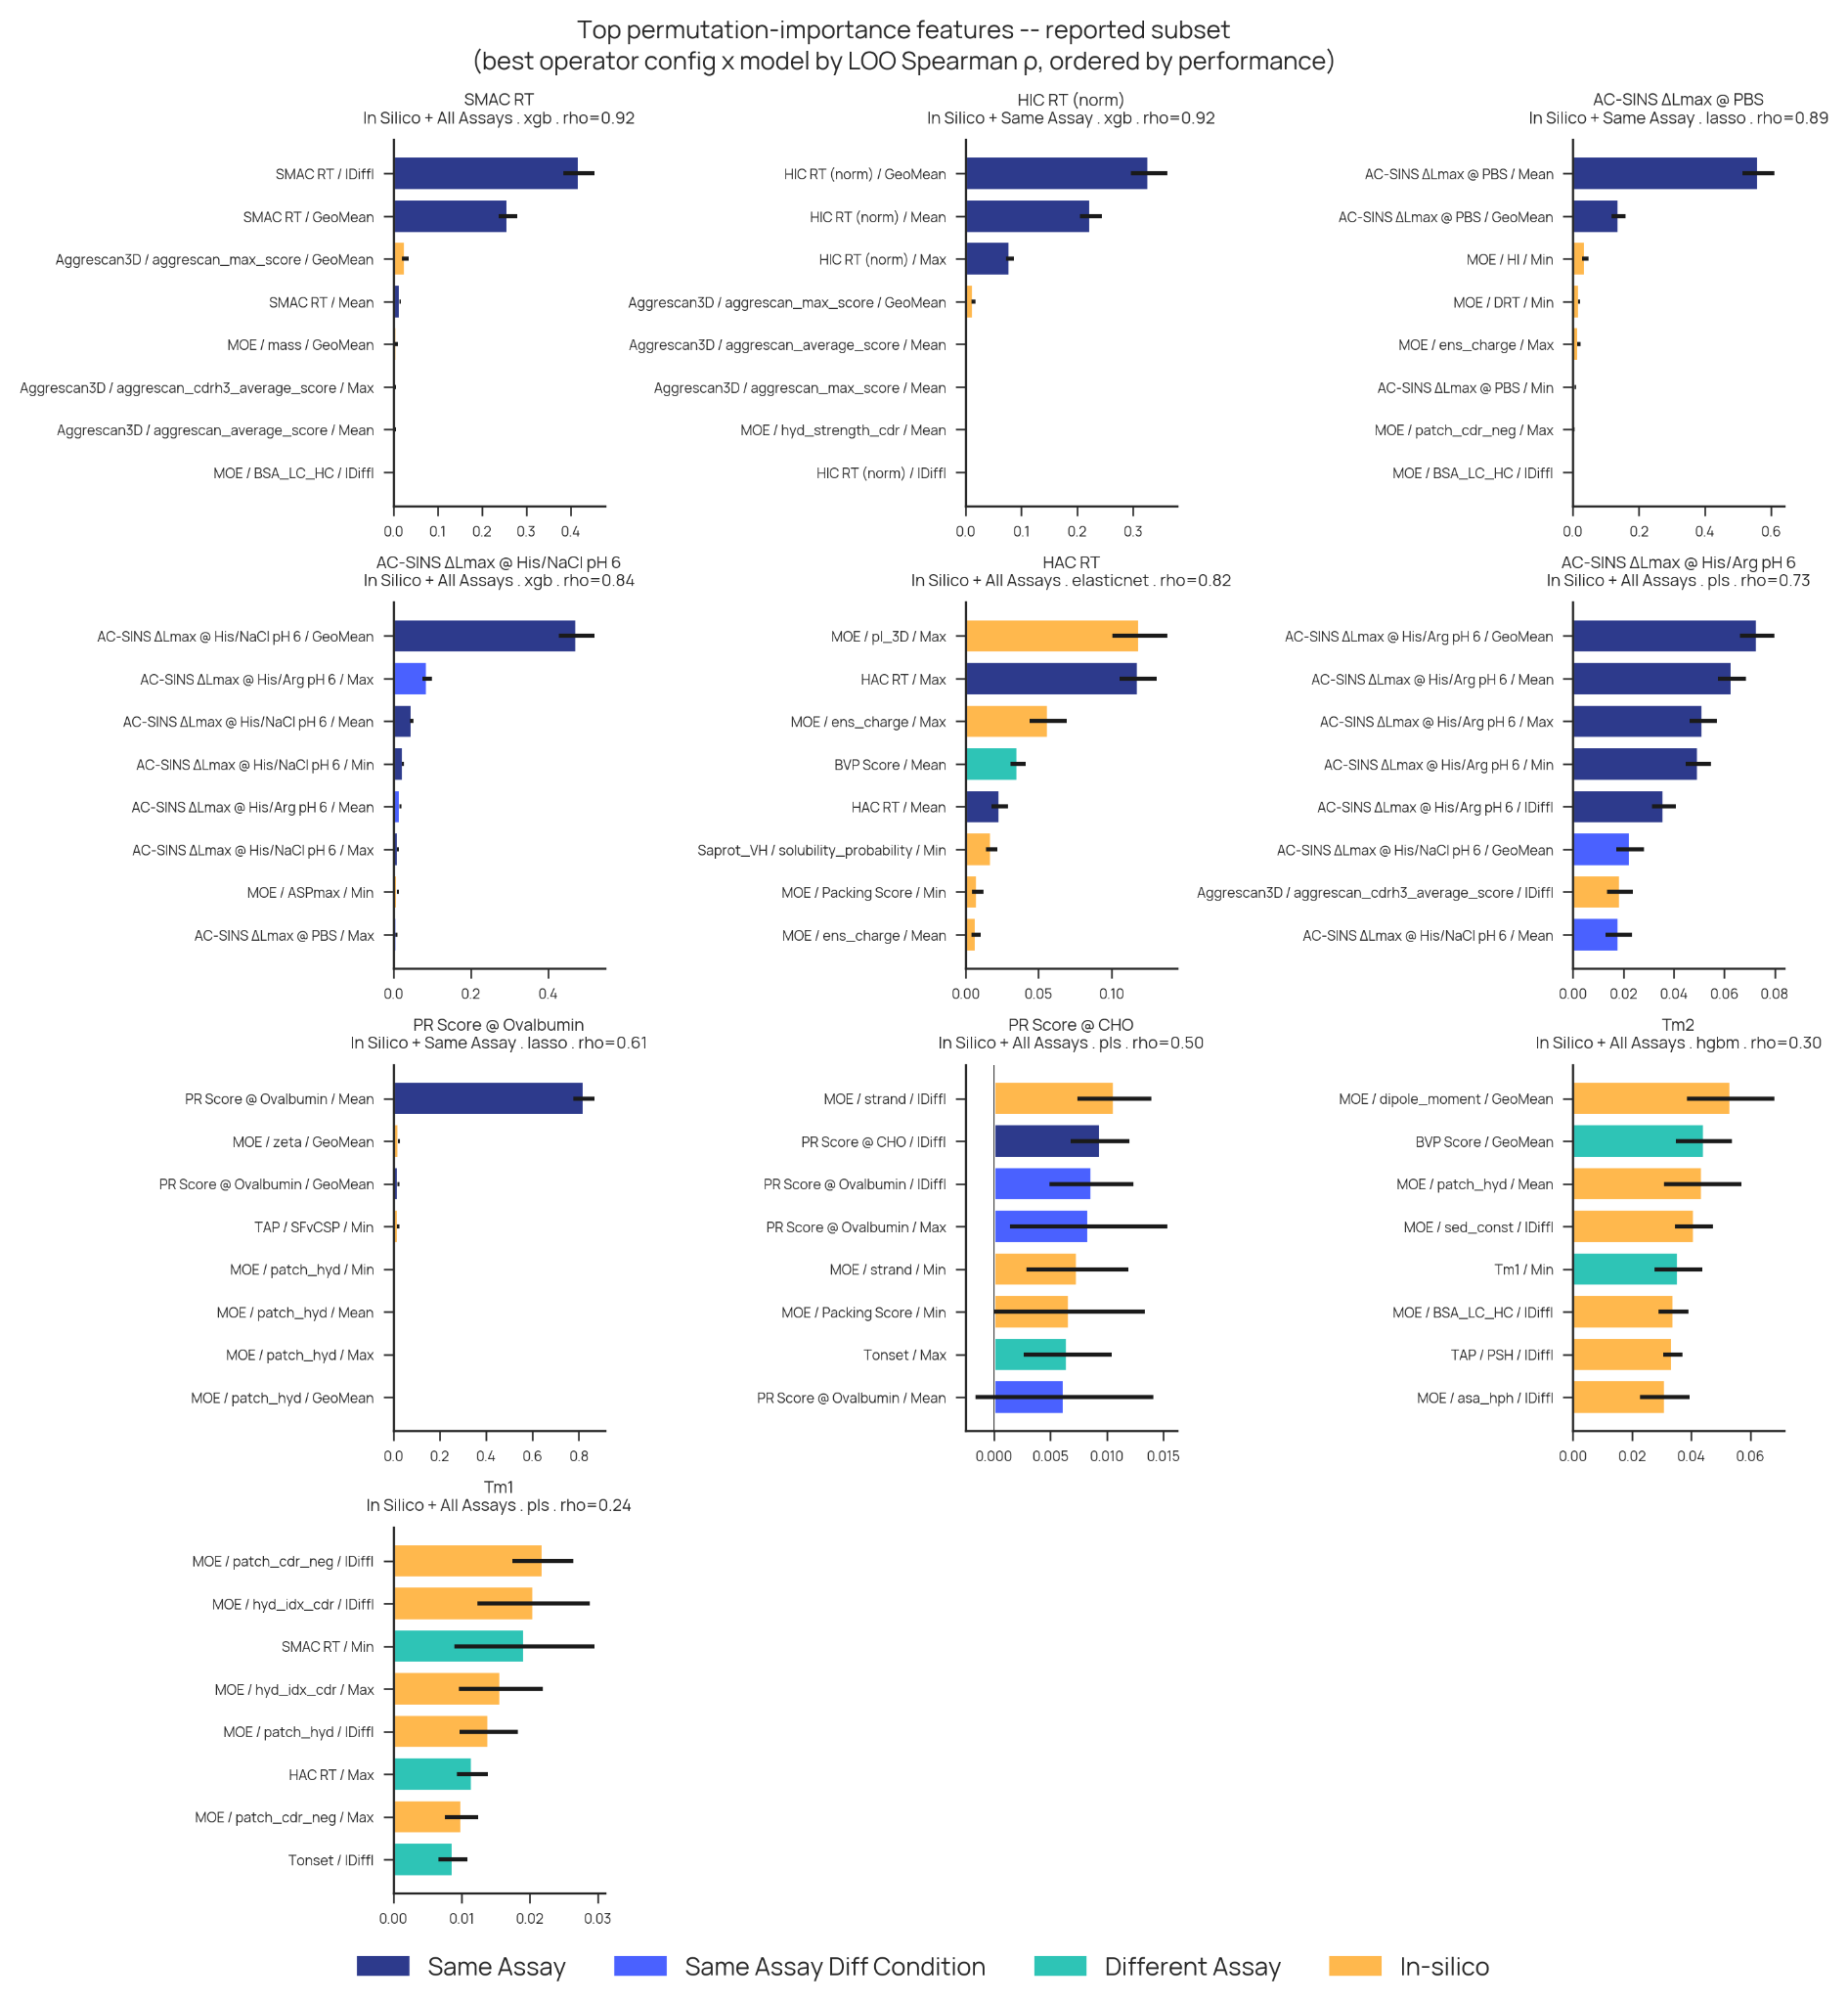
Supplementary Figure 7. Supervised model feature importance. Breakdown of feature importance for the highest performing supervised models for each assay when utilizing all available compositional features.

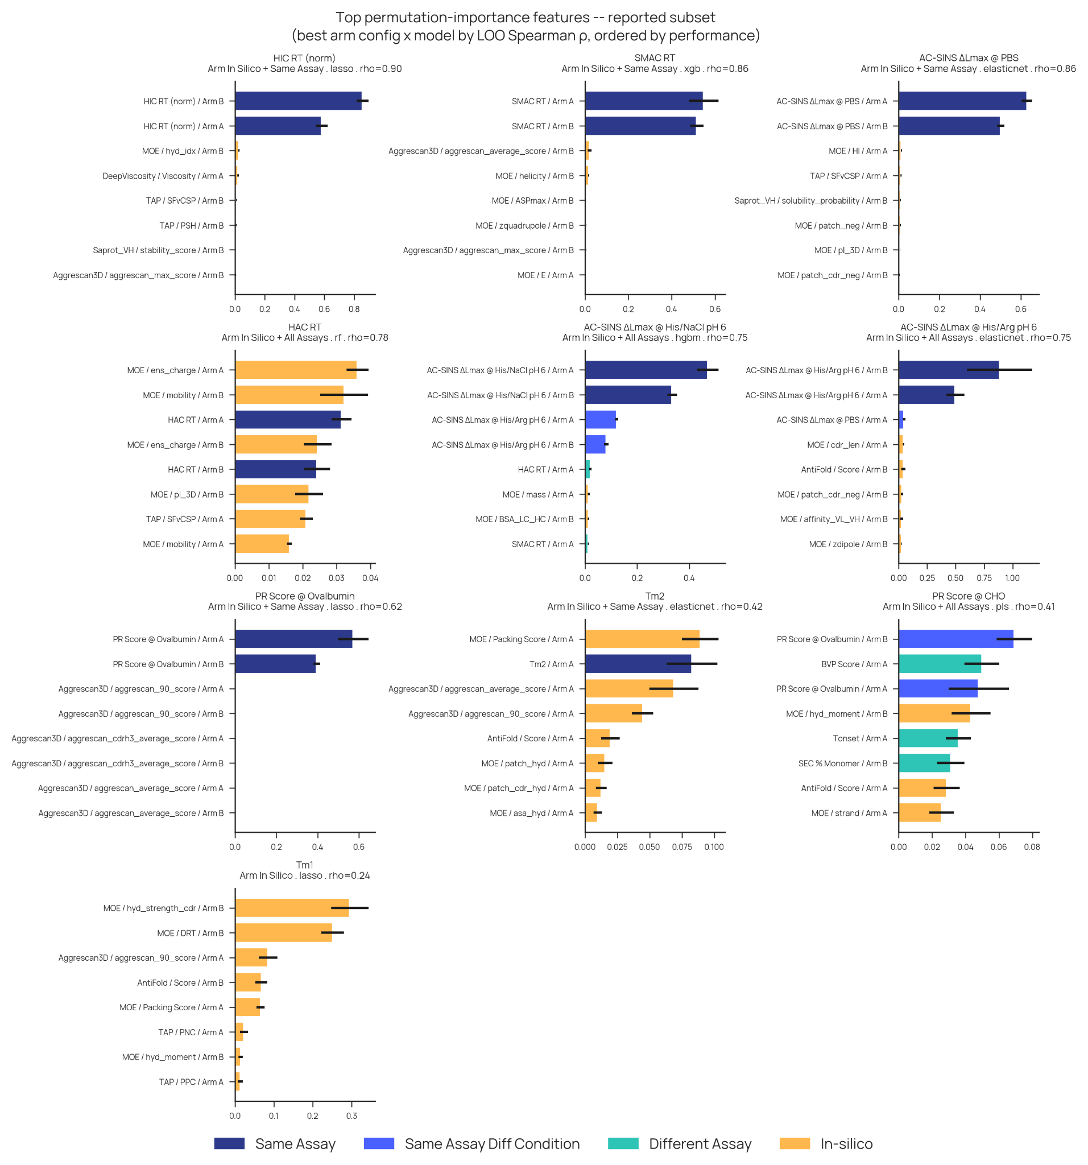
Supplementary Figure 8. Supervised model feature importance. Breakdown of feature importance for the highest performing supervised models for each assay when utilizing all available arm features.

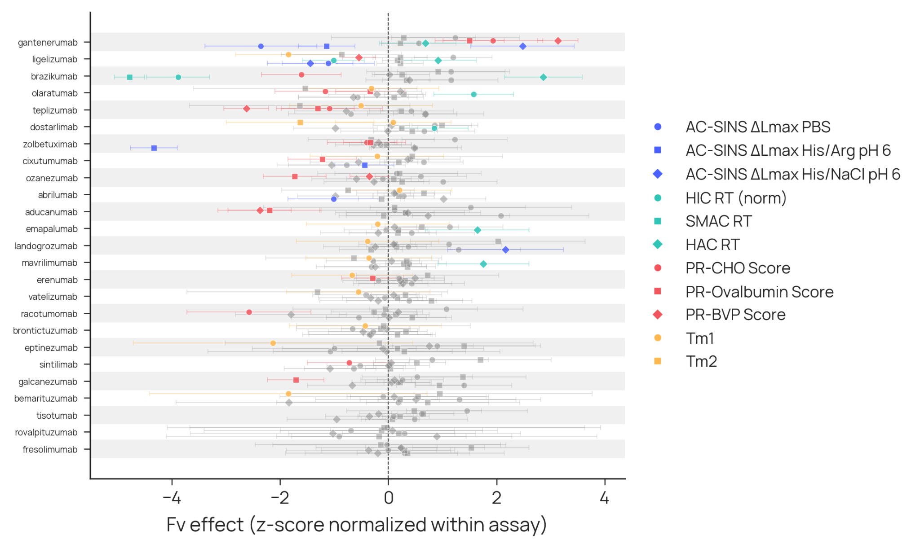
Supplementary Figure 9. Per-Fv Format Effect Sizes. For those Fv present in at least 3 different bispecifics, a linear model of mean + Fv_a + Fv_b was fit. This network analysis permits the estimation of Fv effects for assays independent of the particular bispecific. The observation of Fvs with effects statistically different than zero provide evidence for Fvs which exhibit emergent behavior when no longer present as a two-Fv mAb.

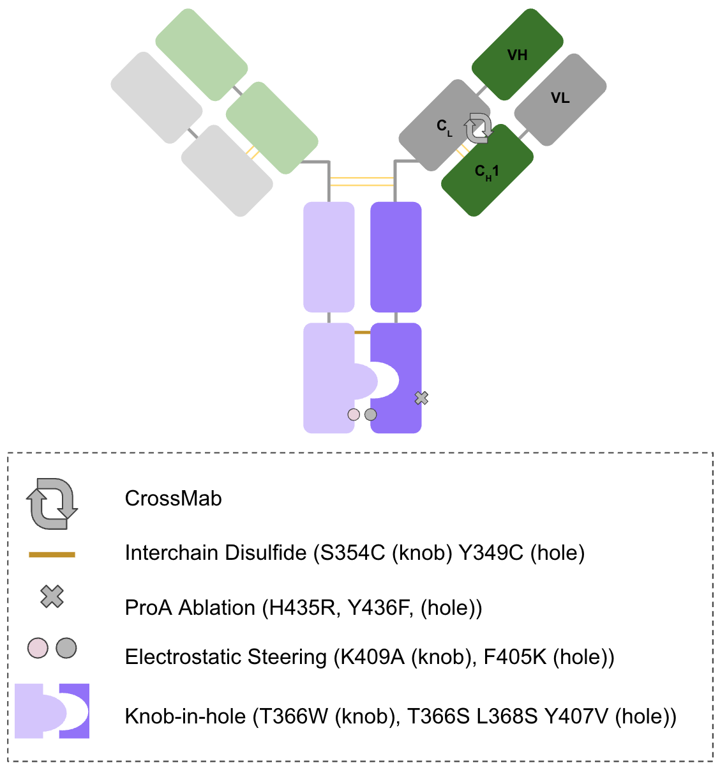
Supplementary Figure 10. Schematic of bispecific scaffold used in this study

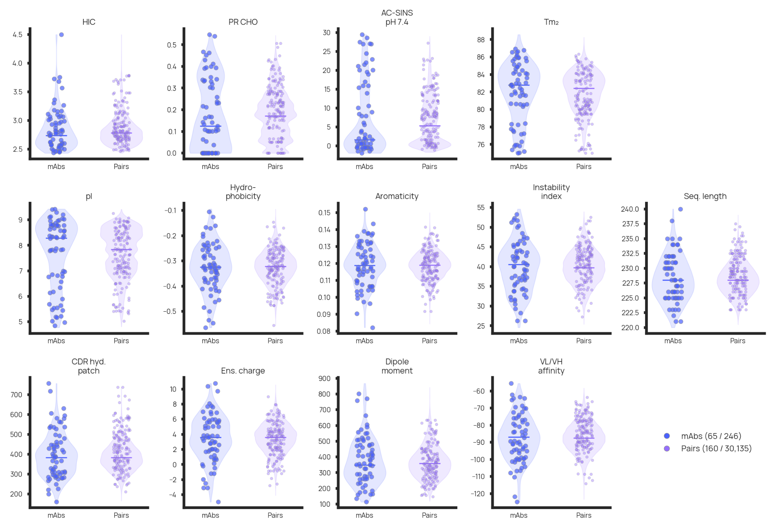
Supplementary Figure 11. mAb property distributions. Assay readouts as provided in GDPa1, used in part as features for furthest point sampling. Each subplot shows two violins side by side: the full GDPa1 mAb population (blue, left) and all possible bispecific pair averages (purple, right), with the selected 65 parents and 160 pairs overlaid as scatter dots.

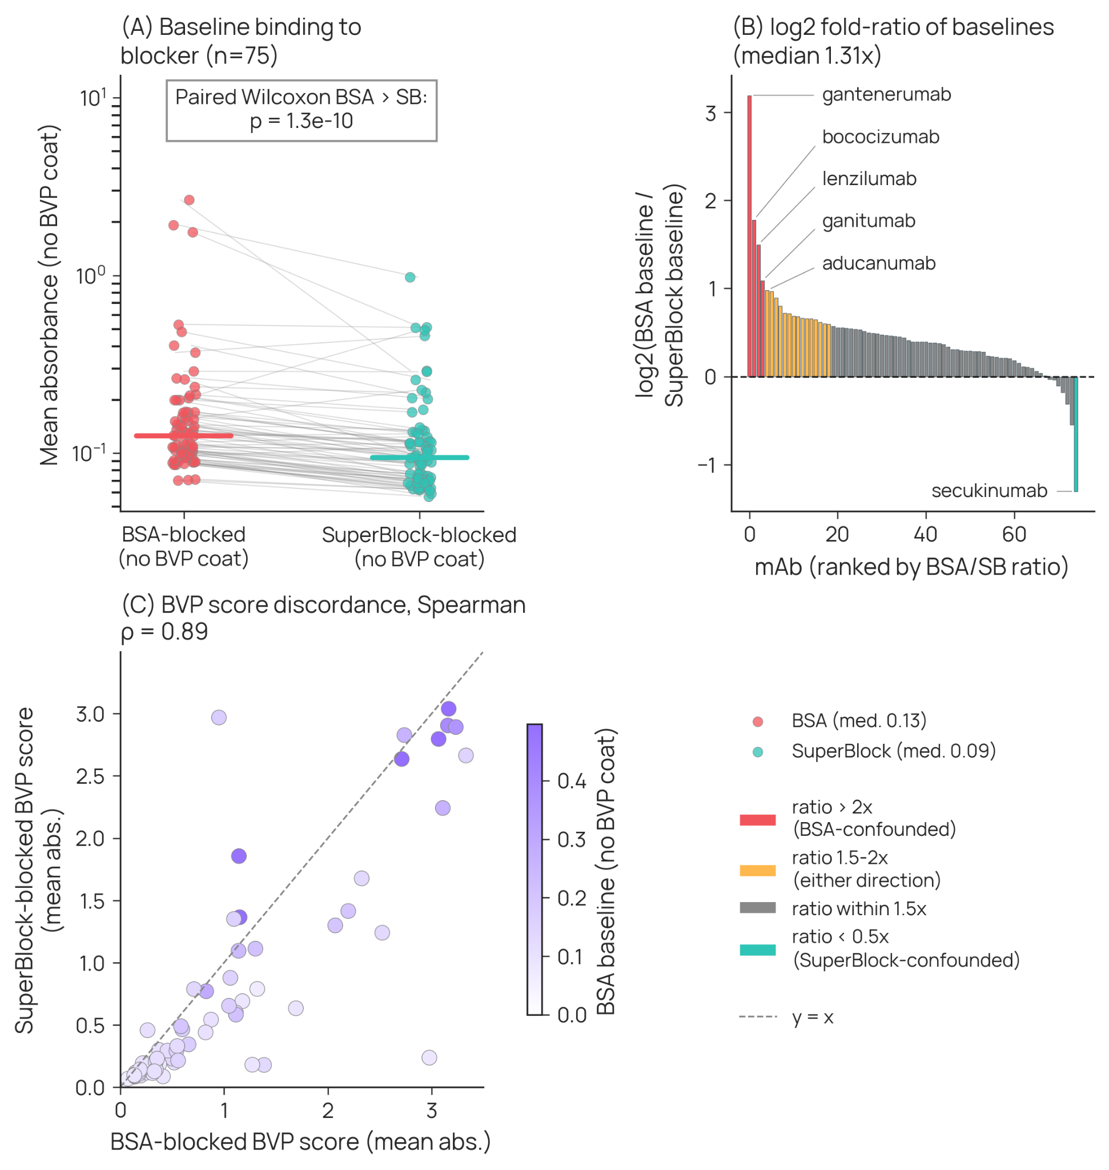
Supplementary Figure 12. Influence of BSA and SuperBlock as blocking reagents in BVP ELISA assay. (A) Paired BVP assay results using either BSA (left) or SuperBlock (right) for blocking. (B) Ratio of baseline binding with labeling of mAbs exhibiting high BSA baseline compared with SuperBlock. (C) Correlation of BVP assay readouts with coloring by BSA baseline.
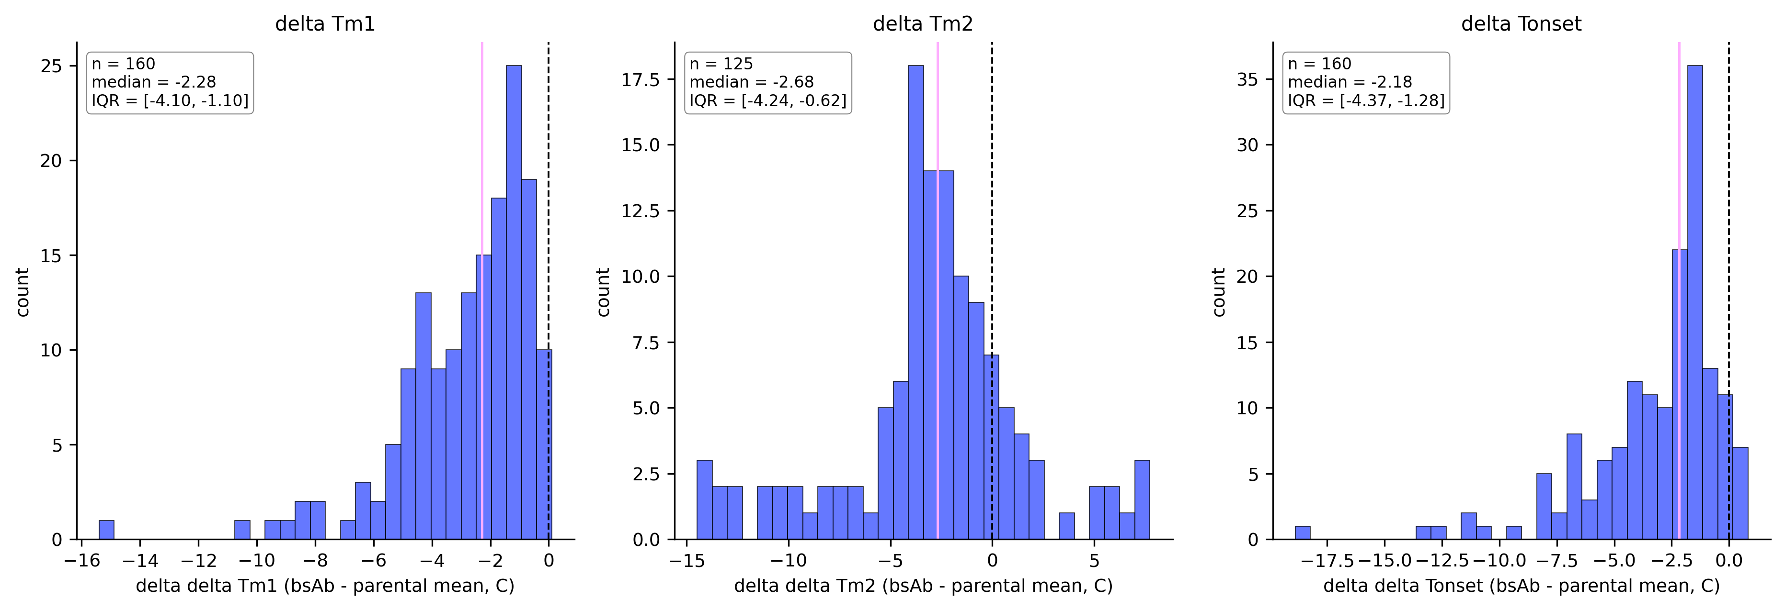
Supplementary Figure 13. Library-wide CrossMab thermal penalty. For each of the 160 bispecifics, ΔTm is the bispecific transition temperature minus the arithmetic mean of the two parental monospecific values. (A) ΔTm1: median −2.28 °C, IQR [−4.10, −1.10]; 37.5% of bispecifics below −3 °C, 13.1% below −5 °C, and 5.0% below −7 °C (n = 160). (B) ΔTm2: median −2.68 °C, IQR [−4.24, −0.63]; 43.2% below −3 °C, 19.2% below −5 °C, and 14.4% below −7 °C (n = 125). (C) ΔTonset: median −2.18 °C, IQR [−4.37, −1.28]; 38.8% below −3 °C, 19.4% below −5 °C, and 9.4% below −7 °C (n = 160). Dashed vertical lines mark zero and the median of each distribution. The left tail is heaviest for Tm2, consistent with the CH1-CL crossover perturbing the Fab region rather than the Fc.
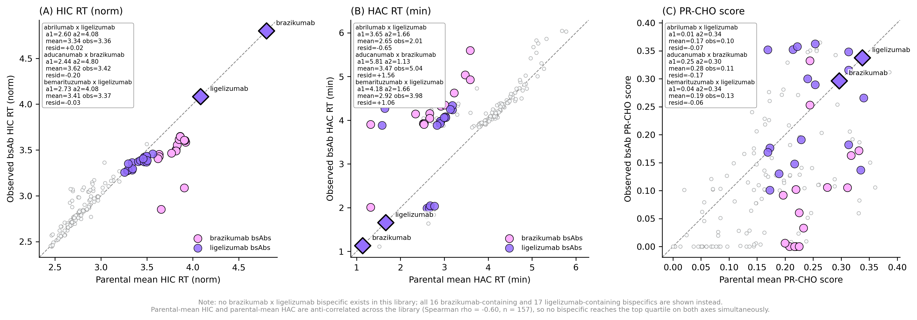
Supplementary Figure 14. Brazikumab-containing and ligelizumab-containing bispecifics across the surface-property assays. No brazikumab × ligelizumab bispecific exists in this library, so all 16 brazikumab-containing (pink) and 17 ligelizumab-containing (purple) bispecifics are shown instead, overlaid on the full library (grey). The two monospecific parents are plotted as diamonds on the y = x diagonal. (A) HIC normalized retention time. (B) HAC retention time. (C) PR-CHO score. Insets list arm 1 value, arm 2 value, parental mean, observed value, and residual for three representative bispecifics. Parental-mean HIC and parental-mean HAC are anti-correlated across the library (Spearman ρ = −0.60, n = 157), so no bispecific reaches the top quartile on both axes simultaneously.
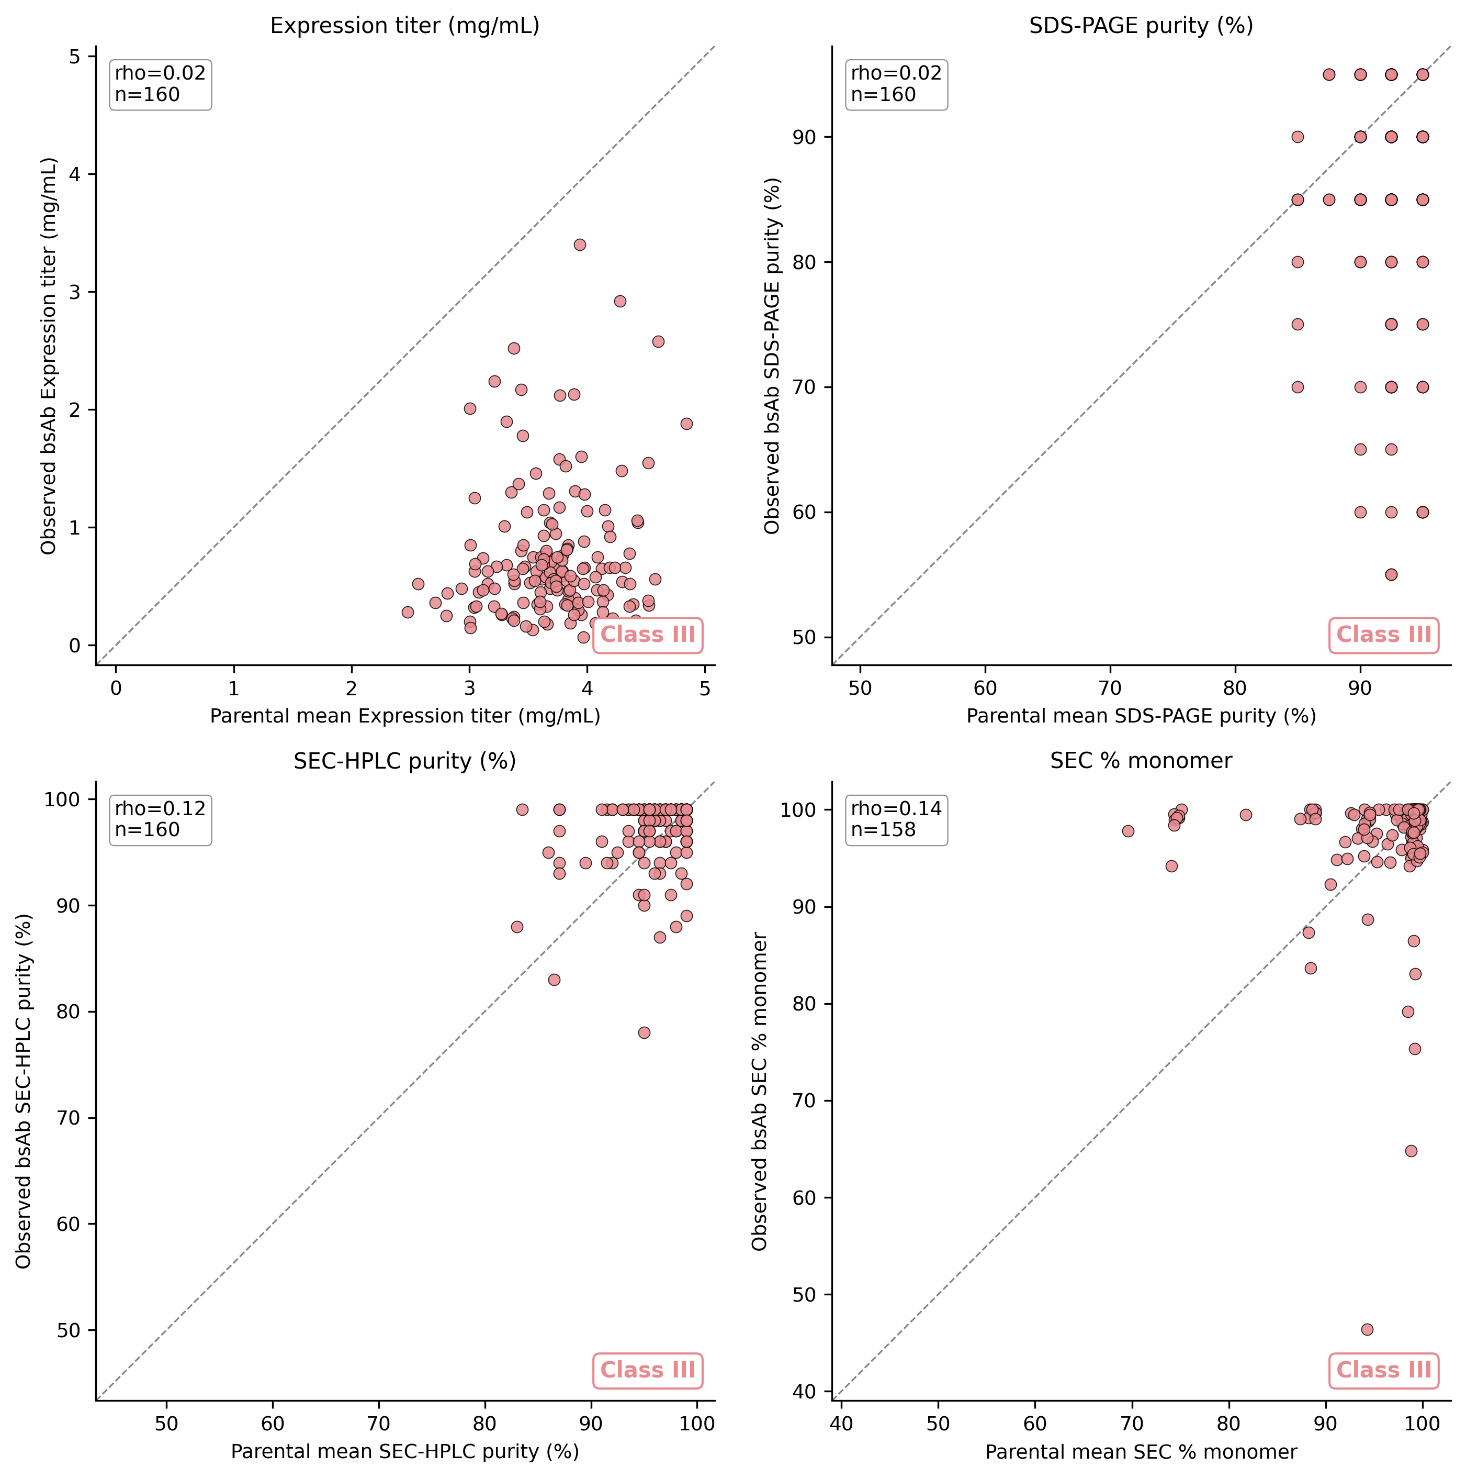
Supplementary Figure 15. Production and purity attributes within the parental inheritance framework. For each attribute the arithmetic mean of the two parental monospecific values (x-axis) is plotted against the observed bispecific value (y-axis), with the y = x diagonal shown dashed. (A) Expression titer (Spearman ρ = 0.02, median residual −3.0 mg/mL). (B) SDS-PAGE purity (ρ = 0.02, median residual −5.0 percentage points). (C) SEC-HPLC purity (ρ = 0.12, median residual −0.6 percentage points). (D) SEC percent monomer (ρ = 0.14, median residual −1.9 percentage points). All four attributes are Class III (format-driven): parental values do not predict the bispecific value, and each attribute shows a systematic negative residual upon assembly.
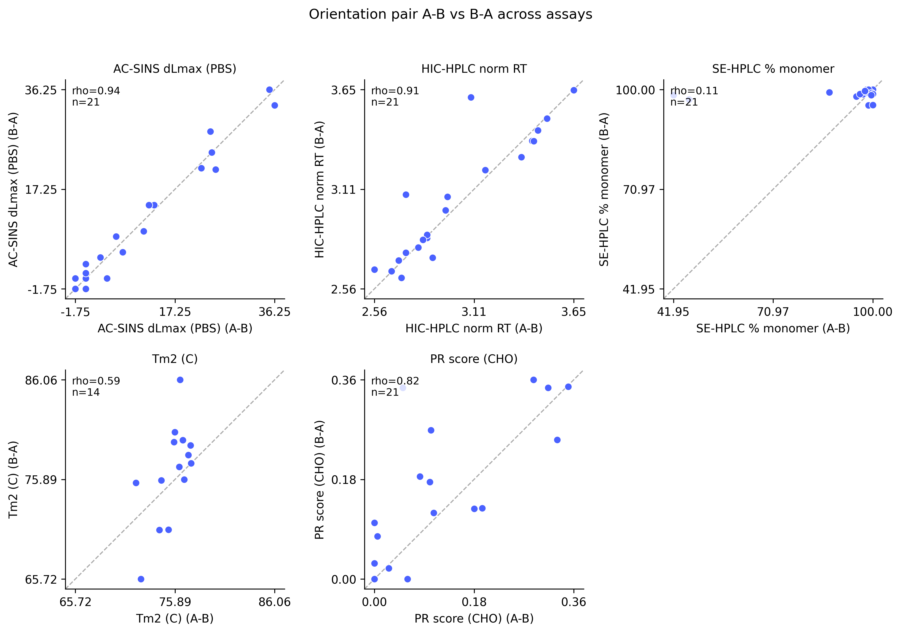
Supplementary Figure 16. Orientation invariance shown as a direct A-B versus B-A comparison. For the 21 bispecifics produced in both orientations, the value measured for the A-B configuration is plotted on the x-axis against the value for the corresponding B-A configuration on the y-axis; the dashed line is y = x. Spearman ρ by assay: AC-SINS ΔLmax in PBS 0.94 (n = 21), HIC normalized retention time 0.91 (n = 21), PR-CHO 0.82 (n = 21), Tm2 0.59 (n = 14), and SE-HPLC percent monomer 0.14 (n = 21). Adsorptive chromatography and self-association are strongly orientation-invariant, thermostability is moderately so, and SEC percent monomer is essentially orientation-dependent, consistent with the Class III assignment of aggregation-related properties. This panel is the orientation-by-orientation complement to Figure 2 in the main text.

