Design of Weirs

iCAD offers the **Diversion Weir Design** product to handle the design of weirs and regulating structures in an interactive environment, allowing engineers to solve design and analysis tasks for diversion weirs and canal headwork structures on previous foundations.

Note: this module is developed for the design of weirs on previous foundations. However, owing to the fact that many of the surface hydraulic analysis follow the same principle, it may be used to assess and design weirs on different foundation material with due diligence.

Note: This module covers all design aspects, except the design of abutment structures which is solved using a different module.

## Conventions

* Draw Weir Axis, from Left to Right, Face-upstream view
* Transverse design is drawn in Face-upstream view
* Longitudinal view drawn facing the right-bank (facing upstream).

## Workflow

iCAD software handles the design using the ‘Diversion Weir Design module. The module requires:

* a weir axis object defined in AutoCAD, that is referenced, and contains sufficient profile data
* a river/stream section downstream of the weir axis, that is solved for stage-disharge relations using the CnanelRateWSPRO module.

The module creates a tentative design using default parameters, and displays that design. Other project specific data and information are provided in-process. There are two steps to input these informations:

* change the view to as desired
* start the variable editor to edit inpus to parameters relevant to the view.

A typical weir design task using iCAD follows the outline shown in the flow chart. Tasks related to each step are described below.

# Prepare Object types

Prepare three objects, namely (a) the weir axis object, (b) the stream cross-section object downstream of the weir axis, and (c) a data host object, as described here.

1. Weir Axis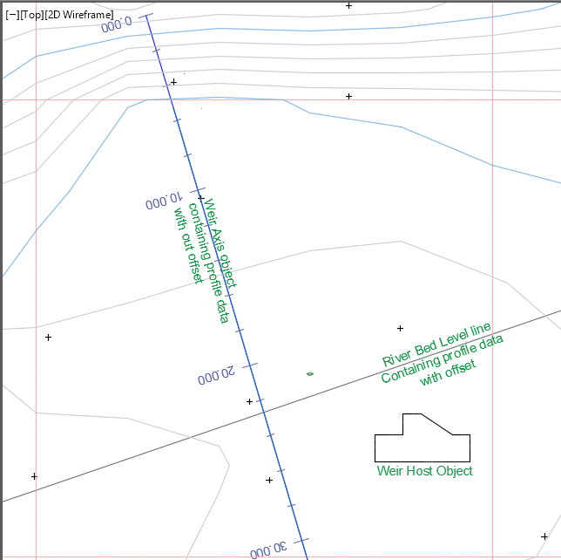

The axis line should cover the expected weir position in the head work area and some more. Draw the axis using the AutoCAD polyline tool, and reference it to AutoCAD WCS. Run a profile extraction session with sufficient offset detail for both incremental distance and offset distance.

For medium structures the following can be used as a starting guide:

Incremental distance: 2.5m;

Offset distance: -10:2.5:20

2. Rated Downstream section

This section is the selected river cross-section for stage-discharge relationship determination, some distance downstream of the weir axis created above. The relationship is must be solved using iCAD’s **ChannelRate_WSPRO** module, and readily available for use in this module. This can be ensured by properly defined session, and saved solutions.

Tip: To Check appropriate data are readily available on the cross-section object, collect the object to the workspace, click on it, and hit the **Preview Data on Current Object** tool button. If the data is available, the data preview table interface launches listing the stored data..

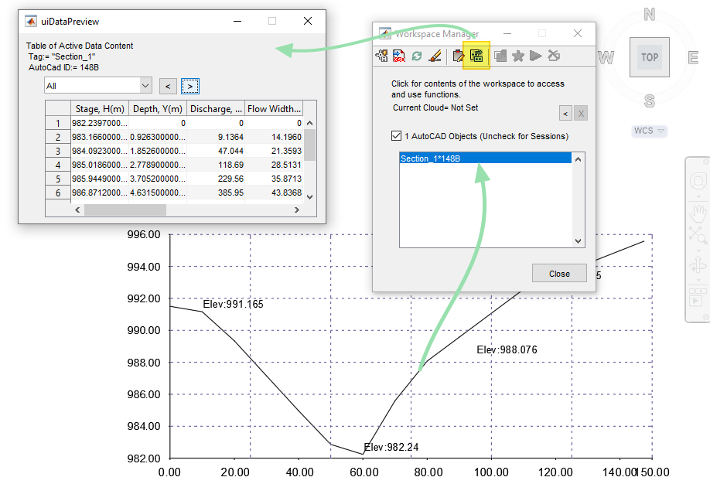

This object is not required during session definition. However, it is required immediately upon running the defined session,

3. The Host Object

A third object is needed to complete the session definition. This object stores all the information regarding the design process at all times. Any object can be used as a host. It is strongly recommended to use the appropriate shape from CAD Tools > Create Host Objects’. To create the host object from this list:

1. start by drawing a starter object. Draw a diagonal line that is somewhat equal in height and width using the polyline tool.
2. Then hit the **Plot Sketch to AutoCAD** button on the top right. Back in AutoCAD, select the starter object (the diagonal line).

This will:

1. reshape the starter object to take the desired shape, and
2. assign a Tag string to the Object, that makes it easy to identify it in subsequent processes.

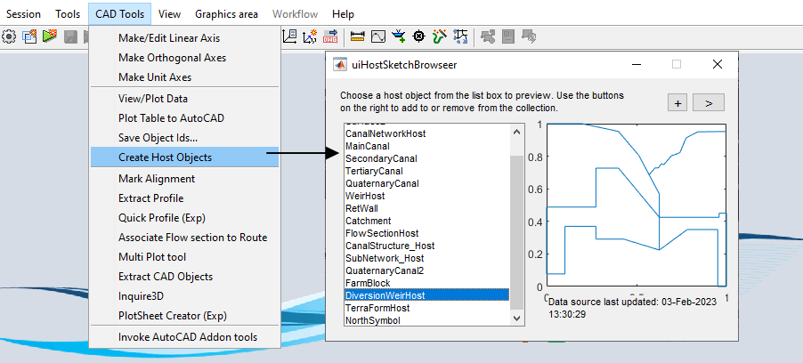

NOTE: If this object is DELETED, all the information saved will be inaccessible permanently.

# Defining the session

1. Clear iCAD work space. Start Workspace Manager from Session > Workspace Manager. Use the Clear Workspace button or use CTRL+0.
2. Define a new session using Sessions > Create & Run New Session and select DiversionWeirDesign module.

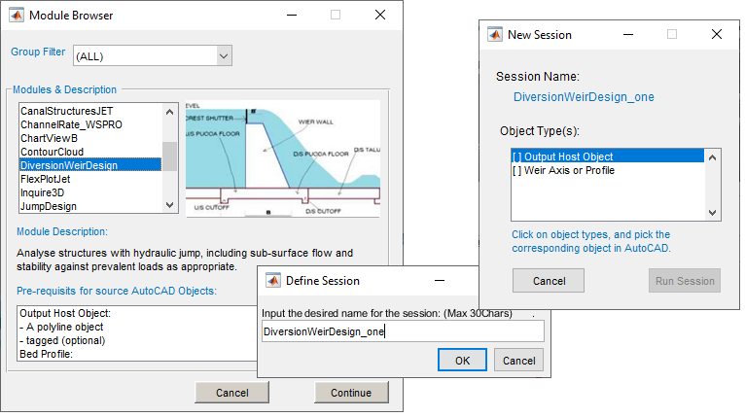

1. Give the session desired and related name to the task, e.g., Weir Design at Axis-001. Accept and continue.
2. There are two object types listed in the New Session dialog corresponding to the two objects outlined above in the first step of this workflow. Click on each object type, and go to AutoCAD and select the corresponding object.

Tip: iCAD DataLiview status bar will report OK for each successful association of the object with the object type. When association is successful, object types are marked [x], and the **Run Session** button is active.

1. The session is now completely defined and the active session. Hit the Run Session button to begin the solution. You will be prompted to pick the rated river section. Choose **Pick in AutoCAD**, and select the ready section object.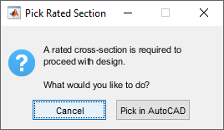

If all data are available as expected, the module will start by displaying the longitudinal cross-section view of the structure. This is the default starting view for the module. Below, workflow tasks are discussed in detail.

## 

# Transverse design

Often the first design sub-task is the transverse design of the weir structure. Simply put, this is the positioning and dimensioning of key components of the weir structure across the stream (and along the weir axis.).

To change from any view to this view, go to Workflow > Transverse View.

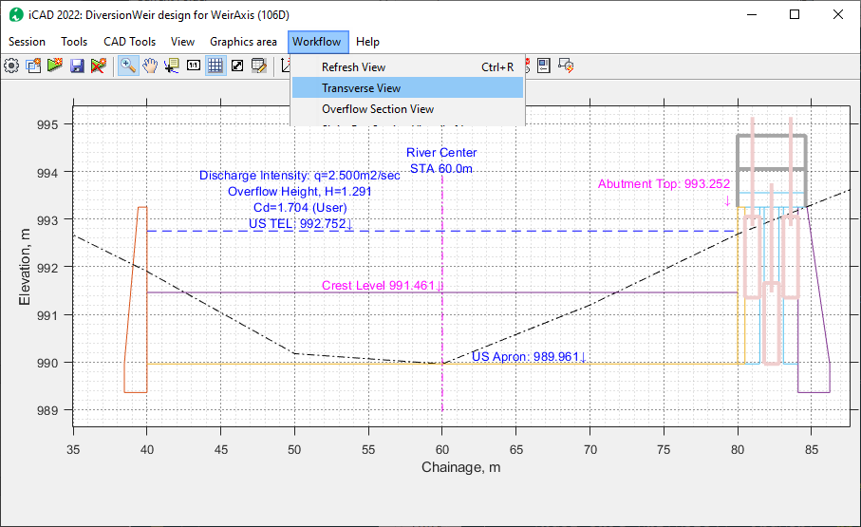

Note, the module automatically positions the structure as follows:

* center of overflow span located to the center of the river. The river center along the weir axis line, is taken to be the station where the minimum elevation is recorded from the profile data.
* Right and left position of the overflow span located at equal distance from the identified center line
* The weir crest level is determined based on the default weir height given.
* Overflow depth is calculated for the default discharge, available overflow span and default coefficient of discharge.

Numerous variables are set by default to create the tentative design in the first place. These parameters can be accessed from *Workflow > Edit Variables* menu command (Ctrl+E).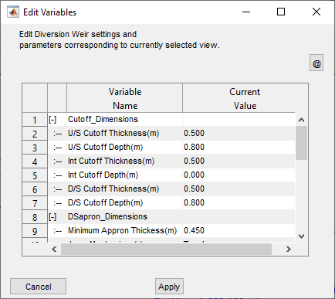

Below each category of variables is presented with detail.

## Hydraulic Parameters

The hydraulic parameters are used to determine the upstream flow hydraulics, and corresponding structural components such as abutment elevation and total width.

| NO | Variable Name | Default Values | Notes |
| --- | --- | --- | --- |
| 1 | Coefficient of Discharge, Cd | 1.704 | Number value representing the anticipated overflow condition over the weir span.  1.0<= Cd <=2.0 |
| 3 | Calculation Method for Cd | User | There are five methods.  1. User Input Value (The default method, uses the user input value above  2. Critical Flow method  3. Momentum Eqn  4. Bos Equation  5. Salmasi |
| 3 | Discharge Range(m3/sec) | 100 | The maximum design discharge (peak flood) for which design is desired.  1.0<Q<=1000 |

See technical notes at the end for details on each method of rating curve determination.

## Sluice bay dimensions

These variables determine the size and orientation of sluiceways at one or both ends of the weir

| No | Variable Name | Default Values | Notes |
| --- | --- | --- | --- |
| 1 | Crest Sill Height(m) | 0.150 | Height of sluice crest above upstream apron level (Max of 0.50 meter is allowed.)  0.0<=hbay<=0.50 |
| 2 | Individual Bay Width(m): [Left, Right] | [1.0, 1.0] | Width of individual bays (Face Up Stream):   * for left side bays * for right side bays   Accepted range of values: 0.0<=Wbay<=2.0  0 value means no bay is needed. |
| 3 | Number of Bays: {Left, Right]= | [1, 3.000] | Number of bays desired on each side. The bays are provided using the bay width value provided above.  If bay width is 0/0, this value is ignored, and no bay is provided. |
| 4 | Pier Thickness(m) | 0.300 | The thickness of pier columns dividing sluice bays.  Accepted Range of Values; 0.30<=t<=0.50  If the bay width is 0.0, this value is ignored, and no piers walls are provided. |
| 5 | Divide wall Width(m) | 0.500 | The thickness of divide wall provision separating the overflow span from the sluice bay (if any).  Accepted Range of Values: 0.50<=t<=2.0  If bay width is 0/0, this value is ignored, and no divide wall is provided. |
| 6 | Divide wall extension(m) | 1.0 | The extension length of the divide wall downstream of the end of the weir structure (behind the end of glacis).  Accepted Range of Values: 0<=L<=1000  1000 represents a length equal to the length of the downstream apron, resulting in complete isolation of undersluice flow from crest overflow. |
| 7 | Gate Proud Height(m) | 0.200 | The height of the gate panels above the weir crest elevation.  Accepted Range of Values: 0.10<=h<=0.30 |

The schematic below shows a right side sluice bay, with three bays, a slightly raised crest, with automatically sized gate panels.

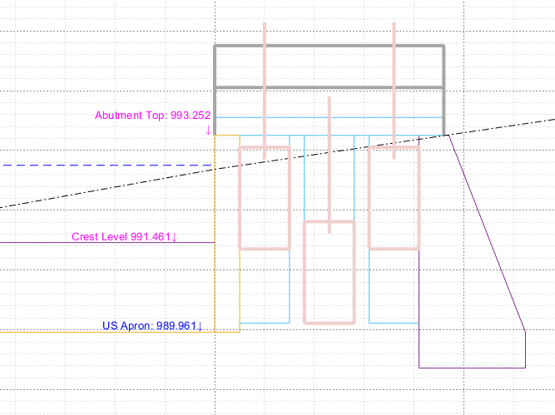

See Technical notes, to learn about sluice bay capacity determination.

### 

## Transverse Dimensions

| No | Variable Name | Default Values | Notes |
| --- | --- | --- | --- |
| 1 | Weir Crest Elevation | Calculated | Calculated crest elevation, from the sum of:   * Upstream Apron Level, which equals the minimum bed level at the weir axis. * Weir height (can be set from the Longitudinal view)   Accepted Range of Values: displayed on the popup menu. The minimum and maximum values of crest elevation are determined based on allowable ranges for weir height (see longitudinal view). |
| 2 | Overflow Span(excl. Scour Bays) (m) | 15.0 | The clear overflow length of the weir, excluding divide wall and other provision (if any).  Accepted Range of Values: |
| 3 | Wall Free Board (m): | 0.500 | Free board provision above upstream energy grade line (US EGL).  Acceptable Range of Values: 0.5<=FB<=3.0 |
| 4 | Abutment Location, Left (m) | -1.0 | Left side abutment location measured from the start of axis.  -1 indicates centered automatic positioning with respect to the river center line.  Accepted Range of Values, -1 <=Xl<=Inf  Setting this value will reposition the Right abutment location as well, based on values set for other variables. |

### 

## Abutment Provisssions

These values are a sequence of settings dictating the shape and length of segments of the abutment wall portion beyond the upstream and downstream aprons, on each side of the weir.

The values are input as Angle, Length Pair. The angle is measured from abutment wall extension as shown below.

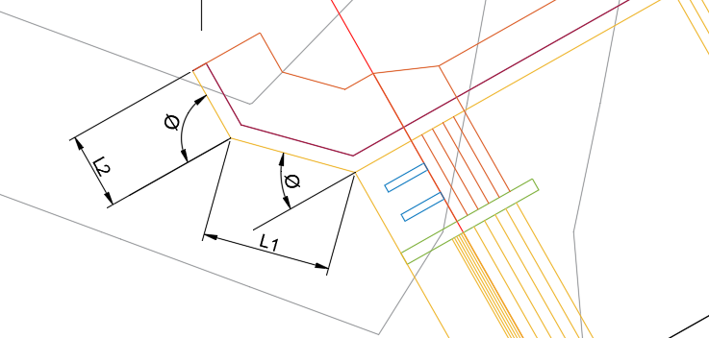

| No | Variable Name | Default Values | Notes |
| --- | --- | --- | --- |
| 1 | Angle & Length of Abutment Extension, US Left (Deg, m) | [45.000, 5.000, 90.000, 3.000] | Minimum input size: 2  Maximum input size: 6;  Acceptable range of values: 0<=values <=90; |
| 2 | Angle & Length of Abutment Extension, DS Left (Deg, m) | [60.000, 7.000] |
| 3 | Angle & Length of Abutment Extension, US Right (Deg, m) | [45.000, 5.000, 90.000, 3.000] |
| 4 | Angle & Length of Abutment Extension, DS Right (Deg, m) | [60.000, 7.000] |

## 

# Longitudinal Design

Longitudinal design handles the sizing and detailing of the weir elements in the longitudinal direction. This involves working on a number of components mainly the main overflow section and the sluice bay section.

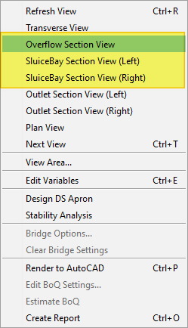

The user can change between this views from the workflow menu. Depending on whether sluice bays are provided, and on which side, the available number of longitudinal section views vary. of sluice bays, the available views also vary.

The overall sizing of the elements of the weir are as follows.

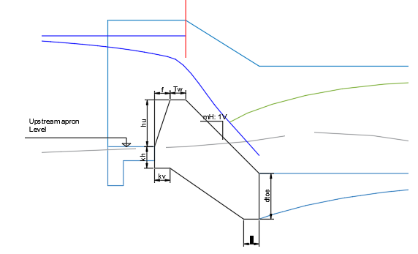

## Longitudinal Dimensions

| NO | Variable Names | Default Value | Notes |
| --- | --- | --- | --- |
| 1 | Height of Weir(m) | 1.500 | The height of the weir body, measured from the upstream apron level.  Acceptable Range of Values: 1.0<=hu<=2.5m |
| 2 | Height of Silt Deposit(m) | 0.000 | The silt deposit level to be considered for design.  Allowable Range of Values: 0<= hs<=1000  1000 denotes maximum height up to the height of the weir. |
| 3 | Top Width of Weir(m) | 0.500 | The length of the crest of the weir, measured in the direction of flow.  Allowable Range of Values= 0.5<=Tw<=5.0 |
| 4 | U/S Flare width(m) | 0.500 | The length of the upstream inclined face measured horizontally from the tip of the weir crest.  Allowable Range of Values: 0<=f<=2.0 |
| 5 | D/S Glacis slope(H:1V) | 1.000 | The slope of the downstream glacis of the weir body.  Allowable Range of Values: 1<=m<=4 |
| 6 | Toe Depth(-) | US | The source of value for the depth of the downstream end of the weir.  Allowable values:  US= use the thickness of the upstream apron.  DS= use the thickness of the downstream apron. |
| 7 | Bottom Key Dims(m) | [0.500, 0.500] | Dimensions of key provisions on upstream end of the weir, specifying vertical drop and horizontal offset from the upstream apron level at the toe of the weir.  Allowable values: h, w >0  (Minimum apron thickness is maintained if lesser value of kv is used). |
| 8 | Total Longitudinal Length (m) | 15.000 | Overall length of the weir structure from upstream to downstream aprons.  Allowable values: 7.0<Lt<=50 |
| 9 | Length of Approach Section(m) | 1.500 | Length of upstream apron from the weir  ALlowable values: 0<=Lu<=5.0’ |

Note the following key positions set automatically:

* The weir is positioned so that the end of its top width (the beginning of the downstream glacis) aligns with the weir Axis.
* The upstream apron level is situated equal to the minimum river bed level. Other positions on the weir structure and its components are based on this key parameter.
* The downstream sill level (exit level) of the structure is also fixed equal to the river bed level at the exact location downstream of the axis. This ensures proper automatic positioning of key components.

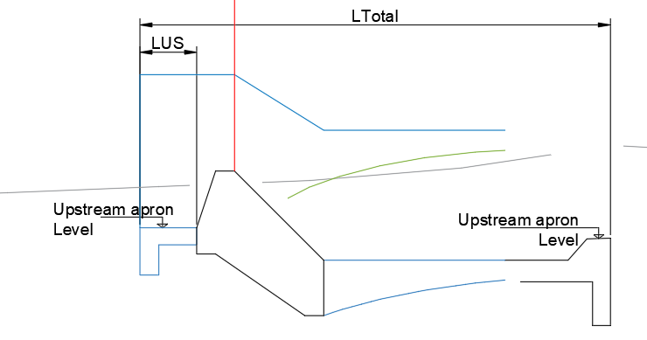

## Overflow Section

This view displays the section along the main overflow region. It allows to handle the main design tasks of (a) surface analysis, (b) Sub-surface analysis, (c) downstream apron design. These are presented below.

## Surface flow analysis:

Surface flow condition for the entire length of the structure, i.e., upstream, over flow, and downstream sections, are automatically evaluated for the current geometric and hydraulic set of parameters.

* The upstream flow hydraulics is estimated from solutions of Bosenisques energy equation at different sections.
* The downstream flow hydraulics is determined by analyzing the type of expected hydraulic jump in relation to the prevalent tail water depth condition.
* The plotted flow surfaces and text info highlight the results.

(For details on these calculations, see Technical Notes section further below.)

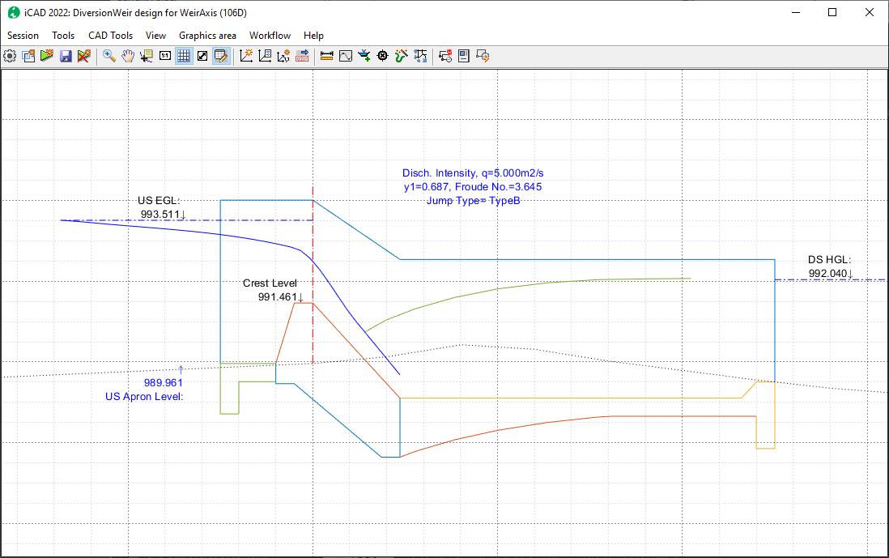

## Subsurface flow analysis:

Subsurface flow analysis is also automatically carried out, as a function of the dimensions and position of the different components of the structure. Khosla's solution to the theory of seepage is used to determine the variation of subsurface pressure along the bottom of the structure.

For details, see the technical notes section.

The variation is calculated and plotted for two key design conditions:

* Maximum flood level (HFL) condition
* Pool Level flow (NPL) flow condition.

These are presented in the overflow section view, shown in dotted lines in below figure. They are automatically calculated every time dimensions are revised.

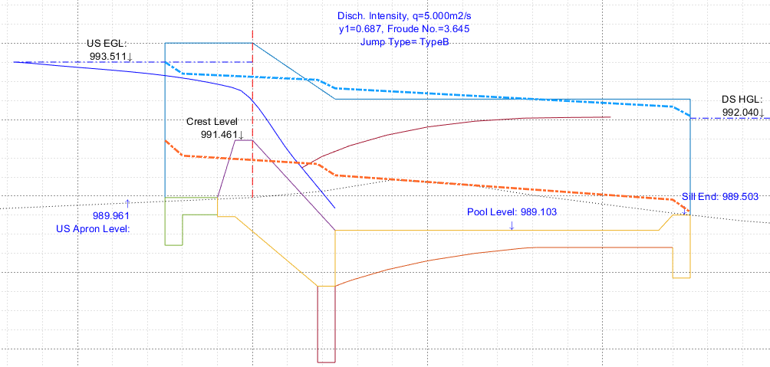

These determined pressure lines are used to estimate the magnitude of unbalanced hydrostatic pressure at the bottom of the downstream apron, to determine its thickness.

The following parameters pertain to the determination and use of subsurface hydraulic pressure variation.

## Cutoff-Dimensions

| No | Variable Name | Default Value | Notes |
| --- | --- | --- | --- |
|  | U/S Cutoff Thickness(m) | 0.500 | Thickness Of upstream cutoff wall:  Allowable Range of Values:  0.05<tu<0.5 |
|  | U/S Cutoff Depth(m) | 0.800 | Depth of upstream cutoff wall measured below upstream apron level (after thickness ta).  Allowable Range of Values:  0.5<=du<=5.0 |
|  | Int Cutoff Thickness(m) | 0.500 | Thickness Of intermediate cutoff wall.  Allowable Range of Values:  0.05<tu<0.5 |
|  | Int Cutoff Depth(m) | 2.000 | Depth of intermediate cutoff wall measured from depressed invert level of the downstream end of the weir body.  Allowable Range of Values:  0.0<=du<=5.0  ti=0.0 indicates no intermediate cutoff wall. |
|  | D/S Cutoff Thickness(m) | 0.500 | Thickness Of downstream cutoff wall.  Allowable Range of Values:  0.1<tu<0.5 |
|  | D/S Cutoff Depth(m) | 0.800 | Depth of downstream cutoff wall measured after the minimum apron thickness provision (below pool depth).  Allowable Range of Values:  0.5<=du<=5.0 |

Furhter more, the following parameters dictate the analysis and sizing for the downstream apron.

## Downstream Apron Dimensions

| No | Variable Name | Default Value | Notes |
| --- | --- | --- | --- |
|  | Minimum Apron Thickness(m) | 0.450 | Minimum apron thickness to maintain across the length of the structure.  Allowable Range of Values: 0.30<ta<=1.0 |
|  | Jump Mechanism (-) | TypeI | The choice of energy dissipation mechanism in the downstream pool.  Allowable values: Currently only Type I pool is available. |
|  | Pool Depth(m) | 0.400 | Depth of the downstream pool, below the end sill level of the weir.  Allowable Range of Values; 0<=dp<=2.0 |
|  | Pool End Chamfer(-) | 1.000 | Slope of end chamfer for pool exit.  Allowable Range of Values: 0.00<dc<2.0 |
|  | Thickness Point(m) | 0.000 | Points along the downstream apron to simplify the bottom geometry of he apron thickness measured as a ration of the apron length.  ALlowable range of values; 0<= la <= 0.70  0 means apply thickness as calculated (curved bottom results)  a maximum of two values can be specified. |
|  | Unbalanced Pressure use | MFL | Source of unbalanced pressure head to use in sizing the apron thickness.  Allowable values:  MFL: use subsurface HGL for maximum flood level  NPL: use subsurface HGL for normal pool level condition  MAX: Calculate for both conditions, and take the maximum. |

## Design of Downstream apron

The design of the downstream apron is carried out by calculating the unbalanced pressure acting on the apron, using the specifics detailed above. Three possible evaluations can be made:

1. Unbalanced head for high flood level conditions
2. Unbalanced head for normal flow conditions (upstream water at pool level, and downstream no water condition)
3. the maximum of the two conditions.

Once the unbalanced head is determined using one of the methods, the thickness at various points along the length of the downstream apron are determined from the below relation ship.

Here h’ represent the magnitude of the unbalanced head above the bottom of the floor level, t is the thickness of the apron, and and are the densities of the apron material and water respectively.

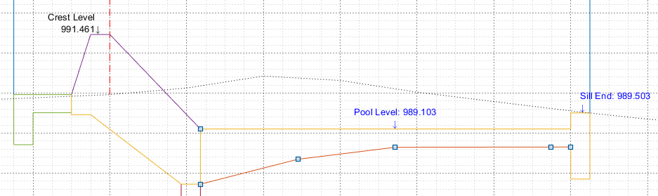

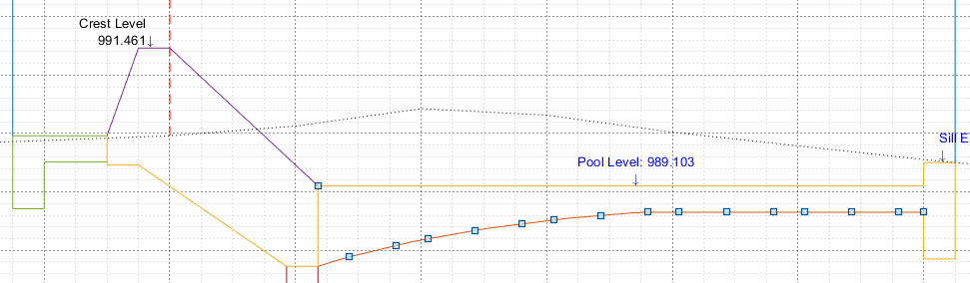

The above figures demonstrate the results of apron thickness design with and with out thickness points specified, respectively.

## Overall stability analysis.

The longitudinal view also allows the analysis of overall stability of the weir body. This is done by following standard procedures in practice, determining the magnitudes of all acting forces on the weir body, evaluating their momentum.

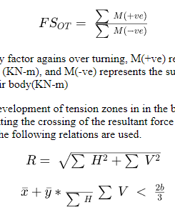



The result is summarized in the schematic presentation, similar to the one shown below.

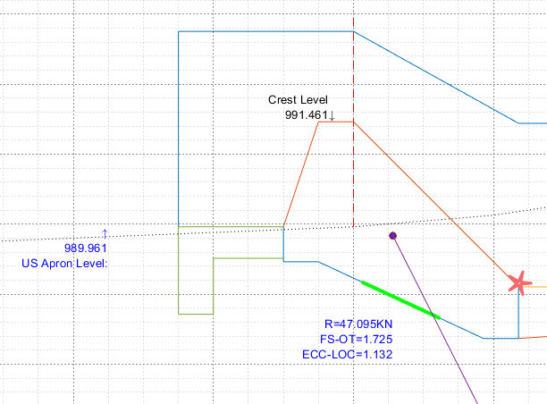

One can see that:

* All moments are calculated with respect to pivot point at toe of the weir (shown in asterisk above figure).
* FS-OT (Factor of safety against overturning) is calculated and shown, along with the resultant of all acting forces
* The crossing of the resultant on the bottom surface is also shown, with the middle-third highlighted in green.

The variables relevant to stability analysis, can also be edited from the overflow section view. They are listed below.

## Safety Parameters

| NO | Variable Name | Default Values | Notes |
| --- | --- | --- | --- |
| 1 | Safety Exit Gradient | 0.167 | Safe exit gradient value for the river bed material.  Allowable Range of Values: 0< GExit < 0.50 |
| 2 | Safety Against Overturning | 1.500 | Limiting factor of safety against overturning.  Allowable range of values: 1.2<=FS-OT <=2.0 |

## The sluice bay section

Sluice bays, if provided, are taken in to consideration in the positioning and sizing of the diversion structure. A cross-section view can be generated and viewed for each of the left and right sluice bays, as provided. These views can be accessed from **Workflow > Sluice Bay View (Left)**, and **Workflow > Sluice Bay View (Right).**

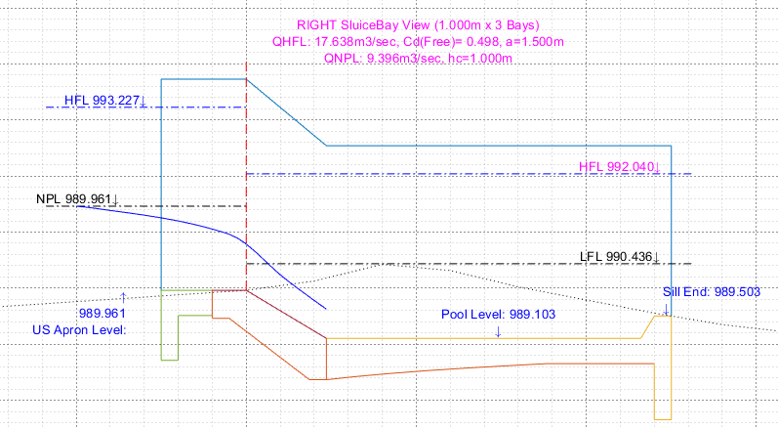

The sluice bay parameters discussed earlier on the Transverse Design section, are at play in this view, and can also be edited from this view.

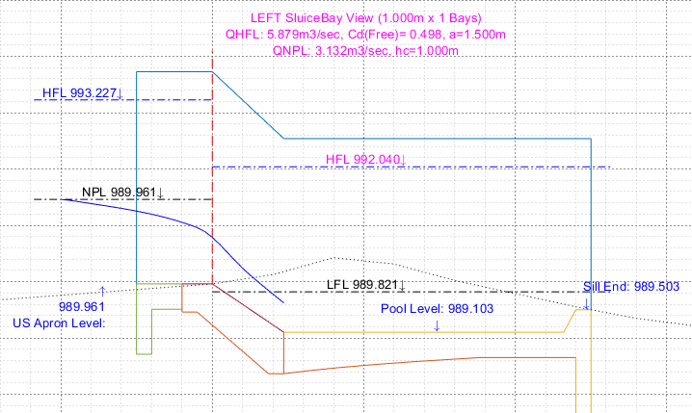

The view provides adequate information on results of hydraulic analysis for both HFL and NPL conditions. The presented discharge capacities of the bays are calculated as follows:

* The maximum opening size for sluice gates are calculated based on sill crest height, gate proud height, the weir height and abutment height.
* NPL Condition: Gates are fully open, and critical flow prevails, with un-submerged hydraulic jump downstream
* HFL condition: Gates are fully open, and under sluice flow prevails, with free or submerged flow conditions.
* Total capacity of each bay is determined by multiplying the discharge through one bay by the number of bays provided.

Refer to technical notes for textbook details on the hydraulic calculations implemented.

## Outlet Designs

This view allows the design and analysis of outlets on either - or both - sides of the diversion weir. The view can be accessed from **Workflow > Outlet Section View (Left)** and **Workflow > Outlet Section View (Right).**

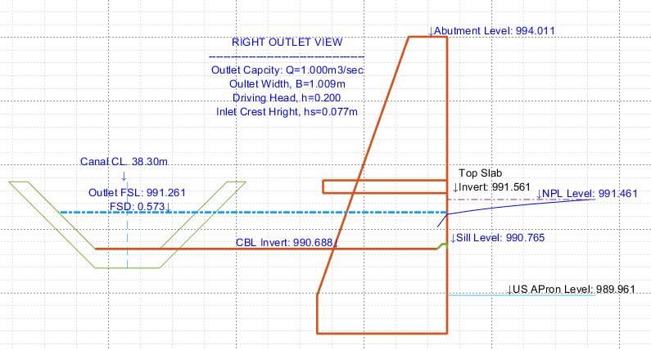

The view positions the outlet relative to the crest level of the weir and the upstream apron level. The following are key assumptions used.

* critical flow prevails on entering the outlet tunnel
* The available width of the outlet is set equal to the width of the offtaking canal.
* The invert level for the top slap is provided by applying the clearance value desired above the crest level of the weir (NPL).
* The FSL in the offtaking canal is calculated by solving the manning's flow equation for uniform flow for the specified canal geometry and bed slope.

## Outlet Settings

| No | Variable Name | Default Values | Notes |
| --- | --- | --- | --- |
|  | Outlet Capacity (m3/sec): | [1.000, 0.500] | The desired capacity of the outlets in the left and right side of the diversion weir (Face up stream).  Allowable Range of Values: 0<= Qdes <=10m3/sec  Note: 0 means there is no outlet on that side of the weir. |
|  | Outlet Canal Distance (Left, Right]:(m) | 5.000 | The (display) distance of the outlet canal from the Abutment wall face.  Allowable Range of Values: 4<D<15 |
|  | Driving Head (m) | 0.200 | Driving head to consider between the crest level (i.e., Normal pool level flow condition) and the offtaking canal FSL flowing at design capacity,  Allowable Range of Values: 0.05<Hd<0.50 |
|  | Manning's Roughness, N(-) | 0.014 | Roughness value of the outlet canal, used in determining the normal flow depth for the canal geometry specified.  Allowable Range of Values: 0.001<N<=0.10’ |
|  | Canal Side Slope (-) | 1.000 | Side slope of the offtaking canal  Allowable Range of Values: 0<m<3.0 |
|  | Design B to D ratio(-) | -1.000 | B?D ratio to be used in sizing the canal for the specified design capacity.  Allowable Values: -1<B/D<10  Note: -1 indicates to use the build in equation  If Q<0.20, B/D= 1.0  If Q>0.20 B/D= 1.76*Q^0.35  If B2D=0.0, indicate to use the USBR recommended ratio shown below. |
|  | Bed Slope, So(m/m) | 1000.000 | Bed slope of the offtaking canal  Allowable Range of Values: 1/50>So>1/1000 |
|  | Freeboard, FB(m) | -1.000 | Freeboard for offtaking canal.  Allowable Range of Values: -1<Fb<2.0  If FB==-1 the USBR recommendation shown below is used to determine the required freeboard corresponding to the canal capacity.  Else the user supplied value is taken. |
|  | Canal Lining type, Ltyp(-) | 0.000 | The lining type desired for the offtaking canal.  Allowable Range of Values: -1<Ltyp<1 (integer)  -1: Unlined canal  0: Thin LIned canal  1: thick lined canal |
|  | Lining Thickness, Thk(m) | 0.300 | Lining thickness |
|  | Foundation Thickness, THK(m) | 0.600 | Foundation thickness. |

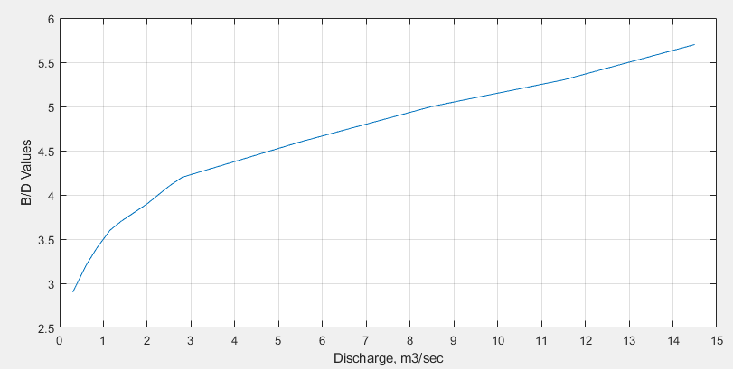

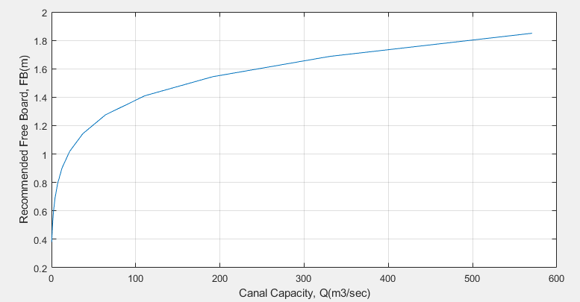

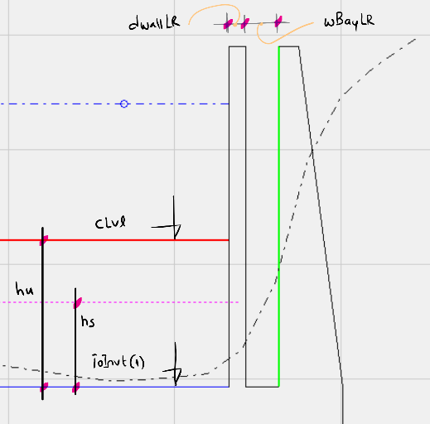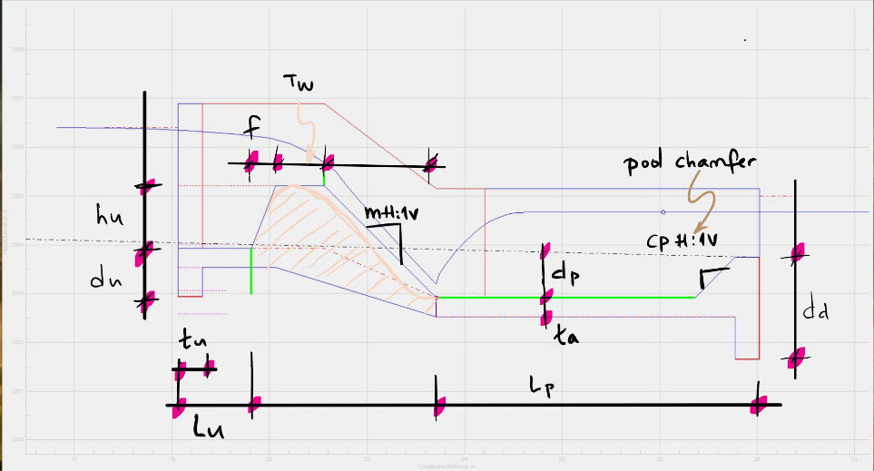

## 

# Technical Notes:

## Overflow rating:

The rating of flow over the weir body can be calculated using one of the below formula.

Bos (Clemmens A J 1984):

Critical flow: (French R H 1987)

Momentum equation (Chow 1959):

Salmasi et al (Franzin Salmasi 2012):

Ogee Profile (H. Wayne Coleman 2004), (Chow 1959):

Where C is determined from a set of curves relating overflow head, Height of regulator and inclination of upstream face as shown in the charts to the right.

In the above equations, Cd= Coefficient of discharge, Ho, H= depth of overflow, B= top width of the weir, P= height of the weir, L= length of overflow, and g= gravitational acceleration.

Flow contraction coefficient is considered when is input. In this case the effective overflow length is calculated from

Where is the total available overflow length, and is the overflow height.

## Surface hydraulics:

The pre-jump flow conditions are computed applying the energy equation between the approach section, and points along the downstream glacis (Asawa 2002).

Hydraulic jump is calculated using the relationship:

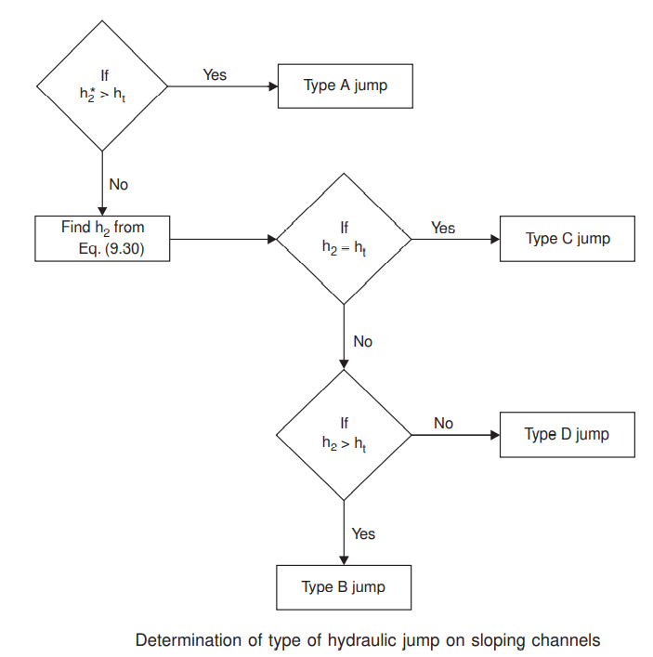

Jumps are classified comparing with tail water conditions as follows:

If Type A jump,

if Type CD jump, and

if Type B jump occurs.

Where Z, y, v, F represent the elevation, depth of flow, velocity and Froude numbers in pre-jump and post jump conditions.

Jump profile is estimated from the design chart shown below, relating to where x is distance from jump beginning, and y2 and y1 are sequent depths of the jump.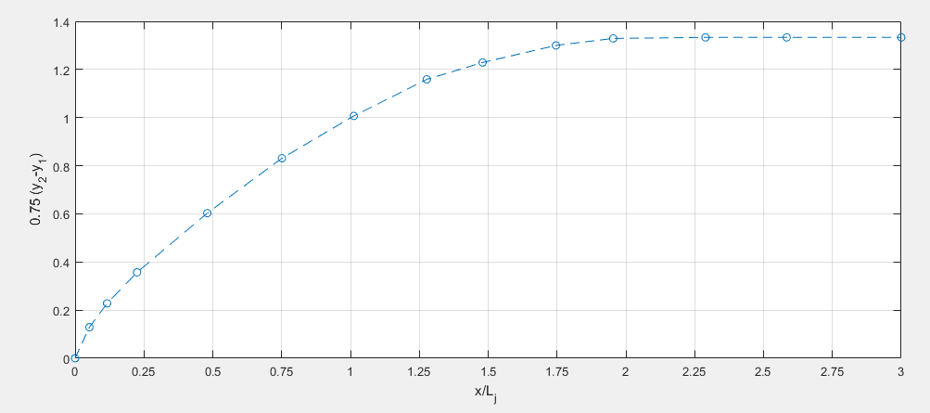

Location and profile of the resulting hydraulic jump is calculated using the following relation ships. For jumps on sloping canals,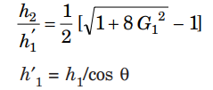

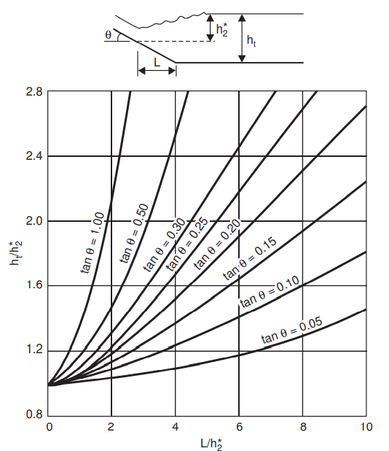

For type B, C and D jumps, the location of the jump on the glacis is determined from the following chart.

The length of the jump is determined from the below chart relating the Froud number calculated above to the ratio of total jump length to the sequent depth .

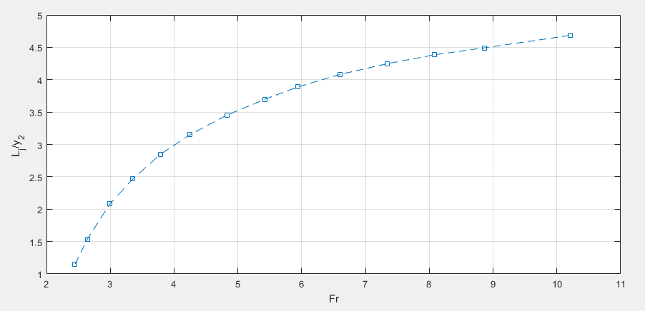

The chart relating flow depth and jump profile is used to approximate the length and shape of the rapidly varied flow after the jump starting point.

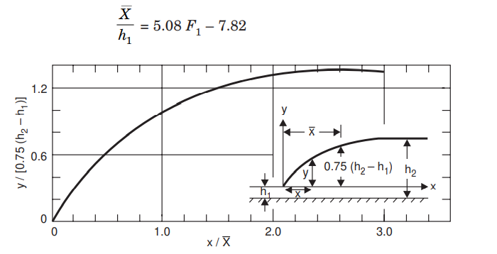

The value of is futher checked against the common practice of

## Subsurface hydraulics:

Khosla’s theory is applied to estimate subsurface flow head loss and residual pressure at different points along the bottom of the impervious floor (Asawa 2002), (Garg 2009). Thus, for the poles at eiher the upsream end or the downstream end,

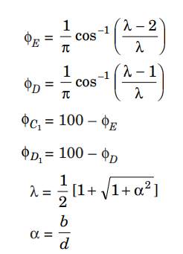

For the piles at the intermediate point,

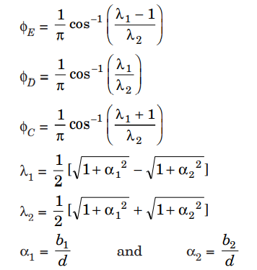

Correction for mutual interference for key points is applied as:

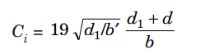

The exit gradient is estimated from:

The cited reference materials provide sufficient detail on the theoretical basis and practical application of the formula above, as implemented in the module.

## Stability analysis:

The stability of the weir body and its component provisions are evaluated against the following (Asawa 2002):

Where is factor of safety against overturning, e= eccentricity, are stresses at heel and toe of the bottom of the weir structure.

### 

## Sluice Bay Hydraulics

The basic relation ship for flow under sluice bay is given by:



where is the coefficient of discharge, Ho and hz are as shown in below figure.

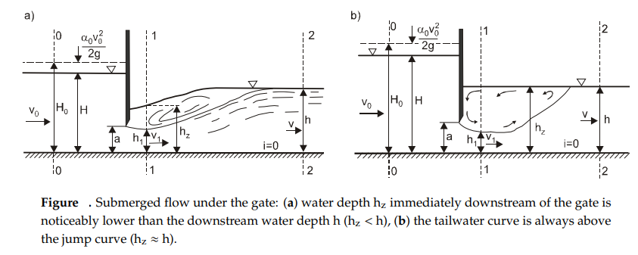

The sluice gate is considered to be submerged if the following condition is fulfilled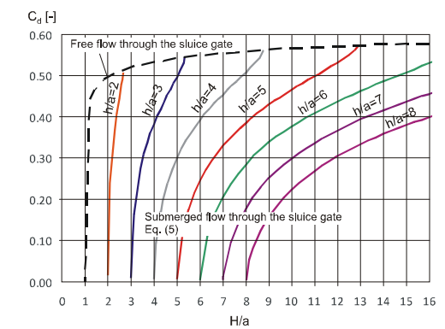



The coefficient of discharge in both cases, for a given set of upstream and downstream hydraulic grade levels, are determined from the below chart.

References:

Elbaban et al, Flow Measurements Using a Sluice Gate; Analysis and Applicability, Water Journal, 2020.

G,L Asawa, Irrigation and Water Resources Engineering, New Age International Publishers, New Delhi, 2008

S.K. Garg, Irrigation and Hydro Power Engineering,

R. Baban, Design of Diversion Weirs, Small Scale Irrigation In Hot Climates. Joh Willey and Sons, New York

R.W.P. May et al, Hydraulic Design of Side weirs, Thomas Telford Publishing, London, 2003.

Wayne Coleman, Civil Engineering Hand Book - Hydraulic Design of Spillways, MC Graw Hill, 2004

Rizghar Ahmad, Variation of Uplift Pressure and Exit Gradient Downstream of Hydraulic Structures, Unpublished, 1997

Stream Hydraulics, Part 654 Stream Restoration Design National Engineering Handbook, United States Department of Agricutlure, 2007

Federal High Way Administration, Users Manual for WSPRO - A computer model for Surface Profile COmputations, Washington (1998)