Design of Earth Retaining Structures

The design and analysis of retaining structures and abutment walls is carried out using the **RetwallDesign** product. It provides a unique and convenient workflow to analyze and document long retaining walls composed of differing section geometry, using widely practiced concepts for the analysis of earth pressure.

The product verifies safety against failure due to overturning, sliding, or heel/toe pressure in excess of allowable bearing capacity. It does not include structural analysis for components. The product offers unique workflow that allows analysis and design of a long retaining wall with different segments, each with separate height and bottom width definition.

## Conventions:

* Water tables and fill heights are measured from the base of the wall.
* Section view (unless in Flip Mode) is from left to right facing the beginning of the alignment route.

## Typical Workflow

A typical workflow process for the use of this module is shown in the illustration. Each step is described in detail in subsequent sections.

### Prepare Objects

The prerequisite objects and their prerequisite is outlined in the Appendix. The following is a summary:

1. Prepare the layout object following the footprint of the toe of the wall (front face edge) with strip profile data. This is the main source object for the design task.

Tip: The vertices of the layout object must be aligned longitudinally with the vertices of wall top and bottom profile objects. In illustration below, for instance, the layout object must have three(3) vertices.

2. Prepare wall top and bottom profile objects. This is best prepared from overlaying the profile plot from the layout object, as shown in the illustration.

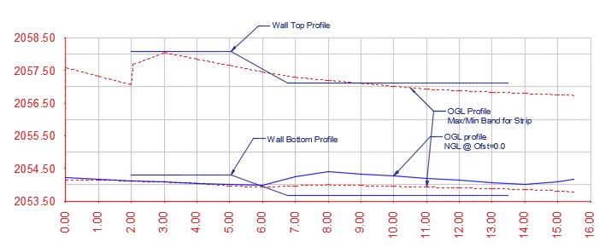

Note: If using layout object generated from weir design task (i.e., ***JumpDesign*** module), this information is already included in to the object and need not be separately prepared.

### Define and Start Session

To start the design session:

1. Clear iCAD workspace from **Workspace > Clear Workspace** or CTRL+0.

Tip: Make sure the guided mode is active from **Workspace > Guided Mode.**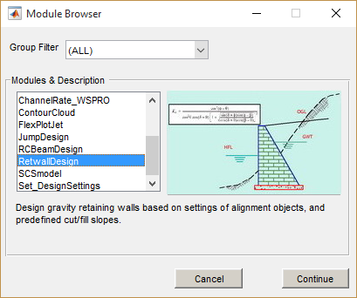

2. Start defining a session from **Session > New Session.** Select **RetwallDesign** module from the module browser, give the session a name and continue.

3. Click on the ***Wall Alignment Object*** type is listed in the left box. AutoCAD will be in select mode. Pick the wall layout object prepared above.

The session is now completely defined. Run the session from **Session > Run Active Session** or CTRL+R or simply hit the Play button.

The **DataLiveiw** interface is raised, showing the profile view.

If the wall alignment object is referenced and does not contain any profile data, simple wall design is possible.Choose **Simple Design** when prompted. Then provide basie the wall height and foundation depth values. The elevation view is generated for the simple wall. Section view uses a sample profile data.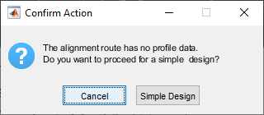

Note the following limitations for simple wall designs:

* BoQ is extracted for the wall only. No earth volume is included.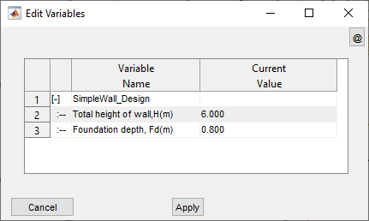
* Plan view is not available.

### ID Segments

If the wall face is displayed in the interface, you can skip to step 2 below. Otherwise, define the top and bottom information from respective AutoCAD objects as follows.

1. Go to **iFunctions > Pick Wall Top Level.** Go to AutoCAD and pick the object defining the wall top level. Similarly, use **iFunctions > Pick Wall Bottom Level** and pick the corresponding object in AutoCAD. Refresh View from **iFunctions > Refresh View** or CTRL+R. The wall face should be visible shaded in the profile view.

2. Use **iFunctions > Id Segments** to define the design segments that can be identified from the current setup. When successful, the grouping is displayed schematically at the bottom of the wall with different colors.

Tip: The segments are identified based on the variation of the height of the wall at incremental stations, grouping locations of similar heights together.

Note: At least three incremental stations are expected under each segment group. If this is not met the following flag is thrown. As recommended, quit the design process and extract profile data at finer intervals again.

### 

### Edit/Review Parameters

Edit the settings for the different aspects of design and analysis from **iFunctions > View Variable Editor.**

1. Edit variables to define load elements and data as shown below.

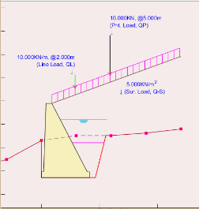

| **Group** | **Variable Name** | **Description** |
| --- | --- | --- |
| **Load Elements** | Ground Water Height (m) | Height of water table in the backfill material behind the wall |
| Intermediate Backfill Height (m) | Height of intermediate backfill material |
| Passive Backfill Height (m) | Height of fill material in front of the wall toe |
| Drain Water Height (m) | Height of water level in front of the wall toe |
| **Loading Data** | Surcharge Load (KN/m^2) | Uniformly distributed load magnitude |
| Line Load (KN/m) | Line load applied along the length of the all |
| Point Load (KN) | Point load applied on top of fill material |

Notes:

* Load elements heights are measured from bottom of the wall
* Loads are applied on top of the backfill material.

2. Edit variables defining the additional geometry and orientation of the retaining wall section

| **Group** | **Variable Name** | **Variable description** | **Remarks** |
| --- | --- | --- | --- |
| **Retwall Settings** | Top width of wall, Tw(m) | The top width of the abutment wall |  |
| T-Shape Dims (m) | [Toe, Stem width, flare, Heel]  Wall dimensions specifying the shape and geometry of the wall body including the footing. | Use [0, 0] for simple gravity wall  See notes below this table on how to define different shapes. |
| Footing Thickness (m) | Thickness of footing block |  |
| Wall friction angle (Deg) | Wall friction angle denoting the backfill vs back of wall interaction |  |
| Default B/H ratio (-) | Default ratio to determine the bottom width of the retaining wall as a function of the wall height. | This value is used to schematically draw the wall before actual designed width is assigned. Once a design value is assigned, this ratio is not used. |
| Side Cut slopes, (-)): | [Bcut, mut, hcut] values to specify earth cut slope | See illustration below.  Bcut or Bfil: Flat space from cut edge  Mcut or mfil: cut slope after flat space  Hcut or Hfil: Height of cut |
| Backfill Slopes, (-): | [Bfil, mfil, Hfil] values to specify earth fill slope |
| Wall face direction, (-) | Wall face direction  1: Orient wall to the left  -1: Orient wall to the right | Direction sect with reference to face looking at end of alignment route.  See notes on *presentation and documentation* section, and the plan view details to learn about the difference. |

All variables related to Retaining wall described above are schematically outlined in the illustration below.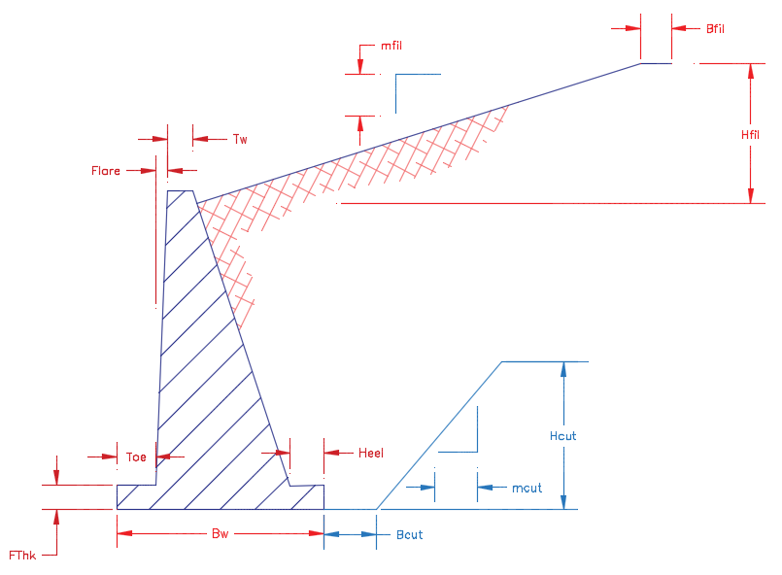

The following are examples of wall shapes that can be generated. Note: Tw= 0.5m



3. Edit material properties that determine the magnitudes of loads acting on the retaining wall body. A list of common materials are built into the variables and reference values are available as shown in the screenshot next to the table.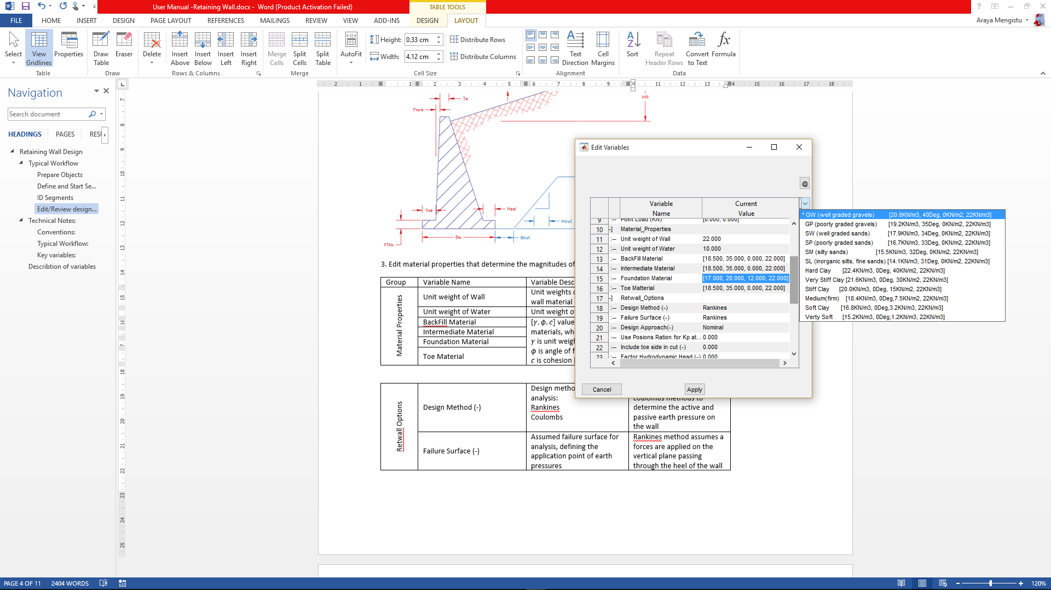

| Group | Variable Name | Variable Description |
| --- | --- | --- |
| Material Properties | Unit weight of Wall | Unit weights of the retaining wall material |
| Unit weight of Water | Unit weight of water |
| Backfill Material | [ values for earth materials, where:  is bulk unit weight [KN/m^3]  is angle of friction [deg]  is cohesion [KN/m^2]  is saturated unit weight  See note below. |
| Intermediate Material |
| Foundation Material |
| Toe Material |

4. Edit and/or set design process related settings and safety parameters for the session.

| **Group** | **Variable Name** | **Variable Description** | **Remarks** |
| --- | --- | --- | --- |
| **Retwall Options** | Design Method (-) | Design method to be used in analysis:  Rankine’s  Coulombs | Apply either Rankine’s or coulombs methods to determine the active and passive earth pressure on the wall |
| Failure Surface (-) | Assumed failure surface for analysis, defining the application point of earth pressures | Rankine’s method assumes a forces are applied on the vertical plane passing through the heel of the wall  Coulombs method assumes earth pressures are applied on the back of the wall. |
| Design Approach(-) | One of available design options:  Nominal  DA-1 (Euro Code)  DA-2 (Euro Code) | These approaches establish the load and moment factors to be applied from known practices to determine safety against failure.  See technical notes further below for details. |
| Use Poisons Ration for Kp at Rest (v) | Poisons ratio value to determine passive pressure at rest condition | See technical notes below for the relationship used. |
| Include toe side in cut (-) | Include or exclude cut volumes in bill of quantity estimates |  |
| Factor Hydrodynamic Head (-) | Consider or ignore hydrodynamic head in pressure analysis | If ignored, hydrostatic pressures is considered factoring the depth of water at the heel and toe of the retaining wall. |

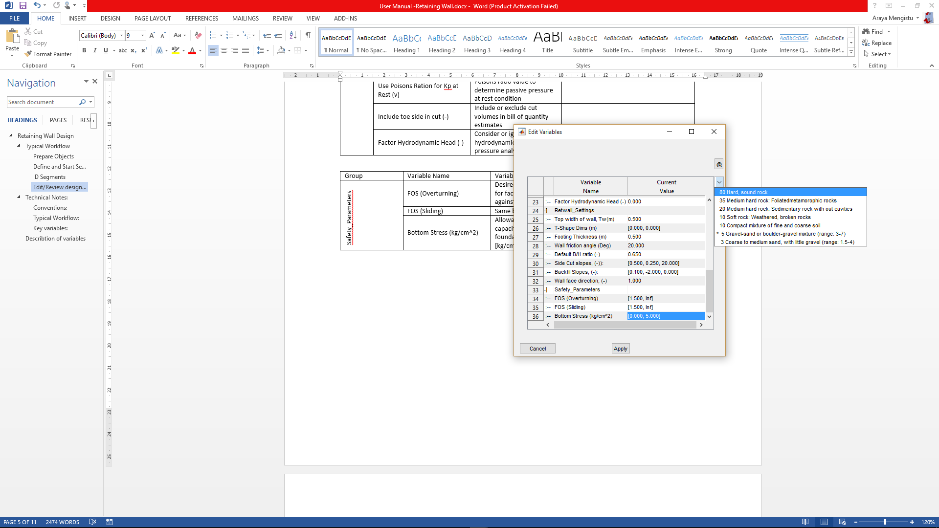

| **Group** | **Variable Name** | **Variable Description** |
| --- | --- | --- |
| **Safety Parameters** | FOS (Overturning) | Desired range of values for factor of safety against overturning. [1.5, Inf] input evaluates safety against minimum of 1.5. |
| FOS (Sliding) | Same but against sliding |
| Bottom Stress (kg/cm^2) | Allowable bearing capacity of the foundation material [kg/cm^2] |

Note:

* Safety parameters are Minimum and Maximum values of parameters with in which range PASS flag is raised. Evaluated safety beyond this range will raise FAIL flag in the analysis report table.
* A list of preset materials are available to help choose the right material, or specify a different one.

### Design Sections

The next step in the process is to design the actual sections of the retaining structures, factoring safety parameters.

1. Once in elevation view, and variables are set as well as design segments are identified, go to **iFunctions > Cross Section view** or CTRL+X. The interface will be on interactive mode to pick a location for the cross-section view. Click on a region where uniform height exists.

Tip: The location picked is rounded to the nearest incremental station recoded during profile extraction, and the section at that location is generated.

2. Select **iFunctions > Design Wall…** to get a design solution guide on bottom width values that can meet required safety parameters.

The interface shown on the right is displayed with guidelines for picking a design point. In this snapshot, for instance, the Factor of safety for overturning is met at a bottom width of close to 2.0metres, while that for sliding is met around 2.8meters.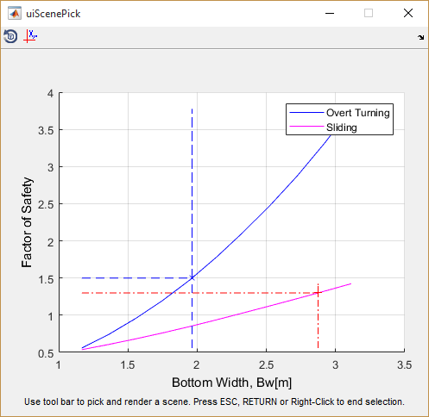

Using the *Pick A Scene Solution* toolbar, a desired width can be selected, and the cross-section view will update automatically.



2. Select **iFunctions > Analyze Wall…** menu to analyze the cross-section using current settings. This will generate loading diagrams and summary of safety evaluations against set values.

Tip: Navigate between incremental stations by using SHIFT+period (>) or SHIFT+comma (<) key.

Ensure all design parameters are met satisfactorily as indicated with the PASS flag at the end of the lower table. If not met, increase or decrease the bottom width as follows: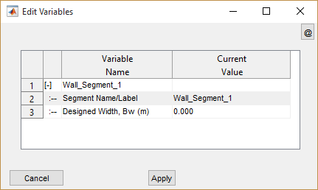

3. Invoke the variable editor for this view from **iFunctions > View variable Editor** or CTRL+E. A compact editor window is displayed, allowing you to edit design segment information.

Note: Segments not designed for bottom width show 0.000 as bottom width value. Once set to a design value, this new value is maintained.

Insert desired value for bottom width and/or segment label and click ***Apply***button.

Note: Transition walls, which are walls with variable height, cannot be directly analyzed. However, bottom widths can be assigned from design results of adjacent uniform height walls. Insert Bottom width for transition walls in pairs, e.g., [2.5, 3.0] implies a uniformly varying bottom width for the wall starting at 2.5m and finishing at 3.0m.

4. Repeat steps 2 and 3 until satisfactory performance is verified against provided safety parameters.

### Save

Save work from **Session> Save** menu.

### Presentation and Documentations

Once the design is satisfactorily completed for all design segments identified – including transition walls, the finishing solutions can be used to present and/or document the numerous details of the design process. The following are available for this module:

1. Standard output functions for report and BoQ and report generation
2. AutoCAD Drawing for Elevations, cross-sectional and plan layout views

#### Standard Output Functions

Any of the finishing and presentation solutions integrated in to iCAD workflow can be used with this module. These include:

* Generating design and analysis report from **Sessions > Build Report.**
* Generating bill of quantity (BoQ) estimate from **iFunctions > Generate BoQ**

Note: To generate a complete listing of BoQ, make sure all segments are designed satisfactorily, and:

(a) Navigate cross-section view from beginning to end

(b) Generate the plan view is also essential.

#### Generating AutoCAD drawings

Refer to the finishing solutions section of the user manual to learn how common tools are use to generate drawings to AutoCAD, including Transverse and longitudinal cross-section views.

#### Generating Plan Views

Plan views are key output for this module. These can be used to generate important layout information overlaying topographic maps, as well as related positioning details for the drawing album. To generate the plan view:

1. Make sure all identified segments are designed for appropriate bottom widths. Then go to **iFunctions > Show Plan** or CTRL+T. The view is generated to maintain the orientation of the layout object.

2. Use the *Generating Additional Plots to AutoCAD* option to render this to AutoCAD.

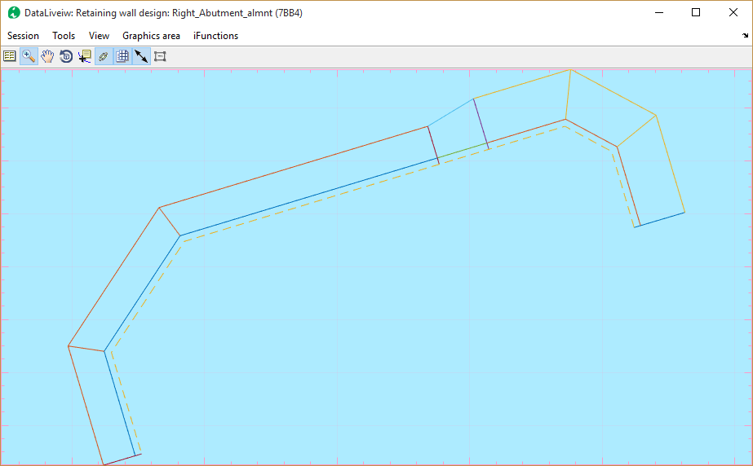

Note: The shape of the plan view may be rendered as shown below, if the **Wall Face Direction** variable under ***Retwall Settings*** group is set to -1 (or Right). Use option as fits the context.

Finally, an important guide to ensure smooth design process. The generation of plan view may result in unrepresentative geometry – such as shown below - if the vertices locations on the alignment route and that of the wall top/bottom profile. 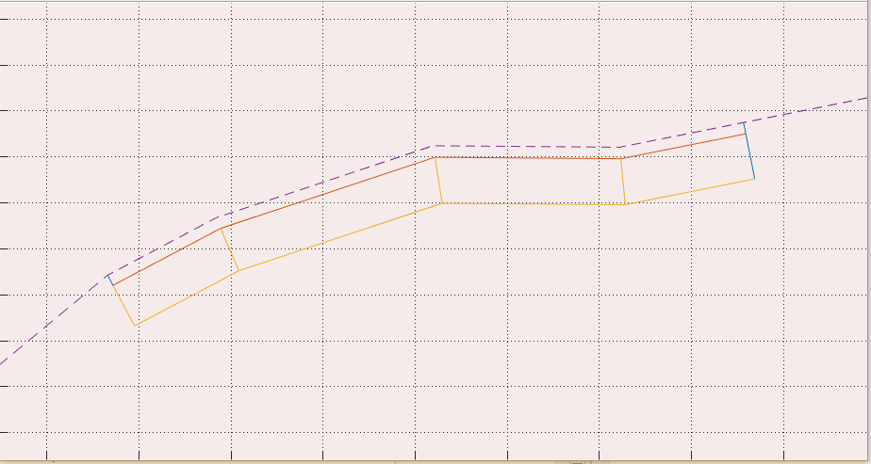

This is common, if the wall top/bottom profile objects are created after the alignment route is set out and the profile is done.

Note: Alignment routes generated from ***JumpDesign*** module during the design of weirs are free from such issues.

If vertices are in alignment, the correct image should appear as shown here.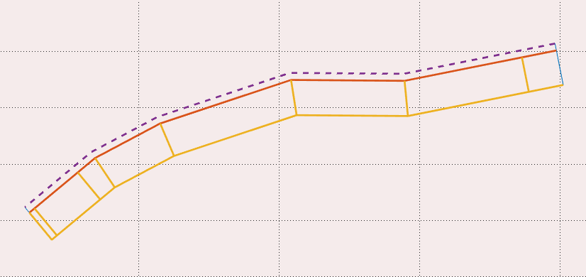

To avoid such issues:

1. Draw the layout object overlaying the base map

2. Mark station locations using appropriate intervals (e.g., 0.25, 0.5, 1.0).

3. Decide the beginning, end and interim points for the retaining wall and ensure vertices are created on those locations.

4. Extract the profile with desired offset settings & save the profile data. Before closing the profile data view, use Tools > Copy Graphics (for AutoCAD plot), and use the iCAD menu Tools > Plot to AutoCAD (or CTRL+P) to plot the data to AutoCAD. Use a scale of 1.0 to plot the data.

5. Now draw the wall top level and wall bottom level geometries using the vertex locations positioned in step 2 above.

The design session defined using layout objects and wall top/bottom profiles prepared in this manner will result in expected geometries.

Vertices at 1.25m and 18m stations – same as the begin and end point of the wall top and wall bottom profile objects - as shown give the correct layout.

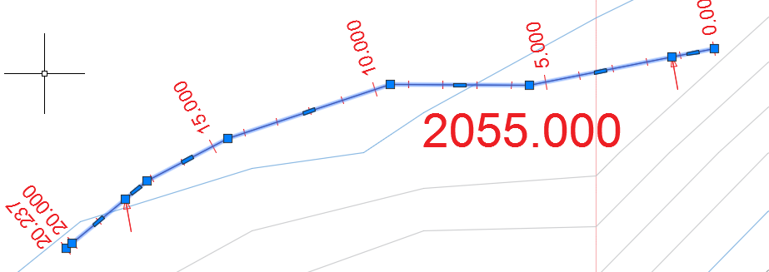

Note: Wall top and/or bottom profiles need to have the same number of vertices. Profiles provided beyond the start and end of the profile data are trimmed to data range.

Tip: A convenient way to ensure proper sync of vertices between the layout object and the eall top/bottom profiles is to align the vertices of the latter to stations that are easy to locate on the layout object. Then the layout object can be edited for new vertices at these locations, and a profile re-extracted.

Walls may not be rendered fully, if WallTop and WallBottom coordinates do not strart at beginning and end of profile data.

## Technical Notes

The product identifies segments along the alignment route of the wall. It uses the wall height to identify design ranges with the same wall height dimension, and label them in to segments. Each segment can then be designed separately to determine the bottom width that gives a stable structure.

### Earth Pressure Calculation

Earth pressure is computed from the relationship

Where unit weight of the back fill material, H is the back fill height, and Ka and Kp are active and passive pressure coefficients, respectively, that depends on the method of analysis.

Rankins Concept: Active pressure coefficient in this concept is determined from (Hunt 1986) (Arrora 2004) (Geo5 2005-2017) (W. 1999):

Coulomb’s concept: Active pressure in this concept is determined from

Where angle of internal friction, back face inclination of structure, angle of friction between structure and soil, and inclination of backfill to the horizontal.

Note: The coefficients are computed for cohesion-less soil conditions. Also for passive conditions condition is assumed.

In the Rankins method, a virtual vertical plane at the heel of the wall is assumed where the earth pressure is acting at an inclination equal to that of the backfill slope.

Normally, in Coulombs method, the forces are assumed to act on the back of the wall, at an angle factoring the soil-structure angle of friction. In Rankine’s method, the failure surface is a virtual vertical plan passing through the heel of the retaining wall. Users can specify failure surfaces as fits their design problem, regardless of the method for computing pressure coefficients.

### Pressure Coefficients on Cohesive soils

Coulomb’s theory for cohesive soils estimates coefficient of active earth pressure from:

Corresponding crack location is computed from:

Where is unit weight of backfill material, is the effective cohesion, is the coefficient of pressure due to cohesion, and is the coefficient of active earth pressure. In computation, can’t exceed the thickness of the topmost layer, or depth to water table in the backfill, whichever is smaller.

### Hydrostatic and Hydrodynamic Pressure

Hydrostatic pressure is computed using

Hydrodynamic pressure is computed from the gradient relationship

Where difference in water is surface elevation, and are the depth of the water table at heel and toe side respectively.

Where is the saturated unit weight of the earth body.

### Pressure from external loads

Pressure distribution from uniformly distributed, line or point loads on the grade line of the back fill is estimated from the following relationships.

**Uniformly distributed loads:**

Where is the load [KN-m-2], is the coefficient of active earth pressure.

**Line loads:**

Where n and m are distance factors.

**Point Loads:**

Where the European code of practice applies, the design approach is set by the user to available options. The following load factors apply respectively.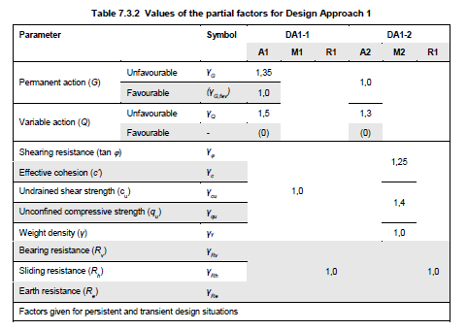

Accordingly, vertical and horizontal components of active pressure are calculated.

Table: Values of partial factors in Design Approach 1 (DA1-1, DA1-2) (Adrew J. Bond 2013)

### Stability Analysis

Stability against acting loads is verified using five parameter test, namely Factor of safety against overturning, Factor of safety against sliding, load eccentricity, stress at toe and heel of the wall. The relationships that are used to verify stability are summarized below.

Where is summation of negative or destabilizing moments, summation of positive or stabilizing moments, summation of vertical forces, B= Bottom width of wall, e= eccentricity, c’ is cohesion of foundation soil, and q= stress at the bottom of the wall (heel and toe respectively).

### Geometric Limitations

The ***RetwallDesign*** module can model most wall shapes including T or cantilever walls, semi-gravity and gravity walls, subject to the following limitations:

* The module solves horizontal bottom
* Unguided use of the module, without adequate technical support, for Wall sizes greater than 7 meters is not recommended.
* The solution may abort with unhandled error if calculated cut profiles do not intersect NGL. This may happen for large bottom width dimensions.