

INSTALLATION GUIDE

iCAD Software, v1.90 (2018) Installation, Licensing and Setup guide

qUANOMIC ites

Table of Contents

Well come! 1

Automatic Installation and setup guide 1

Licensing Guide 3

Setting up AutoCAD 5

Advanced setup guide 6

Matlab Compiler Runtime (MCR) Setup 6

Using iCAD with AutoCAD 2010 and later releases 7

# Well come!

Welcome to iCAD, and Thank you for choosing to use it. This small guide will assist you to get your software up and running.

iCAD is a unique software that has the potential to significantly and positively impact how you work and deliver your projects. Although iCAD is designed to be easy to use and intuitive, a minimum guidance is required to understand how it operates.

iCAD software documentation provides this guide to you through key contents that can make your experience with the software a lot better, than you would if you were to try it out without any guidance. We strongly recommend that you scan these documents for maximum productivity.

**iCAD is Legally protected software**: iCAD is a licensed and copyright protected software under prevailing laws. Please read the End User Licence Agreement (EULA) before installing and using the software. Please DO NOT INSTALL or USE iCAD if you do not agree to the terms of the EULA.

**Operating License**: Currently iCAD line of products are available only on subscription basis, available by request to [www.quanomix.weebly.com](http://www.quanomix.weebly.com) or contacting us at:

Quanomic ITES

No 6, Grnd FLR

IT Village/IT Park

Bole Subcity, POBox 170260

Addis Ababa

ETHIOPIA

You may use the software for a trial period without a (paid) license.

Do not hesitate to contact us on [www.quanomix.weebly.com](http://www.quanomix.weebly.com) or for any queries you may have.

Enjoy!

*Team Quanomic*

# Automatic Installation and setup guide

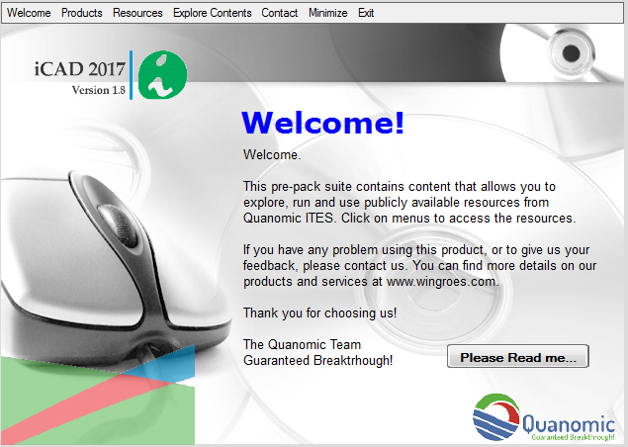The iCAD V1.9 software comes packed on a CD/USB media resource. When you insert your CD/USB you will see the *Installation Menu.*

If you don’t see the installation menu, explore the contents of your media to locate **autorun.exe** and double click on it. This will start the *Installation Menu.*

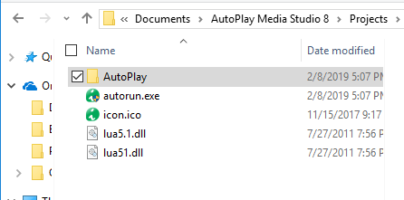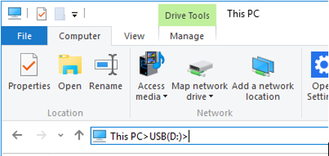

Before you start using any of the resources on the media CD, we strongly recommend that you read the accompanying brief guide by clicking **Please Read Me….**

Also, note that iCAD also has mandatory prerequisites to operate successfully and be of maximum use on any computer. These are:

1. Standard iCAD line of products are compiled to run on 64Bit(x64) computers.
2. iCAD requires:
   1. Windows 8 or 10 operating systems
   2. Installed AutoCAD 2018 version[1]
   3. Installed Excel 2007 or latter
3. iCAD requires Administrative privilege to run. This means your user/login ID on windows must be set to **Administrator**. Make sure you have elevated privilege, if necessary by contacting your IT support person, to use the software.

NOTE: iCAD is not allowed to run on server computers or virtual machines.

Contact us to get appropriate version packs if:

* 1. Your computer is 32Bit(x86)
  2. Your AutoCAD version is earlier than 2010 (e.g., 2007)

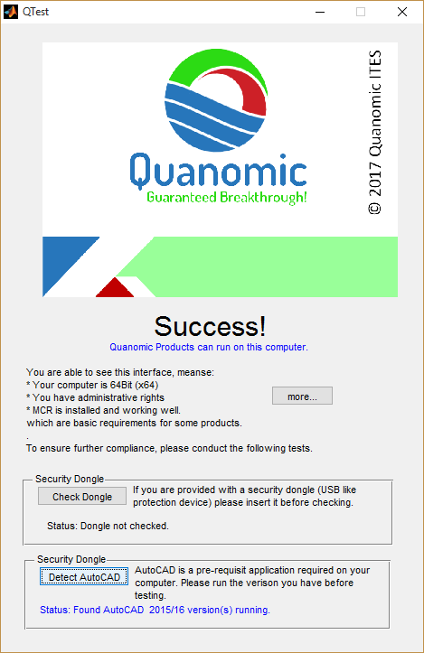Once you have installed iCAD successfully, you will need to setup your AutoCAD to converse with iCAD. This can be assured by following the installation and setup guide in this manual.

**QTEST** is a small program designed to facilitate installation and use of iCAD software. It must be installed and run on your computer before installing iCAD. This ensures successfully that:

1. All the above prerequisites are met on your computer to install and use iCAD

2. Installs a necessary runtime library for iCAD and other products from Quanomic ITES.

Note: For a succesful test, start QTest (from the installation folder) and AutoCAD at the same level, i.e., Normal user of Administrator level. If invoked at different previlege levels, the test algorithm will not be able to detect AutoCAD and may report a false error.

# Licensing Guide

iCAD is a protected by prevailing copyright laws. It is an application provided for use only as described in the license agreement (EULA). To activate your product, follow these steps.

1. 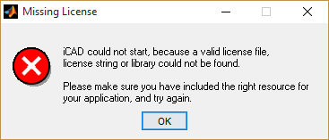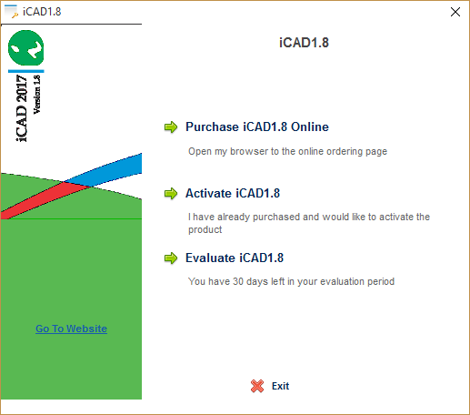On first run you will see the activation interface similar to the one shown below. If you receive a **Missing License** message, please copy and transfer the *ilicense* (.xml, .xsd, .dat) files to the installation folder (default is c:\Program Files\iCAD).

Note: You will need a live internet connection to activate your product. Please open the document (usually email) Activation information sent to you for input when requested.

* 1. Select **Evaluate iCAD1.8** option if that is your wish, and you may skip to the last step, where you will see the main iCAD interface.

Note, however, you **may not see the evaluate option**, depending on the license type issued to you.

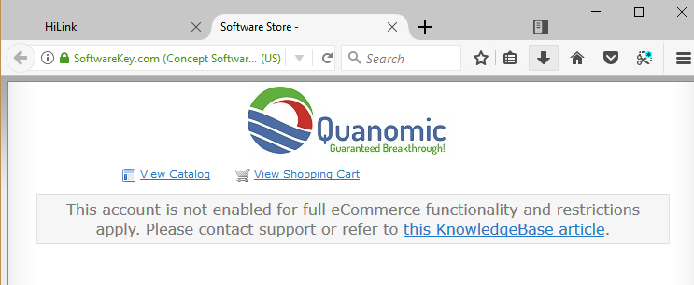

* 1. Select **Activate iCAD1.8** option.

You can choose to evaluate iCAD for 30 days by selecting. You may skip to the last step, where you will see the main iCAD interface.

The online purchase feature is not enabled yet. The website will respond with the below screen if you choose **Purchase** option.

1. Depending on your license provision select one of the following:
   1. 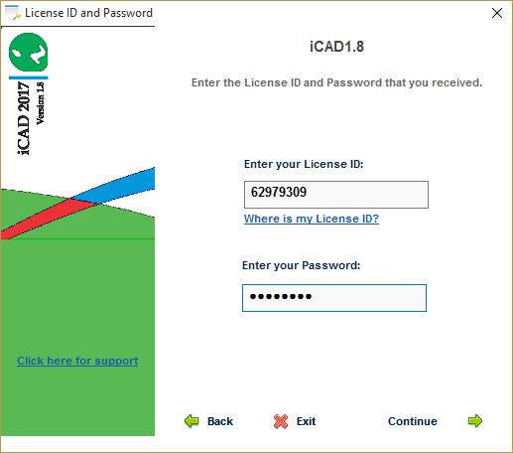Select **Evaluate iCAD1.8,** if you have not contacted us and you do not have a license activation information sent to you

Note: Evaluation will provide you 30days of full featured product use.

* 1. Select **Activate iCAD1.8 online** option if you have received activation information. Input your activation information when requested and proceed. If valid information is provided, the activation will begin and complete successfully.

Note: Passwords are case sensitive.

**Important: Please take a moment to input your customer information in the dialog to register your product. We will use this information to update your software, license and related products.**

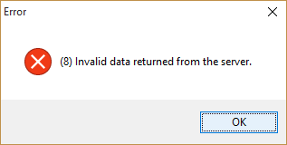If you receive an error message such as shown on the left, check your internet connection and try again. Also make sure you provide the correct details. We recommend to copy and paste license ID and Activation Password information.

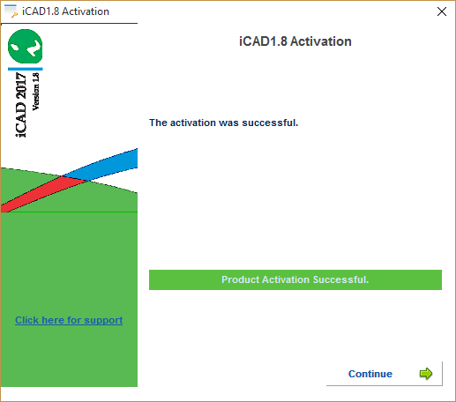Your product is now activated and you can start using it. Please visit our website for quick guides and resources on how to use the product.

For other licensing functions, please contact technical support.

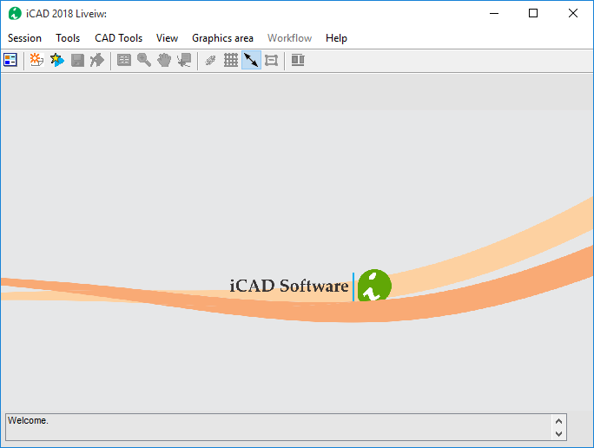

The main iCAD interface will start as below, once successfully activated.

If you see the *Failed Connection* dialog, it means AutoCAD is not started and running on your computer. You can start AutoCAD and restart iCAD to establish connection.

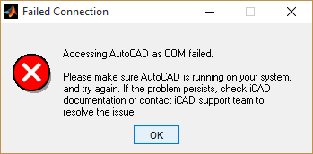

# Setting up AutoCAD

iCAD requires AutoCAD to be configured for streamlined data exchange. This is facilitated through the provided bridging software along with installation package. This is an application called **iCADBridgeX**, where x denotes the version or edition. Check our website for latest versions.

Note: All changes you make as part of this set up do not affect your AutoCAD application, or your experience with AutoCAD in any way. All changes can be reverted.

Important: If you are using AutoCAD 2010 or later, please apply settings outlined in **Advanced Setup** sectionof this guide**, using iCAD with AutoCAD 2010 and Later** section. You will need **VBA Enabler** for AutoCAD installed before you can use iCAD.

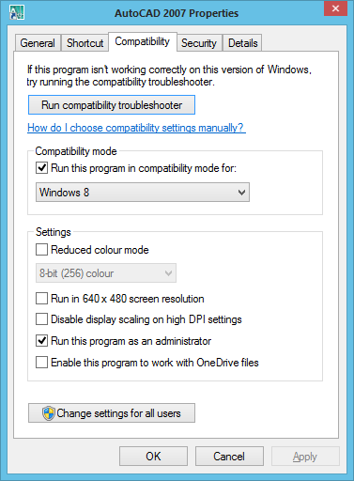

Step I: Elevated Use. Ensure that AutoCAD application always runs with administrator privileges. Also make sure that the compatibility mode is set correctly. For example, if you are running windows 8, set the option to Windows 8. This is particularly important for computers with 64 bit systems and windows 7 or latter OS. To do this:

1. Right click on the AutoCAD application shortcut (on the desktop or on the start menu), and select Properties. The dialog on the right appears.
2. Tick the Run this program as an administrator box, and select the proper compatibility mode as shown

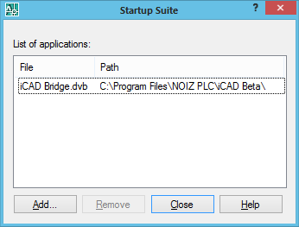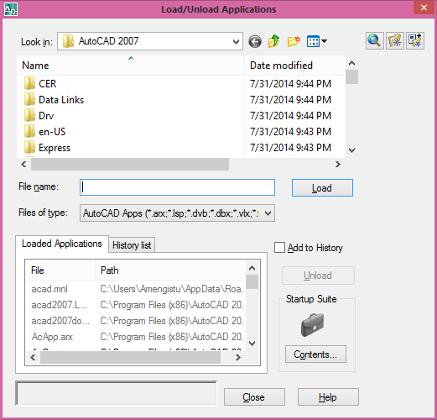Step II: Avail the Bridge application to AutoCAD. To do this:

1. Start AutoCAD and type *appload* on the command line. The *Load/Unload Application* dialog will appear.
2. Go to Startup *Suite* panel and click on *Contents…*
3. In the *Startup Suite* dialog, select *Add* and browse the file **iCADBridgeX.dvb** from the installation folder of iCAD. The default location is C:\Program Files\iCAD.
4. Click *Close* and exit dialogues. Close AutoCAD. This completes the AutoCAD setup process.

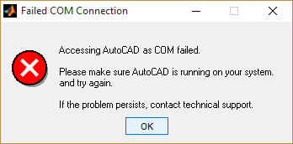To check, Start AutoCAD. Then Start iCAD. You will see that iCAD places utility toolbars on the left side of your AutoCAD working area. If you see an error dialog similar to the one shown:

1. Check your computer complies with requirements
2. Both AutoCAD and iCAD are started as administrator. To do this, DO NOT just click on the short cut. Right-click and select *Run as Administrator.*

# Advanced setup guide

The following steps may assist to troubleshoot unsuccessful installation of the product. Consult technical support at Quanomic for further guidance.

## Matlab Compiler Runtime (MCR) Setup

1. Prerequisites for Deployment

* Verify the MATLAB Compiler Runtime (MCR) is installed and ensure you have installed version 9.2.
* If the MCR is not installed, run MCRInstaller, located in your product CD.

Note: Installing QTEST program on your computer takes care of these prerequisites.

NOTE: Prior to running your deployed application, verify the user locale and system locales have the same value on the Microsoft Windows platform. If these values are not the same, you might see an I18n warning message and garbled text.

1. Definitions

iCAD uses the MATLAB Compiler Runtime (MCR), which is a standalone set of shared libraries that enable the execution of deployed applications. The MCR provides complete support for all features of MATLAB without the MATLAB GUI. If necessary, run MCRInstaller to install version 7.15 of MCR.

1. Procedures

Note: All the following setup processes will be handled automatically during the installation process. You should do this ONLY if iCAD fails to start normally after installation.

On your computer, add the MCR directory to the system path specified by the target system's environment variable.

* + 1. Locate the name of the environment variable to set.
    2. Set the path by doing one of the following: NOTE: <mcr_root> is the directory where MCR is installed on the target machine.

Add the MCR directory to the environment variable by opening a command prompt and issuing the DOS command:

set PATH=<mcr_root>\v714\runtime\win64;%PATH%

Alternately, for Windows, add the following pathname:

<mcr_root>\v714\runtime\win64

to the PATH environment variable, by doing the following:

1. Select the My Computer icon on your desktop.

2. Right-click the icon and select Properties from the menu.

3. Select the Advanced tab.

4. Click Environment Variables.

NOTE: On Windows, the environment variable syntax utilizes backslashes (\), delimited by semi-colons (;).

## Using iCAD with AutoCAD 2010 and later releases

iCAD depends on an Application Interfacing (API) that is built on VBA (Visual Basic for Applications) to interact seamlessly with AutoCAD, and automate users tasks. However, The Visual Basic for Applications (VBA) engine is no longer provided with AutoCAD OEM installation media since 2010. If you are using AutoCAD versions released in 2010 or latter (2012,14 for example), your AutoCAD installation does not support VB.

To check if your AutoCAD installation is supported by VBA, start AutoCAD and type *vbaide* on the command prompt. If VBA is embedded, you will see the VB Editor window. Otherwise you will receive an error message such as “Unknown command "VBAIDE". Press F1 for help.”

Below you will find information to get this engine and install it on your computer.

Visit our website at www.wingroes.com to find a list of downloadable files. Choose the correct version for you and download the application. You can also visit the AutoDESK official website here for further information.

<http://knowledge.autodesk.com/support/autocad/downloads/caas/downloads/content/download-the-microsoft-visual-basic-for-applications-module.html>

After download, follow these steps to install.

1. Close all programs.
2. In Windows Explorer, double-click the downloaded self-extracting EXE file.
3. Unzip the file to the location of your choice, or use the default location.
4. Follow the on-screen instructions.

You will also need to inform iCAD your version of AutoCAD. The default application is AutoCAD 2007. 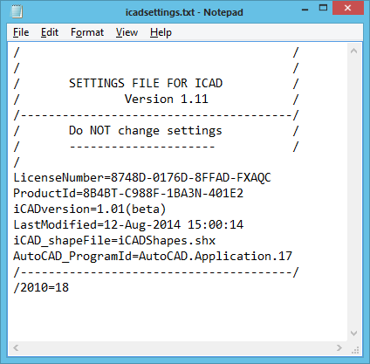Open the icadsettings.txt file from the iCAD installation folder. Edit the line containing information on the version of AutoCAD to conform to your installed product. The default is AutoCAD 2015 denoted by AutoCAD.Application.20.

You can find this information in AutoCAD Help documentation. If you are using AutoCAD 2010, then input AutoCAD.Application.18

Note: DO NOT EDIT anything else, except the program ID version in this file. This will cause iCAD to fail on every attempt to communicate with AutoCAD. Once finished, save the file and exit.

Tip: Depending on your system settings, you may not be able to save files to the installation folder of iCAD. In that case, save your modified settings file elsewhere (e.g., on the desktop). Cut or Copy the file and paste it to the iCAD installation folder. Accept to replace the previous file, when promoted to. Upon security alert, choose *Allow* to confirm saving file.

1. iCAD can also operate on other AutoCAD versions (AutoCAD 2010 or latter) without major modifications. Please contact support for additional guidance if you have older versions installed on your PC.