**Analysis and Planning of Earth Modification Works**

The analysis and visualization of fill and cut works over ground surfaces brings a significant challenge to designers. iCAD’s new **Terraform** module presents the tools and analytic details needed to visualize and present details of earth modification works, be it in cut or in fill, and allow automatic and accurate processing of quantity information.

The module can be used to handle:

* Earth Dams with different filter materials, and complex trench excavation schedules
* Bunds
* Dykes
* Saddle Dams

## Conventions:

* The axis for representing the center of the formation is drawn from left to right facing upstream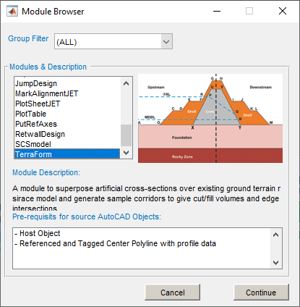
* Section views are, therefore, drawn from upstream to downstream side

## Workflow

TerraForm module in iCAD handles the analysis and presentation of earth structures. For successful execution, two objects are required.

* Axis object, referenced and containing profile data
* Data host object.

The module can be accessed from the **New Session Browser** toolbar, or from the workspace. A session for this module is defined as any other session.

# Preparing Objects

## Axis object:

This object in AutoCAD represents the centerline for the earth formation. This is conveniently drawn overlaying a contour/feature map. The axis object must be:

* Drawn from left to right, facing upstream/upslope direction
* Referenced
* Contain a profile data (generated using the AlignmentProfile module).

The resolution used to create the profile data determines the quality of output information. It is recommended to use moderate settings to extract profiles for use using this modle.

* Earth Dams: -100:10:100 at 10 meters increment
* Small Dams and bunds: -50:5:50 at 5m increment.

## Host Object

The host object is required to store all the design information and analysis results during the use of the module. All information saved, is associated with this object. It is good practice to tag the host object.

Note: This object should not be delted in AutoCAD. If deleted, all indormation may remain inaccessible.

Any object can be used as a host. It is strongly recommended to generate a suitable host object from **CadTools > Generate Host Sketch** to maintain consistency in practice. Host objects generated in this way are automatically tagged, which avoids the need to manually tag them before use.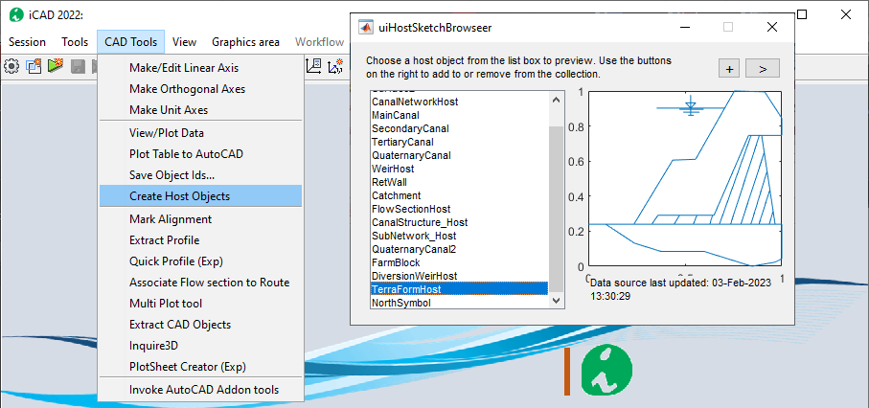

# 

# Defining the session

A session for this module is defined similar to other iCAD modules. Start by invoking the **Module Browser** from either the iCAD main interface, or the workspace browser. In the list, choose the modile and hit continue.

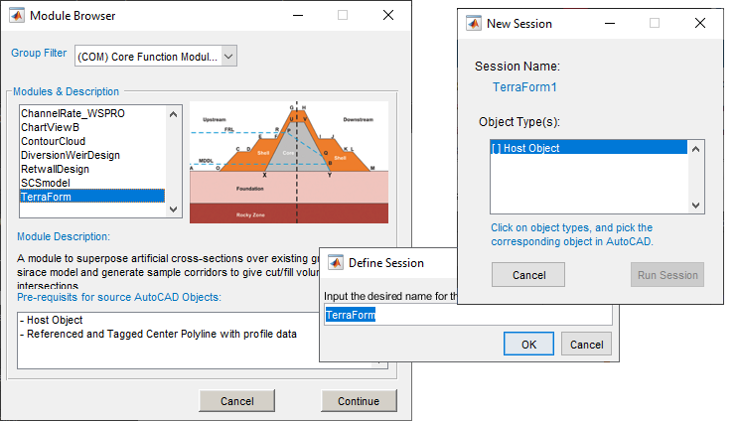

Provide names for the session.

When prompted provide the host object, and hit **Run Session.** The user is prompted to indicate the axis alignment object.

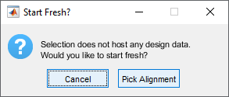

Choose ***Pick Alignment***. In AutoCAD, pick the alignment object that is refernced, and has profile data. If these data are succesfully found, the module will start with a view of the profile data in the main axis.

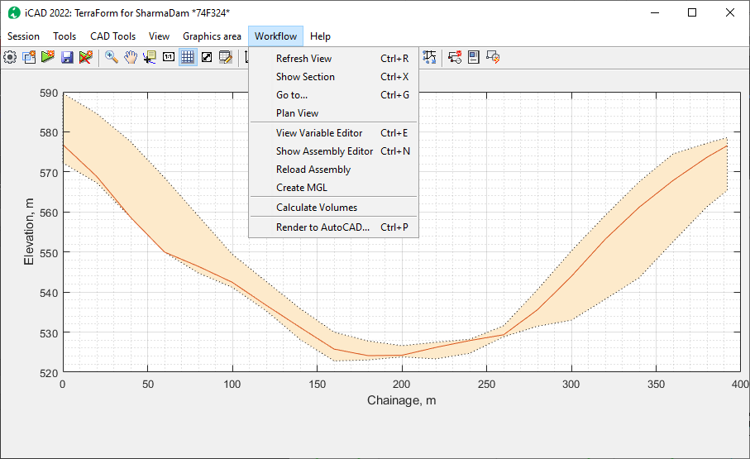

All the tools to use this module are listed under the **Workflow** menu item. It is possible to exevute different functions from this menu. The below sections describe the available features, function and how they can be used to analyze formation data.

# Creating Assemblies

The first task to use the TerraForm module is to create assemblies. Assemblies are cross-sectional information describing the geometric shapes of different formations. For bunds, this would be the finished fill profiles. For earth dams, they also include filter and impervious materials,

As can be seen soon, assemblies constitute a key role in processing formation data on ground levels. This section deals with how to create and save assemblies for processing. There are two types of sections:

* Simple assemblies
* Compound assemblies.

## 

Simple assemblies are defined by using the standard shape definition format for iCAD. They do not include any other information or data. Compund assemblies on the other hand are a combination of two assemblies, that may also have additional information. These will be discussed later.

Before creating assemblies, we will layout some basic principles.

Assemblies are made up of two components:

* Design level object
* Shape data.

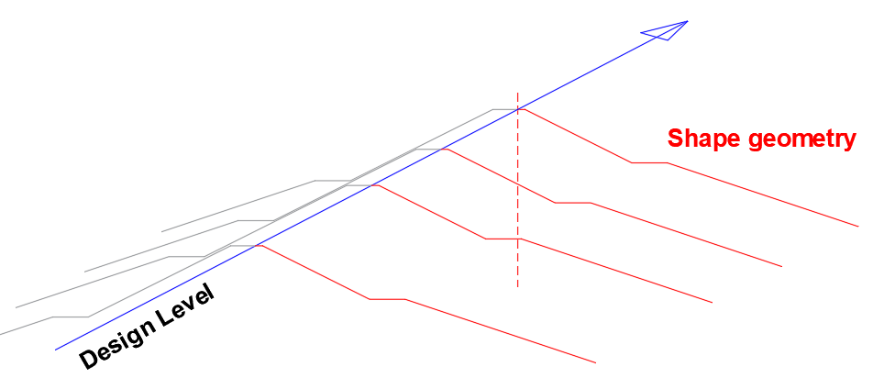

They both add to create the arrangement needed to completely define a spatial formation. Therefore, every assembly at least requires these two components.

## Creating Design Levels

The first step is hence to prepare desgn levels, for the various formation shape geometries. This can easily be done in AutoCAD over the profile drawing of the axis object. Below figure shows a snapshot of such profile information plotted in AutoCAD.

Design levels can easily be created using on this profile plot. Taking the example of an earth dam, three design levels are indicated in the next figure, representing the following three formations:

* Crest level
* Core level
* Blanket level.

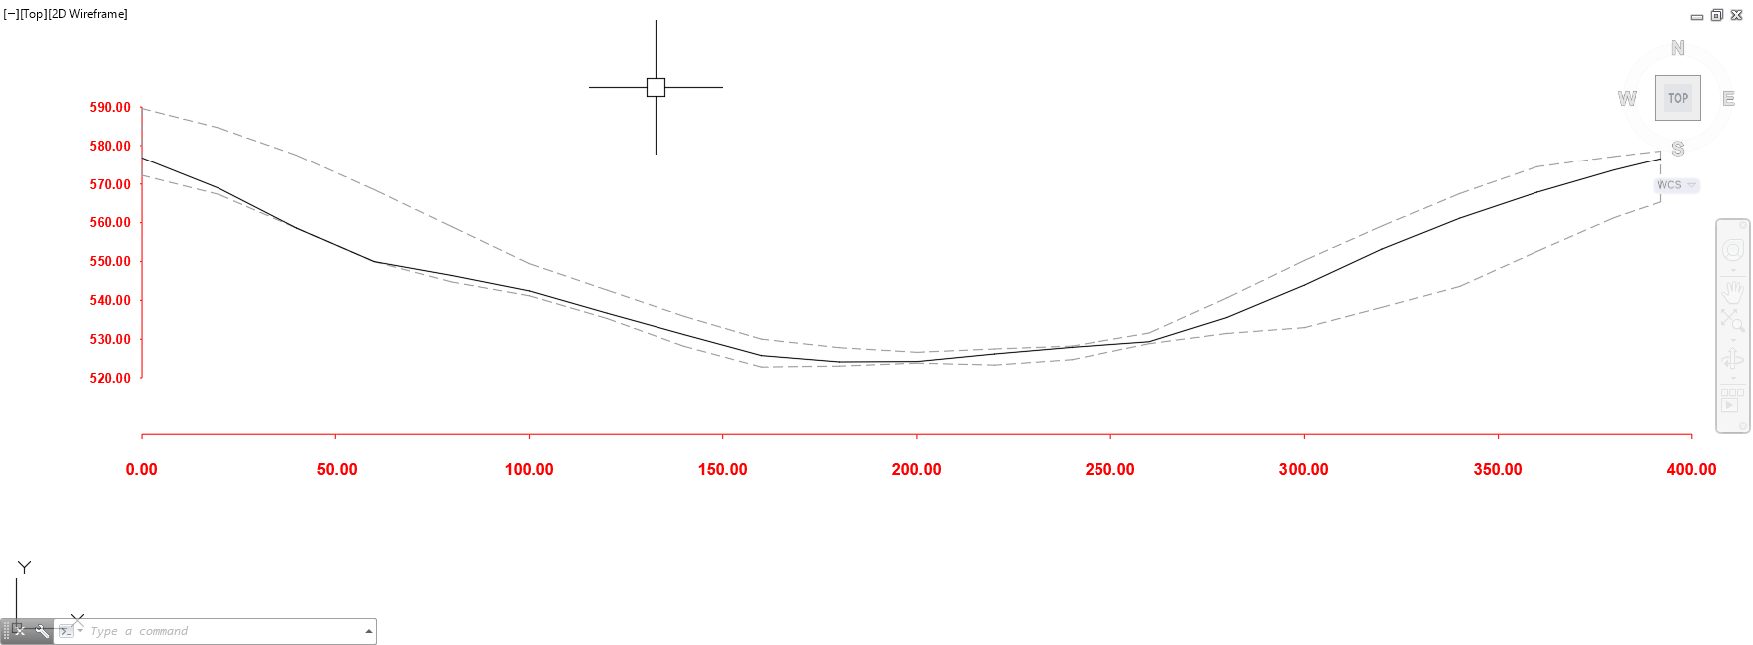

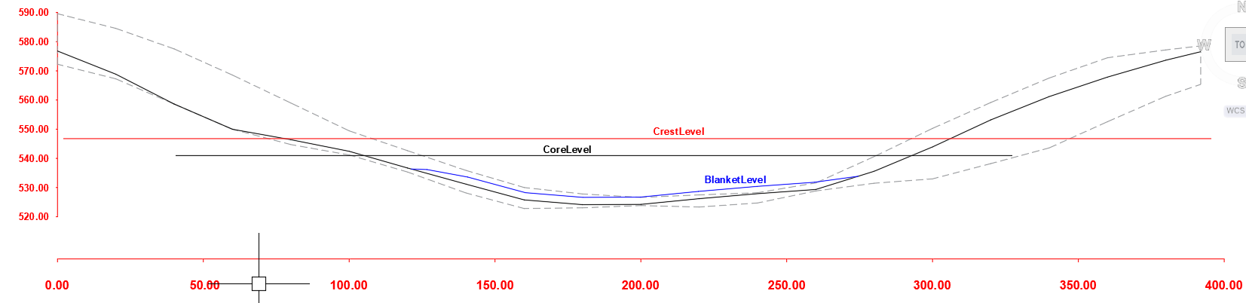

Before continuing, make sure that all design levels are referenced and appropriately tagged. Note: Do not use spaces or hyphens when tagging the design level objects. Use Underscores in stead of spaces or hyphens,

The creation of assemblies can now continue.

Simple assemblies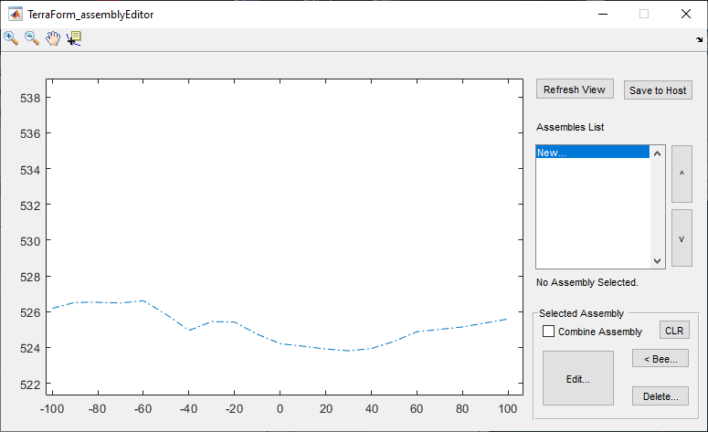

To create assemblies, first start the **Assembly Editor** from ***Workflow > Show Assembly Editor.*** This will start the interface for assembly editore.

On the Assembly List, click on **New…** this will start the dialog to pick design levels. Choose the ***Pick Level*** button, and once in AutoCAD, pick the desired design level object.

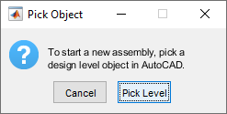

In the Variable editor dialog, enter unique informations to the desired assembly such as Tag, and earth shape. The Design Level name value is set to the tag provided to the object in AutoCAD and can not be changed.

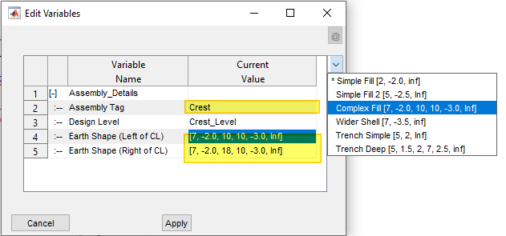

When done, hit **Apply.** The assembly is created with the provided details. Once created, use the provided tool buttons to edit the informaitons, or delete the assembly.

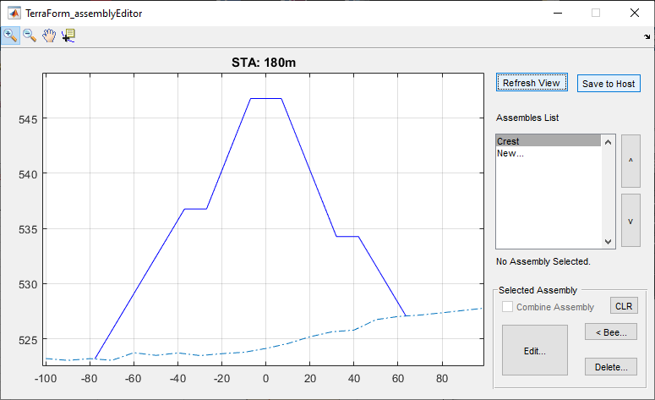

Note: It may be required to use **Save to Host,** then **Workflow > Reload Assembly** then **Refresh View** to update contents and display of assembly.

Other assemblies can also be created using a similar set of steps. The two additional assemblies for the core and blanket levels are shown here..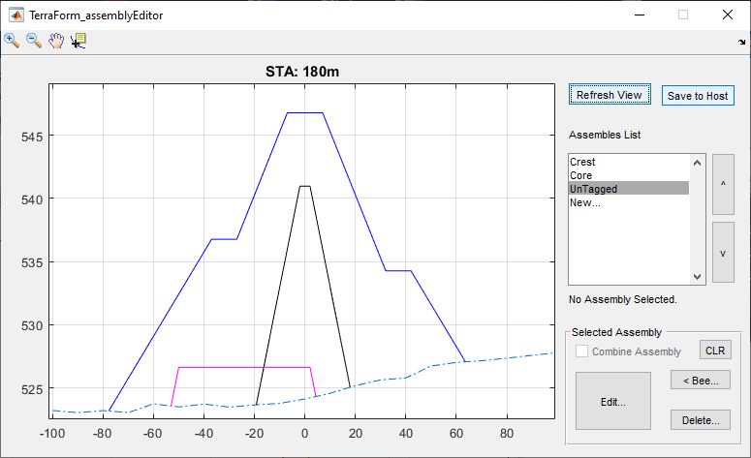

To review edit any of the assemblies, select it from the list. This will highlight the assembly in the graph area. Click on the **Edit** button to invoke the editor dialog, and review the settings.

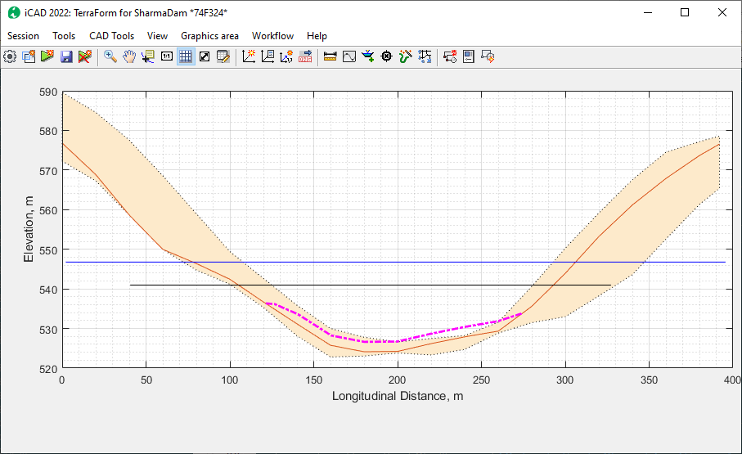

Refreshing the view in iCAD main interface now also shows the imported design levels

A dynamic view can show how the assemblies playout at different stations along the axis, by starting the **Workfllow > Cross-Section** menu command.

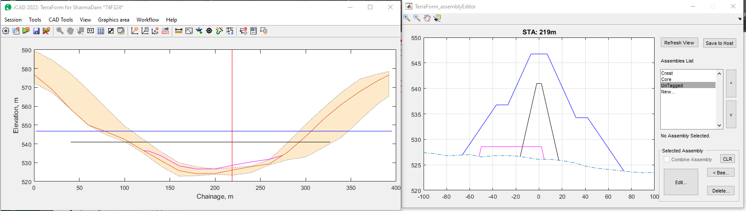

## Compound assemblies

Assemblies can be bound together to create a combined enclosed area to represent one material. In the above example, the Core and Blanket assemblies can be bound together to represent the impervious fill material.

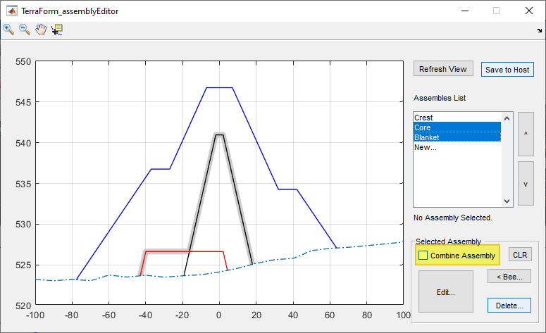

To combine assemblies, select the desired assemblies, and click on the ***Combine Assembly*** check box.

To remove combination informaiton from source assemblies, select the assemblies one at a time, and hit the **CLR** button.

Use the **Save to Host** button, to save the modified assembly information as needed.

# Creating views

Now that we have assemblies ready, generating views is possible. The views can help in further building the assemblies to be more responsive to the ground conditions as will be seen later. Here the creation of plan and section views is discussed.

## Section Views

To create cross-secional view at any point, change to default (profile) view and start **Workflow > Show-section.** An interavtive tool is created, which dynamically updates the section on the Assembly Editor window for the current station. Click any where, and the section view for that location is generated in the main iCAD interface.

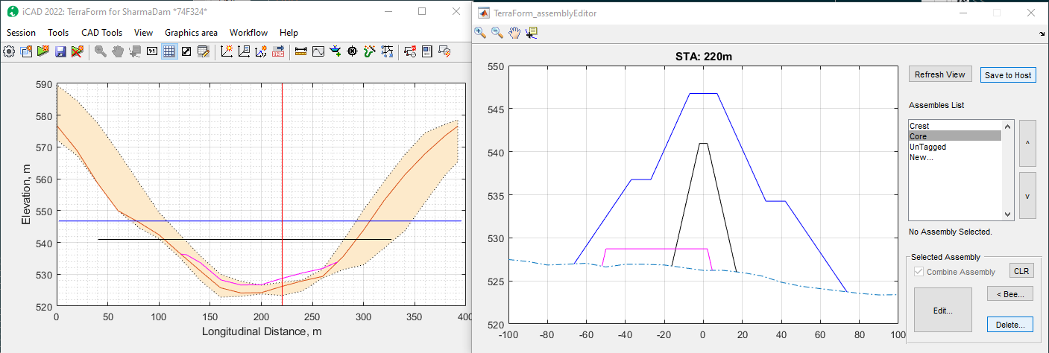

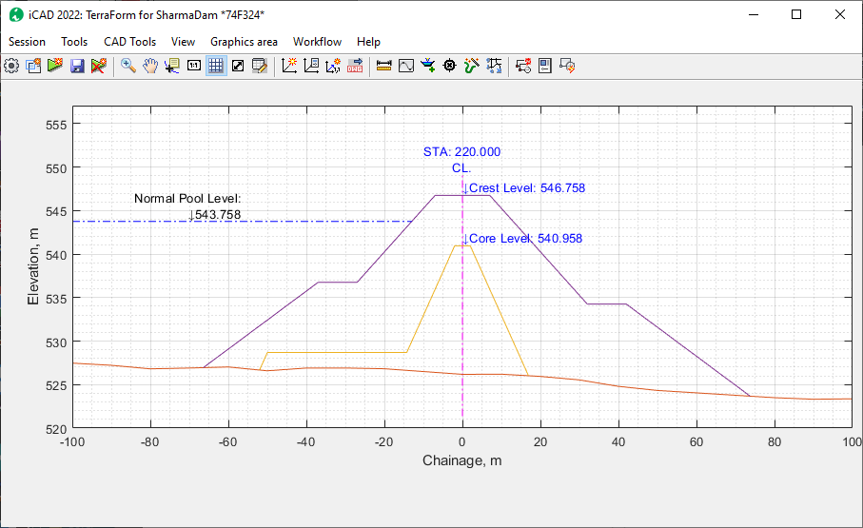

This can also be achieved by using **Workflow > Go To** menu command. Insert the required station on the **Input STA** dialog.

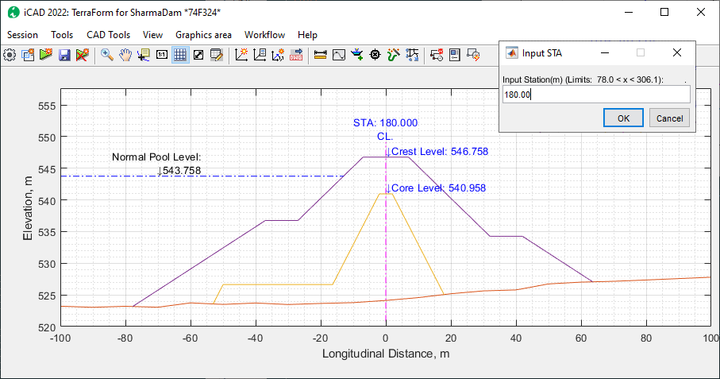

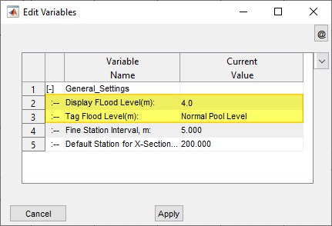

Note: The normal pool level information is a label only informaiton. It enhances display and visualization. The label text and elevation can be adjusted from **Workflow > Variable Editor.** To supress this label, set the *Display Flood Level* variable to 0.0.

# Calculating Fill Work Estimates

Once assemblies are defined, volumes of work involved for each area between assemblies can be done from the Calculate Volumes menu command.

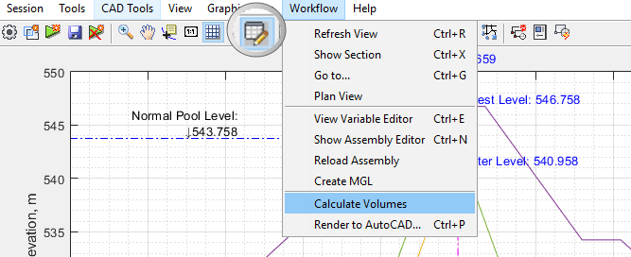

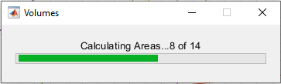

The results of calculation are sent to the Data Table. If not visible, you can toggle the visibility of this table from the toolbar menu (See above)

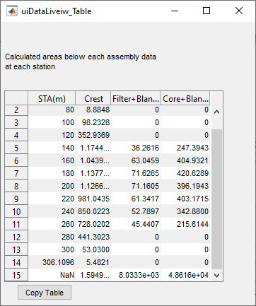

The last row of the table shows cumulative volumes based on the area and stations for each calculation. Note: Each volume is worked out as the net amount corresponding to each assembly (single or combined),

The table data can be copied for further documentation, or processing using the Copy Table button.

# Assemblies with Traced (Bees):

Tracer assemblies are assemblies with additional geometric constraints defined. The constraints are defined using an AutoCAD object representing a plan view of the desired constraint. The constraint represents the extent to which b (in b,m,h triplet) extends at any given station.

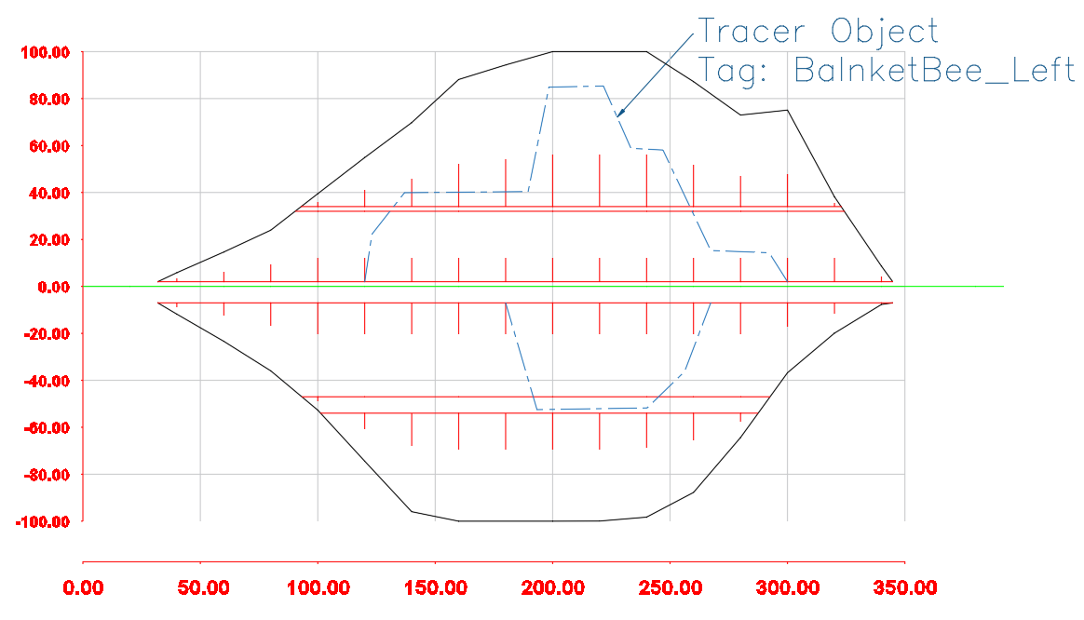

Fig: Plan view of a fill work with schematic of tracer objects or lines.

This can be applied to any assembly section to dynamically transform how the assembly changes shape along the stations.

Note: All tracer lines must be drawn to scale, referenced to a valid axis pair, and properly Tagged.

To add a tracer line to an assembly:

1. Select the assembly from the list box.
2. Click on the <Bee button. AutoCAD will be in select mode, prompting *Pick a Tracer Objects:*
3. Upon selection, the geometry of the selected object is applied to the assembly. Choose the Edit button, and you will notice that the selected object is included in the last row.

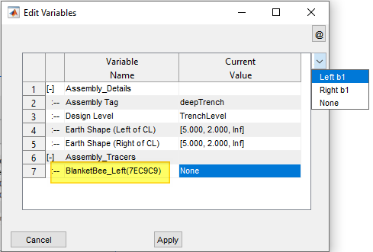

To complete the definition, choose how it is to be applied (either to the left or right side of the assembly, defined in rows 4 or 5 above).

Cross-section views from the main interface now show the assembly dynamically changing size and shape as the cross-section line is moved along various stations.

# Modified Ground Levels Processing