TASK - 1
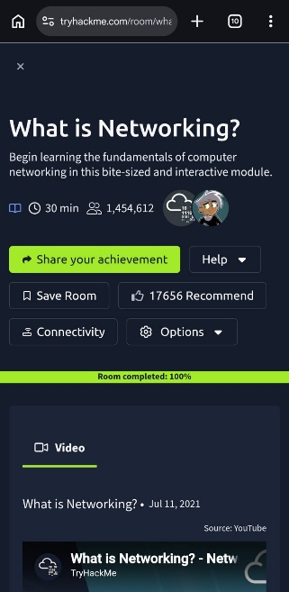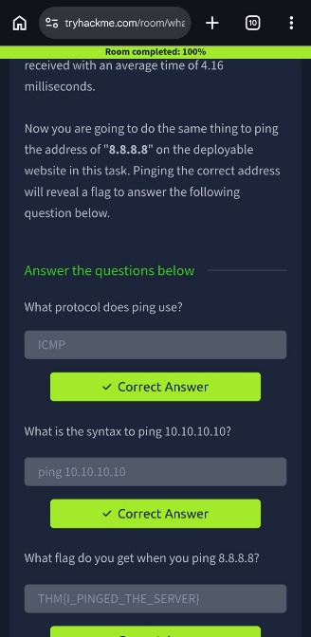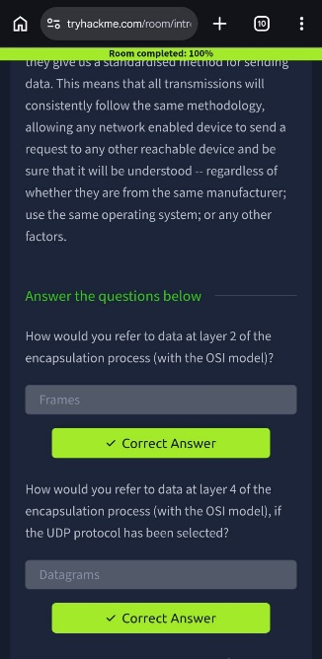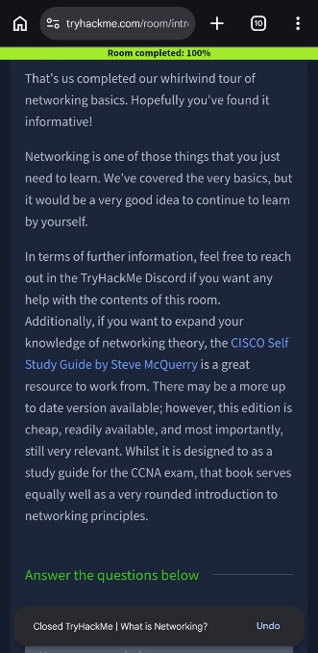
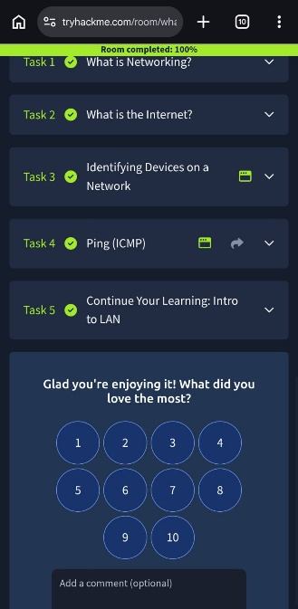

TASK – 1

First of all, Just like every beginning we start off with “What is networking?”. Which obviously a basic and necessary for cyber security domain with some test which tests how you find your knowledge while learning in this room, and the questions were just like comprehension type with clues and no of characters present which were easy to crack.
In the task-1 of this room:
This task directs you, the recap of what you have studied in class 12 networking and basic knowledge and what usually happens in networking.
In task-2 of this room:
This task is basically all about “What is internet?” this task teaches about the internet and safety protocols of a network with examples and diagrams.
In task-3 of this room:
This task enlighten people with the fundamental knowledge of ‘how
network addresses work’, like IP and MAC addresses and types of IP address and about Ipv4 and Ipv6 addresses with basic interactive lab grasp.
In task-4 of this room:
This task teach how to ping IP address which is the very first step of ethical hacking to receive the information about the trasmissions of packets.
In task-5 of this room:
This task just to confirm that you have finished the previous 4 tasks but this redirects you to more rooms where you learn more about networking very minutely with many types of rooms like this.

What I learned??
Now its time to express what I have leart from this, Actually I have already learned these things in my past, but many terms were missed out by me, which just educated me with more depth, easy to remember and briefly, and as I learned some stuff already, they refreshed my mind by making me remembering these syllabus and was very grateful to gain more knowledge which were skipped previously.

TASK - 2
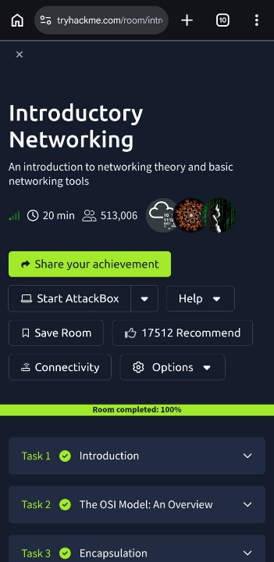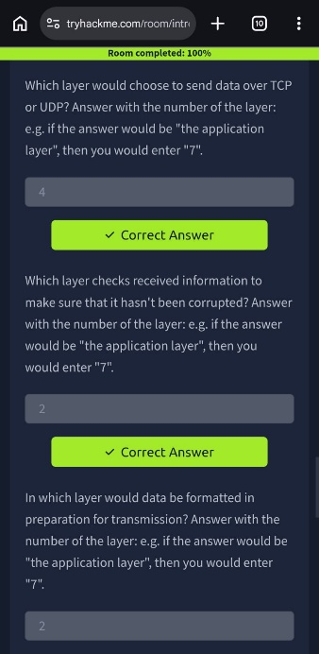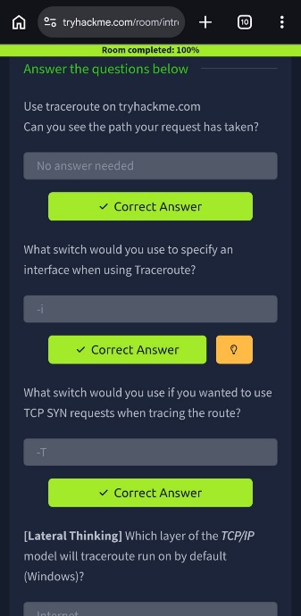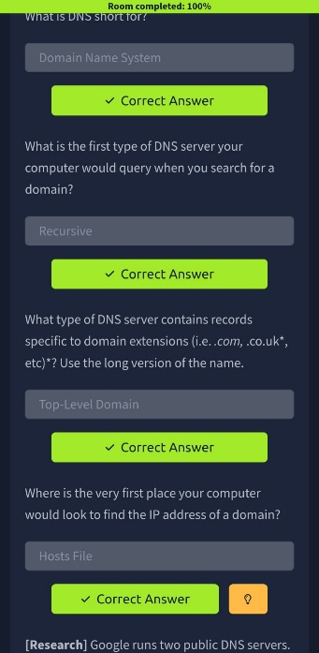
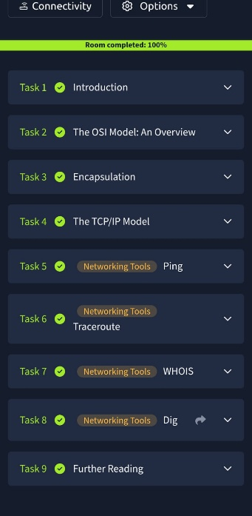

TASK – 2
The TryHackMe Introduction to Networking room provides beginners with a basic understanding of computer networks and common networking tools. The room is completed step by step through explanations, examples, practical commands, and questions.
1. Introduction:
The room begins with an overview of networking and explains how computers communicate with each other over networks.
2. OSI Model:
The learner studies the seven layers of the OSI model: Physical, Data Link, Network, Transport, Session, Presentation, and Application. Each layer has a specific role in network communication.
3. Encapsulation:
The room explains how data is prepared for transmission. As data moves through the networking layers, headers and other information are added. The process is generally represented as Data → Segment/Datagram → Packet → Frame → Bits.
4. TCP/IP Model:
The learner is introduced to the TCP/IP model and its four layers: Application, Transport, Internet, and Network Interface. The relationship between the OSI and TCP/IP models is also explained.
5. TCP and the Three-Way Handshake:
The room explains how TCP establishes a reliable connection using the three-way handshake: SYN → SYN/ACK → ACK. This allows two devices to establish a connection before exchanging data.
6. Ping:
The learner uses the ping command to test connectivity between devices. It uses ICMP and can provide information about whether a destination is reachable and its response time.
7. Traceroute:
The traceroute command is introduced to identify the network hops taken by packets while travelling from one computer to another. The learner examines the output and different command options.
8. WHOIS:
The learner uses the whois command to obtain publicly available information about domain names, such as registration details and name servers.
9. DNS:
The room explains the Domain Name System (DNS), which translates human-readable domain names into IP addresses. The learner studies DNS servers, DNS hierarchy, caching, and common DNS records.
10. Dig:
The dig command is used to perform DNS queries manually. The learner examines DNS responses, including the answer section and TTL values.

What I learned ??
Through this TryHackMe room, I learned the fundamentals of computer networking, including the OSI and TCP/IP models, data encapsulation, TCP communication, DNS, and basic networking commands such as ping, traceroute, whois, and dig. This helped me understand how devices communicate over networks and provided a strong foundation for further learning in cybersecurity and network security.

