The CIA Triad is a fundamental model in cybersecurity. It consists of Confidentiality, Integrity, and Availability. Together, these principles help protect information and systems from unauthorized access, unauthorized changes, and disruption.
I’ll also cover Authentication vs. Authorization and Threat vs. Vulnerability vs. Risk.
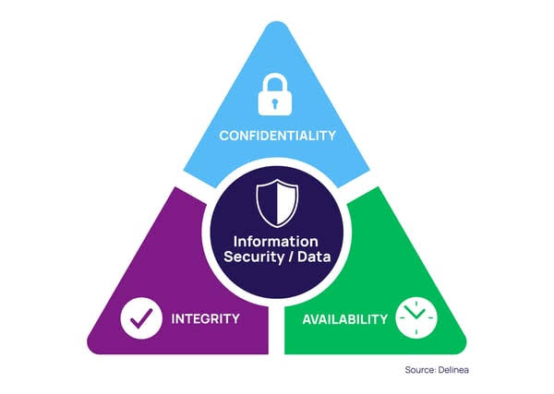

1. Confidentiality
Confidentiality means ensuring that information is accessible only to authorized people or systems.
Real-world scenario: Online banking
Imagine you use an online banking application. You log in and can see your account balance, transaction history, and personal information.
Suppose an attacker obtains your login credentials through phishing and logs into your account. The attacker can now see your balance and transaction history even though they are not authorized to access them.
In this situation, confidentiality has been violated because private financial information has been exposed to an unauthorized person.
Banks protect confidentiality using mechanisms such as:
- Passwords and multi-factor authentication
- Encryption
- Access controls
- Session management
Key point: Confidentiality is about preventing unauthorized disclosure of information.
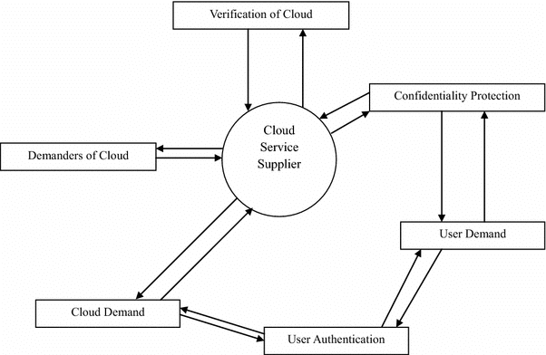

2. Integrity
Integrity means ensuring that information remains accurate, complete, and protected from unauthorized modification.
Real-world scenario: School examination results
Imagine a school's examination database contains the marks of every student. A student has scored 65 marks in a subject.
If someone gains unauthorized access to the database and changes the student's marks from 65 to 95, the information is no longer accurate.
Even though the database is still available and the student's information may still be private, its integrity has been compromised because the original information was changed without authorization.
Organizations protect integrity using:
- Access controls
- Hashing
- Digital signatures
- Audit logs
- Database permissions
- File integrity monitoring
Key point: Integrity is about preventing unauthorized or accidental modification of data.
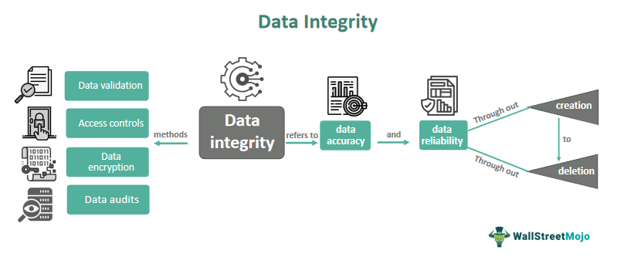

3. Availability
Availability means ensuring that authorized users can access systems and information when they need them.
Real-world scenario: Hospital system
Imagine a hospital uses an online system to access patient records. Doctors need this system to check medical history, allergies, and current treatments.
Now suppose an attacker launches a Distributed Denial-of-Service (DDoS) attack against the hospital's servers. The servers receive enormous amounts of malicious traffic and become unavailable.
Doctors may still have permission to access the records, and the records may not have been modified or leaked. However, they cannot access them when needed.
Therefore, availability has been compromised.
Organizations improve availability through:
- Backups
- Redundant servers
- Load balancing
- DDoS protection
- Disaster recovery plans
- Failover systems
Key point: Availability ensures that systems and data are accessible when required.
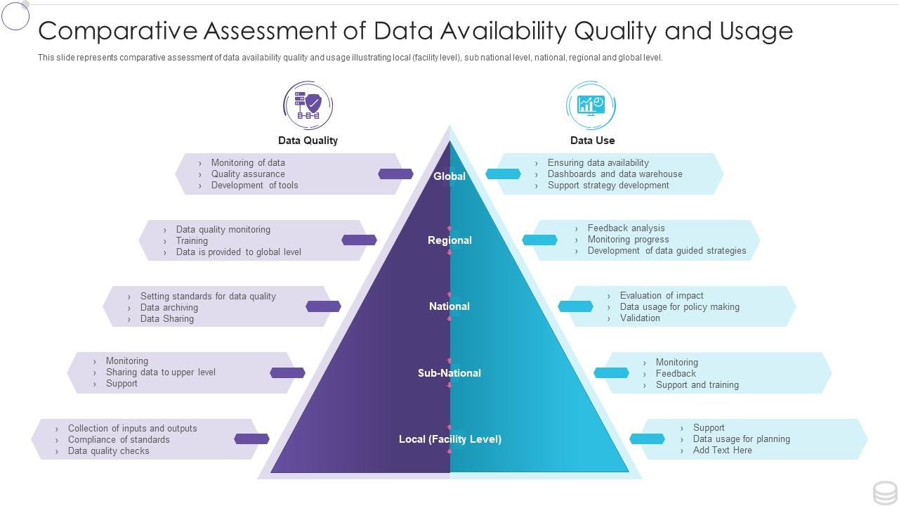

4. Authentication vs. Authorization
These two concepts are closely related but have different purposes.
Authentication
Authentication asks: "Who are you?"
It verifies a user's identity.
Examples:
- Password
- Fingerprint
- Face recognition
- Security key
- One-time password (OTP)
Authorization
Authorization asks: "What are you allowed to do?"
After a user is authenticated, the system determines what resources or actions that user is permitted to access.
Real-world scenario: Company file server
Suppose an employee named Rahul logs into a company's internal file server using his username, password, and MFA.
The system verifies that Rahul really is Rahul.
That is authentication.
However, Rahul works in the marketing department, so he is allowed to access the Marketing folder but not the Finance folder.
Determining which folders Rahul can access is authorization.
If an attacker somehow obtains Rahul's password and successfully logs in as him, authentication has been compromised.
If Rahul can log in legitimately but the system incorrectly gives him access to confidential Finance documents, authorization has been incorrectly implemented.
Simple distinction:
Authentication = Who are you?
Authorization = What are you allowed to access/do?
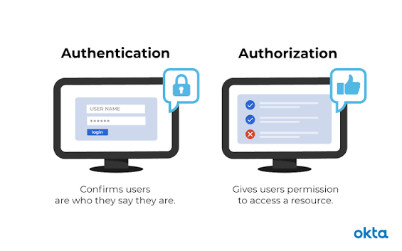
5. Threat vs. Vulnerability vs. Risk
These three terms describe different parts of a security problem.
Threat
A threat is something that has the potential to cause harm.
Examples:
- Hacker
- Malware
- Insider
- Natural disaster
- Phishing attack
Vulnerability
A vulnerability is a weakness that can be exploited.
Examples:
- Outdated software
- Weak password
- Misconfigured server
- Unpatched security flaw
Risk
Risk is the potential for a threat to exploit a vulnerability and cause damage.
A simple way to think about it is:
Threat + Vulnerability → Potential Risk
Real-world scenario: Outdated web server
Imagine a company runs an online shopping website. Its web server uses an outdated version of software containing a known security vulnerability.
The vulnerability is the unpatched software.
An attacker who knows about this weakness represents a threat.
If the attacker exploits the vulnerability and gains access to customer information, the company experiences a security incident and potentially suffers financial, legal, and reputational consequences.
The possibility and potential impact of this happening constitute the risk.
The company can reduce the risk by:
- Updating the vulnerable software.
- Monitoring the server.
- Restricting network access.
- Using security controls such as a Web Application Firewall.
- Maintaining backups and an incident-response plan.
Simple distinction:
Threat = Something that can cause harm
Vulnerability = A weakness that can be exploited
Risk = Potential loss or damage resulting from that threat exploiting the weakness
