Assignment3 for CV776

Dong Nie

In this assignment, I just follow the steps described in the instruction and implemented two functions. Here are some results after running the codes:

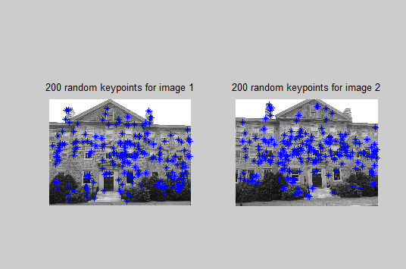

Fig.1 keypoints

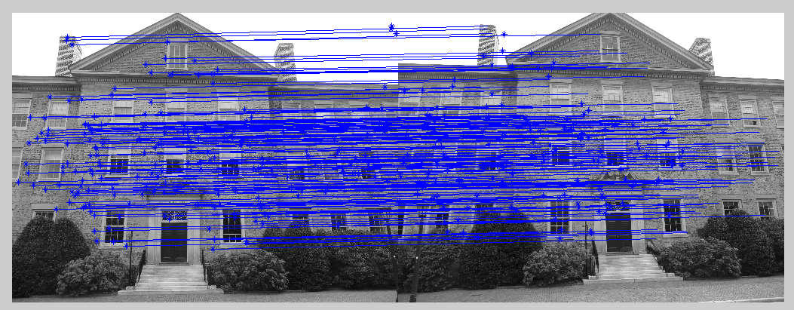

Fig.2 match

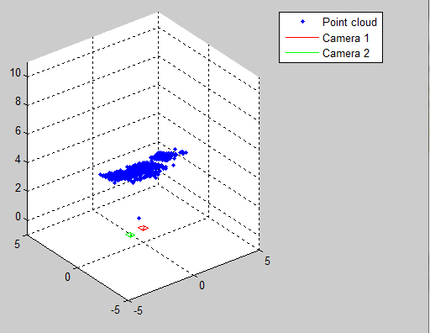

Fig.3 Cloud point