SSL Certificates

Overview

Contents
Messaging 2
Quick Pitch 2
Top-line Benefits 2
SSL Product Summaries 2
Features 3
Features Overview 3
Plans, Pricing and Features 4
Customer Experience 5
Sales Support 8
Probing Questions 8
Selling Points 8
Objection Handlers 10
Frequently Asked Questions 11
General 11

Messaging

Quick Pitch
Ensure your website is trustworthy with an SSL certificate.
Provide an extra layer of security to customers browsing your website with an SSL Certificate. Denoted by the secure icon on browsers, an SSL certificate encrypts data between your web server and browser, ensuring both your information and your customers’ remains private from interception. Apart from building trust and security for your website, SSL certificates also help improve your SEO, as search engines including Google favor website pages served over HTTPS.
Give customers confidence in your website and business with SSL.

Top-line Benefits
- Protect your customers. When customers submit their personal information to you, make sure you protect it. SSL encrypts information submitted on your website.
- Safely accept credit cards and customer info. In order to meet Payment Card Industry (PCI) compliance, websites need an SSL certificate of at least 128-bit encryption from a trusted source. Most customers will look for the https:// before visiting a website, this is even more important when they are submitting their credit card information or personal data, like providing their email in a form.
- Don’t get penalized by Google. Google marks sites without HTTPS as non-secure, and may penalize non-HTTPS negatively in their search ranking algorithm. Simply put, if your website is not secure, it will affect your online visibility.
- Increase customer confidence. Improve your brand power, giving customers confidence in your website and business.

SSL Product Summaries
- Positive SSL is a basic SSL certificate providing minimum coverage. Your website will display a static SiteSeal and a basic warranty of $10,000 will protect your business.
- Improve visitor trust with Sectigo SSL, providing SSL encryption with a dynamic site deal with your company name and validation timestamp. Your business will be protected with a $250,000 warranty.
- For websites selling online and collecting customer data, increase your online conversions with Sectigo EV SSL certificate. EV SSL displays a visible secure sign: the green browser address bar. Exclusive to EV SSL certificates, the green bar assures your site visitors that their sensitive data is transmitted by a highly secured, trustworthy domain. EV SSL provides full business validation.
- For e-commerce websites, the Premium SSL certificate is designed for securing websites carrying out high-volume, high-value transactions. Give shoppers peace of mind by validating your domain and authenticating your company. All Premium SSL certificates come with a $500,000 warranty to protect your business and your customers.
- For websites with multiple sub-domains, Sectigo Wildcard SSL saves you money and time by securing your domain and unlimited sub-domains on a single certificate. Wildcard certificates work the same way as a regular SSL Certificate, allowing you to secure the connection between your website and your customer's Internet browser – with one major advantage. Sectigo Wildcard SSL covers any and all of the sub-domains of your main domain.

Features

Features Overview
SSL Encryption | - Protect your business and you customers with 128/256 bit encryption. “Point-to-verify” technology shows real time verification of your business credentials and warranty whenever a visitor hovers the mouse cursor over the seal.
Site Seal | - Show your customers that your website is secure and employs SSL.
Warranty | - The SSL Certificate warranty covers any damages that may derive from improper issuance of a certificate to a fraudulent entity.
Pages Secured | - Your web pages secure user information from being intercepted by attackers.
99.9% Browser Capability | - Browsers are now warning visitors that a website is “unsecure” if there is no valid SSL certificate. Visitors will be discouraged to proceed to your site.  - Our SSL Certificates are recognized by 99.9% of all browsers and devices.
Mobile device compatibility | - SSL certificates are compatible with mobile devices for security on the go.
Authentication | - Trusted SSL certificates are issued by Certificate Authorities after the applicant (website owner) passes their verification procedures. There are three levels of validation:  - Domain validation: the Certificate Authority verifies only domain control rights for a particular domain name  - Organization validation: OV certificate should prove that the organization is real, with verified phone number and additional paperwork verified. SSL certificates of this type contain the company name and address by default.  - Extended validation: Besides OV requirements, an EV certificate can be applied for by a legal employee (VP, Officer, CEO, CIO) who has the authority to sign a subscriber agreement and a certificate request. EV certificates provide a green bar with the company name and the highest user trust level.

Plans, Pricing and Features
Features | Positive SSL | Sectigo SSL | Sectigo EV SSL | Premium SSL | Sectigo Wildcard SSL
Price 1 year
Price 2 year
Price 3 year
Domain Validation | ✓ | ✓ | ✓ | ✓ | ✓
SSL Encryption | 256-bit SSL Encryption | 256-bit SSL Encryption | 128/256-bit SSL Encryption | 256-bit SSL Encryption | 256-bit SSL Encryption
Express 5 Min Issuance | × | × | × | ✓ | ×
Static True Site Seal | ✓ | ✓ | ✓ | ✓ | ✓
Dynamic Site Seal (displays company name, date/time stamp) | × | × | ✓ | × | ×
Mobile Compatibility | ✓ | ✓ | ✓ | ✓ | ✓
99% browser Compatibility | ✓ | ✓ | ✓ | ✓ | ✓
Full Organization Validation | × | × | ✓ | × | ×
Warranty | $10K Warranty | $250K Warranty | $1.75M Warranty | $500k Warranty | $250k Warranty
Free Re-Issuance | ✓ | ✓ | Unlimited Re-Issuance | ✓ | ✓
Equifax Secure Certificate Authority | × | × | ✓ | × | ×
20148-bit next generation SSL Certificate (recommended by NIST) | × | × | × | ✓ | ×

Customer Experience
Once you have access to your dashboard if can see and overview of your SSL certificates and their status.
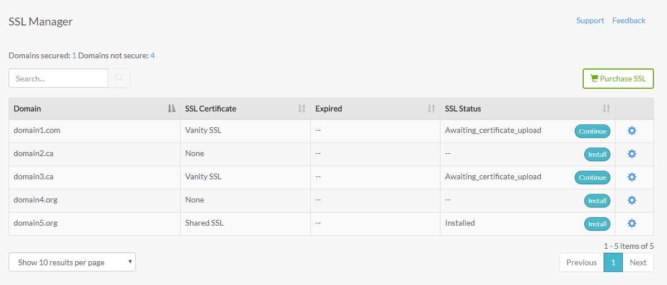

Clicking on the options wheel will show the status of your domain.
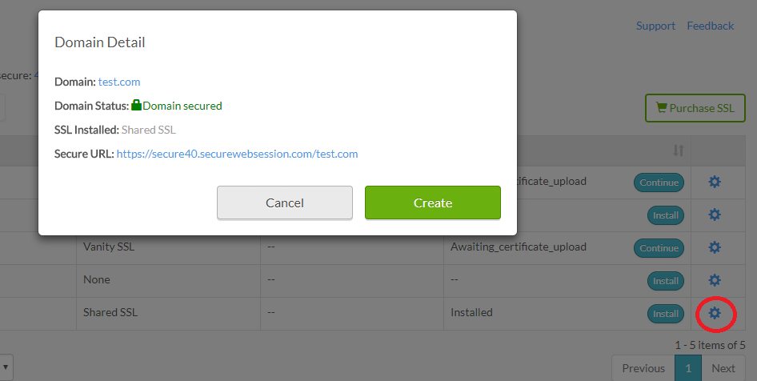

To install an SSL certificate choose install on the domain you would like to activate it on and follow the instructions.
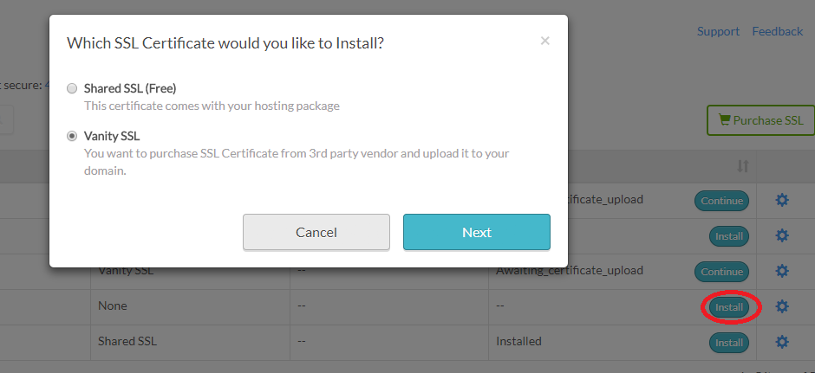
After you have chosen the certificate just follow the 5 steps and complete the set-up.
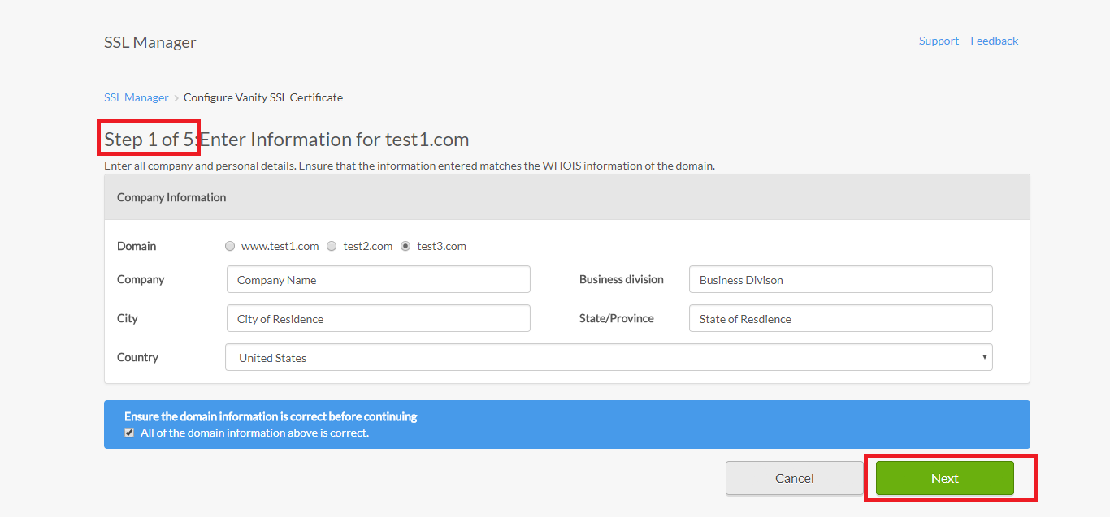

Enter your company and domain information for verification. Your information needs to match the information provided with your domain registration, to verify against WHOIS data.
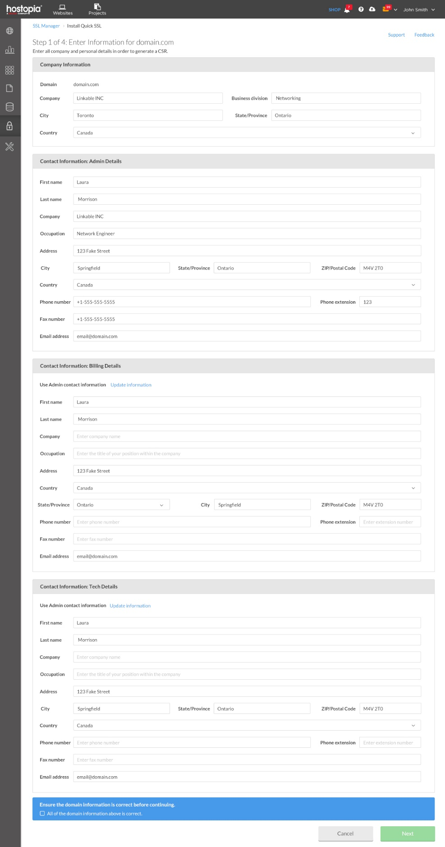

Sales Support

Probing Questions
Do you have an SSL certificate installed on your website?

Search engines like Google check whether a website is secure with SSL as an important part of their search ranking factors. Websites that have SSL are more likely to rank higher in Google, and customers are more likely to trust a website with SSL.

Adding SSL is only $XX per year.

Do you plan on selling products to your customers?

- Yes.
  - Great! You’re going to need an SSL Certificate to create a secure connection between you and your customers. You need to make sure your customers’ private information is secure and inaccessible to outside threats.

Selling Points
Secure browsing. Browsers will often provide a warning if a website is “unsecure” (without an SSL Certificate). This often discourages customers from proceeding to the website.

Improve your SEO. Having a website that has HTTPS:// will help your search engine ranking. Having a secure website will help you rank higher than non-secure websites.

Create trust. An SSL Certificate creates a trust chain for the users. If a customer sees a warning against a website they will no longer trust that business. A SSL Certificate ensures the trust is there.

Why should I choose this SSL offering?
- You can manage your SSL certificate(s) with the same login as your other online services.
- It’s very easy to get your website SSL secured.
- It provides customers with a very high level of security for their personal data.
- Customers can feel safe using their credit cards to purchase products from your website.
- Customers are sure they are in contact with your actual website rather than a malicious version of your website made by hackers.
- SSL is required for PCI compliance.

Competitive Information
How do your SSL options compare to other website security providers in the market?
Features | Positive SSL | Sectigo SSL | Sectigo EV SSL | Premium SSL | Sectigo Wildcard SSL
Encryption | 256 bit | 256 bit | 128/256 bit | 256 bit | 256 bit
Issuance speed | 5 mins | 5 mins | 1-7 days | 1-3 days | 5 mins
Static SiteSeal | ✓ | × | × | × | ×
Dynamic Site Seal (displays company name, date/time stamp) | × | ✓ | ✓ | ✓ | ✓
Warranty | $10k | $250k | $1.75M | $500k | $250k
Validation type | Domain | Domain | Full Organization | Domain and Company | Domain
Browser Compatibility | 99% | 99% | 99% | 99% | 99%
Notes | Free re-issuance | Free re-issuance | Unlimited re-issuance | Unlimited re-issuance | Free re-issuance
Thwate | SSL 123 | SSL Web Server | SSL Web Server EV | SSL Web Server Wildcard | SSL 123 Wildcard
Encryption | up to 256 bit | up to 256 bit | up to 256 bit | up to 256 bit | up to 256 bit
Issuance speed | Minutes | One day | 1-3 days | One Day | Minutes
SiteSeal | ✓ | ✓ | ✓ | ✓ | ✓
Warranty | $500k | $1.25M | $1.5M | $1.25M | $500k
Validation type | Domain | Organization | Full Organization | Domain | Domain
Browser Compatibility | 99% | 99% | 99% | 99% | 99%
Notes 1/2 yr $ | $149 | $218 | $344 | $688 | $745
GoDaddy | DV SSL | OV SLL | EV SSL
Encryption | up to 256 bit | up to 256 bit | up to 256 bit | N/A | N/A
Issuance speed | Not listed | Not listed | Not listed | N/A | N/A
SiteSeal | Yes/McAfee | Yes/McAfee | Yes/McAfee | N/A | N/A
Warranty | $100k | $250k | $1M | N/A | N/A
Validation type | Domain | Organization | Full Organization | N/A | N/A
Browser Compatibility | "Compatible with all major browsers" | "Compatible with all major browsers" | "Compatible with all major browsers" | N/A | N/A
Notes | $63.99, renews at $79.99 | $135.99, renews at $169.99 | $124.99, renews at $249.99 | N/A | N/A
GlobalSign | DomainSSL | OrganizationSSL | ExtendedSSL | Multi-Domain | Wildcard SSL
Encryption | 256 bit | 256 bit | 256 bit | 256 bit | 256 bit
Issuance speed | 5 mins | 1-2 business days | 3-4 business days | 5min/1-2/3-4 days | 5min/2-3 days
SiteSeal | Yes | Yes | Yes | Yes | Yes
Warranty | $10k | $1.25M | $1.5M | $10k/1.25M/1.5M | $10k/$1.25M
Validation type | Domain | Organization | Full Organization | Dom/Org/Full | Domain/Org
Browser Compatibility | "Universal Support" | "Universal Support" | "Universal Support" | "Universal Support" | "Universal Support"
Notes 1yr | $249 | $349 | $599 | Option for all three types | Domain/Org WildCard

Objection Handlers
I don’t need SSL – I don’t sell online.
Actually, today it’s important that all websites are secured with SSL. Some browsers provide a warning if a website is “unsecure” (without an SSL Certificate). This often discourages customers from proceeding to the website. Plus, if you don’t have SSL, it can negatively impact your search engine ranking, since it’s included as an important factor in Google’s search algorithm.
We have a basic option that will protect your business for only $XX. If you ever decide to start selling online, we can upgrade your SSL to an extended validation version.
I already have website security tools for my website.
Website security tools and SSL serve different purposes. SSL provides a secure encrypted link between the customer and your website. Web security tools are specific for your website. Even if the backend of your website is secure and free from malware and exploits the connection between you and your customer can be intercepted and exploited.
I don’t know how to add an SSL certificate to my website.
It’s simple and easy! There is no coding required and no maintenance is required until you have to renew your certificate. When you purchase an SSL certificate, you will be able to verify your business through the SSL Manager application in your website dashboard. Follow the installation wizard to set up your SSL Certificate.

Frequently Asked Questions

General
What is SSL?
SSL (Secure Sockets Layer) is the standard security technology for creating an encrypted, secured link between a web server and a browser. It makes sure that all the data exchanged remains secure and private without being compromised. It is an industry standard used by millions of website for online browsing and transaction to make sure that the data of the customer is secure.

Will SSL impact website performance?
It may, very slightly. Although SSL can add a few millisecond delay to the full loading of the website the level of security provided far outweighs the negligible slowdown.

How do I install an SSL certificate?
Follow your instructions to launch SSL Manager. Choose the website you would like to apply from SSL Manager and the certificate and follow the five steps and fill out all the required information. After that, you can see the status of your website’s SSL certificates in your SSL Manager.

How do I install the SSL seal?
Simply include the JavaScript code that Sectigo SSL provides in the footer area of your website.

What does the Warranty actually mean?
The relying party warranty set forth herein (the "Relying Party Warranty") may provide an avenue of relief to individuals whose reliance on the information contained in a Sectigo-issued Certificate results in a loss of money due to a fraudulent charge to their credit card by the holder of a Sectigo-issued certificate. If Sectigo was negligent in issuing a certificate that resulted in a loss to you and you meet the criteria of a Covered Person below, you may be eligible to receive reimbursement for your loss, subject to a maximum aggregate limit of the amounts stated herein for all claims related to that Certificate.

Why does the website say the SSL certificate is 'Untrusted'?
The usual cause of this is that the intermediate certificate has not been loaded.

When trying to go to the site over HTTPS it displays the message 'The page cannot be displayed'?
Usually caused by port 443 not allowed through firewall or by the SSL Certificate not having a corresponding key file.

Why do you ask for documentation when I apply for a certificate?
Before issuing a certificate, it is validated both that the applicant owns or has legal right to use the domain name featured in the application and secondly that the applicant is a legitimate and legally accountable entity. To do this we need to have access to documentation which verifies these two factors.

