**Procedure for Angular 2.0 Framework environment setup**

**Angular 2 Features :**

Angular2 with Angular-cli Toolset includes the following

* **TypeScript**.
* **Jasmine** Unit Test Case.
* **Angular2** library.
* Lint (TypeScript).
* Webpack.
* **Karma** Test Runner with **Code Coverage**.
* **Protractor E2E Testing** with in-build **Selenium Web Drivers**.

**Installation Procedure :**

1. **Prerequisite : Install Node.js and npm**

If Node.js and npm aren't already on your machine, install them. Angular 2.0 require node **v5.x.x** or higher and npm **3.x.x** or higher. To check which version you are using, run node -v and npm -v in a terminal window.

1. **Extraction of npm node modules**

As we are in an restricted access environment, we can’t be able to do npm install each time so the project zip file should be used as a base code and new projects should be derived from it.

Extract the npm - node modules available in wiki link : <http://aries.vzbi.com/wiki/software/AngularJS/npm.7z> .

Replace the node modules which is available in “C:\program files\nodejs” by using the above extracted files.(OR) Rename the exitsting node_modules in “C:\program files\nodejs” to a different name and use the extracted node_modules instead.

1. **Prototype Project for testing**

Wiki Link for Angular 2.0 project generated using angular – cli : <http://aries.vzbi.com/wiki/software/AngularJS/app12345.7z>

**Basic Commands to verify the successful npm node modules installation**

## Setup

$ npm install -g angular-cli – this command will not be working in local due to proxy issue.

#### Creating your angular2 app

$ ng create **<**app-name**>** [options]

#### Running your app

$ cd **<**app-folder**>**

$ ng init

$ ng serve

#### Running tests

$ ng test

#### Lint

$ npm run lint

#### Dev and Production builds

$ ng build --dev

$ ng build --prod

$ ng serve --dev

$ ng serve --prod

## Help

$ ng --help

$ ng **<**command**>** --help

**Below are some of the supportive screenshots for using the Angular cli toolset list.**

1. **To build the project and validate the bundle using webpack :**

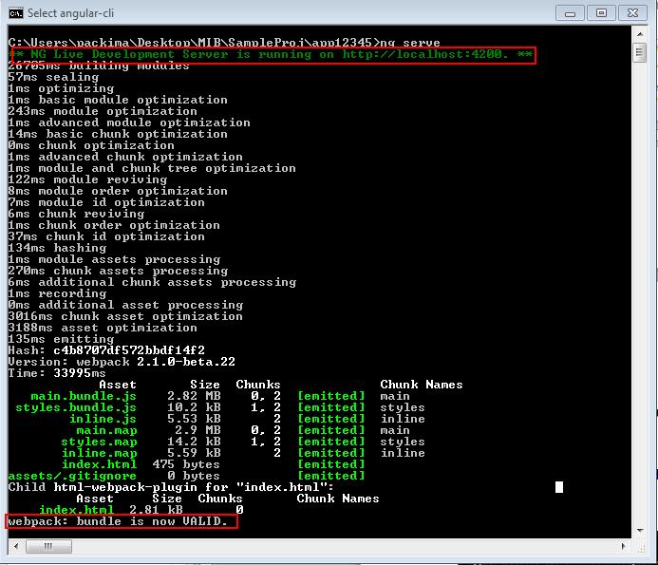

1. **Use the default port : 4200 to verify the page is loading fine.**

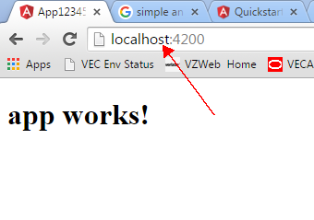

1. **Protractor E2E Testing with Selenium Web Driver Automation for Browser based testing:**

**Note : Pls use the latest version of chrome : 49.0.2623.0 for e2e testing and exclude the pree2e execution by modifying the config as -- "pre-e2e": "webdriver-manager update" in package.json**

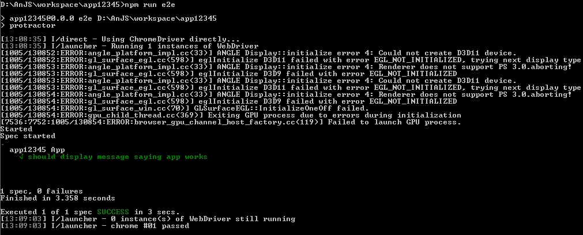

1. **Continuous Unit Testing with Karma & Jasmine:**

**m**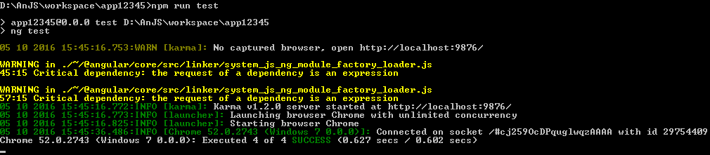

1. **Production code build, which will emit plain JS files (within ‘/dist’ folder) instead of Typescript that will work fine in all browsers.**

