Engineering Proposal Work Breakdown Structure: Integrated SysML v2 Flight System Safety Architecture
The integration of uncrewed aerial systems (UAS) and electric vertical take-off and landing (eVTOL) platforms into densely populated urban airspaces and sophisticated defense networks represents a profound shift in aerospace engineering. As commercial logistics and defense applications converge, original equipment manufacturers (OEMs) targeting global markets face a complex matrix of regulatory mandates, safety criticalities, and architectural standards. For a global dual-use (civilian and defense) drone manufacturer, the engineering pathway must navigate the rigorous requirements of top-tier regulatory bodies, including the US Federal Aviation Administration (FAA), the European Union Aviation Safety Agency (EASA), and the US Department of Defense (DoD).

The primary objective of this consulting engagement is to deliver a comprehensive, machine-readable flight system safety architecture and SysMLv2 model. This entails translating high-level regulatory frameworks—such as RTCA DO-178C, DO-254, SAE ARP4754B, and JARUS SORA v2.5—into a formal Model-Based Systems Engineering (MBSE) environment.

The ultimate output is a fully integrated SysML v2 Flight System Safety Model, mathematically verified through top-down System-Theoretic Process Analysis (STPA) and bottom-up Failure Mode, Effects, and Criticality Analysis (FMECA).

The detailed Work Breakdown Structure (WBS) is divided into six primary phases, representing a sequential progression from domain definition to model code synthesis, culminating in project governance and final delivery.

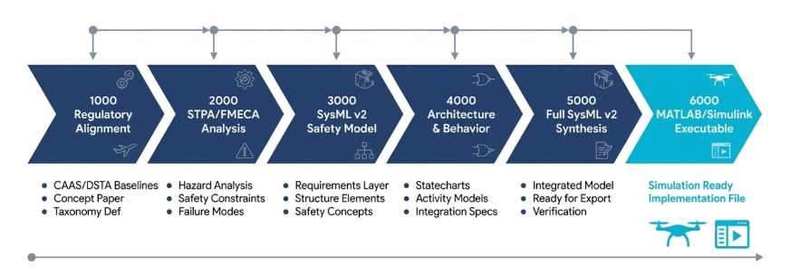

WBS 1000: Global Regulatory Architecture and Compliance Baseline
The foundation of the flight systems safety model relies on strict adherence to the governing authorities in the target global markets. For a manufacturer targeting both civilian commercial logistics and defense applications globally, the project must harmonize FAA and EASA civil aviation regulations with US DoD and NATO defense acquisition standards, ensuring that all engineering artifacts support universal flight authorization.

1.1: FAA/EASA BVLOS and U-space ConOps Matrix
Execute a regulatory cross-walk against FAA Part 108 (proposed) and EASA U-space regulations to establish the necessary System Safety Assessment (SSA) framework. Define parameters for obtaining FAA waivers for Beyond Visual Line of Sight (BVLOS) operations and EASA Specific Category authorizations for high-risk operations. Address the requirements for operations over people and moving vehicles, establishing risk mitigation strategies and kinetic energy thresholds.

1.2: US DoD & NATO Defense Standard Integration Roadmap
Formulate an integration roadmap ensuring the UAS architecture adheres to US Department of Defense (DoD) and NATO acquisition guidelines. Map the system architecture to the Sensor Open Systems Architecture (SOSA) v2.0 and the Modular Open Systems Approach (MOSA) principles to prevent vendor lock-in and enable rapid, secure sensor processing integration. Define compliance requirements for the Future Airborne Capability Environment (FACE) Technical Standard v3.1, establishing time and space-partitioned software environments.

1.3: JARUS SORA v2.5 Ground Risk and SAIL Definition Model
Develop a quantitative risk model adapting the Joint Authorities for Rulemaking on Unmanned Systems (JARUS) Specific Operations Risk Assessment (SORA) v2.5. Calculate the intrinsic Ground Risk Class (iGRC) by modeling the critical ground impact area, factoring in the aircraft's characteristic dimension, impact speed, and coefficient of restitution. Apply M1 (sheltering) and M2 (impact reduction) mitigations to define the final Specific Assurance and Integrity Level (SAIL I to VI), subsequently mapping these levels to global EASA and FAA design integrity requirements.

WBS 2000: Defense UAV Aerospace Taxonomy and Systems Integration Architecture
With the regulatory baseline established, the project defines the physical and operational boundaries of the UAS platforms. This phase generates the core structural concepts required for the Defense UAV Aerospace Taxonomy & Systems Integration Architecture.docx deliverable, transitioning abstract requirements into concrete engineering specifications.

2.1: Dual-Use Operations Taxonomy (Priority Scenarios)
Compile a catalog of top 20 civilian and defense operational scenarios dictating the avionics payload, environmental complexities, and primary bus protocols. Categorize operations into domains like: C5ISR & Persistent Surveillance; Kinetic Strike & Loitering Munitions; Electronic Warfare (EW); Tactical Cargo & Medical Evacuation; Manned-Unmanned Teaming (MUM-T); and CBRN. Define the required authoritative standards (e.g., MIL-STD-810H for environmental extremes, MIL-STD-461G for EMI control) and telemetry schemas (e.g., Cursor-on-Target XML, STANAG 4609 KLV metadata) for each scenario.

2.2: Dynamic Capacity and Airspace Corridor Optimization Model
System level model defining how the UAS will navigate cooperative Air Traffic Management (xTM) corridors and U-space frameworks.

The taxonomy produced in this phase acts as the boundary condition for the safety analysis. By explicitly defining the operational parameters—ranging from BVLOS maritime logistics to dense urban environment monitoring—the engineering team can identify the specific environmental and operational stresses the flight control system will encounter. The models further inform the safety requirements by defining the temporal and spatial constraints the UAS must navigate when communicating with ground control stations and avoiding mid-air collisions.

WBS 3000: Flight Systems Safety Concept Integration (STAMP/STPA and FMECA)
This phase represents the analytical core of the project. It merges top-down systems-thinking with bottom-up component reliability analysis, eliminating the historical disconnect between static safety assessments and system architecture. The methodology heavily leverages the Systems-Theoretic Accident Model and Processes (STAMP) and System-Theoretic Process Analysis (STPA) frameworks tailored for advanced UAS operations.

3.1: STAMP/STPA 6-Step Execution Protocol
Execute a formalized STPA based on established frameworks for UAS integration.

Step 0: Identify the case study, historical accident data, and explicitly define stakeholder roles (e.g., FAA/EASA, Vertiport Operators, Emergency Services).

Step 1: Define the purpose, System Losses, and System-Level Hazards. Step 2: Model the hierarchical control structure, mapping controllers, actuators, sensors, and the physical plant.

Step 3: Identify Unsafe Control Actions (UCAs).

Step 4: Establish Risk Priority and execute the prioritization engine. Step 5: Identify detailed Loss Scenarios and Causal Factors.

Step 6: Generate SysMLv2 Flight System Safety Model..

3.2: UCA Mathematical Formulation and Prioritization
Systematically evaluate control actions across four flaw categories: Not Provided, Provided Unsafely, Provided Too Early/Late, and Applied Too Long.
Generate formal UCAs (e.g., pitch/roll logic flaws, auto-throttle errors).
Apply a prioritization framework evaluating Pre-Mitigation Severity (PMS), Controller Impact Factor (CIF), and Expert Judgment (EJ). Generate and model targeted list of high-priority UCAs requiring mitigation.

3.3: Bottom-Up FMECA and Hardware Reliability Modeling
Conduct a quantitative bottom-up reliability analysis evaluating physical hardware component degradation, electronic single-point failures, and semiconductor soft errors.
Calculate component failure rates.
Calculate the Risk Priority Number for critical subsystems, like ARINC 429 parity bit flips, MIL-STD-1553B bus babbling, and IMU MEMS gyroscope drift.
Define mechanical mitigation strategies (e.g., Triple Modular Redundancy, SRAM scrubbing) for hardware failure modes.

3.4: Partitioned Execution and DO-178C Traceability
Model RTCA DO-178C DAL A requirements.
Establish a Bi-Directional Safety Traceability Matrix, mapping System Hazard IDs to STPA UCAs, FMECA IDs, Safety Constraint IDs, and specific test suite symbols to ensure 100% Modified Condition/Decision Coverage (MC/DC).
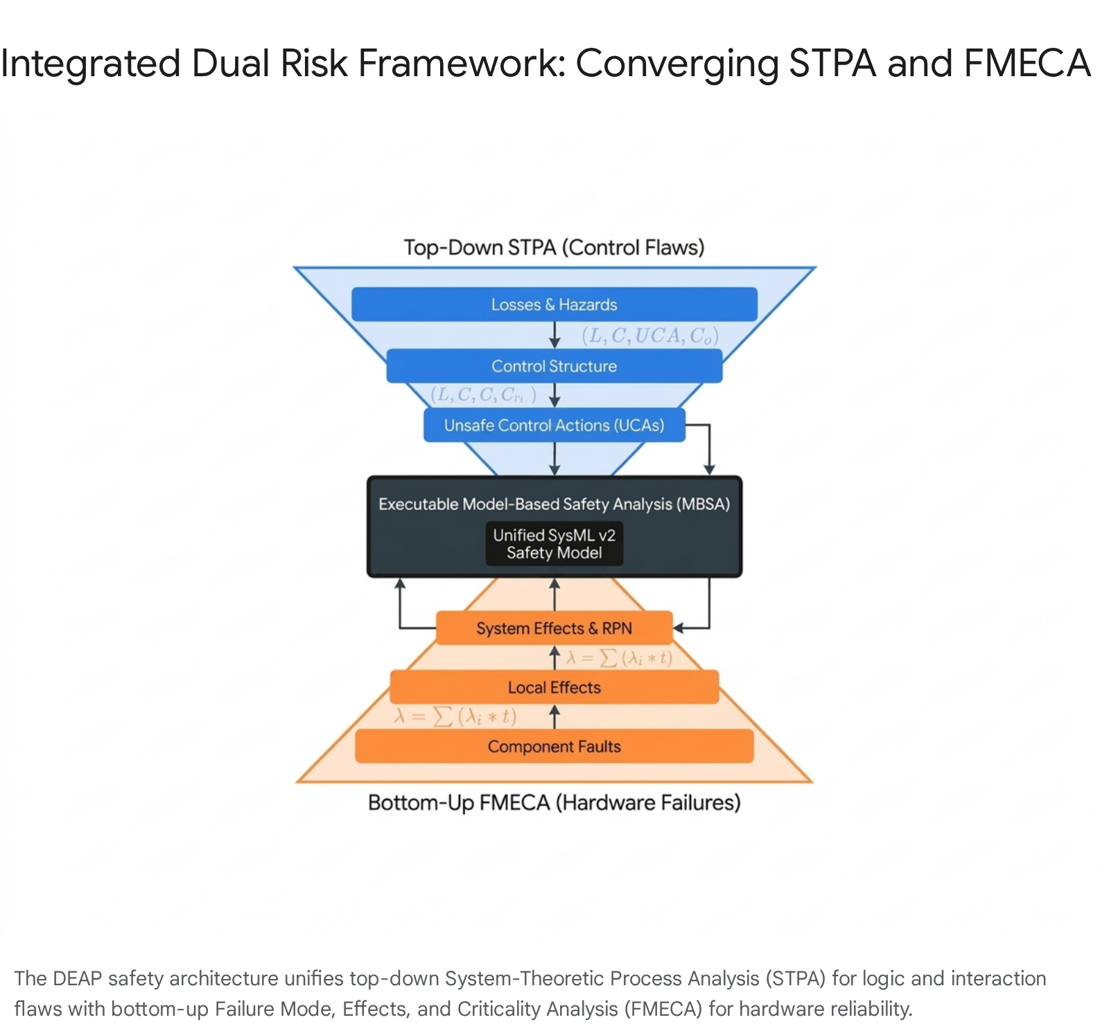
The concurrent execution of FMECA ensures that the physical realities of aerospace hardware—such as Single-Event Upsets (SEU) from cosmic radiation in SRAM or pitot tube icing—are quantitatively assessed and mitigated through hardware redundancy. This dual-risk framework provides the empirical and logical foundation required for the subsequent modeling phases.

WBS 4000: SysML v2 Textual Safety Model Specification
Translating the conceptual safety framework into a machine-readable architecture is achieved in Phase 4. This phase produces the Safety Model Specification document, detailing the structural syntax for the SysML v2 textual representation. The goal is to evolve from heavy, graphical XML Metadata Interchange (XMI) models toward version-controlled, declarative textual models that serve as a Single Source of Truth (SSOT) using SysMLv2 across the full tool chain.

4.1: Regulatory and Context Packages Specification
Define the syntactical blueprints for embedding certification targets and top-level safety definitions within the SysML v2 ecosystem. Specify the Certification_Requirements package, establishing requirement def constructs for DO-178C DAL A-E, DO-254 hardware targets, and JARUS SORA v2.5 SAIL targets. Specify the System_Losses_And_Hazards package, translating the ARP4761 losses and hazards into SysML requirement def objects with embedded severity and probability attributes.

4.2: Domain Architecture and State Space Specification
Formulate the syntactical blueprints defining the physical and digital boundaries of the UAS. Specify the Aircraft_State_Space package using attribute def to formalize the continuous physical state vector, encompassing parameters like altitude, calibrated airspeed, angle of attack, engine thrust, and flight phase. Specify the Avionic_System_Parts (part def) for the primary computers and sensor suites, and Databus_Port_Definitions (port def) defining protocols for ARINC 429, MIL-STD-1553B, and C2 5G links.

4.3: STPA and FMECA SysML Package Specification
Transform the top-down and bottom-up safety analyses into formal SysML v2 requirements. Specify the STPA_Unsafe_Control_Actions package, mapping the formal UCAs to requirement def constructs, explicitly utilizing the @TriggersHazard metadata annotation to link UCAs back to system hazards. Specify the STPA_Safety_Control_Constraints package, mapping the safety control constraints using the @SafetyRealises tag to ensure traceability back to specific UCAs. Specify the FMECA_Risk_Profiles package using attribute def to capture Severity, Occurrence, Detection, and RPN metrics.

4.4: Execution and Statecharts Specification
Establish the syntactical rules for defining system behavior. Specify the Stateflow_Execution_State_Machines package, defining hierarchical state def constructs for the ARINC 653 Major Frame Schedule and the UAS Failsafe State Machine. Define a three-layer semantic chain (Avionic_Control_Structure, Safety_Statecharts, ARINC661_Display_Interfaces) to bind state models to logic and actuator interfaces. The meticulous specification of the SysML v2 textual syntax ensures that every safety artifact is inherently traceable.

WBS 5000: Executable SysML v2 Artifact Generation
With the specification document complete, Phase 5 executes the direct authoring and validation of the SysML v2 code. This phase generates the highly critical SysMLv2 model

5.1: Authored SysML v2 Core Packages
Develop the complete, human-readable, and machine-parsable .sysml source code file acting as the SSOT. Author the 14 fundamental packages defined in WBS 4000 utilizing strict SysML v2 textual syntax. Populate the file with distinct requirement definitions, part definitions, attribute definitions, port definitions, and state definitions. Ensure all cross-references correctly resolve within the package namespace, effectively creating an executable model of the aircraft's safety logic.

