Nama : Gilang Trisetya Indrawan

Kode Peserta : FSDO002ONL018

Heroku Link : <https://final-project-csharp.herokuapp.com>

Github Link : <https://github.com/ginwa123/GIC-OCBC-NISP-FINAL-PROJECT-1>

Login account

Create Account

Refresh Token

GET All payment

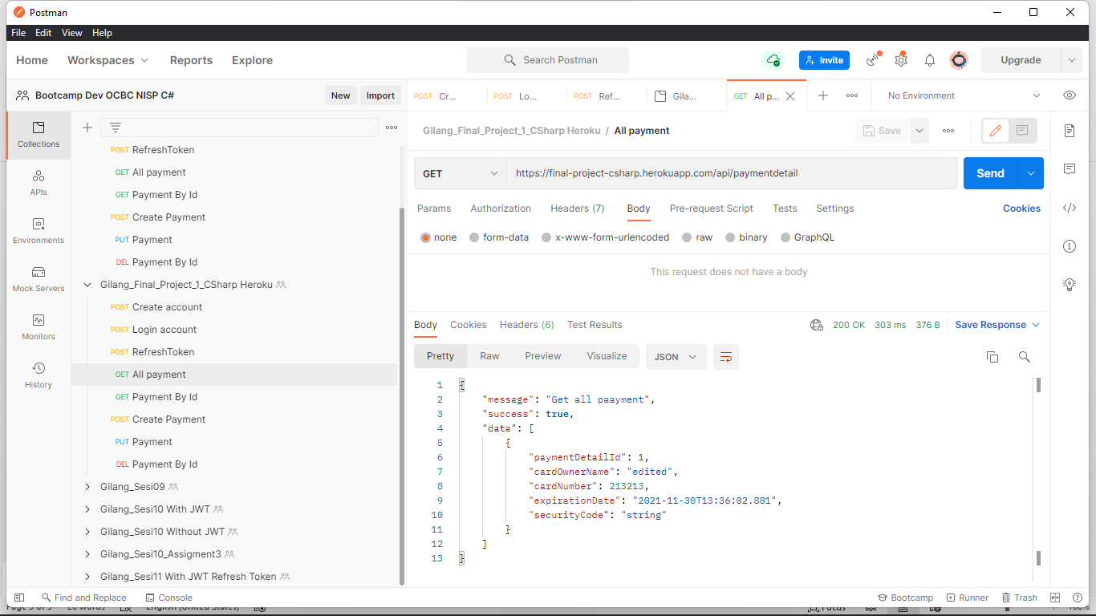

GET Payment By Id

CREATE payment

Update Payment

Data terupdate

Delete payment

Data terupdate

