Enviar notificaciones firebase por medio de servicios.

Manual:

<https://www.it-swarm.dev/es/curl/enviando-push-postman-usando-firebase-messaging/827151240/>

Video:

<https://www.youtube.com/watch?v=FmPp-JKtRmU>

Url: https://fcm.googleapis.com/fcm/send

“Content-Type”: “application/json”

“Authorization”:” key=AAAAq3xqqhI:APA91bHdKVkAh-lce8w9nv75P2kZNtcASHazvNUxbbHBBW_qOtVtibcGRDWxqh65edNvbkO7WJhFxHOBAhOWmAPiRjn12pz87kMBMJ-OJaVPvHpNsyNgq3dxKytNsaV8RYLorb6xcMye”

En el headers

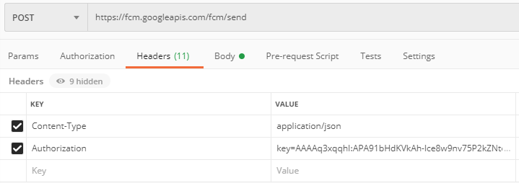

En el body

|  |
| --- |
| Solo data |
| {  "data":{  "title":"notification postman 6",  "message": "hello World"  "img_url": "https://previews.123rf.com/images/dstarky/dstarky1702/dstarky170200477/71558432-icono-de-internet-o-logotipo-en-estilo-de-l%C3%ADnea-moderna-pictograma-de-contorno-negro-de-alta-calidad-p.jpg"  },  "to": "ch_mIQ-dytA:APA91bFgWhwYPCZ_BpmeP49z4nJ72X_f6H1b0Hk5xNpYNEJdzW6neM6D7GE9plxs3j516n0EDAOsGy02ZO4LfrF7_hd0tB27vZY1X6LdhhFebNfx9orUDCD0kXhuNvkxJkYqHzWo__mB"    } |

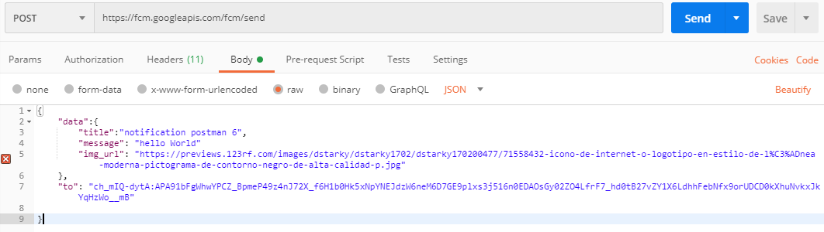

|  |
| --- |
| Solo notificationes |
| {  "to": "cpa8cZPjq-w:APA91bF122f1Rnhu9v47bL  YMajaNTHAIU5SzItDwTy9o2MCIveG0PlK78VPvp3d  CqjwnUKZ4  ngi1trSyM3_aXttW62iknFfbPGtjRLhZr6wq-3qFdboz8gzdOGPz**********",  "notification": {  "body": "Hello",  "title": "This is test message."  }  } |

|  |
| --- |
| Notificationes y data ambos |
| {  "to" : "YOUR_FCM_TOKEN_WILL_BE_HERE",  "collapse_key" : "type_a",  "notification" : {  "body" : "Body of Your Notification",  "title": "Title of Your Notification"  },  "data" : {  "body" : "Body of Your Notification in Data",  "title": "Title of Your Notification in Title",  "key_1" : "Value for key_1",  "key_2" : "Value for key_2"  }  } |