DOCUMENT MANAGEMENT SYSTEM FOR CENTRAL PHILIPPINE UNIVERSITY LOCAL AND INTERNATIONAL LINKAGES AND AFFILIATIONS CENTER WITH JACCARD SIMILARITY ALGORITHM

A Thesis
Presented to
The College of Computer Studies
Central Philippine University
Iloilo City

In Partial Fulfillment of the Requirements for the Degree of Bachelor of Science in Computer Science

By
Pañares, RJ
Lomadilla, Miles
Patricio, Chrisjane
Trono, Giovanni

CHAPTER I
INTRODUCTION
Overview of the Current State
In today’s interconnected academic landscape, educational institutions are striving to enhance their global footprint through international linkages and academic partnerships. The efficient management of such partnerships, as well as related academic documentation and recognitions, has become crucial for institutional development, ranking, and competitiveness. With increasing emphasis on internationalization, schools and universities are now transitioning from manual documentation practices to intelligent, automated systems that manage partnerships, monitor academic performance, and track award qualifications in an integrated environment.
The Local and International Linkages and Affiliations Center (LILAC) at Central Philippine University is crucial in expanding the university’s global reach and facilitating student mobility programs. It bridges CPU and various academic institutions, organizations, and industries worldwide, creating opportunities for students and faculty to engage in exchange programs, internships, and collaborative research initiatives. The center is dedicated to fostering partnerships that enhance internationalization efforts, enabling students to gain cross-cultural experiences and academic exposure beyond the university. By organizing and facilitating student exchange programs, faculty mobility, internships, and research collaborations, the center ensures that CPU remains competitive in a rapidly globalizing academic landscape.
At present, LILAC relies on manual methods such as spreadsheets and physical documents to track international student activities, academic partnerships, and other pertinent documents. Student data is currently stored in Microsoft Excel, making retrieval and filtering inefficient. If the director or secretary needs specific records, they must manually search for them or request data from other staff. Compiling reports for different college departments or administrative purposes results in inefficiencies due to the absence of a structured system.
The management of the Memorandum of Understanding (MOUs) and Memorandum of Agreement (MOAs) lacks an automated system for tracking contract expiration. There are no notifications or reminders to prompt the secretary when a contract is about to expire. As a result, renewal of contracts is often missed, leading to potential lapses in partners, and determining whether partnerships are still valid or need renewal becomes challenging. This absence of a system hinders the university’s ability to maintain strong academic collaborations.
The monitoring of academic awards is also inefficient due to the absence of a system that aligns institutional activities with award requirements. The monitoring progress for awards is done manually, making it difficult to ensure compliance with criteria and submit requirements. This often results in missed opportunities for recognition, which could enhance the university’s reputation and attract new partnerships.

Desired State of Technology
The desired state of technology for Local and International Linkages and Affiliations Center (LILAC) is a web-based Document Management System that will address the limitations of manual processing by designing a centralized platform to automate document-related tasks, ensuring accuracy, accessibility, and efficiency when managing information within the center.
The system will feature a Document Management module that allows the users to add, store, and retrieve files in a centralized platform, minimizing the risks of misplacement or duplication of documents. The Meeting Scheduler and Events and Activities modules will also be integrated to check the meetings and events in a calendar form to minimize conflicts in scheduling and provide notifications for the schedules ahead of time.
To monitor academic partnerships, the system will include a Memorandum of Understanding (MOU) and Memorandum of Agreement (MOA) module for tracking the deadlines of each contract with a notification of 6 months before the expiration. The Award Progress module will enable users to monitor compliance with award requirements by cross-matching submitted documents with specified criteria.
The Templates module will provide available forms for users, simplifying documentation preparation and standardization. After filling in these forms, they can be uploaded in the Reports module to be submitted to the Registrar Office.

Statement of the Problem
- LILAC uses spreadsheets and physical documents to track international student documents, activities, and academic partnerships, making data entry, retrieval, and filtering slow, and prone to human error.
- There is no system to track the expiration of MOUs and MOAs, leading to missed renewals and potential disruptions in partnerships.
- The lack of a system that maps CPU’s activities to potential academic awards results in missed opportunities to gain recognition, enhance the university’s reputation, and attract partners, students, and funding.
- Lack of a centralized system for tracking and monitoring events managed by LILAC.
- Generating reports for administrative purposes or different college departments requires manual data compilation, which results in delays and inefficiencies.

Objectives of the Study
General Objective
To design and implement a document management system for the Local and International Linkages and Affiliations Center (LILAC).

Specific Objectives
- Design a database repository digital platform to streamline the management of international student records, activities, and academic partnerships.
- Create a module to track the status and expiration dates of MOUs and MOAs, with automated notifications for timely renewals to maintain institutional partnerships.
- Design and develop the Award Progress tracking module using a cross-matching algorithm, which helps the university connect its international activities, programs, and achievements with academic award criteria and ensures that the university doesn’t miss any chances for recognition.
- Create an event organizer to track, monitor, and manage events held by the Local and International Linkages and Affiliations Center (LILAC).
- Create a report module that automatically gathers and organizes data from centralized records.

Conceptual Framework of the Study
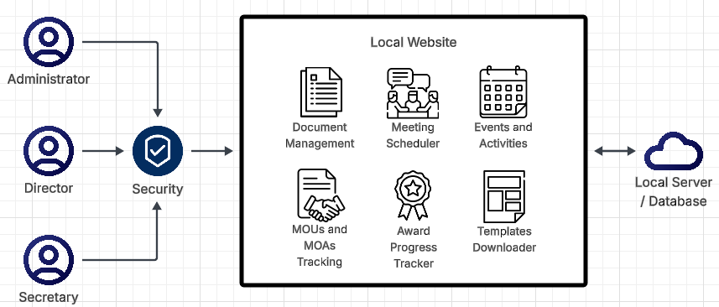
Figure 1. Conceptual Framework of the Study
Administrator
A system administrator is an information technology professional who supports a multi-user computing environment and ensures continuous, optimal performance of IT services and support systems (TechTarget, 2021).
Director / Secretary
The user of the system that is authorized to access information to perform assigned duties (NIST, 2018).
Security
Web security protects networks, servers, and computer systems from damage to or the theft of software, hardware, or data. It includes defending computer systems from misdirecting or disrupting the services they are designed to provide (Fortinet).
Local Website
A website is a collection of files accessed through a web address, covering a particular theme or subject, and managed by a particular person or organization. A local website resides locally on your computer for storage (Gartner).

Documents
A document is a computer file containing information input by a user and usually created with an application such as a Word document or a spreadsheet (Merriam-Webster).
Meetings
A meeting is an act or process of coming together, such as an assembly for a common purpose (Merriam-Webster).
Events
An event that is planned for a special purpose and usually involves a lot of people (Cambridge Dictionary).
Contracts
A contract is a binding agreement between two or more people or parties (Merriam-Webster).
Award Eligibility
Award eligibility refers to the conditions or criteria that need to be met for an award (SAP).
Templates
A template is a form, mold, or pattern used as a guide to create something consistently and efficiently. It refers to saved letters or forms that can be downloaded for future use (TechTarget).
Local Server
A local server is a computer that serves a client within the local network or LAN. That means that in most cases, it will not be connected to the internet (Aloa).

Scope and Limitations of the Study
This study focuses on developing a LAN-based system to improve the manual process of managing documents and data at LILAC of CPU. The system will automate event tracking, MOU/MOA management, and academic award qualifications.
However, the study has its limitations. The system will not handle direct communication with international partners or manage the execution of events but will focus on data organization and tracking. Additionally, access to the system will be restricted to LILAC staff and administrators, with no external user access.

Significance of the Study
Director and Secretary. The study will streamline document and data management within LILAC. By implementing this system, the staff can efficiently track and manage events and contracts, improving accuracy, reducing human error, and enhancing reporting and decision-making.
Students and Faculty. The system will indirectly benefit students and faculty by enhancing internationalization efforts. Improved management of exchange programs, internships, and academic partnerships will create more opportunities for global exposure and academic collaboration, enriching the educational experience.
University. The study will help Central Philippine University monitor active partnerships, ensuring the timely renewal of MOUs and MOAs. This will strengthen and expand academic collaborations, improving the university’s global competitiveness. Additionally, the system will reduce mismanagement risks and missed award opportunities, reinforcing CPU’s reputation as an institution committed to internationalization.

Partner Universities. The study will support partner institutions by ensuring that the contracts and activity collaborations are properly tracked and maintained. Timely renewals of MOUs and MOAs will prevent lapses in partnerships and sustain active engagements. This will promote stronger collaboration, smoother coordination of joint activities, and greater assurance that commitments are being fulfilled.

CHAPTER II
REVIEW OF RELATED LITERATURE
Document Management System
Efficiency of Electronic Document Management Systems: A Case Study
This study explores the transformation of health data management systems over the past century, emphasizing the role of technological advancements such as big data analytics and the Internet of Things (IoT). This study contributes to the existing literature by analyzing the progression of health data systems from paper-based records to digital platforms, including blockchain technology. The findings highlight the limitations of current systems and underscore the need for a secure and real-time health data management framework. The study further suggests that integrating big data analytics can enhance disease diagnosis, prognosis, and prevention strategies. These insights offer a valuable foundation for future research aimed at improving healthcare information systems and optimizing patient care. (Abaci and Medini, 2022)

The Role of the Document Management System in Optimizing Business Processes
This study examines the role of digital document management (DMS) systems in enhancing organizational flexibility, productivity, and agility. It emphasizes the importance of DMS in automating and optimizing business processes through integration with Enterprise Resource Planning (ERP) systems. The research outlines a business model for electronic document and records lifecycle management, focusing on processes such as document creation, approval, and secure distribution. The findings suggest that this approach improves organizational structure, reduces costs, and increases operational efficiency by streamlining workflows and minimizing errors. The study also highlights key DMS features such as digitization of physical documents, centralized storage, and advanced search capabilities, which contribute to improved productivity. (Orlov, 2024)
Event Tracking System
Event Tracking System Using Web APIs and Expert System: A Review
This study focuses on developing a global event management system that uses modern technologies such as Artificial Intelligence, Distributed Database Management Systems, and Web 3.0 services to address the challenges of managing increasingly complex events. The study highlights the limitations of traditional event management systems, such as spreadsheets and outdated databases. It proposes a web-based platform to automate registration, event listing, venue selection, gallery management, and crowd control tasks. The system includes separate interfaces for both administrators and participants, streamlining event planning and reducing costs. The findings suggest that such an advanced system can efficiently handle all aspects of event management, providing a unique identity for users and improving overall management efficiency. (Shrivastava et al., 2024)

Jaccard Similarity Algorithm
Implementation of the Jaccard Similarity Algorithm on Answer Type Description
This study aims to measure the similarity of the answers to the description by using alternative answers as reference answers provided by the lecturer with a view to overcoming diversity of student answers. This research focuses more on Indonesian language questions and answers by combining Jaccard similarity algorithm and keyword similarity. After combining the two, the correlation value increased, and the error decreased. (Riyanto, 2022)

CHAPTER III
METHODOLOGY
Agile methodology with RAD components organizes software development around rapid, iterative prototyping and continuous feedback loops. Rather than waiting to deliver a complete feature, our approach quickly produces working prototypes refined in successive iterations.

CHAPTER IV
DOCUMENT MANAGEMENT SYSTEM FOR CENTRAL PHILIPPINE UNIVERSITY LOCAL AND INTERNATIONAL LINKAGES AND AFFILIATIONS CENTER (LILAC) WITH JACCARD SIMILARITY ALGORITHM
System Overview
The Document Management System for Central Philippine University Local and International Linkages and Affiliation Center (LILAC) is a web-based application designed to store, retrieve, manage, and organize documents in a centralized platform. The system is designed not only to secure files but also to enhance productivity through additional features such as meeting and events scheduler, tracking of Memorandum of Understanding (MOUs) and Memorandum of Agreement (MOAs), award progress monitoring, templates downloader, and storing separate files to be passed to Registrar Office. By combining all these features, the system provides a solution for document management within the office.
The main purpose of the system is to streamline the management of documents while assisting the director and secretary in monitoring the award progress module to know whether an award is met or not. The document management feature allows users to upload, categorize, search, and retrieve files efficiently. The meeting and event scheduler provides a calendar to easily track future meetings or events managed by the center. The system also enables the tracking of MOUs and MOAs, ensuring that the partnerships are properly recorded and updated. For awards-related processes, the Award Progress Tracker monitors the percentage met in each award, while the Jaccard Similarity Algorithm analyzes uploaded documents to match it against predefined award criteria.
Other modules are included to support institutional workflow. The templates downloader provides ready-to-use document formats, making it easier for users to prepare standardized files. The registrar files module allows documents from the main platform to be stored separately so that the user can easily compile documents to be passed to the Registrar Office.

System Objectives
- Develop a document management module that allows users to upload, organize, search and retrieve files efficiently.
- Design a meeting and events scheduler so the users can plan and keep track of activities.
- Implement a tracking system for MOUs and MOAs to make sure partnerships are updated and renewed on time.
- Integrate an Award Progress Tracker using Jaccard Similarity Algorithm to crossmatch documents with award criteria and compute a percentage that reflects the extent to which the award requirements are met.
- Provide a templates downloader that allows users to access and download standardized document formats.
- Develop a registrar file management feature that routes documents from the main platform to a separate module for generating reports.

System Functions
Landing Page. It is first page that appears when users access the system through the web browser. It displays an overview of the office along with a few of its main features. There’s also a gallery section to show images of activities held by the center.

Gallery. Button link that directs users to the gallery section of the website. The gallery displays images related to the institution, providing a visual representation of important events. By clicking the button, users can browse through the available images, which are organized for easy viewing.
Log In. Button link that allows users to access the system by entering their registered username and password. The system validates the provided credentials, and upon successful authentication, they are directed to the dashboard.
Dashboard. The dashboard serves as the main page of the system after logging in. It provides an overview of key information about the whole system. From the dashboard, users can quickly navigate to different modules, view summarized data, and monitor other tasks.
Documents. The documents button directs users to the document management module of the system. Users can upload, organize, search and retrieve files efficiently.
Scheduler. The scheduler button opens the scheduling module that allows users to plan and organize meetings for important events.
Events & Activities. The events and activities button provides access to the section where upcoming and past events are recorded and displayed. Users can view details of activities, ensuring activities are properly managed and coordinated.
MOUs & MOAs. The MOUs and MOAs button allows users to access the module dedicated to tracking Memorandum of Understanding and Memorandum of Agreement. This feature ensures that partnerships are properly documented, updated, and monitored for future renewals and reference.
Awards Progress. The awards progress button opens the module that monitors award-related submissions and evaluations. It integrates the Jaccard Similarity Algorithm to match documents against award criteria and provides progress updates through percentage completion rates shown in the pie chart.
Templates. The templates button links to the section where users can access and download standardized document templates. This feature ensures consistency and efficiency in preparing documents.
Registrar Forms. The registrar forms button opens the module responsible for compiling documents that need to be sent to the registrar’s office. This feature collects and organizes all necessary files from the main platform, ensuring that they are properly prepared and submitted for official processing.

Software Specification
Front-End: HyperText Markup Language
HyperText Markup Language (HTML) is the standard markup language for creating web pages and web applications. It is used to structure the content of a web page, and to define the meaning and hierarchy of that content using a series of tags and attributes. (webreference.com)
Front-End: Cascading Style Sheets
Cascading Style Sheets (CSS) is a stylesheet language that is used to describe the presentation of a document written in a markup language, such as HTML. It is used to control the appearance of the content on a web page. (webreference.com)
Front-End: JavaScript
JavaScript (JS) is a programming language that is commonly used to add interactivity and dynamic behavior to web pages. It is used to create functions and events that can respond to user actions, such as clicking a button or submitting a form. (webreference.com)
Back-End: Hypertext Preprocessor
Hypertext Preprocessor (PHP) is particularly well-suited for building dynamic websites and web applications. It can be used in conjunction with a variety of frameworks and templates, making it easy to create complex, interactive websites. (php.net)
Integrated Development Environment: Visual Studio Code
One of the main reasons for choosing VS code is its user-friendly interface and wide range of features that make coding more efficient. It provides syntax highlighting, code suggestions, and debugging tools that help reduce errors and improve the quality of the code. (mozilla.org)
Database: My Structured Query Language
My Structured Query Language (MySQL) is utilized in this project, which was accessed through the XAMPP package. MySQL served as the backbone for storing and organizing all application data, such as user records, login information, and other system transactions. (ionos.com)

Tangible and Intangible Benefits
Tangible Benefits
Digitalize Document Management. The system provides a centralized repository where files can be securely stored, organized, and retrieved. This eliminates the need for bulky physical storage while ensuring that important records are not misplaced or lost. By improving accessibility, the director and secretary can save time on locating files and focus more on productive tasks.
Meeting and Event Management. Offers a built-in calendar and scheduling tool that allows users to set meetings, deadlines, and reminders, reducing conflicts and overlaps.
Efficient Tracking of MOUs and MOAs. Partnerships are easily monitored and updated, avoiding delays or overlooked deadlines.
Automated Award Matching. The Jaccard Similarity Algorithm provides quick results with percentage to show which award criteria are met, improving accuracy and speed of award evaluations.
Ready-to-Use Templates. The availability of downloadable templates ensures faster preparation of standardized documents.
Consolidated Registrar Reports. Documents are automatically compiled so that they can easily be retrieved when the Registrar Office needs reports.

Intangible Benefits
Enhanced Productivity. The integration of scheduling, events, and reporting allows the director and secretary to manage tasks more efficiently.
Transparency and Accountability. Tracking modules for MOUs, MOAs, and Awards Progress promote accountability and ensure that processes are properly documented.
User Convenience. A web-based application provides easy access to documents and system functions.
Consistency and Standardization. Templates and structured modules ensure that documents follow uniform formats and procedures.
Institutional Reliability. By reducing errors and delays, the system strengthens the credibility of institutional processes and record-keeping.
Sustainability Contribution. The shift to digital management supports environmentally sustainable practices by reducing reliance on paper.

Use Case Diagram
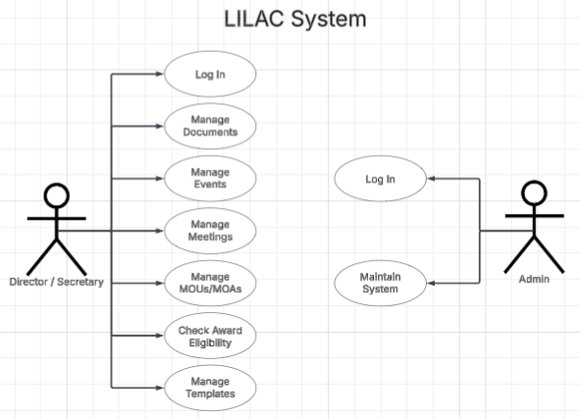
Figure 2. Use Case Diagram
Users can access the system by logging in whether as a director, secretary or administrator. After logging in, they are taken to the dashboard, which serves as the home page of the system. From here, the director and secretary can easily navigate through different modules such as Documents, Scheduler, Events & Activities, MOUs & MOAs, Award Progress, Templates, and Registrar Forms. For both users, the system provides access to all records but depending on their level of access, they can add or edit some entries, which are automatically stored in the database for safekeeping and easy access. This makes sure that records remain secured and readily available whenever needed. The administrator, on the other hand, has access to the back end of the system to maintain it properly. They can only view other data added by the director and secretary and must upload his own sample document for testing purposes only. Once the users finish their tasks, they can log out of the system and end their session.
Sequence Diagram
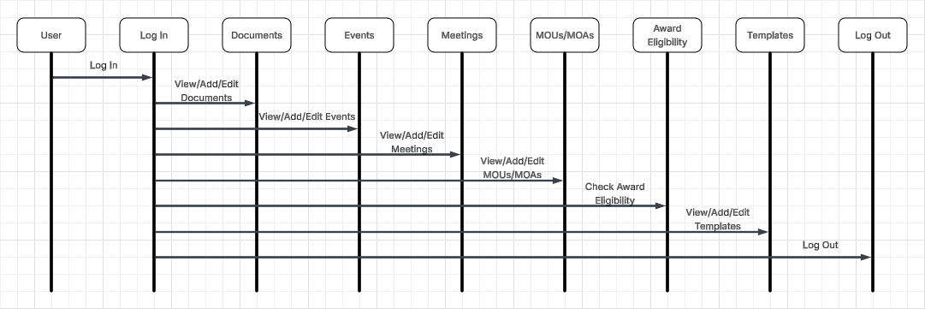
Figure 3. Sequence Diagram
The director / secretary will log in first for authorization, and they will be able to access the system. In the dashboard, the director can access all the features while the secretary has some limitations while navigating the system.

Activity Diagram
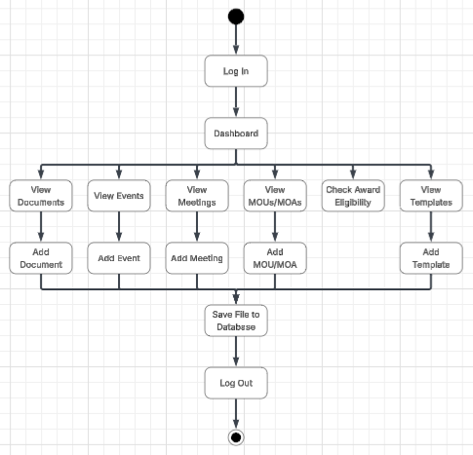
Figure 4. Activity Diagram
The user begins with the Log In process, which authenticates the users into the system. Upon successful log in, they are directed to the Dashboard, where they can navigate through several modules. The user can look at the documents, and add, edit or delete it. By adding a document, it will automatically categorize itself on where it will be stored in those several modules. The user can also look at the calendar in the scheduler where they can see their upcoming meetings. They can set up a schedule and it will notify in the notification icon if there is an upcoming meeting ahead of time. There is also a separate calendar in the events and activities module where it focuses on the programs held by the center. In the MOUs and MOAs module, the users can see the past and current partners of the university and the date when they will expire. Six months prior to the expiration of the contract, it will notify the user if they want to renew the contract. On the award progress tracker, the user will see the criteria for each award and what are the things they still need to do to achieve that criteria. On the templates module, the user can download forms to be filled up by international students and those filled up forms will be saved in the Registrar Forms tab for easy access if the Registrar will require those reports.

