Model A Progress Report
Weather x Post-MoU Interaction Analysis: Results, Diagnostics, and Interpretation
Giorgio Coppola | MDS Thesis, Hertie School | March 2025

1. Research Design
The thesis asks whether the 2017 EU-Libya Memorandum of Understanding (MoU) made the Central Mediterranean Route (CMR) more dangerous for migrants. The primary analysis (Model A) tests a specific mechanism: did the MoU amplify the lethality of adverse sea conditions?

1.1 Estimand
The theoretical estimand is the change in the weather-mortality gradient: how much more sensitive did per-incident mortality become to weather conditions after the MoU? This is a causal interaction, not a standard ATT. On the multiplicative scale, exp(beta_3) is the ratio of the post-MoU weather IRR to the pre-MoU weather IRR.

1.2 Model Specification
dead_missing_i ~ NegBin(mu_i), log(mu_i) = alpha_g + lambda_t + beta_3(Weather_i x Post_t) + X'gamma
where dead_missing is the total dead + missing per incident (>= 1 for all CMR incidents by construction), alpha_g is a grid fixed effect (1-degree), lambda_t includes year and month-of-year FE, Weather is SWH, wind speed, or wind gust at the incident location on the day of the incident (ERA5), and Post is a binary indicator for dates >= Feb 2, 2017.

1.3 Identification Assumptions
1. Weather exogeneity conditional on FE (physics determines weather, not policy)
2. MoU exogeneity (no parents in the DAG)
3. Gradient stability: absent the MoU, the weather-mortality gradient would have remained stable over time (testable with placebos)
4. Exclusion restriction for the interaction
5. SUTVA
6. No anticipation

1.4 Why No Control Routes
The Eastern Mediterranean Route is contaminated by the 2016 EU-Turkey deal. The Western Mediterranean and West African Atlantic routes have fundamentally different climate, sea conditions, and smuggler networks. Cross-route parallel gradient trends are not credible. The analysis relies on within-CMR temporal variation and placebo treatment dates.

2. Data

2.1 IOM Missing Migrants Project
1,381 CMR incidents (type 'Incident' only), geocoded, 2014-2025. Outcome: dead + missing per incident (min = 1, median = 2, mean = 14.4, max = 550). Var/Mean ratio = 113.9 (strong overdispersion). Pre-MoU: 239 incidents. Post-MoU: 1,142 incidents.

2.2 ERA5 Weather
Daily weather extracted at each incident's nearest grid cell on the day of the incident (day 0) and 7 preceding days. Variables: significant wave height (SWH, 0.5 deg), wind speed (u10/v10 -> speed, 0.25 deg), 10-m wind gust (i10fg, 0.25 deg), SST (0.25 deg), mean wave period (0.5 deg), total precipitation (0.25 deg). Max wave height (hmax) had a grid index bug (now fixed, pending re-extraction).

2.3 Estimation Sample
After dropping 149 incidents with missing SWH (coastal grid cells without wave data) and 25 singleton grid cells dropped by fixest: N = 1,207 incidents (211 pre-MoU, 996 post-MoU) for the primary specification.

3. Weather Overlap Diagnostic
A prerequisite for the interaction design: do incidents occur under comparable weather conditions in both periods? If post-MoU incidents only occur in calm seas, beta_3 is identified off extrapolation.
Variable | n pre | Mean pre | Median pre | n post | Mean post | Median post | KS stat | KS p
SWH (m) | 211 | 0.81 | 0.67 | 1021 | 0.69 | 0.55 | 0.169 | <0.001
Wind (m/s) | 239 | 4.84 | 4.64 | 1142 | 4.69 | 4.42 | 0.062 | 0.427
Gust (m/s) | 239 | 7.31 | 6.85 | 1142 | 7.61 | 7.22 | 0.071 | 0.278
Wave period (s) | 211 | 4.66 | 4.40 | 1021 | 4.29 | 4.11 | 0.178 | <0.001
SST (C) | 188 | 22.2 | 23.0 | 634 | 21.8 | 21.6 | 0.097 | 0.130

Result: Common support holds. For all variables, the pre-MoU range sits within the post-MoU range. Wind speed and gust show no distributional shift. SWH and wave period shift modestly toward calmer seas post-MoU (consistent with literature on boat degradation). The interaction is identified over shared support, not extrapolation.

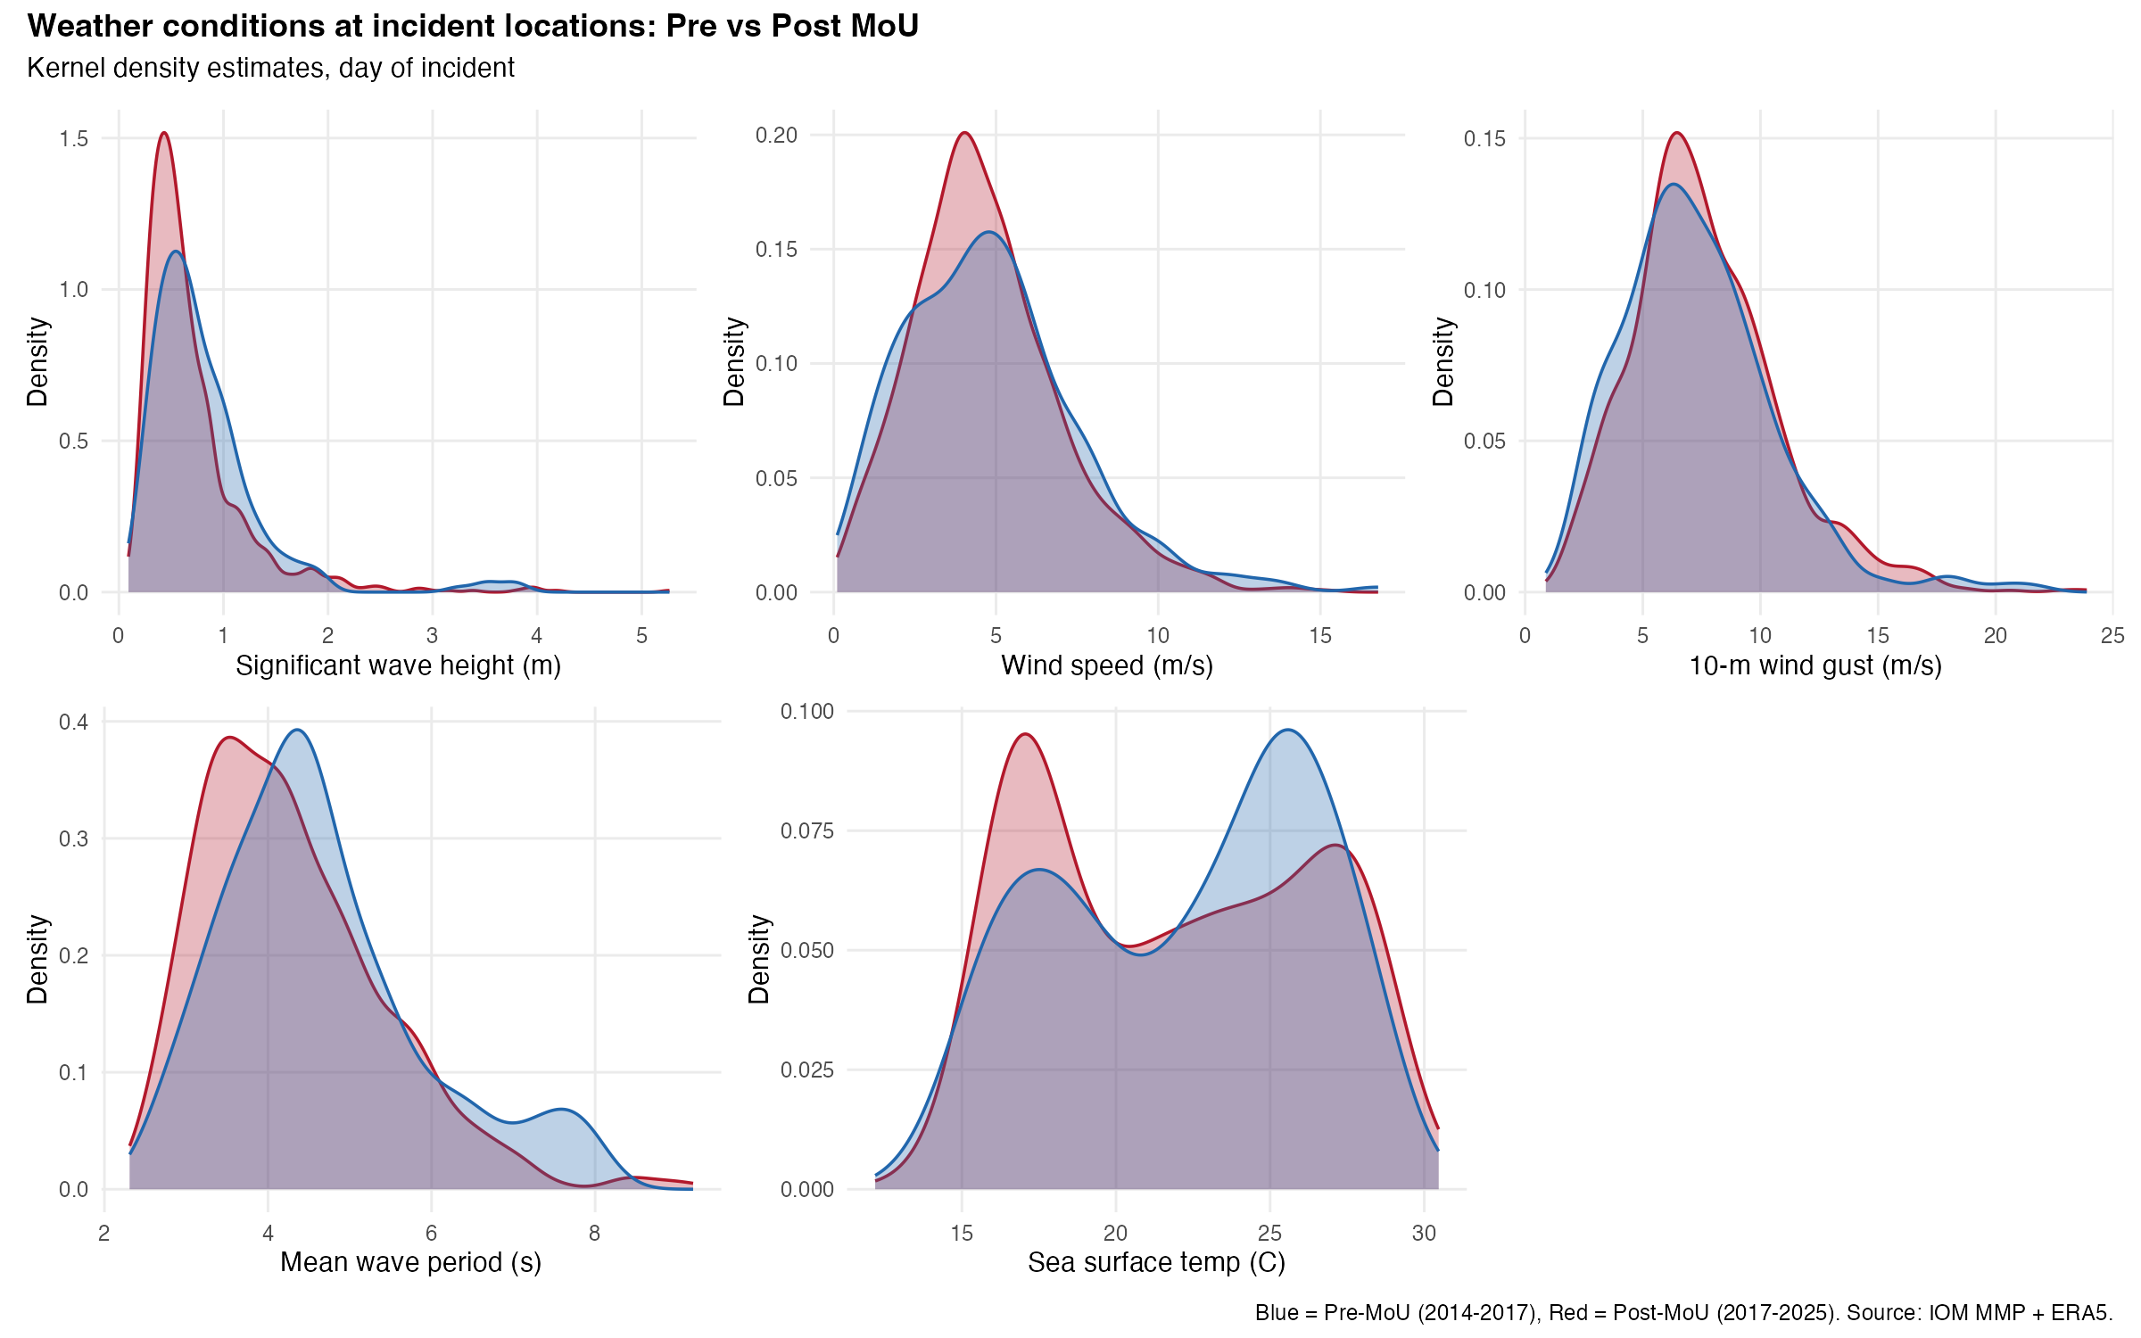
Figure 1: Weather conditions at incident locations, pre vs post MoU.

4. Model A Results
All models estimated with fixest::fenegbin (proper high-dimensional FE handling, no convergence issues). Heteroskedasticity-robust SEs unless noted. 1-degree grid FE + year FE + month-of-year FE.

4.1 Primary Specifications
Specification | beta_3 | SE | p-value | exp(beta_3)
A: SWH x Post | -0.204 | 0.204 | 0.319 | 0.816
B: Wind x Post | -0.053 | 0.051 | 0.294 | 0.948
C: Joint (SWH + Wind) | -0.101 / -0.035 | 0.333 / 0.083 | 0.762 / 0.668 | 0.904 / 0.965
D: Gust x Post | -0.092 | 0.038 | 0.016 ** | 0.913

The SWH and wind interactions are not significant. The gust interaction is significant at 5% (p = 0.016): a 1 m/s increase in gust intensity is associated with 8.7% fewer deaths per incident post-MoU compared to pre-MoU. All signs are negative -- the gradient decreased, opposite to the hypothesis.

4.2 Sensitivity and Robustness
Specification | beta_3 | SE | p-value | exp(beta_3)
A: no grid FE | -0.301 | 0.230 | 0.191 | 0.740
A: 0.25-deg grid FE | -0.104 | 0.244 | 0.668 | 0.901
A: month-only FE | -0.044 | 0.227 | 0.845 | 0.957
A: trim <= 100 | -0.125 | 0.199 | 0.531 | 0.883
D: trim <= 100 | -0.056 | 0.036 | 0.124 | 0.946
A: cluster SE (grid) | -0.204 | 0.194 | 0.294 | 0.816
D: cluster SE (grid) | -0.092 | 0.044 | 0.039 ** | 0.913
A: Poisson | -0.331 | 0.240 | 0.168 | 0.718
D: Poisson | -0.076 | 0.048 | 0.116 | 0.927

Key findings from sensitivity analysis:
- The SWH interaction is robustly null across all specifications (grid resolution, temporal FE, outlier trimming, SE clustering, Poisson).
- The gust interaction survives grid-clustered SEs (p = 0.039) but does NOT survive outlier trimming (p = 0.124) or Poisson estimation (p = 0.116). It is not robust.
- Outlier trimming (dead+missing > 100) drops 33 incidents, all pre-MoU mass-casualty events. The top 5 deadliest incidents (400-550 dead+missing) are all pre-MoU.

5. Placebo and Stability Tests

5.1 Placebo Treatment Dates -- SWH
The SWH x Post interaction was re-estimated at 14 placebo treatment dates (quarterly, 2015-Q1 to 2018-Q3). If the MoU date is special, beta_3 should stand out against placebo estimates.
Placebo date | beta_3 | SE | p-value | n pre | n post
2015-01 | -0.312 | 1.499 | 0.835 | 43 | 1189
2015-04 | -0.850 | 0.287 | 0.003 ** | 49 | 1183
2015-07 | -0.407 | 0.272 | 0.135 | 64 | 1168
2016-01 | -0.302 | 0.253 | 0.233 | 88 | 1144
2016-07 | -0.069 | 0.274 | 0.801 | 116 | 1116
2017-02 (MoU) | -0.204 | 0.204 | 0.319 | 211 | 1021
2017-07 | -0.173 | 0.204 | 0.395 | 314 | 918
2018-01 | -0.147 | 0.205 | 0.475 | 346 | 886
2018-07 | -0.120 | 0.202 | 0.551 | 373 | 859

Result: The MoU date is not special. beta_3 hovers between -0.04 and -0.30 at all dates from 2016 onward, always with p > 0.19. The coefficient path is flat -- there is no break at February 2017. The one significant placebo (April 2015, p = 0.003) is driven by only 49 pre-period observations and a convergence warning.

5.2 Placebo Treatment Dates -- Gust
Placebo date | beta_3 | SE | p-value
2015-04 | -0.095 | 0.099 | 0.337
2016-01 | -0.076 | 0.060 | 0.202
2016-07 | -0.076 | 0.055 | 0.164
2016-10 | -0.085 | 0.052 | 0.107
2017-02 (MoU) | -0.092 | 0.038 | 0.016 **
2017-07 | -0.084 | 0.037 | 0.024 **
2017-10 | -0.072 | 0.036 | 0.047 **
2018-04 | -0.088 | 0.035 | 0.013 **
2018-07 | -0.071 | 0.035 | 0.043 **

Result: The gust interaction is significant at the MoU date (p = 0.016) but also at every date from mid-2017 through 2018. The coefficient is approximately constant at -0.07 to -0.09 from 2015 onward. This is a gradual pre-existing trend, not a policy break. The MoU date does not stand out.

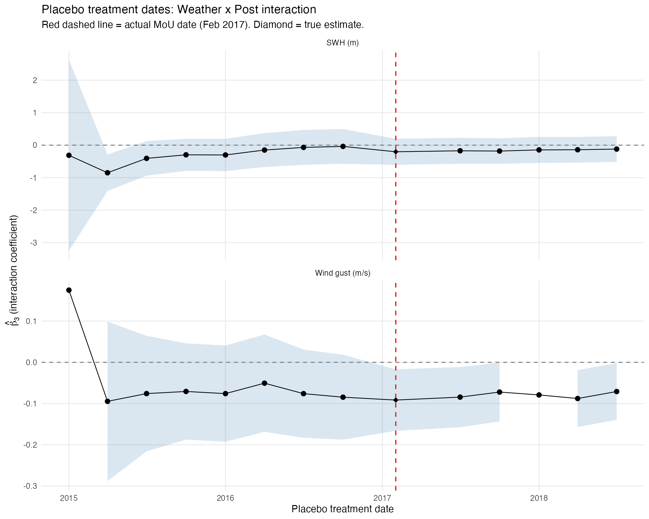
Figure 2: Placebo treatment dates. Red dashed line = actual MoU (Feb 2017). Diamond = true estimate.

5.3 Pre-Period Gradient Stability
The SWH-mortality gradient was estimated separately for each pre-MoU year (Poisson, no grid FE due to small samples):
Year | n | SWH slope | exp(slope)
2014 | 43 | -0.219 | 0.804
2015 | 45 | +0.964 | 2.622
2016 | 110 | -0.274 | 0.760
2017 (Jan) | 13 | -0.889 | 0.411

The gradient is not stable: 2015 shows a strongly positive slope (higher waves associated with more deaths), while 2014 and 2016 show negative slopes. A Wald test for joint significance of year interactions rejects at the 10% level (p = 0.083). This weakens the gradient stability assumption (Assumption 3).
Caveat: these are Poisson estimates with very small samples (43-110 obs) and no spatial FE. The instability may reflect noise from small samples rather than genuine gradient variation. However, the evidence does not support gradient stability.

6. Interpretation

6.1 What the Results Say
The weather x post-MoU interaction design does not detect evidence that the MoU changed the weather-mortality gradient on the CMR. The primary SWH interaction is null (beta_3 = -0.20, p = 0.32), robust across all specifications. The gust interaction, while nominally significant, fails the placebo test (it is a pre-existing trend) and does not survive outlier trimming.

6.2 Possible Explanations
- The MoU changed the type of danger, not the weather sensitivity. Pre-MoU: large boats, open-sea crossings, weather-driven mass-casualty shipwrecks (the top 5 deadliest events are all pre-MoU), SAR present. Post-MoU: small fragile boats, short-range crossings near Libya in calm seas, deaths from overcrowding, engine failure, dehydration, and LCG interceptions. The weather gradient flattened because weather is no longer the dominant killer.
- Detection bias. Post-MoU, the worst weather incidents (sinkings far from shore, no witnesses) may go undetected. If these 'ghost boats' have high mortality in bad weather, their absence from the data would attenuate beta_3 toward zero or even reverse it.
- Power limitations. The pre-MoU sample is small (211 incidents with valid SWH). The SEs on beta_3 (~0.20) imply we could only detect effects larger than ~0.40 (exp(0.40) = 1.49, a 49% gradient increase) at 5% significance. Moderate gradient changes would go undetected.
- Pre-MoU gradient instability. The gradient varied substantially across pre-MoU years (Wald p = 0.083). If the baseline gradient was already noisy, detecting a shift at the MoU date is difficult.

6.3 What This Does NOT Mean
A null weather gradient interaction does not mean the MoU did not make the route more dangerous. The MoU may have increased danger through channels that Model A cannot detect: more incidents overall (extensive margin), deaths in calm conditions (not captured by the gradient), or systematic under-detection of the worst outcomes.

7. Open Questions and Next Steps

7.1 Analyses Not Yet Performed
- Monthly-level analysis: did total monthly deaths increase post-MoU? This captures the extensive margin (more incidents) that Model A, by conditioning on incidents, cannot see.
- Crossings diagnostic: did the MoU change the volume of crossings in response to weather? (crossings as outcome, not conditioning variable)
- DML (double machine learning): partially linear model for beta_3 with flexible ML nuisance functions, to check whether the log-link functional form drives the null result.
- Detection sensitivity analysis: parameterized (pi, d-bar) grid to assess how much detection must have worsened to mask a positive beta_3.
- Re-run 02_build_event_data.R with the hmax grid index fix to recover max wave height data (currently 1,362/1,381 NAs due to a bug, now fixed).

7.2 Thesis Direction Decision
The null weather gradient result is a genuine finding. The thesis can proceed on the following path:
1. Report the Model A null as the per-incident severity result (the MoU did not amplify weather sensitivity).
2. Add monthly-level analysis for the aggregate effect (total deaths, total incidents, controlling for crossings volume).
3. Interpret the combination: if total deaths increased but per-incident weather sensitivity did not, the mechanism is volume (more incidents) and/or non-weather mortality (calm-sea deaths), not amplified weather risk.
4. Support with descriptive evidence: geographic shift toward Libya, survivor ratio decline, weather overlap shift toward calmer conditions.

7.3 Data Integrity Note
Four incidents (0.3% of sample) have 'Number Dead' > 'Total Dead and Missing' in the IOM data. This reflects IOM internal inconsistencies between separate fields, not a coding error. The analysis uses IOM's curated 'Total Dead and Missing' field (dead_missing) as the authoritative outcome. The largest discrepancy is the April 18, 2015 shipwreck (dead = 750, dead_missing = 472), reflecting different source estimates for the same event.

8. Technical Notes
- Estimation: fixest::fenegbin (R). Properly handles high-dimensional FE via demeaning, automatic singleton drops, heteroskedasticity-robust and cluster-robust SEs.
- Previous convergence issues with MASS::glm.nb (alternation limit reached with 188 grid FE levels) are resolved by switching to fixest.
- Grid FE: 1-degree grid (84 cells, 25 singletons dropped). Sensitivity tested at 0.25-degree (317 cells) and no grid FE.
- Weather extraction: ERA5 daily data at incident coordinates, nearest grid cell lookup. A bug in 02_build_event_data.R used 0.25-deg atmospheric grid indices for the 0.5-deg wave_hmax file, causing 98.6% NAs. Fixed (line 260: ft == 'wave' -> ft %in% c('wave', 'wave_hmax')), pending re-extraction.

