TUẦN 3: PARSER

I. Kết quả chạy

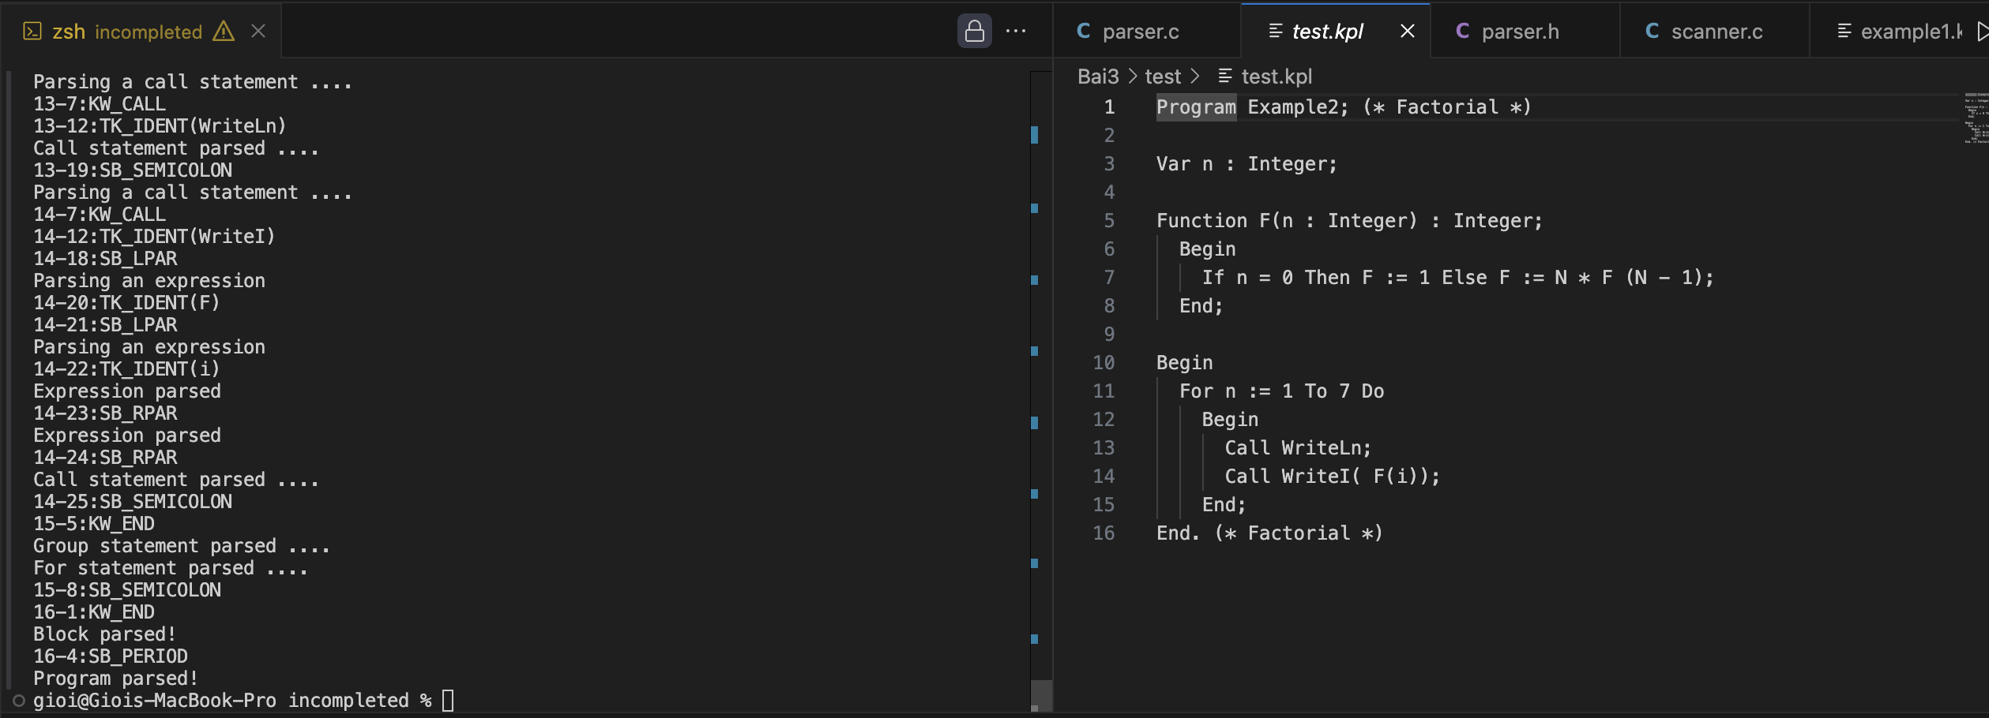

II. Bắt lỗi

1. ERM_INVALIDCONSTANT "Invalid constant!"

1. ERM_INVALIDTYPE "Invalid type!"

1. ERM_INVALIDBASICTYPE "Invalid basic type!"

1. ERM_INVALIDPARAM "Invalid parameter!"

1. ERM_INVALIDSTATEMENT "Invalid statement!"

1. ERM_INVALIDARGUMENTS "Invalid arguments!"

1. ERM_INVALIDCOMPARATOR "Invalid comparator!"

1. ERM_INVALIDTERM "Invalid term!"

1. ERM_INVALIDFACTOR "Invalid factor!"

