Giovanni Jackson
CS 340
October 18, 2026

README

Project Overview
For this project, I developed an interactive dashboard for Grazioso Salvare to help identify shelter dogs that may be suitable for rescue training. The dashboard connects to MongoDB and allows the user to filter animal records by rescue category. It displays the results in a table, a breed distribution chart, and a location map.
I reused my AnimalShelter CRUD module from Project One to connect the dashboard to the database. This allowed me to build on my previous work while keeping the database operations separate from the dashboard interface.

Dashboard Features
The dashboard includes Water Rescue, Mountain/Wilderness Rescue, Disaster/Individual Tracking, and Reset options. Each rescue filter uses breed, sex, and age criteria to request matching records from MongoDB. Reset returns the dashboard to the unfiltered records.
The data table supports sorting, filtering, pagination, and single-row selection. The breed chart summarizes the animals represented in the table. The map is designed to display the location of the selected animal, with a marker containing identifying information.
The dashboard also includes the Grazioso Salvare logo and my name. Clicking the logo opens the Southern New Hampshire University website.

Tools and Design
MongoDB and PyMongo: MongoDB stores the animal records in the animals collection within the aac database. PyMongo connects the Python CRUD module to MongoDB. This supports querying the records using multiple criteria without having to manually search the dataset.
Python CRUD module: The AnimalShelter class contains the database operations. The dashboard uses its read() method to retrieve all records or records matching a rescue filter.
Dash and JupyterDash: These tools provide the dashboard interface and allow it to run inside the course’s JupyterLab environment. Dash callbacks connect the filter controls and table selections to changes in the displayed results.
Pandas: Pandas organizes the returned records into a DataFrame for use in the table and charts. The MongoDB _id field is removed before displaying the records because its ObjectId values can cause serialization problems.
Plotly Express: Plotly Express creates the breed distribution chart so users can compare the breeds represented in the current results.
Dash Leaflet: Dash Leaflet provides the map, location marker, tooltip, and popup.
The application follows the model-view-controller approach. MongoDB and the CRUD module handle the data model. The dashboard components provide the view. The callback functions act as the controller by responding to user actions and updating the table and visualizations.

Files Included
- ProjectTwoDashboard.ipynb: Dashboard layout, rescue filters, callbacks, chart, and map.
- CRUD_Python_Module.py: AnimalShelter class and MongoDB CRUD operations.
- Grazioso Salvare logo image: Image used in the dashboard header.
- README document: Project explanation, setup instructions, testing notes, and screenshots.

Setup and Reproduction
- Open the CS 340 Codio environment and launch JupyterLab.
- Place the dashboard notebook, CRUD module, and logo image in the same folder. Keep the logo filename consistent with the notebook’s image-loading code.
- Confirm that MongoDB is running on localhost at port 27017.
- Confirm that the animal dataset has been imported into the aac database and animals collection.
- Use a valid MongoDB username and password in the dashboard connection section. My working account authenticated against the admin database, while the animal records remained in aac.
- Confirm that the course environment has the required packages: pymongo, jupyter_dash, dash, dash_leaflet, plotly, pandas, numpy, and matplotlib. This notebook uses the JupyterDash setup provided for the course.
- Open ProjectTwoDashboard.ipynb and run the cells in order. After changing the CRUD module, restart the kernel and run all cells to load the saved changes.
- The dashboard runs in inline mode on port 8051. Keep the notebook kernel running while using it.
- Select a rescue category to view matching records. Use the table controls to explore the results and select an animal to view its location.

Testing and Results
I confirmed that the dashboard loads inside JupyterLab and displays animal records from MongoDB. The table, breed distribution chart, and map rendered in the notebook. I tested the filter buttons and confirmed that the logo link opens the SNHU website.
The screenshots document the dashboard header, animal table, and chart/map sections. They show the application running, although they do not capture every filter state or prove every interactive behavior.

Challenges and Display Limitation
One issue I encountered was MongoDB authentication. The dashboard could not connect until I used the correct password and authentication database. I tested the login through the terminal and then updated the dashboard and CRUD module to use the working settings.
I also had difficulty opening the dashboard in a separate browser tab. I was able to use it inside JupyterLab, but my screen and the notebook’s limited display area did not allow me to show the entire dashboard at once. Because of this, I captured the dashboard in separate sections. The screenshots show different portions of the same running application.
Another challenge was connecting the table selections to the map. The code uses named latitude and longitude fields instead of fixed column positions. It also handles empty results and missing coordinates to avoid errors when a record cannot be mapped.

Screenshot Documentation
Figure 1: Dashboard Header
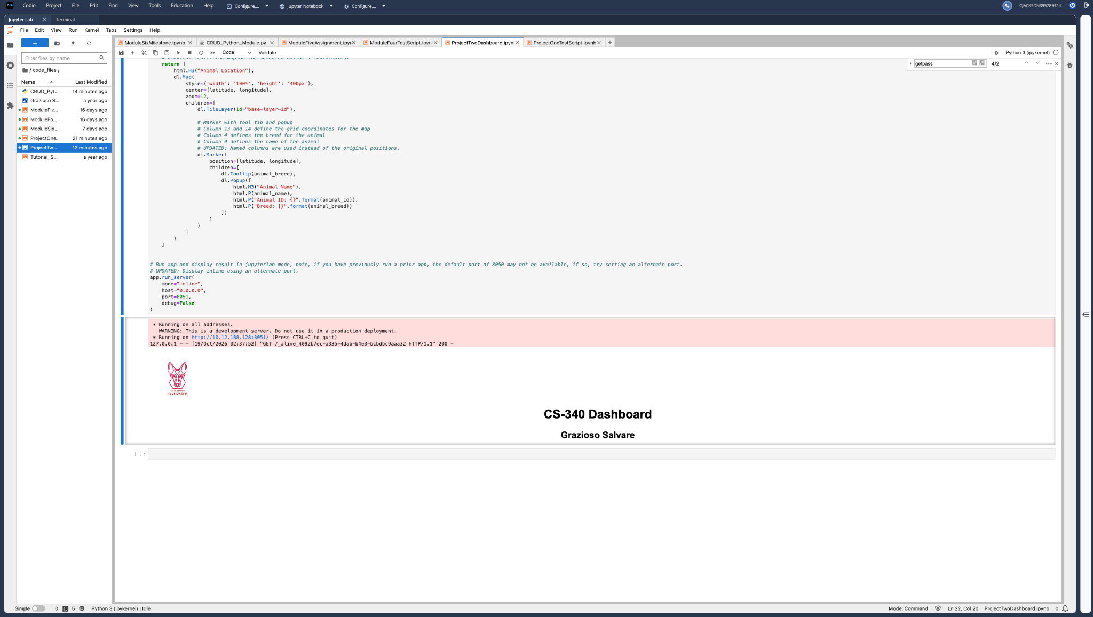This screenshot shows the running notebook output, Grazioso Salvare logo, and dashboard title.
Figure 2: Animal Data Table
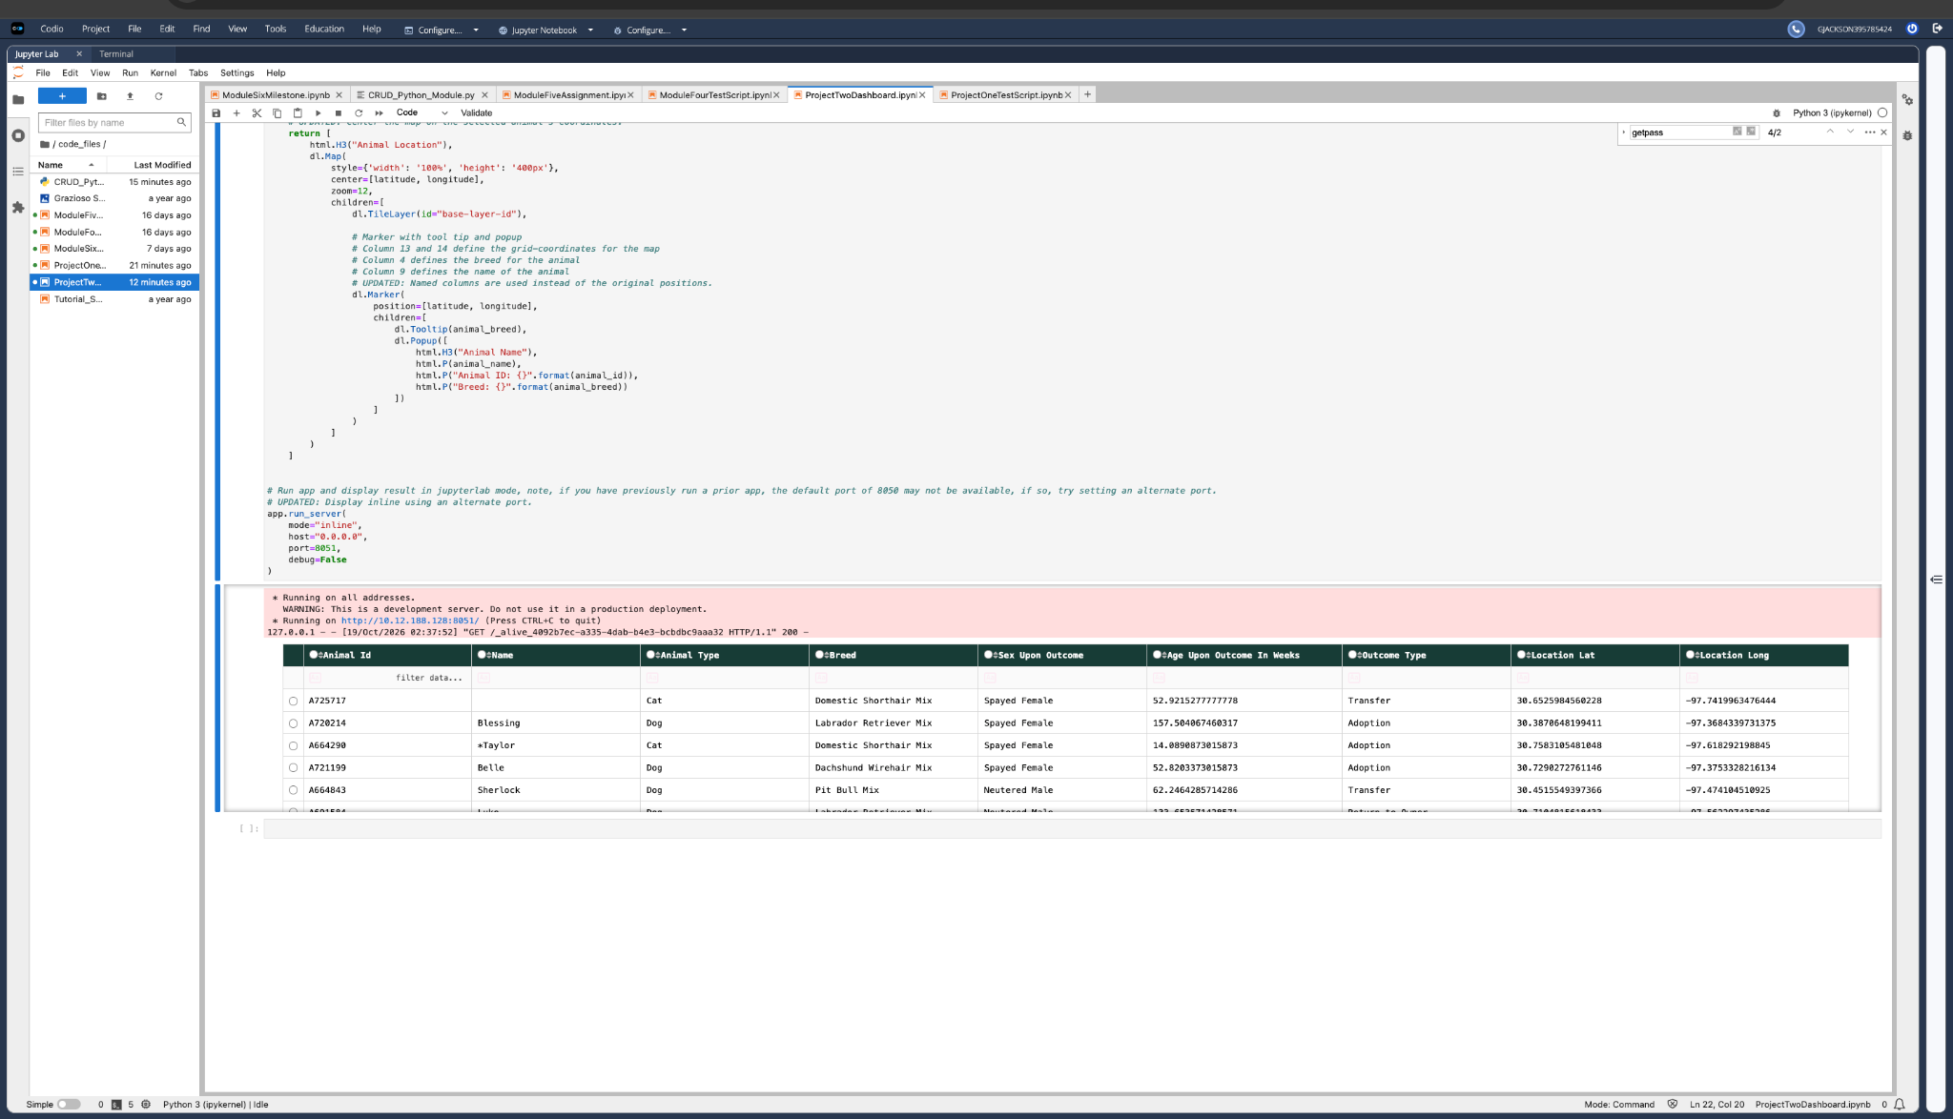This screenshot shows animal records retrieved from MongoDB and displayed in the interactive table.
Figure 3: Breed Chart and Location Map
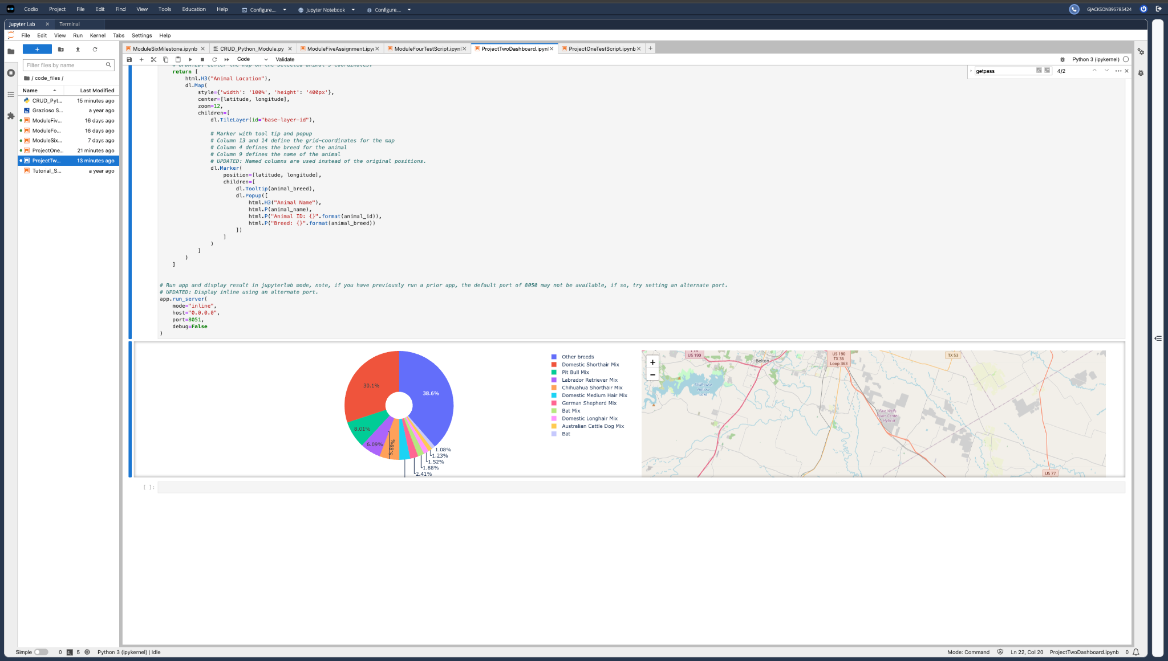This screenshot shows the breed distribution chart and the visible portion of the location map.
Additional screenshots of the rescue filters and Reset state are needed to fully document the filter results.

References
MongoDB. (n.d.). PyMongo Python driver. https://github.com/mongodb/mongo-python-driver
Plotly. (n.d.). Sorting, filtering, selecting, and paging natively. https://dash.plotly.com/datatable/interactivity
Plotly. (n.d.). Part 2. Adding interactivity. https://dash.plotly.com/basic-callbacks
Dash Leaflet. (n.d.). Getting started. https://www.dash-leaflet.com/docs/getting_started
Southern New Hampshire University. (n.d.). CS 340 dashboard specifications document. Course materials.

