BLOCKDOJO for ninjas and families
BLOCKDOJO

For ninjas and families
The cave on the TV is your dojo’s coin book. You earn coins in class. You earn EXP for the same work. You spend coins at the shop and at the fridge.
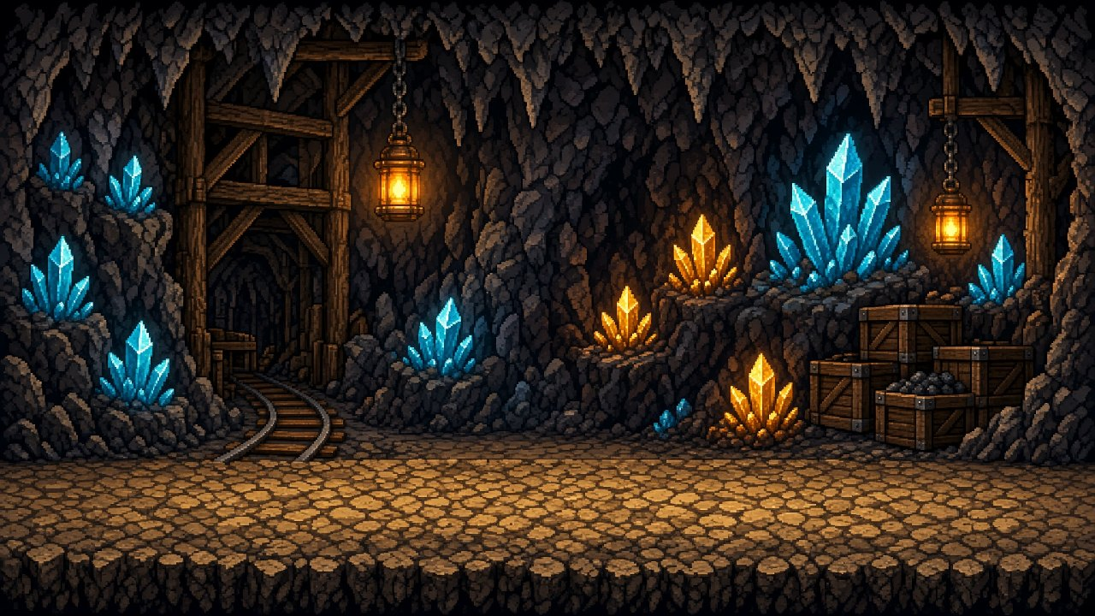
COINS

To spend
Senseis pay your card. Coins buy shop prizes and anything from the fridge.
EXP

To keep
EXP rises with every coin you earn. It is never spent. Some prizes are claimed once with EXP.
BELTS

The Code Ninjas path
White to Gold. Each page after the shop is one belt and what your ninja learns there.

THE CAVE

What the game is
Block Dojo is the cave you see at the dojo. It is not a second class. It is how the center keeps your coins, your EXP, and your belt in one place.
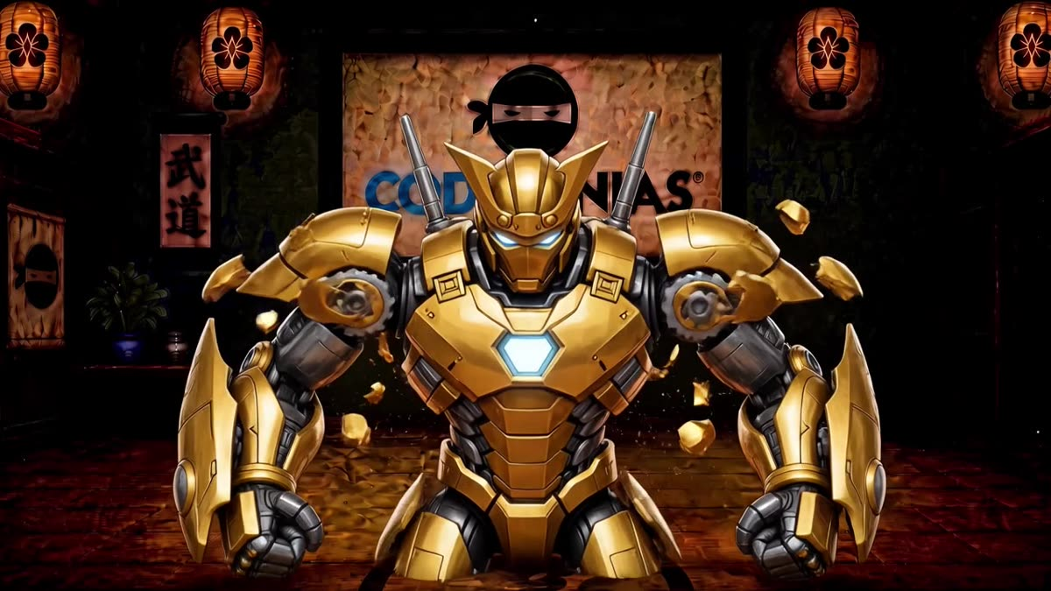

On the TV
- The mine is the cave’s coin pile. Pays come out of it.
- When a sensei pays you, your name runs across the screen.
- Belt up plays that belt’s show on the whole TV.
- The EXP button opens a board of every ninja, A to Z, with a bar toward the biggest EXP prize.

On your card
- One ninja, one card. A second card does not start a new pile of coins.
- Your sensei searches your name and pays that card.
- You do not tap the shop yourself. You ask, and the sensei redeems or claims it.
- Parents: this is dojo coins, not a charge to your card at home.

COINS

How you earn them
Coins are for spending. They come off your card when you buy something.
A PAYOUT

Up to 25
A sensei can give 5, 10, or 25 at a time. They wait 15 seconds before paying you again.
A DAY

75 on your card
That is the cap for class payouts, including welcome coins when you first join. It does not reset if someone types your name again.
BONUSES

Outside the 75
Daily and weekly achievements add extra coins. They do not count against the cap. You can earn each one once in that period.

Where coins go
- Shop prizes that say “coins.”
- Anything from the fridge. That part is new. The next page is the rule.
- If a sensei undoes a payout, those coins leave your card.

They are not cash
You cannot buy coins. You earn them by coding, helping, and the challenges your sensei posts. If the card is short, you earn more next class. Nobody charges a parent at the fridge.

IMPORTANT CHANGE

The fridge takes coins.
Ninjas now use ninja coins to purchase anything from the fridge. Drinks. Snacks. All of it. It is not free anymore.

Pick it
Choose what you want. Look before you open the door and take it.

Tell a sensei
They look up your card and take the coins off before you get it.

Then take it
Not enough coins means it stays in the fridge. You can earn more in class.

EXP

It stays with you
EXP is the long path. Coins get spent. EXP does not.
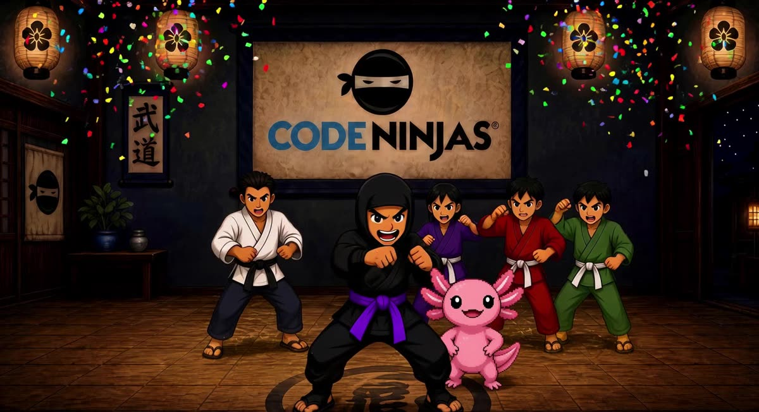

How EXP goes up
- Every coin you earn adds the same EXP. A +10 payout is +10 EXP.
- Welcome coins and daily or weekly achievements count too.
- A sensei fixing a balance does not add EXP.
- If a payout or achievement is undone, that EXP comes back off.

How you use it
- You do not spend it. A claim does not lower the number.
- EXP prizes can be claimed once, when your EXP is high enough and your belt is high enough.
- On the TV, open EXP. Find your name. The bar shows the way to the top EXP prize.
- The list is alphabetical. It is not a leaderboard.

THE SHOP

What you can claim
Ask a sensei. They pick your name, then tap the prize. You need the price and the belt. Coin prizes also need to be in stock.
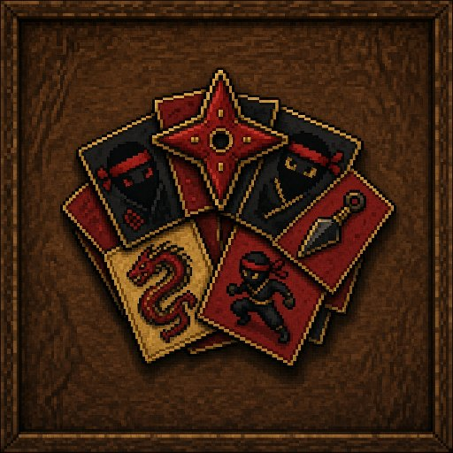

Sticker Pack
15 coins · any belt
Sensei taps Redeem. 15 coins leave your card. One pack leaves the shelf.
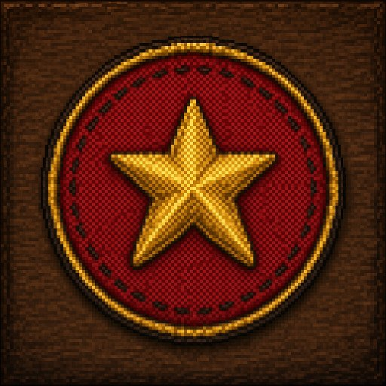

Code Patch
25 coins · Yellow+
Same as a coin redeem. You need a Yellow belt or higher.
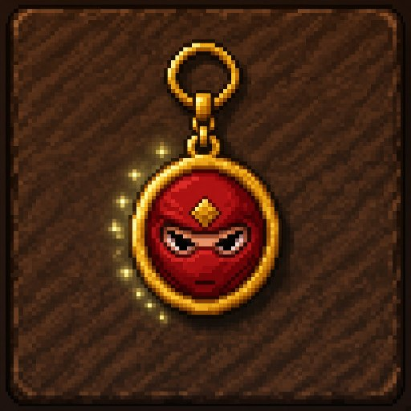

LED Keychain
40 coins · any belt
Coins come off your card. The sensei hands you the keychain.
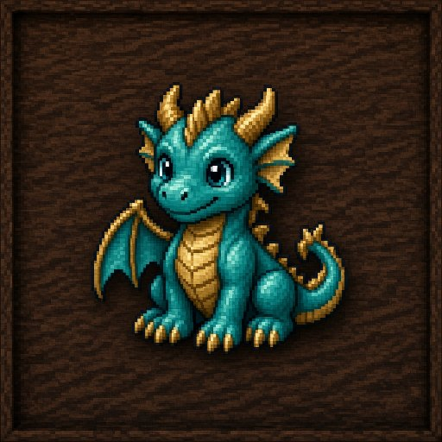

3D Printed Dragon
80 coins · Green+
Green belt or higher. Coins leave your card. One dragon leaves the shelf.
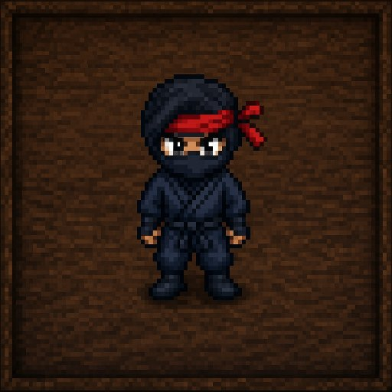

Mini Figure
120 coins · Blue+
Blue belt or higher. A coin redeem, same as the smaller prizes.
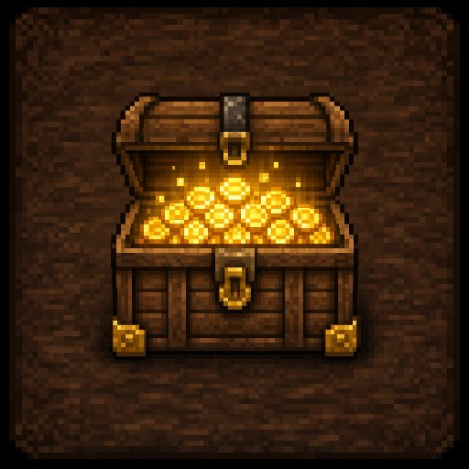

Treasure Chest
200 EXP · Purple+ · once
This one is EXP, not coins. Your EXP stays. You can claim it one time.
Coin prizes can be bought again while they are in stock. The fridge is not in this shop. Fridge items are paid in coins at the desk, then taken.

BELT 1 OF 13 · CODE NINJAS CREATE

White
Introduction to IMPACT and coding with blocks
WHAT YOUR NINJA LEARNS
- Make a sprite, the character in your game.
- Put instructions in order so the game does one thing, then the next.
- Move the sprite and notice when it overlaps something else.
- Use variables, functions, and the loop that keeps a game running.
- Fire projectiles, use a simple “if,” and add animation and music.
This is the start. There is no white-belt show. Your first ceremony on the TV is Yellow.
Next belt: Yellow

BELT 2 OF 13 · CODE NINJAS CREATE

Yellow
Advanced coding with blocks
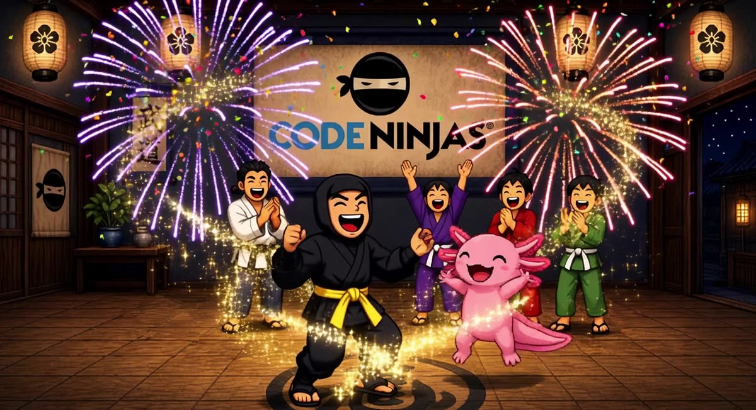
WHAT YOUR NINJA LEARNS
- Build tile maps, both top-down worlds and side-view platformers.
- React when a sprite or a tile is touched.
- Use variables and arrays, and both simple and advanced loops.
- Write functions with inputs and functions without them.
- Add simple game physics and true-or-false logic.
Still in IMPACT, still with blocks. When you belt up, this show plays on the cave TV.
Next belt: Orange

BELT 3 OF 13 · CODE NINJAS CREATE

Orange
Transition to coding with JavaScript
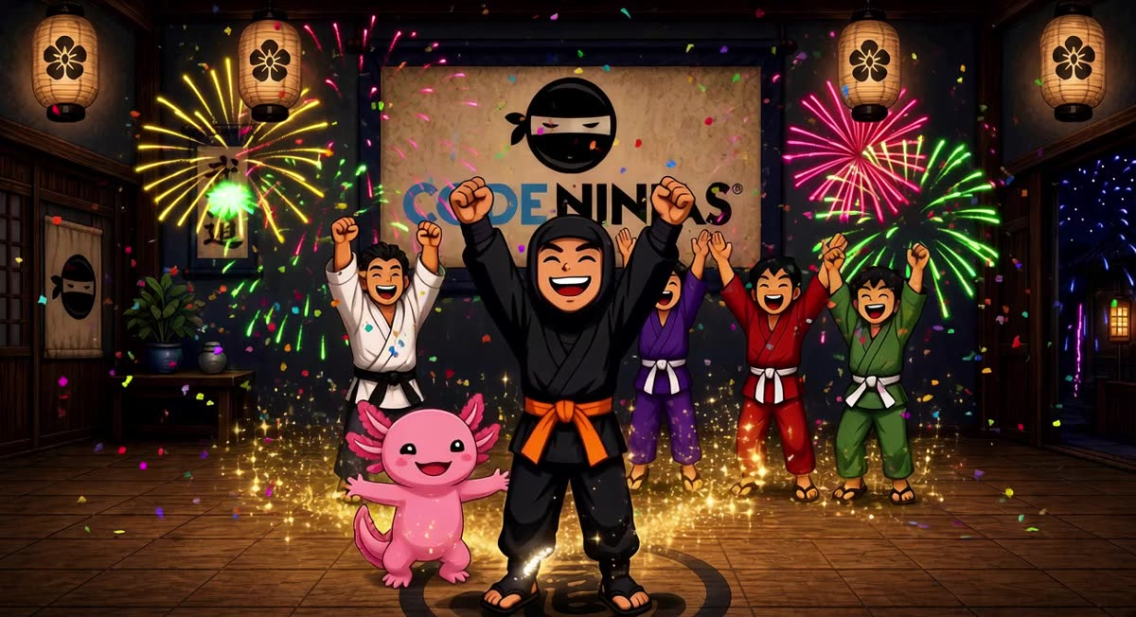
WHAT YOUR NINJA LEARNS
- The same game ideas, now typed in JavaScript.
- Create and change variables, and update a sprite’s properties.
- Use events, loops, and conditionals, including nested ones.
- Use assignment, equals, and true-or-false operators.
- Make sprite kinds, overlap events, and a for-loop that changes as it runs.
This is the step from blocks into real code. The orange show plays when you earn it.
Next belt: Green

BELT 4 OF 13 · CODE NINJAS CREATE

Green
Intermediate coding with JavaScript
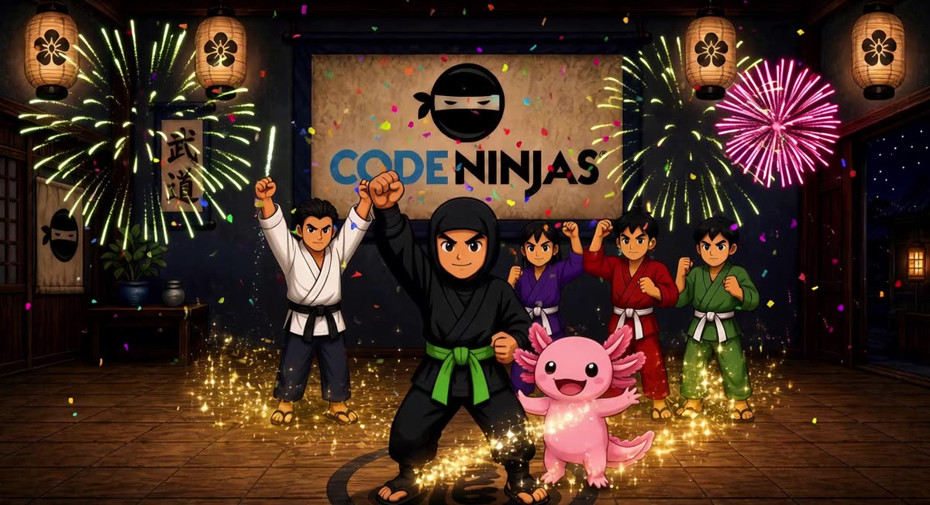
WHAT YOUR NINJA LEARNS
- Manage art and assets, including tile maps and their events.
- Move sprites with physics.
- Remix pixel art, then draw your own, and build sprite packs.
- Animate, and add menus, on-screen text, and other UI.
- Use raycasting to detect what is in front of a sprite.
The 3D printed dragon in the shop opens at this belt. The green show plays on the TV.
Next belt: Blue

BELT 5 OF 13 · CODE NINJAS CREATE

Blue
Advanced coding with JavaScript
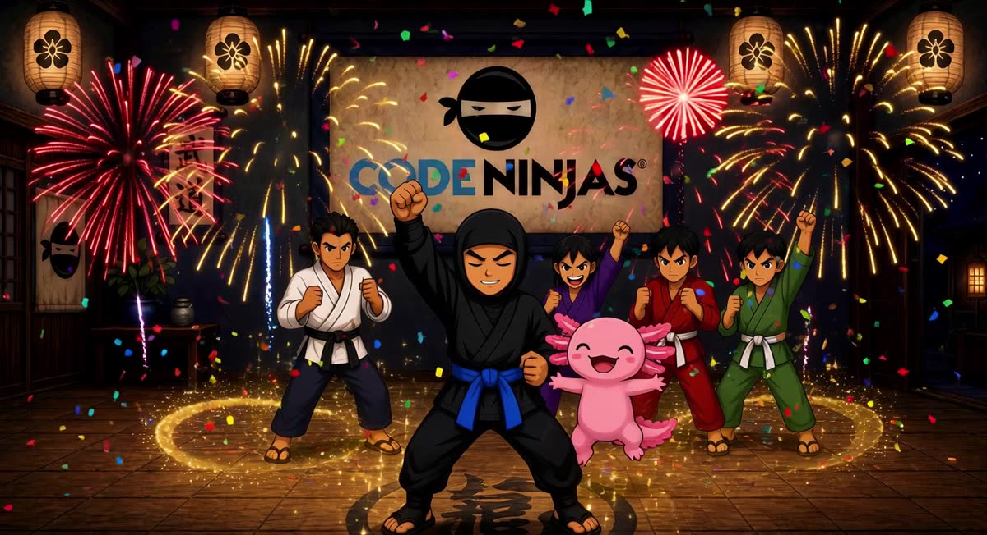
WHAT YOUR NINJA LEARNS
- Build larger games, not a single trick.
- Plan a project, make it, and improve it in passes.
- Use the deeper tools in MakeCode Arcade.
- Keep a big project organized so it still runs.
The mini figure in the shop opens at this belt. The blue show plays when you belt up.
Next belt: Purple

BELT 6 OF 13 · CODE NINJAS CREATE

Purple
Professional development environment
WHAT YOUR NINJA LEARNS
- The Unity workspace, a tool professional game teams use.
- Intermediate game-design ideas, past a single screen.
- Custom animations.
- The foundations of building a game in Unity.
The Treasure Chest opens here: 200 EXP, once, and your EXP stays. The purple show plays on the TV.
Next belt: Brown

BELT 7 OF 13 · CODE NINJAS CREATE

Brown
Advanced programming
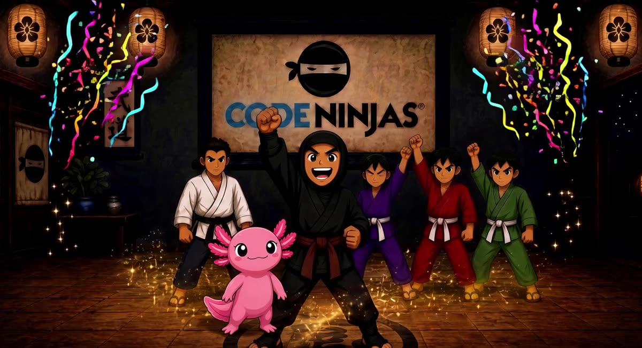
WHAT YOUR NINJA LEARNS
- Meshes and art assets in a 3D scene.
- Ray casting, so the game can tell what a line of sight hits.
- Unity’s built-in tools.
- Object-oriented programming in C#: objects that hold both data and actions.
This is text-based C#, not blocks. The brown show plays when you earn the belt.
Next belt: Red

BELT 8 OF 13 · CODE NINJAS CREATE

Red
Advanced game design
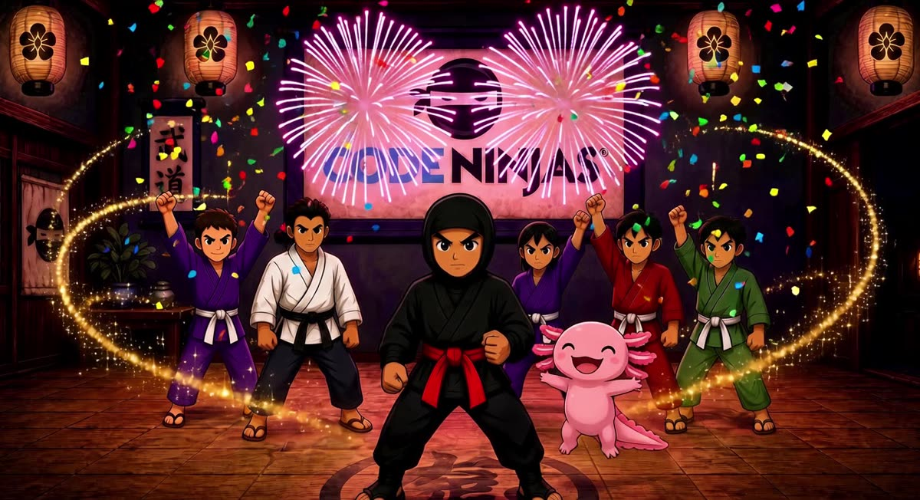
WHAT YOUR NINJA LEARNS
- Scene management: more than one place in a game.
- World design, so those places feel like a world.
- Game mechanics the player can learn and use.
- The Unity Asset Store, and how to bring outside assets into a project.
The red show takes the cave TV when a sensei belts you up.
Next belt: Black

BELT 9 OF 13 · CODE NINJAS CREATE

Black
Custom game development
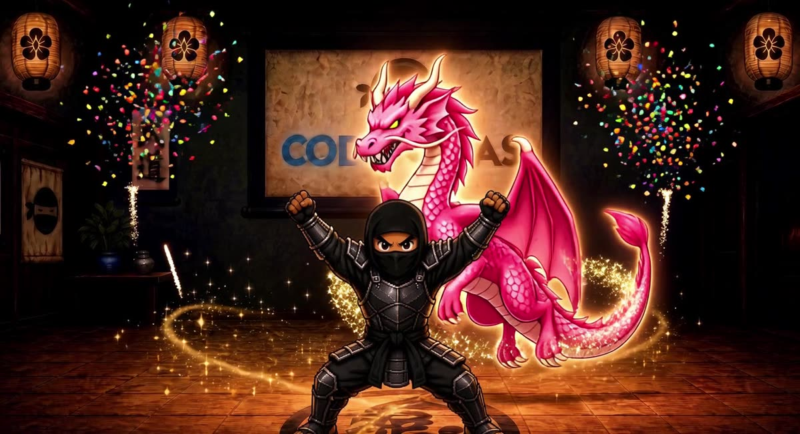
WHAT YOUR NINJA LEARNS
- Storyboard the game before you build it.
- Plan the work, then make a prototype.
- Playtest, and change the game because of what players do.
- Publish: take a project from an idea to something other people can play.
Black belt finishes the main path. After that come Bronze, Silver, Platinum, and Gold.
Next belt: Bronze

BELT 10 OF 13 · ADVANCED

Bronze
Black belt, bronze. Professional engines.
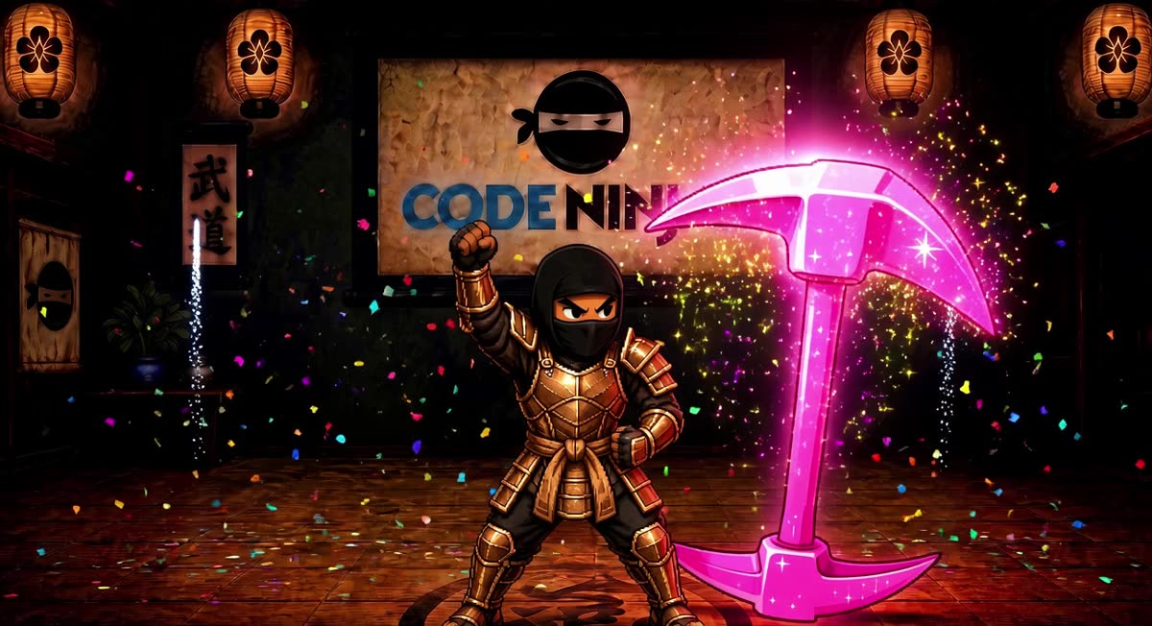
AT THIS BELT
- Bronze, Silver, Platinum, and Gold come after Black. They are the advanced belts.
- Your ninja uses Unity and Godot, the same engines professional studios use.
- Bronze is the first of that track. They learn the workspace, build a scene, and get a project running.
- The sensei sets the project for this belt.
The bronze show plays on the whole TV when you earn it.
Next belt: Silver

BELT 11 OF 13 · ADVANCED

Silver
Black belt, silver. Deeper in the engine.
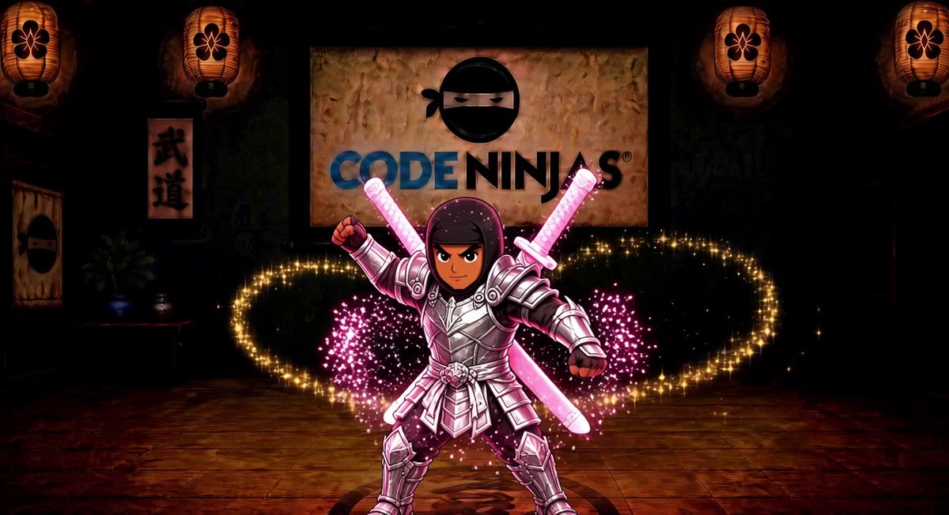
AT THIS BELT
- Your ninja keeps working in Unity and Godot.
- They build past a first scene: movement, cameras, and space a player can travel.
- Projects get bigger, so they learn to keep the work organized.
- The sensei sets the project for this belt.
The silver show plays on the cave TV when you belt up.
Next belt: Platinum

BELT 12 OF 13 · ADVANCED

Platinum
Black belt, platinum. One whole game.
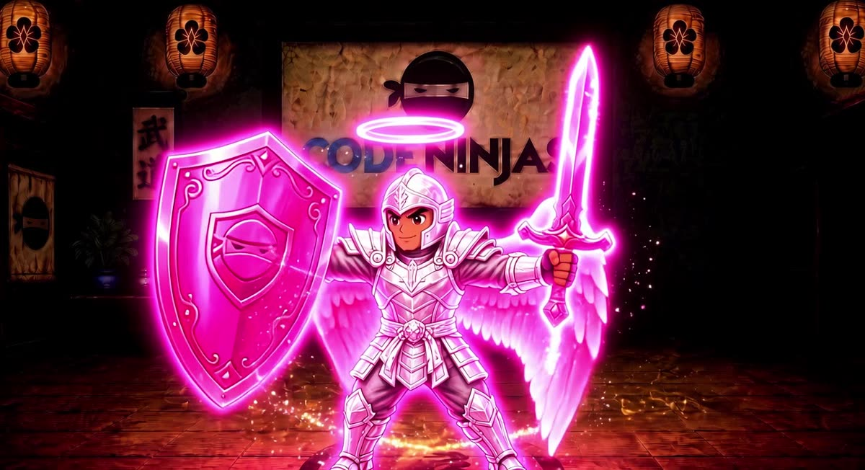
AT THIS BELT
- Your ninja is near the top of the advanced track, still in Unity and Godot.
- They build the systems that make a project feel like one game: goals, menus, and a loop a player can finish.
- Polish matters here. A scene that runs is not the same as a game someone can play.
- The sensei sets the project for this belt.
The platinum show plays on the whole TV.
Next belt: Gold

BELT 13 OF 13 · ADVANCED

Gold
Black belt, gold. The top of the path.
AT THIS BELT
- Gold is the last belt. There is no belt after it.
- Your ninja finishes an original game in Unity or Godot.
- They design it, build it, and playtest it.
- Belt up stops here. The gold show is the last ceremony on the cave TV.
Coins and EXP still work the same way. The fridge still takes coins. The shop still follows the belt on your card.
You are at the top of the path.

