BLOCKDOJO staff guide
BLOCKDOJO

Staff guide
One cave for the whole center. The TV is the mine. Phones are the desk. Coins, EXP, and the roster stay in that one book.
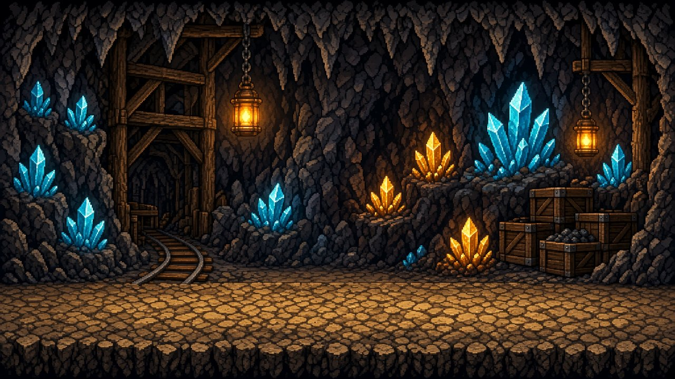

Open the TV
Leave the cave link on the TV. It shows the mine, the ticker, the phone code, and the belt show.

Read the phone code
A 4-character code sits on the TV. It changes at the top of every hour. Every phone in class can use the same code.

Open the desk
On a phone, open the same link and add /sensei. Type the code from the TV. A wrong or old code locks that phone until you type the new one.
Phones do not stay linked all day. When the hour turns, read the new code off the TV. The desk never shows that code.

DURING CLASS

Coins and EXP
Search the ninja. Pay the coins. EXP rises with them.
DESK

A payout
- Search the ninja and tap their name. The card shows coins and EXP.
- Hit +5, +10, +25, or type a custom amount and Add.
- Coins leave the vault and land on that card. EXP goes up by the same amount.
- The cave ticker shows the payout.
Wrong tap? Hit the undo line. Undoing a payout takes those coins and that EXP back.

Each tap
25 coins max. Custom amounts stop there too.

Same ninja
15s between pays, so a double tap cannot double-pay.

The day
75 on that card. Welcome coins count. A second card does not reset it.
COIN PRIZE

Redeem
Needs enough coins, stock, and the belt. Coins leave the card and return to the vault. Stock drops by one. Hand the prize over.
EXP PRIZE

Claim once
Needs enough EXP and the belt. EXP is not spent. Each ninja can claim that prize one time. Undo only clears the claim.
BONUS

Achievements
Daily and weekly bonuses sit outside the 75. They still add the same EXP. Each ninja can take each one once in that period.
TV

EXP path
The EXP button covers most of the cave. Names are A to Z, not a race. The bar runs toward the top EXP prize. Cheaper EXP prizes are marks on the bar. The phone code stays above the board.
CEREMONY

Belt up
Belt up moves one rank and plays that belt’s show on the whole TV. It sits above the EXP board, pauses the music, and loops until the TV is tapped or a key is pressed. The phone does not stop it.

THE BOOK

One card. One fridge rule.
The 75 lives on the card. A new name does not start a new day.
DO THIS EVERY TIME

The fridge is paid in ninja coins.
Nothing from the fridge is free. Drinks, snacks, all of it. The ninja tells you what they want. You take the coins off their card first. Then they may take it. Not enough coins means they wait. Do not hand it over and charge them later.

Add a ninja
- Roster, then Add ninja. First name and one last initial.
- Welcome coins are 10. They count toward today’s 75 and add the same EXP.
- If that name is already here, even resting, the desk refuses a second card.
- Two real kids with the same name and initial need a nickname or a different initial.

Rest a ninja
- Edit the card and mark it archived.
- Show archived, edit, and uncheck it to bring the same card back. Today’s coins stay.
- After 30 days of rest, coins still on that card return to the vault. The ledger records it.
CLOSE OF DAY

Save the day
Opens an Outlook draft. It does not send. The draft has the day’s pays, redeems, undos, EXP claims to hand out, and the closing balances. If the day was long, the full ledger is copied. Paste it into the draft, then send when it looks right.
THE VAULT

Where coins live
Pays, welcome coins, and achievements come out of the vault. Redeems, undos, and 30-day returns put coins back. While a screen is open, the mine adds 10 to 50 coins a minute. It does not catch up overnight. Prize prices can be set up to 10,000.
Editing a coin balance does not add EXP. New prizes and balance fixes stay with the director.

BELT SHOW

Yellow through Brown
White is the starting belt. There is no ceremony for white. Belt up from white plays Yellow. These are stills from the TV show.
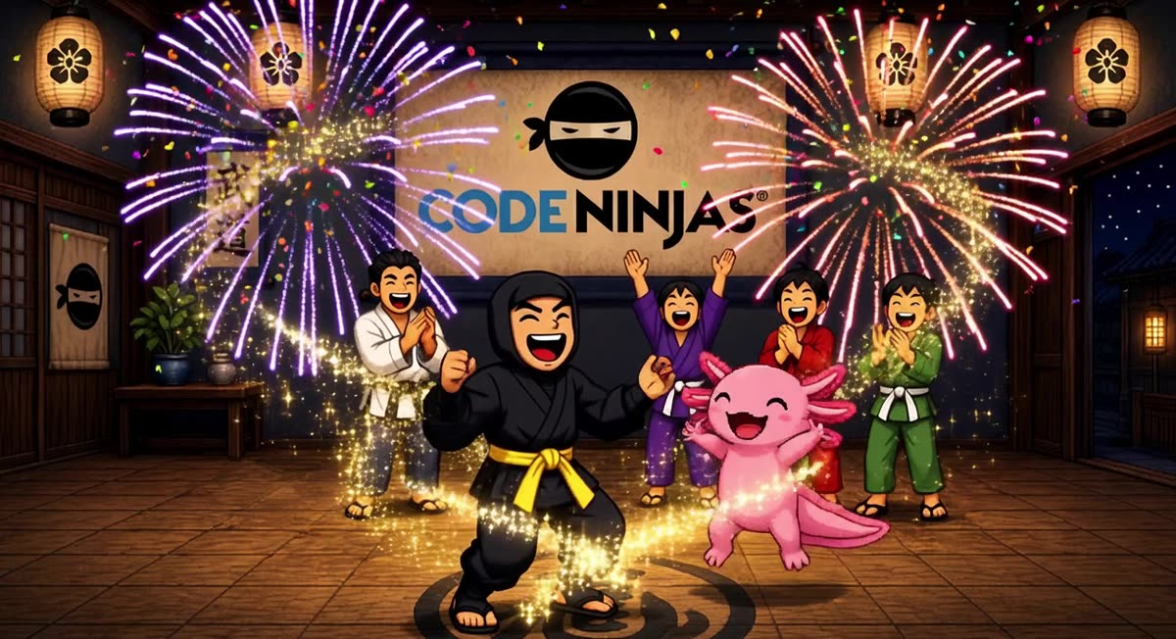
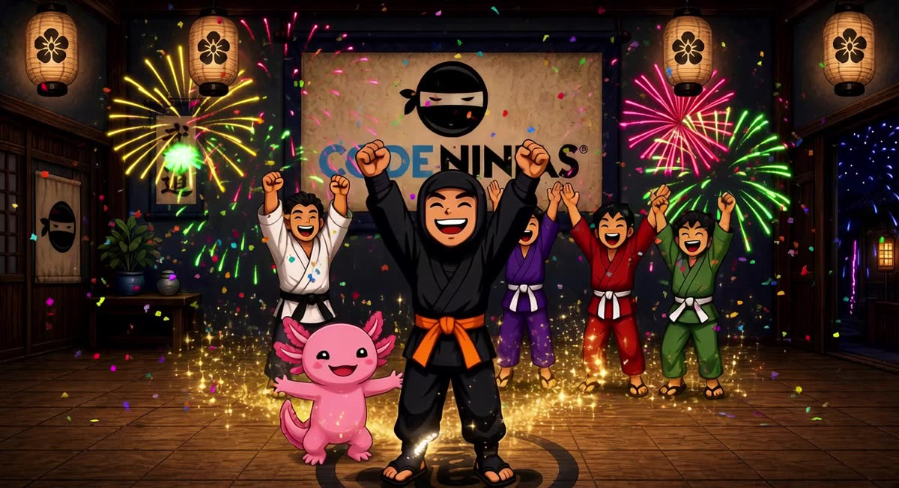
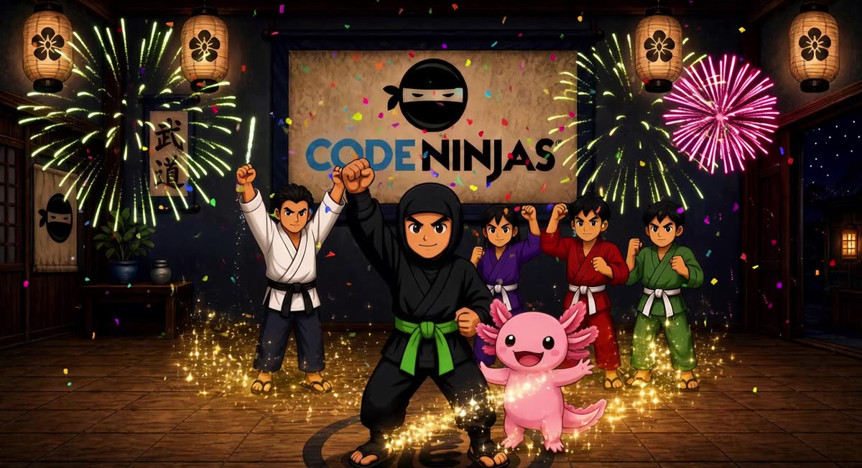
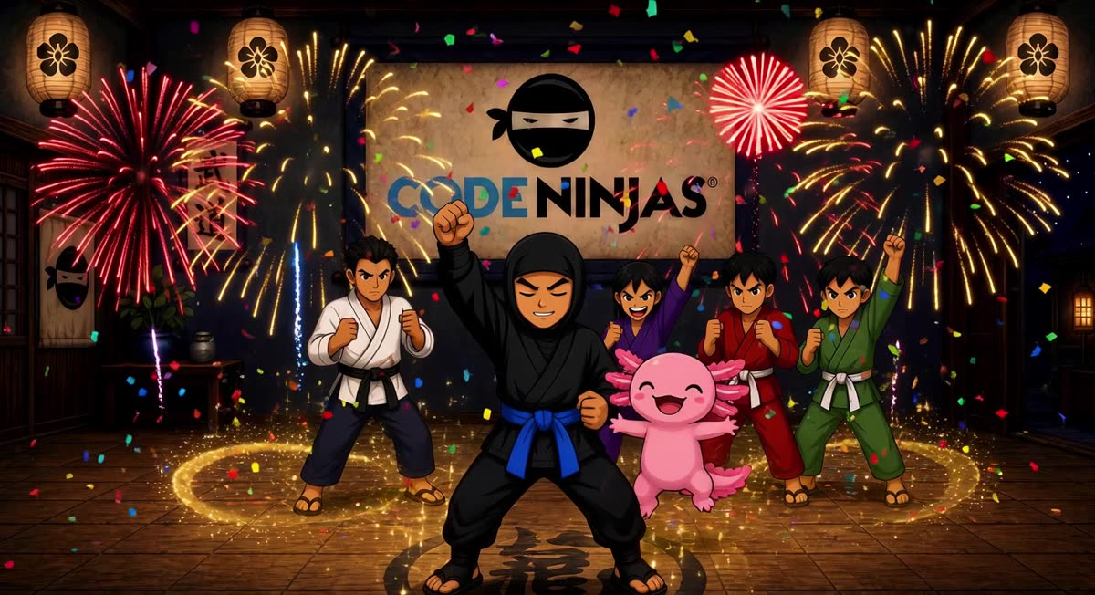
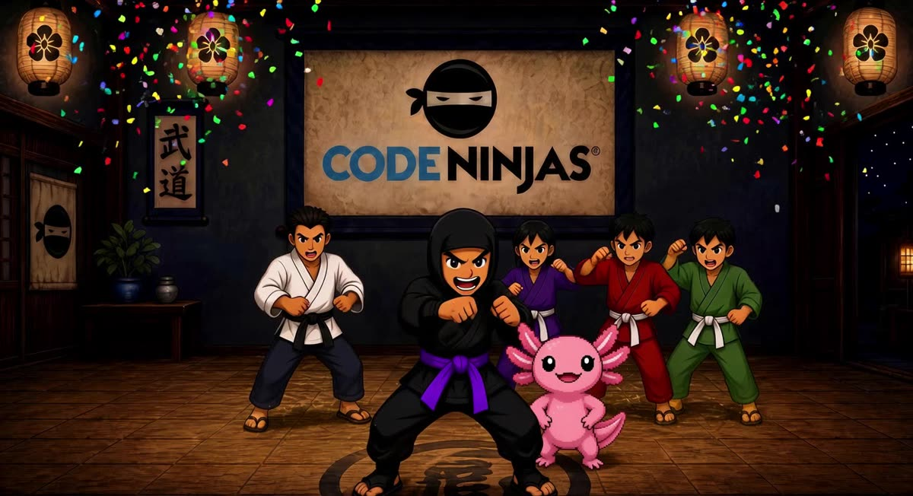
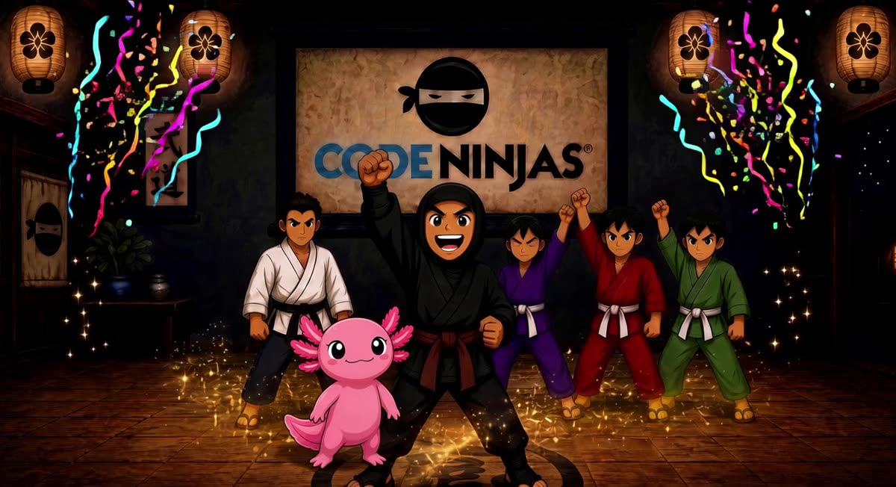

BELT SHOW

Red through Gold
Gold is the last belt. Belt up stops there. The show takes the whole TV and loops until the TV is tapped or a key is pressed. What each belt teaches is in the family guide.
