CIP Course
IoT Prototyping
Step-by-Step Guide

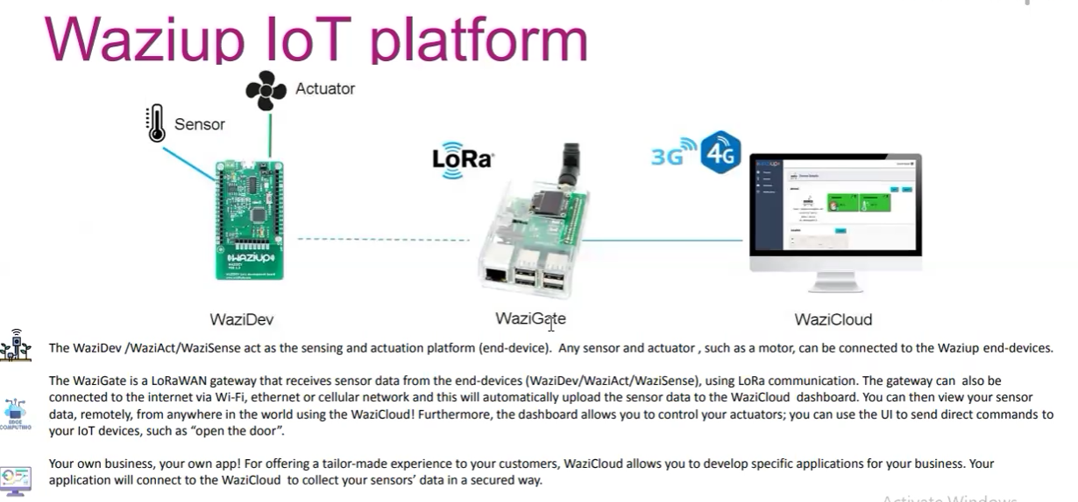
YouthTeamUp · Constructor University Bremen
IoT, AI & Prototyping

Table of Contents
1. Overview — Hardware, Boards & Sensors 1
1.1 Development Boards 1
1.2 Gateways 1
1.3 Most Used Sensors 1
2. Setting Up the LoRa Development Board 1
2.1 Physical Wiring 1
Method A — Via Breadboard (Recommended for Beginners) 1
Method B — Direct with Jumper Wires 1
2.2 Programming — Arduino IDE Setup 1
Install WaziDev Libraries 1
Optional: ESP Board Libraries 1
Additional Libraries 1
Sensor-Specific Libraries 1
Code Examples 1
2.3 Device Keys — Address, NetworksKey & AppKey 1
3. Gateway (Raspberry Pi) Setup 1
3.1 Download & Flash WaziGate OS 1
3.2 Enable SSH on the SD Card 1
3.3 Physical Assembly 1
3.4 Find the Pi's IP Address & SSH In 1
3.5 Configure the Gateway (raspi-config) 1
3.6 Access WaziGate Dashboard 1
3.7 Make WaziGate Its Own WiFi Hotspot (No Ethernet Needed) 1
What is Access Point Mode? 1
Method A — RaspAP (Recommended — One Command) 1
Method B — Manual Setup (Advanced) 1
Step 1 — Install tools 1
Step 2 — Assign a fixed IP address to the Pi 1
Step 3 — Configure DHCP (address assignment) 1
Step 4 — Configure the hotspot 1
Step 5 — Point hostapd to the config 1
Step 6 — Enable and reboot 1
Connecting Devices to the Pi Hotspot 1
From your laptop browser (while connected to Pi WiFi): 1
Troubleshooting — Hotspot Not Working? 1
4. WaziCloud — Data in the Cloud 1
4.1 Create Your Account 1
4.2 Visualise Sensor Data on WaziCloud 1
4.3 Python — Real-Time Data via MQTT 1
4.4 Alternative Cloud & Visualisation Platforms 1
Example: Using InfluxDB + Grafana 1
4.5 Continuous 2-Week Data Collection 1
4.6 Remote Access with Tailscale 1
5. Setting Up the ESP32 Board with WiFi 1
5.1 Add ESP32 to Arduino IDE 1
5.2 Key Libraries 1
5.3 Example: Sending Sensor Data to Raspberry Pi via WiFi 1
6. Web Applications — HTML, CSS & JavaScript 1
6.1 What Is a Web Dashboard? 1
6.2 Create Your First Dashboard File 1
Complete Starter Dashboard (one file — copy this exactly): 1
6.3 Run the Dashboard 1
6.4 Python Flask Backend on the Pi 1
6.5 Add a Chart to the Dashboard 1
6.6 Databases for IoT Applications 1
Example: Store Data in MongoDB 1
6.7 Data Security 1
Example: Simple API Key Protection 1
6.8 Real-Time Updates with WebSockets 1
6.9 Mobile App Development 1
7. Team-Specific Sensor Guides — CIP Course 1
7.1 Team 1 — DiverseGrow: Smart Agricultural Cooperative Platform 1
Optional IoT Extension — Only if you want live farm data in the app 1
7.2 Team 2 — Smart Solar Dryer for Small Farmers (Rwanda) 1
Sensor 1 — DHT22: Temperature & Humidity Inside the Drying Chamber 1
Wiring: 1
Library: Sketch → Manage Libraries → search "DHT sensor library" → Install by Adafruit. Also install "Adafruit Unified Sensor". 1
Sensor 2 — DS18B20 or Second DHT22: Outside Ambient Temperature 1
Wiring (DS18B20): 1
Libraries: install "DallasTemperature" by Miles Burton and "OneWire" by Jim Studt from Library Manager. 1
Sensor 3 — Anemometer: Airflow Speed 1
Wiring: 1
Sensor 4 — Load Cell + HX711 Amplifier: Crop Weight / Dryness 1
Wiring — HX711 to Arduino: 1
Wiring — Load Cell to HX711: 1
Library: install "HX711" by bogde from Library Manager. 1
Hardware 5 — I2C LCD Display (16×2 or 20×4) 1
Wiring (I2C): 1
Library: install "LiquidCrystal I2C" by Frank de Brabander. 1
Hardware 6 — SD Card Module: Offline Data Logging 1
Wiring (SPI): 1
Libraries: built-in "SD" and "SPI" — no download needed. 1
Hardware 7 — 12V DC Fan with Relay 1
Relay to Arduino: 1
Fan through relay: 1
Hardware 8 — Solar Panel + Battery + Charge Controller 1
Connection order — follow exactly: 1
Board Choice: ESP32 (WiFi) vs WaziDev (LoRa) 1
7.3 Team 4 — WeCare: Health, Equality & Technology 1
1) MAX30102 — Heart Rate & Blood Oxygen (SpO2) 1
2) MLX90614 — Non-Contact Infrared Temperature 1
3) BME680 — Air Quality, VOC, Humidity & Temperature 1
4) PIR Motion Sensor — Visitor/Footfall Counting 1
5) Sound Sensor — Noise Level Monitoring 1
6) ESP32-CAM — Camera Module 1
8. Quick Reference 1
8.1 Default Credentials & Addresses 1
8.2 Arduino Library Quick List 1
8.3 Useful Links 1

1. Overview — Hardware, Boards & Sensors
ℹ This section introduces all the hardware components used in the course. Read this first to understand the building blocks before setting anything up.

1.1 Development Boards
Types of Development Boards: WaziDev board series
- WaziDev
- WaziSense
- WaziAct
- WaziHat Pro Single
WaziHat Pro Single: This is a LoRa hat that sits on the Raspberry Pi to act as a Gateway.

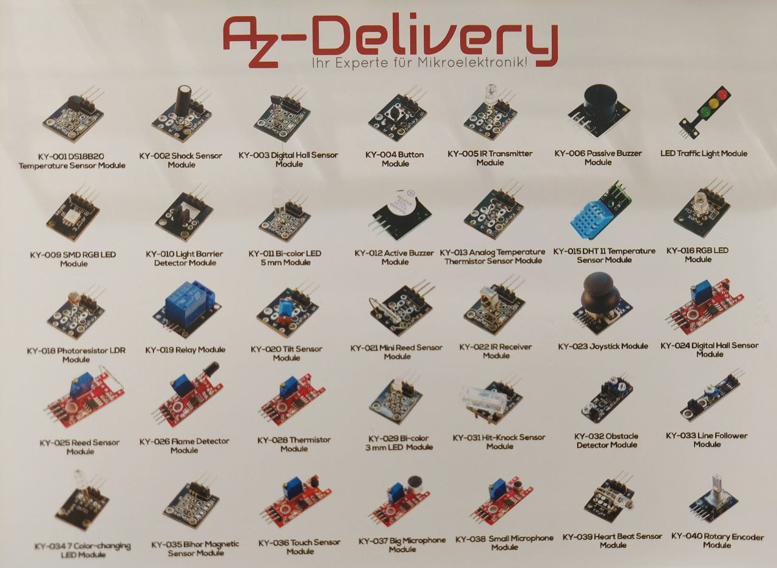

1.2 Gateways
Types of Gateways: Raspberry Pi board version 3, 4 or 5 with LoRa hat & Antenna.

1.3 Most Used Sensors
Full sensor catalogue: Lab Resources — WaziLab

- DHT11 / DHT22 — Humidity and Temperature Sensor
- Capacitive Soil Moisture Sensor v1.2
- IR-08H Infrared Obstacle Avoidance Sensor
- PIR Motion Sensor (Passive Infrared)
- Analog pH Sensor
- Photoresistor (Light Sensor)

2. Setting Up the LoRa Development Board

2.1 Physical Wiring
Attach your IoT sensors (temperature, LED, …) to the development board via wires, using the breadboard if needed. Be careful of the input and output of the sensors (VCC, GND …).
There are 2 ways of connecting sensors with wires to the board:

Method A — Via Breadboard (Recommended for Beginners)
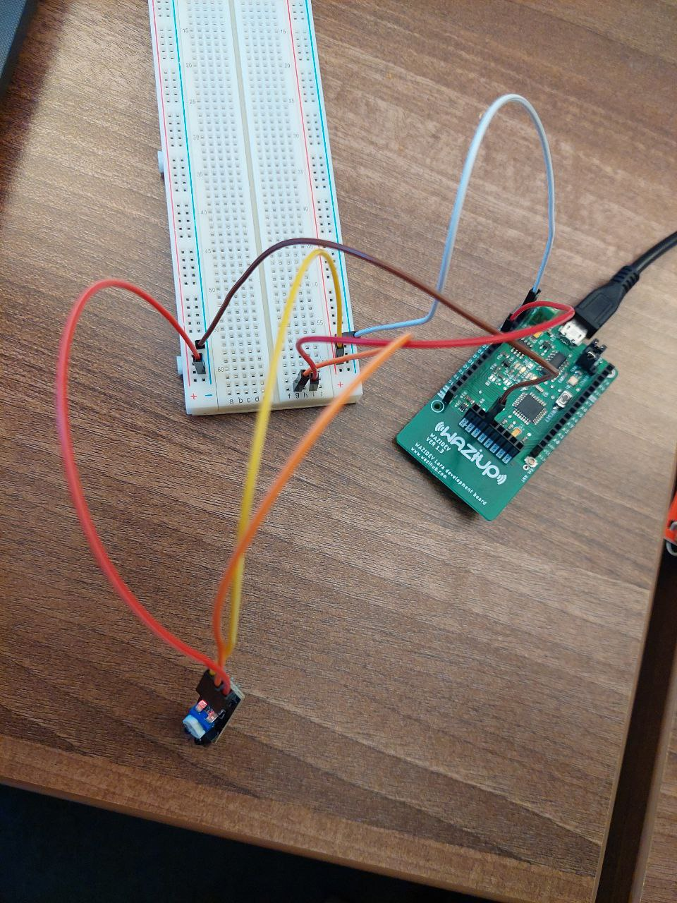
Every sensor has mainly 2 to 4 pins: +, −, out OR VCC, GND, Out. You can imagine VCC as positive and GND as negative.
Connect the negative (GND) pin to the blue row on the breadboard, then run a wire from that row to the GND pin on the board. Do the same for VCC (positive) on a different row. For the output pin, connect to one of the a–j holes and run a branch to one of the A0–A7 or D0–D7 pins on the board.

Method B — Direct with Jumper Wires
Tutorial: How to connect DHT11 Sensor with Arduino
You can connect sensors directly to the board with jumper wires only if you are sure everything is correct, you have no resistor, and you do not need to swap sensors frequently. The breadboard is always better for prototyping.

2.2 Programming — Arduino IDE Setup
After everything is attached, connect your board to your laptop via the USB cable.
Install Arduino IDE: Download and install Arduino IDE

Install WaziDev Libraries
WaziDev official repository: GitHub — Waziup/WaziDev
WaziDev library: GitHub — Waziup/wazidev-lib
Click the green Code button → Download ZIP. Then in Arduino IDE: Sketch → Include Library → Add .ZIP Library and select the downloaded file.
Also add LoRa libraries: Sketch → Include Library → Manage Libraries → Install "LoRa" by Sandeep Mistry.
Extract the WaziDev library to your Arduino Sketch folder: File → Preferences to find the path, then navigate to: C:\users\...\Arduino\Sketch and place the WaziDev master folder there.

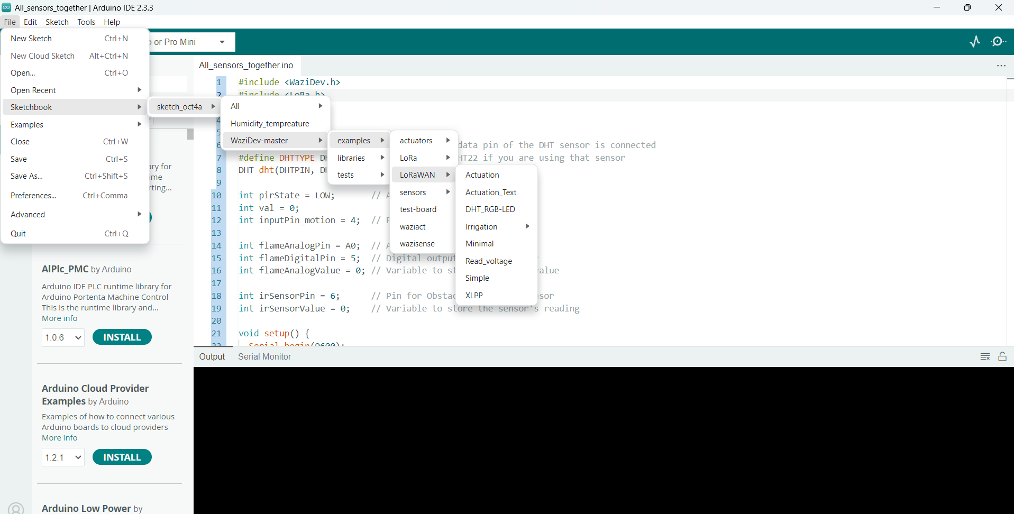
Also download the XLPP repository: https://github.com/Waziup/xlpp

Optional: ESP Board Libraries
ℹ Only needed if your project uses ESP8266/ESP32 boards — not required for WaziDev-only projects.
Go to File → Preferences → paste this URL in "Additional Board Manager URLs":
◼ CODE
http://arduino.esp8266.com/stable/package_esp8266com_index.json

Then go to Boards Manager → search ESP8266 → Install.

Additional Libraries
You also need the Base64 library for encoding/decoding data with HTTP/MQTT/APIs:
arduino-base64 on GitHub
You may also need the AES library: go to Arduino Library Manager → search "AESlib" by Matej Sychra → Install.

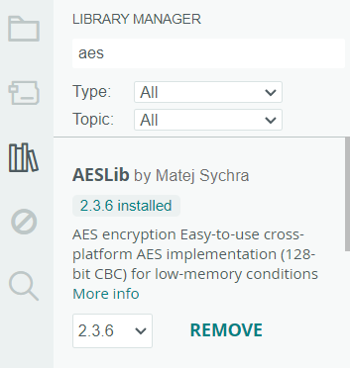

Sensor-Specific Libraries
For humidity/temperature sensors (DHT11/DHT22): Sketch → Include Library → Manage Libraries → Install "DHT sensor library" by Adafruit.
Choose the correct board: Tools → Board (most often: Arduino Pro or Pro Mini). Then set the port: Tools → Port → select your serial port. Set processor: Tools → Processor → ATMega 328P (3.3V, 8MHz).

ℹ When you add the WaziDev library to Arduino it already includes xlpp, base64 and other libraries inside it — but experience shows it is better to install them manually as well!

After installing all libraries, your library list should look like this:
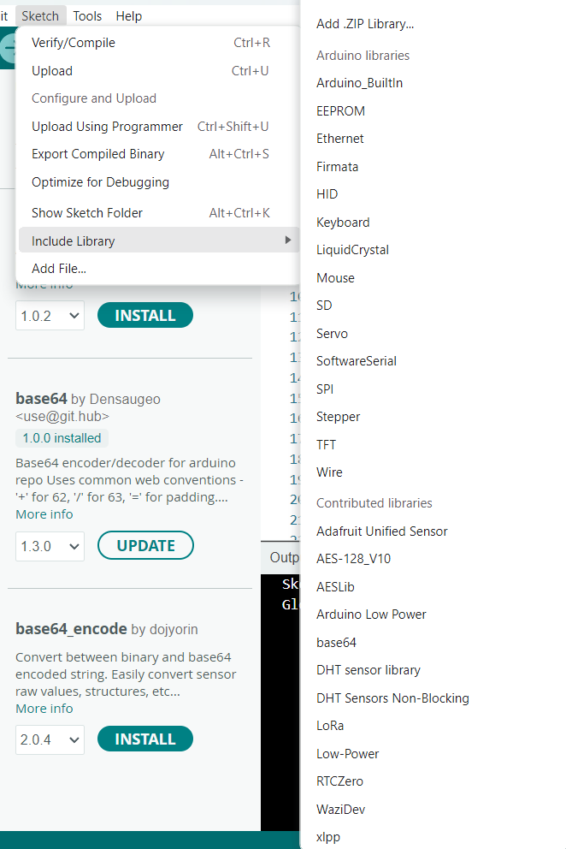

Code Examples
Wiring and programming sensors: WaziLab tutorial
Arduino Programming guide: WaziLab tutorial

2.3 Device Keys — Address, NetworksKey & AppKey
⚠ Very important! You must generate and embed Device Address, NetworksKey and AppKey in your Arduino code to connect to the Raspberry Pi gateway.
Full guide: Sensor Device Preparation — WaziLab
Generate hex numbers here: Random Hex Generator — Browserling
Generate two 32-digit hex numbers and one 8-digit hex number, then convert the hex strings to byte arrays and insert them in your Arduino code. Done now proceed to set up the gateway.

3. Gateway (Raspberry Pi) Setup

3.1 Download & Flash WaziGate OS
ℹ Before setting up the Raspberry Pi as a LoRa gateway, you need to download and flash the WaziGate operating system onto an SD card. WaziGate is the official free gateway software from Waziup — it turns a Raspberry Pi into a fully functional LoRaWAN gateway that auto-syncs to WaziCloud.

Official WaziGate Downloads: https://downloads.waziup.io/

ℹ WHAT IS "FLASHING"? The Raspberry Pi has no built-in storage — it boots from a microSD card. Flashing means writing the WaziGate operating system onto that card so the Pi knows what to do when it powers on.

- Go to https://downloads.waziup.io/ and download the latest WaziGate image file (ends in .img.gz or .zip).
- Download and install Balena Etcher from https://etcher.balena.io/ — free, works on Windows, Mac and Linux.
- Insert your microSD card (minimum 8 GB) into your laptop using a USB card reader.
- Open Balena Etcher → click 'Flash from file' → select the WaziGate image.
- Click 'Select target' → choose your SD card. IMPORTANT: double-check you selected the SD card and not your laptop drive!
- Click 'Flash!' and wait 3–5 minutes.
- Once done, safely eject the SD card and insert it into the slot on the underside of the Raspberry Pi.

✔ The Raspberry Pi now has WaziGate installed. Continue with physical setup below.

3.2 Enable SSH on the SD Card
Open the root directory of the SD card on your computer (accessible without special permission). Create an empty file named ssh (no extension, no content) in the boot directory. Eject the SD card, reinsert it into the Pi and power it on. SSH is now enabled.

3.3 Physical Assembly
- Insert the SD card into the slot on the underside of the Raspberry Pi.
- (Optional) Install heat sinks on the board to prevent overheating.
- Install the LoRa hat on top of the Raspberry Pi GPIO pins and attach the antenna.
- Connect the power cable to the left-side USB port and plug the USB end into power.
- Power on — the green LED should light up after a few seconds.
- Connect a LAN/Ethernet cable from the Pi to your router (needed for the first setup see Section 3.7 to remove this requirement later).

3.4 Find the Pi's IP Address & SSH In
Find the Raspberry Pi IP address using Advanced IP Scanner on your computer, or by logging into your router settings (e.g., 192.168.0.3 in the browser), going to DHCP Clients, and finding "WaziGate" or "Raspberry" in the list. Write down this IP address.
Then open Command Prompt (Windows) or Terminal (Mac/Linux) and type:
◼ CODE
ssh pi@<raspberry-IP-address>
# Example:
ssh pi@192.168.0.107

The password is: loragateway

3.5 Configure the Gateway (raspi-config)
After logging in, a blue configuration window appears. Go to option 4 (Synchronization) and enter your WaziCloud username and password. Then check option 1 (Network Settings) to confirm the gateway is accessible.

3.6 Access WaziGate Dashboard
Way 1: In your browser type: http://wazigate.local/#/login
Username: admin | Password: loragateway. You should see your LoRa gateway listed with a green link icon.
Way 2: Type the Pi's IP address directly in the browser URL bar.

Configuration video tutorials: WaziGate — WaziLab

3.7 Make WaziGate Its Own WiFi Hotspot (No Ethernet Needed)
ℹ Once the hotspot is set up, you no longer need an Ethernet cable connected to the Pi. The Pi broadcasts its own WiFi network — your laptop, phone, and ESP32 boards all connect to it directly. This is perfect for classroom demos and field deployments with no router.

What is Access Point Mode?
Normally the Raspberry Pi connects to a router, the same way your phone connects to home WiFi. Access Point mode reverses this: the Pi becomes the router, broadcasting its own private WiFi. Everything connects through the Pi - no internet needed.

Method A — RaspAP (Recommended — One Command)
ℹ RaspAP is a free tool that turns the Pi into a WiFi hotspot with one command, plus a web dashboard to manage settings. Recommended if you have never configured Linux networking before.
⚠ You need an internet connection (via Ethernet) once to install RaspAP. After installation, the Ethernet cable is no longer needed.

- SSH into the Pi as described in Section 3.4.
- Run this single command:
◼ CODE
curl -sL https://install.raspap.com | bash

- Press Y and Enter for every prompt. The Pi reboots automatically.
- After reboot the Pi broadcasts a WiFi network with these defaults:
- Network name (SSID): raspi-webgui
- Password: ChangeMe
- Use this document https://app.wazilab.io/resources/waziup-e-v/wazigate/docs/bGuPUvE1_Sx#connect-to-your-gateway to know how you can download AngryIP software to find the local IP of your PI, so you can SSH locally without Ethernet.
- If you have problem with AngryIP, just run systemctl in terminal
- Pi's local IP address: 10.3.141.1 (Example)
- Connect your laptop to "raspi-web gui" with password "ChangeMe".
- Open a browser and go to: http://10.3.141.1
- Log in (username: admin, password: secret) and change the network name and password to something meaningful for your team.
- Update the WiFi name and password in your ESP32 Arduino code to match.

✔ Done! Your Pi is a WiFi hotspot. Access WaziGate at http://wazigate.local or http://10.3.141.1 while your laptop is connected to the Pi network.

Method B — Manual Setup (Advanced)
ℹ This method uses two built-in Linux tools: hostapd (the WiFi transmitter — broadcasts the network signal) and dnsmasq (the address manager — gives each connecting device its own IP address, like a receptionist handing out visitor badges).

Step 1 — Install tools
◼ CODE
sudo apt update
sudo apt install hostapd dnsmasq -y
sudo systemctl stop hostapd
sudo systemctl stop dnsmasq

Step 2 — Assign a fixed IP address to the Pi
The Pi needs a permanent, predictable address on its own network:
◼ CODE
sudo nano /etc/dhcpcd.conf

Scroll to the bottom and add:
◼ CODE
interface wlan0
static ip_address=192.168.4.1/24
nohook wpa_supplicant

Save and exit: Ctrl+X → Y → Enter.

Step 3 — Configure DHCP (address assignment)
◼ CODE
sudo mv /etc/dnsmasq.conf /etc/dnsmasq.conf.backup
sudo nano /etc/dnsmasq.conf

Type exactly:
◼ CODE
interface=wlan0
dhcp-range=192.168.4.2,192.168.4.20,255.255.255.0,24h
# Gives addresses .4.2 to .4.20 to connecting devices, valid 24h

Save and exit.

Step 4 — Configure the hotspot
◼ CODE
sudo nano /etc/hostapd/hostapd.conf

Type the following — replace "RaspberryPi-AP" with your team name and "YourPassword123" with a password of at least 8 characters:
◼ CODE
# WiFi interface
interface=wlan0
driver=nl80211
# Network name — CHANGE THIS
ssid=RaspberryPi-AP
hw_mode=g # 2.4 GHz — compatible with all devices
channel=7
wmm_enabled=0
macaddr_acl=0
auth_algs=1
ignore_broadcast_ssid=0
# Password — CHANGE THIS (minimum 8 characters)
wpa=2
wpa_passphrase=YourPassword123
wpa_key_mgmt=WPA-PSK
wpa_pairwise=TKIP
rsn_pairwise=CCMP

Step 5 — Point hostapd to the config
◼ CODE
sudo nano /etc/default/hostapd

Find the line: #DAEMON_CONF="" and change it to:
◼ CODE
DAEMON_CONF="/etc/hostapd/hostapd.conf"

(The # symbol "comments out" a line — removing it activates it.)

Step 6 — Enable and reboot
◼ CODE
sudo systemctl unmask hostapd
sudo systemctl enable hostapd
sudo systemctl start hostapd
sudo systemctl start dnsmasq
sudo reboot

✔ After reboot the Pi broadcasts your WiFi network. The Pi's IP address is 192.168.4.1. Connect your laptop to it.

Connecting Devices to the Pi Hotspot
In your ESP32 Arduino code — update the WiFi credentials:
◼ CODE
// Change to match your hotspot name and password
const char* ssid = "RaspberryPi-AP";
const char* password = "YourPassword123";
// Pi is always at 192.168.4.1 on its own hotspot
const char* serverURL = "http://192.168.4.1:5000/data";

From your laptop browser (while connected to Pi WiFi):
- WaziGate dashboard: http://wazigate.local or http://192.168.4.1
- Flask/Python API: http://192.168.4.1:5000
- Your HTML dashboard: http://192.168.4.1:3000

Troubleshooting — Hotspot Not Working?
Problem | Solution
Cannot see the WiFi network | SSH into Pi and run: sudo systemctl status hostapd — look for errors. Most common cause: typo in hostapd.conf.
Can see network but can't connect | Password must be at least 8 characters. Confirm you removed the # from /etc/default/hostapd.
Connected but cannot reach 192.168.4.1 | Run: sudo systemctl status dnsmasq. Verify the static IP lines in /etc/dhcpcd.conf have no extra spaces.
ESP32 connects but server gets no data | Start your server with host="0.0.0.0" not "127.0.0.1". The 0.0.0.0 means "listen on all network interfaces including WiFi".
Pi loses internet when hotspot is on | Expected — wlan0 is now the hotspot. Connect via Ethernet cable if you need internet at the same time.

4. WaziCloud — Data in the Cloud

4.1 Create Your Account
Go to dashboard.waziup.io and register an account. Your username is your email address.

4.2 Visualise Sensor Data on WaziCloud
Set your devices on WaziCloud either manually or let the gateway auto-create them. If the gateway is running, sensors appear automatically under your device on the dashboard.
If doing it manually:
Watch: LoRaWAN Sensing & Actuating video
Test your sensors by checking real-time data on the WaziCloud dashboard. For example, put the soil moisture sensor in soil and confirm values change.

4.3 Python — Real-Time Data via MQTT
Get sensor data from the gateway using Python. Install dependencies first:
◼ CODE
pip install pycryptodome paho-mqtt requests

Test the MQTT connection:
◼ CODE
curl -X GET "https://api.waziup.io/api/v2/devices"

If data appears in the terminal, MQTT is working. Now write a Python script — change the IP to your WaziGate IP and update sensor names to match your Arduino code:
Example code repo: Constructor-University-Waziup/Waziup-example-codes
Run it:
◼ CODE
python mqtt_to_plot.py

IoT data analysis tutorial: WaziLab

4.4 Alternative Cloud & Visualisation Platforms
You are not limited to WaziCloud. You can also use:
- InfluxDB Cloud — store gateway data in an external cloud, visualise with Grafana
- MongoDB, AWS, Azure — flexible storage options
- Tableau — for data analysis and visualisation

Example: Using InfluxDB + Grafana
- Go to influxdata.com and create a free account on the cloud platform.
- Create a new bucket called wazi_sensors.
- Go to Manage Database → Security → Tokens → Generate All Access API Token. Write this token down — you will need it.
- Write a Python script with your DevAddress, AppsKey, NwsKey, sensor names, gateway IP and the InfluxDB token:
Example script: Waziup-example-codes on GitHub
- Run:
◼ CODE
python mqtt_to_influx.py

Query your data in InfluxDB using SQL:
◼ CODE
SELECT *
FROM "temperature"
WHERE
time >= now() - interval '15 minutes'

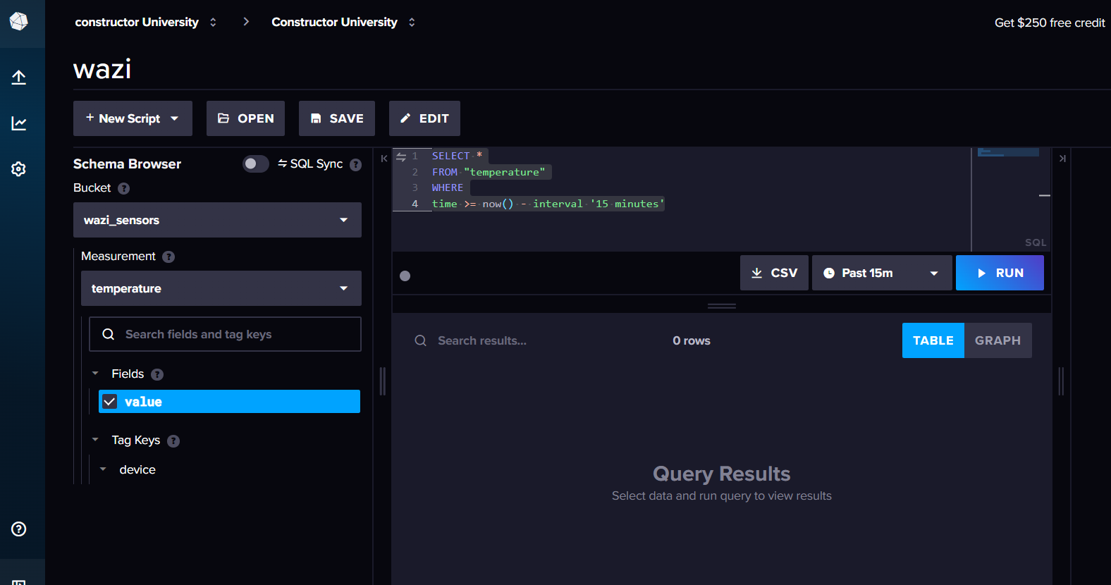

4.5 Continuous 2-Week Data Collection
For long-term data collection, set up a Python script on the Raspberry Pi itself to push data directly to InfluxDB via HTTP API or MQTT:
◼ CODE
SSH pi@<raspberry-pi-ip>
sudo apt update
sudo apt install python3 python3-pip -y
pip3 install paho-mqtt requests pycryptodome matplotlib
scp mqtt_to_influx.py pi@192.168.0.100:/home/pi/
python3 mqtt_to_influx.py

To keep it running after reboot, add to crontab:
◼ CODE
crontab -e
@reboot python3 /home/pi/mqtt_to_influx.py

Or use:
◼ CODE
nohup python3 mqtt_to_influx.py &

4.6 Remote Access with Tailscale
To SSH into the Raspberry Pi from anywhere without being on the same network:
◼ CODE
curl -fsSL https://tailscale.com/install.sh | sh
sudo tailscale up

Also install Tailscale on your laptop: tailscale.com/download
Log in with the same account on both devices. Then SSH from anywhere:
◼ CODE
ssh pi@raspberrypi-name.tailnet-yourname.ts.net
# or use the IP shown in Tailscale device list:
ssh pi@100.x.x.x

5. Setting Up the ESP32 Board with WiFi
ℹ WHAT IS AN ESP32? It is a small microcontroller chip with built-in WiFi and Bluetooth — like the WaziDev but it communicates over WiFi instead of LoRa radio. Use the ESP32 for short-range (same room / same building) projects, and the WaziDev for long-range (hundreds of metres to km) field deployments.

5.1 Add ESP32 to Arduino IDE
- Open Arduino IDE → File → Preferences.
- Find "Additional Board Manager URLs" and paste:
◼ CODE
https://raw.githubusercontent.com/espressif/arduino-esp32/gh-pages/package_esp32_index.json

- Click OK → Tools → Board → Boards Manager → search "esp32" → Install by Espressif Systems.
- Select board: Tools → Board → ESP32 Arduino → "ESP32 Dev Module".
- Set Tools → Upload Speed to 115200 and select your port under Tools → Port.

5.2 Key Libraries
Built-in with the ESP32 package (no download needed):
- WiFi.h — connects the ESP32 to any WiFi network
- HTTPClient.h — sends HTTP requests to a server (like a web browser)

Install from Library Manager (Sketch → Include Library → Manage Libraries):
- ArduinoJson — converts sensor data into JSON format for sending between devices
- PubSubClient — enables MQTT messaging with WaziGate

5.3 Example: Sending Sensor Data to Raspberry Pi via WiFi
◼ CODE
#include <WiFi.h>
#include <HTTPClient.h>

// ---- change these to your Pi hotspot name and password ----
const char* ssid = "RaspberryPi-AP";
const char* password = "YourPassword123";
// Pi is always at 192.168.4.1 on its own hotspot
const char* serverURL = "http://192.168.4.1:5000/data";

void setup() {
Serial.begin(115200);
WiFi.begin(ssid, password);
Serial.print("Connecting to WiFi");
while (WiFi.status() != WL_CONNECTED) {
delay(500); Serial.print(".");
}
Serial.println(" Connected!");
}

void loop() {
if (WiFi.status() == WL_CONNECTED) {
HTTPClient http;
http.begin(serverURL);
http.addHeader("Content-Type", "application/json");
// Replace 25.3 and 60 with real sensor readings
String payload = "{\"temperature\": 25.3, \"humidity\": 60}";
int code = http.POST(payload);
Serial.print("Response: "); Serial.println(code);
// 200 = success
http.end();
}
delay(10000);
// send every 10 seconds
}

✔ When 200 appears in the Serial Monitor, the ESP32 is sending data successfully to the Pi.

6. Web Applications — HTML, CSS & JavaScript
ℹ This section shows you how to build a web dashboard to display IoT sensor data using only the three languages every browser understands natively: HTML (structure), CSS (visual design), and JavaScript (logic). No installation, no frameworks, no command line needed — just a text editor and a browser.

6.1 What Is a Web Dashboard?
A web dashboard is a page that automatically fetches the latest sensor readings from your Raspberry Pi and displays them in a browser. Your team's laptop, phone or tablet all access the same page by visiting a URL while connected to the Pi WiFi hotspot.

IoT Web Apps tutorial: WaziLab

6.2 Create Your First Dashboard File
Create a new file called index.html on your laptop. Open it in any text editor (Notepad, VSCode, TextEdit). Copy the complete starter template below — this one file contains everything: HTML structure, CSS styling and JavaScript logic all together.

Complete Starter Dashboard (one file — copy this exactly):
◼ CODE
<!DOCTYPE html>
<html lang="en">
<head>
<meta charset="UTF-8">
<meta name="viewport" content="width=device-width, initial-scale=1.0">
<title>IoT Sensor Dashboard</title>

<style>
/* ---- Page layout ---- */
body {
font-family: Arial, sans-serif;
background: #1B2631;
color: #FFFFFF;
margin: 0;
padding: 20px;
}
h1 { color: #85C1E9; text-align: center; }

/* ---- Sensor card grid ---- */
.grid {
display: grid;
grid-template-columns: repeat(auto-fit, minmax(200px, 1fr));
gap: 20px;
margin-top: 30px;
}
.card {
background: #2E4057;
border-radius: 12px;
padding: 24px;
text-align: center;
border-top: 4px solid #2471A3;
}
.card .label { font-size: 14px; color: #AED6F1; margin-bottom: 8px; }
.card .value { font-size: 42px; font-weight: bold; color: #FFFFFF; }
.card .unit { font-size: 18px; color: #85C1E9; }

/* ---- Status bar ---- */
#status {
text-align: center;
margin-top: 20px;
font-size: 13px;
color: #888;
}
</style>
</head>

<body>
<h1>IoT Sensor Dashboard</h1>

<!-- Sensor cards — add or remove as needed -->
<div class="grid">
<div class="card">
<div class="label">Temperature</div>
<div class="value" id="temperature">--</div>
<div class="unit">°C</div>
</div>
<div class="card">
<div class="label">Humidity</div>
<div class="value" id="humidity">--</div>
<div class="unit">%</div>
</div>
<div class="card">
<div class="label">Soil Moisture</div>
<div class="value" id="moisture">--</div>
<div class="unit">%</div>
</div>
</div>
<div id="status">Waiting for data...</div>

<script>
// ---- Change this URL to your Raspberry Pi address ----
const API_URL = "http://192.168.4.1:5000/data";

function updateDashboard() {
// fetch() asks the server for the latest sensor data
fetch(API_URL)
.then(response => response.json())
.then(data => {
// update each card with the value from the server
document.getElementById("temperature").textContent = data.temperature;
document.getElementById("humidity").textContent = data.humidity;
document.getElementById("moisture").textContent = data.moisture ?? "--";
document.getElementById("status").textContent =
"Last updated: " + new Date().toLocaleTimeString();
})
.catch(err => {
document.getElementById("status").textContent = "Error: " + err.message;
});
}

updateDashboard(); // run once immediately
setInterval(updateDashboard, 5000); // then every 5 seconds
</script>
</body>
</html>

6.3 Run the Dashboard
ℹ You need a small Python server running on the Raspberry Pi that the HTML page fetches data from. See the Flask example in Section 6.4 below.
- Make sure your laptop is connected to the Raspberry Pi WiFi hotspot (Section 3.7).
- Open the index.html file directly in your browser — either double-click it, or serve it from the Pi.
- The page fetches fresh data from the Pi every 5 seconds automatically.

6.4 Python Flask Backend on the Pi
The dashboard HTML fetches data from a URL. You need a simple Python server running on the Pi that responds with JSON sensor data. Install Flask and run this on the Pi:
◼ CODE
pip3 install flask

Create a file called app.py on the Pi:
◼ CODE
from flask import Flask, jsonify
app = Flask(__name__)

# This stores the most recent sensor reading
latest_data = {"temperature": 0, "humidity": 0, "moisture": 0}

# The dashboard fetches from this URL
@app.route("/data")
def get_data():
return jsonify(latest_data)

# The ESP32 posts to this URL
@app.route("/data", methods=["POST"])
def receive_data():
from flask import request
global latest_data
latest_data = request.json
return jsonify({"status": "ok"})

if __name__ == "__main__":
# 0.0.0.0 = listen on WiFi too, not just local
app.run(host="0.0.0.0", port=5000)

Run it:
◼ CODE
python3 app.py

✔ ESP32 POSTs sensor readings to http://192.168.4.1:5000/data. The HTML dashboard GETs the same URL. Both see fresh data.

6.5 Add a Chart to the Dashboard
To show a live graph, add Chart.js from a CDN (no installation needed). Insert these additions into your index.html:
◼ CODE
<!-- Add in <head> -->
<script src="https://cdn.jsdelivr.net/npm/chart.js"></script>

<!-- Add in <body> after the grid div -->
<canvas id="myChart" style="max-width:700px; margin:30px auto; display:block;"></canvas>

<!-- Add in <script>, before the closing </script> -->
const labels = [];
const tempData = [];
const ctx = document.getElementById("myChart").getContext("2d");
const chart = new Chart(ctx, {
type: "line",
data: {
labels: labels,
datasets: [{
label: "Temperature (°C)",
data: tempData,
borderColor: "#2471A3",
backgroundColor: "rgba(36,113,163,0.15)",
tension: 0.3
}]
}
});

// In your updateDashboard function, after setting values, add:
labels.push(new Date().toLocaleTimeString());
tempData.push(data.temperature);
if (labels.length > 20) { labels.shift(); tempData.shift(); }
// keep only last 20 points
chart.update();

6.6 Databases for IoT Applications
To store sensor data permanently, you can use:
- SQL (PostgreSQL, MySQL) — good for structured, table-based data
- NoSQL (MongoDB, Firebase) — flexible for IoT data with varying fields

Example: Store Data in MongoDB
◼ CODE
sudo apt update
sudo apt install mongodb -y

Python API to store incoming sensor data in MongoDB:
◼ CODE
from flask import Flask, request, jsonify
from pymongo import MongoClient
app = Flask(__name__)
client = MongoClient("mongodb://localhost:27017/")
db = client["iotDB"]
col = db["sensor_data"]

@app.route("/data", methods=["POST"])
def save_data():
col.insert_one(request.json)
return jsonify({"message": "Saved!"})

if __name__ == "__main__":
app.run(host="0.0.0.0", port=5000)

6.7 Data Security
IoT applications should comply with GDPR and ISO 27001 standards. Key principles:
- Encrypt sensitive sensor data
- Use authentication and authorisation for all API endpoints
- Use HTTPS instead of HTTP for production deployments

Example: Simple API Key Protection
◼ CODE
API_KEY = "my_secret_key"

@app.route("/secure-data", methods=["GET"])
def secure_data():
if request.headers.get("API-KEY") != API_KEY:
return jsonify({"error": "Unauthorized"}), 401
return jsonify({"message": "Access granted"})

6.8 Real-Time Updates with WebSockets
For instant updates (without polling every 5 seconds), use WebSockets:
- MQTT — best for IoT devices communicating with the gateway
- WebSockets — best for pushing live data directly to a web page

◼ CODE
# Python WebSocket client example
pip install websocket-client

import websocket
def on_message(ws, message):
print(f"Received: {message}")

ws = websocket.WebSocketApp("ws://192.168.1.100:81", on_message=on_message)
ws.run_forever()

6.9 Mobile App Development
To display IoT sensor data on a smartphone app you can use:
- React Native — builds for both iOS and Android from one codebase
- Flutter — Google's framework, also cross-platform
Both require some programming knowledge. For the CIP course, a well-designed HTML dashboard served from the Pi is usually sufficient and much simpler to build.

7. Team-Specific Sensor Guides — CIP Course
ℹ Find your team below. Only the sensors in your team section are relevant to you. Every step is explained from scratch — no prior electronics knowledge required.

7.1 Team 1 — DiverseGrow: Smart Agricultural Cooperative Platform
ℹ DiverseGrow is primarily a SOFTWARE platform (web and mobile app). You do NOT need to purchase any hardware unless your team decides to add the optional IoT extension. If you are only building the app, skip to Section 6.

Optional IoT Extension — Only if you want live farm data in the app
If your team decides to add real sensor readings from the field, these components are recommended. They are entirely optional — the platform works without them.
- WaziDev LoRaWAN board — microcontroller that sends sensor data over LoRa radio to the gateway, hundreds of metres without WiFi
- Capacitive Soil Moisture Sensor — measures soil wetness. Connects to pin A0. Does not corrode unlike resistive sensors.
- DHT22 — air temperature and humidity. Connects to D2 with 10 kΩ pull-up resistor.
- Analog pH Sensor — soil acidity (important for crop health). Connects to A1.
- Water Flow Sensor YF-S201 — counts pulses as water flows through a pipe (irrigation volume). Digital interrupt pin.
- Ultrasonic Sensor HC-SR04 — measures distance using sound pulses (water tank level). Needs TRIG pin and ECHO pin.
- Solar Panel 5–10W + Charge Controller — off-grid power for field deployment

⚠ If your team is NOT adding IoT extension, you do not need any hardware. Skip this team section entirely.

7.2 Team 2 — Smart Solar Dryer for Small Farmers (Rwanda)
This team builds a fully hardware-integrated prototype. All components listed below are required.
ℹ WHAT IS A SENSOR PIN? Every sensor has small metal legs called "pins". Connect them to the board with jumper wires. VCC = power (3.3V or 5V), GND = ground / negative, DATA or OUT = the signal that carries the measurement.

Sensor 1 — DHT22: Temperature & Humidity Inside the Drying Chamber
Measures air temperature (°C) and relative humidity (%) inside the solar dryer box.

Wiring:
VCC (Pin 1) → 3.3V or 5V on board — power supply
GND (Pin 4) → GND on board — ground / negative
DATA (Pin 2) → D2 on board — add 10 kΩ resistor between DATA and VCC

Library: Sketch → Manage Libraries → search "DHT sensor library" → Install by Adafruit. Also install "Adafruit Unified Sensor".
◼ CODE
#include <DHT.h>
#define DHTPIN 2 // Data pin D2
#define DHTTYPE DHT22
DHT dht(DHTPIN, DHTTYPE);

void setup() { Serial.begin(9600); dht.begin(); }
void loop() {
float temp = dht.readTemperature();
float hum = dht.readHumidity();
Serial.print("Temp: "); Serial.print(temp); Serial.print("C ");
Serial.print("Humidity: "); Serial.println(hum);
delay(2000);
}

Sensor 2 — DS18B20 or Second DHT22: Outside Ambient Temperature
Measures temperature OUTSIDE the dryer. Comparing inside vs outside shows heating effectiveness.

Wiring (DS18B20):
Red (VCC) → 3.3V or 5V — power
Black (GND) → GND — ground
Yellow (DATA) → D4 — add 4.7 kΩ resistor between DATA and VCC

Libraries: install "DallasTemperature" by Miles Burton and "OneWire" by Jim Studt from Library Manager.

Sensor 3 — Anemometer: Airflow Speed
Measures how fast air moves through the chamber. Spinning cups trigger a pulse every rotation — the Arduino counts pulses per second to calculate metres/second.

Wiring:
VCC → 5V — power
GND → GND — ground
Signal/OUT → D3 — interrupt-capable pin — never misses a pulse
ℹ INTERRUPT PIN: A special pin that reacts instantly to a signal, pausing all other code. On WaziDev, D2 and D3 are interrupt-capable.

Sensor 4 — Load Cell + HX711 Amplifier: Crop Weight / Dryness
Measures the weight of produce on the drying tray. As moisture evaporates, weight decreases — the most reliable way to know when drying is complete.
ℹ HX711: The load cell produces a tiny electrical signal. The HX711 chip amplifies it to a level the Arduino can read. Always use them as a pair.

Wiring — HX711 to Arduino:
VCC → 5V — power
GND → GND — ground
DT (Data) → D5 — sends weight readings
SCK (Clock) → D6 — synchronises communication

Wiring — Load Cell to HX711:
Red → E+ | Black → E− | White → A− | Green → A+

Library: install "HX711" by bogde from Library Manager.
◼ CODE
#include <HX711.h>
HX711 scale;
void setup() {
Serial.begin(9600);
scale.begin(5, 6); // DT=D5, SCK=D6
scale.set_scale(2280.0); // calibration factor
scale.tare(); // zero the scale
}
void loop() {
float g = scale.get_units(1);
Serial.print("Weight: "); Serial.print(g); Serial.println(" g");
delay(1000);
}

Hardware 5 — I2C LCD Display (16×2 or 20×4)
Shows live sensor readings on the dryer without needing a phone. Use the I2C version — only 4 wires instead of 12.

Wiring (I2C):
VCC → 5V — power
GND → GND — ground
SDA → A4 (SDA) — data line
SCL → A5 (SCL) — clock line

Library: install "LiquidCrystal I2C" by Frank de Brabander.
ℹ I2C: a protocol that lets multiple devices share just 2 wires (SDA + SCL). Each device has a unique address number so the Arduino knows which one to talk to.

Hardware 6 — 12V DC Fan with Relay
⚠ NEVER connect a 12V fan directly to the Arduino. Use a relay module as a switch — the Arduino controls the switch, the switch controls the 12V power.

Relay to Arduino:
IN (signal) → D7 on Arduino — HIGH = relay ON, LOW = relay OFF
VCC → 5V — relay power
GND → GND — ground

Fan through relay:
Connect the 12V fan positive wire through the relay COM and NO terminals. When Arduino sets D7 HIGH, relay closes and fan runs.

Hardware 7 — Solar Panel + Battery + Charge Controller
The solar panel charges a 12V battery via the charge controller. The battery then powers everything. Recommended: 20–30W panel, 12V battery, PWM/MPPT controller.

Connection order — follow exactly:
- Solar panel wires → PV input terminals on charge controller
- 12V battery → BATT terminals on charge controller
- Load (fan, Arduino power supply) → LOAD terminals on charge controller
- Add a 12V-to-5V DC–DC buck converter to power the Arduino from the 12V system
⚠ Always connect: solar first, battery second, load last. Wrong order can damage the controller or cause sparks.

Board Choice: ESP32 (WiFi) vs WaziDev (LoRa)
- ESP32 (WiFi) — best for classroom demos. Range: same room/building.
- WaziDev (LoRa) — best for field deployment in Rwanda. Range: hundreds of metres to km.
💡 For CIP classroom prototype: use ESP32 + WiFi. For real deployment in Rwanda: switch to WaziDev + LoRa.

7.3 Team 4 — WeCare: Health, Equality & Technology
ℹ WeCare is primarily a MOBILE APP project (Bridge for Balance app). NO hardware is required. The sensors below are only if your team builds a physical health monitoring kiosk prototype.

1) MAX30102 — Heart Rate & Blood Oxygen (SpO2)
Shines a red/infrared LED through the fingertip — different amounts of light pass through oxygenated vs deoxygenated blood.
I2C wiring: VCC → 3.3V, GND → GND, SDA → A4, SCL → A5.
Library: "SparkFun MAX3010x" from Library Manager.

2) MLX90614 — Non-Contact Infrared Temperature
Measures body temperature without touching the patient — detects infrared heat radiating from skin.
I2C address 0x5A. Wiring: VCC → 3.3V, GND → GND, SDA → A4, SCL → A5 (shares bus with MAX30102).
Library: "Adafruit MLX90614" from Library Manager.

3) BME680 — Air Quality, VOC, Humidity & Temperature
Measures air quality index, volatile organic compounds, temperature, humidity and atmospheric pressure — good for monitoring clinic room conditions.
I2C address 0x76 or 0x77. Same wiring as above. Library: "Adafruit BME680" + "Adafruit Unified Sensor".

4) PIR Motion Sensor — Visitor/Footfall Counting
Detects movement. Output goes HIGH (1) when someone walks past, LOW (0) otherwise. Counts clinic visitors.
Wiring: VCC → 5V, GND → GND, OUT → D3. No library — use digitalRead(3) in code.

5) Sound Sensor — Noise Level Monitoring
Measures ambient noise. Useful for detecting crowded or distressed situations in a waiting room.
Wiring: VCC → 5V, GND → GND, AO → A0 (continuous level), DO → D4 (threshold trigger).

6) ESP32-CAM — Camera Module
⚠ ESP32-CAM has NO USB port. You need a USB-to-Serial (FTDI) adapter. During upload: connect IO0 to GND. After upload: disconnect IO0 from GND, then press Reset.
In Arduino IDE: Tools → Board → ESP32 Arduino → "AI Thinker ESP32-CAM".

8. Quick Reference

8.1 Default Credentials & Addresses
Problem | Solution
WaziGate Dashboard URL | http://wazigate.local or http://<Pi-IP>
WaziGate Login | Username: admin | Password: loragateway
SSH into Pi | ssh pi@<Pi-IP> | Password: loragateway
Pi hotspot IP (AP mode) | 192.168.4.1 (manual) or 10.3.141.1 (RaspAP)
WaziCloud | dashboard.waziup.io | Username: your email
Flask API default | http://192.168.4.1:5000/data

8.2 Arduino Library Quick List
Problem | Solution
DHT22 / DHT11 | DHT sensor library — by Adafruit + Adafruit Unified Sensor
DS18B20 | DallasTemperature (Miles Burton) + OneWire (Jim Studt)
HX711 (Load Cell) | HX711 — by bogde
LCD I2C | LiquidCrystal I2C — by Frank de Brabander
MAX30102 (Heart Rate) | SparkFun MAX3010x
MLX90614 (IR Temp) | Adafruit MLX90614 + Adafruit Unified Sensor
BME680 (Air Quality) | Adafruit BME680 + Adafruit Unified Sensor
ESP32 WiFi / HTTP | WiFi.h and HTTPClient.h — built into ESP32 board package
MQTT (PubSubClient) | PubSubClient — from Library Manager
JSON (ArduinoJson) | ArduinoJson — from Library Manager

8.3 Useful Links
WaziGate download: https://downloads.waziup.io/
Balena Etcher: https://etcher.balena.io/
WaziLab tutorials: https://lab.waziup.io/
WaziCloud dashboard: https://dashboard.waziup.io/
Arduino IDE download: https://support.arduino.cc/hc/en-us/articles/360019833020-Download-and-install-Arduino-IDE
Waziup example code repo: https://github.com/Constructor-University-Waziup/Waziup-example-codes
Tailscale (remote access): https://tailscale.com/download

