

GIORGIA

EDUCATION

**UI Designer**

Start2impact $∙$ January 2022 – February 2023

PROFILE

NUCARO

­­­

My name is Giorgia and one of my biggest passions is graphic design.

After graduating from high school I have decided to start the road to become a UI designer and follow my true passion.

User Interface, Graphic, Wireframing, Discovery, Copywriting, Design & Development, HTML e CSS.­­­­­­­

CONTACT ME

**specialization chemistry and materilas**

**Chemistry, materials and biotechnologies;**

Pordenone, Italy

[giorgianucaro03@gmail.com](mailto:giorgianucaro03@gmail.com)

+39 320 776 2580

I.T.S.T. J.F. Kennedy $∙$ September 2017 – June 2022

Organic chemistry and microbiology, analytical and instrumental chemistry, chemical and industrial technologies.

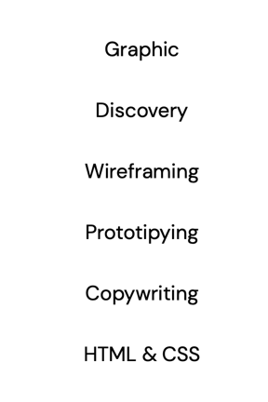­

**Hard skills**

**Soft skills**

**S**KIL**LS :**

**Software**

­­­­­