Test project structure follows Page Object Model (POM) design pattern.

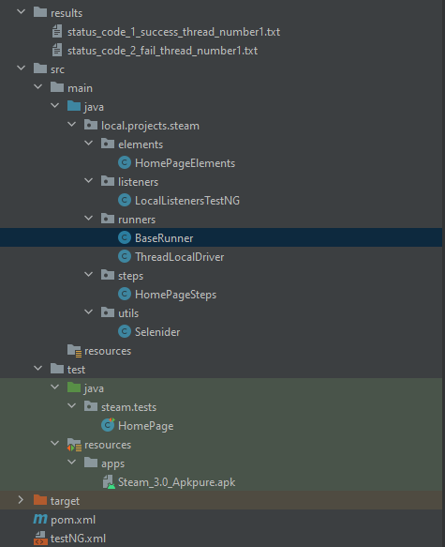



These classes handle driver initialization



Package for element selectors



Package with step objects



Package for listeners

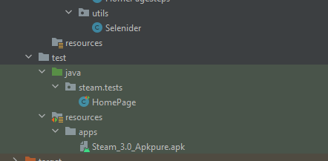

Helper class for easy writing with Selenium,

Test class and app installation file.

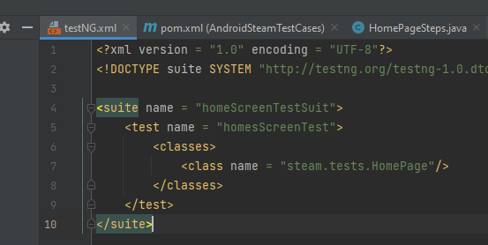

Testing.xml file to run test suit with HomePage.class tests.

Test results:

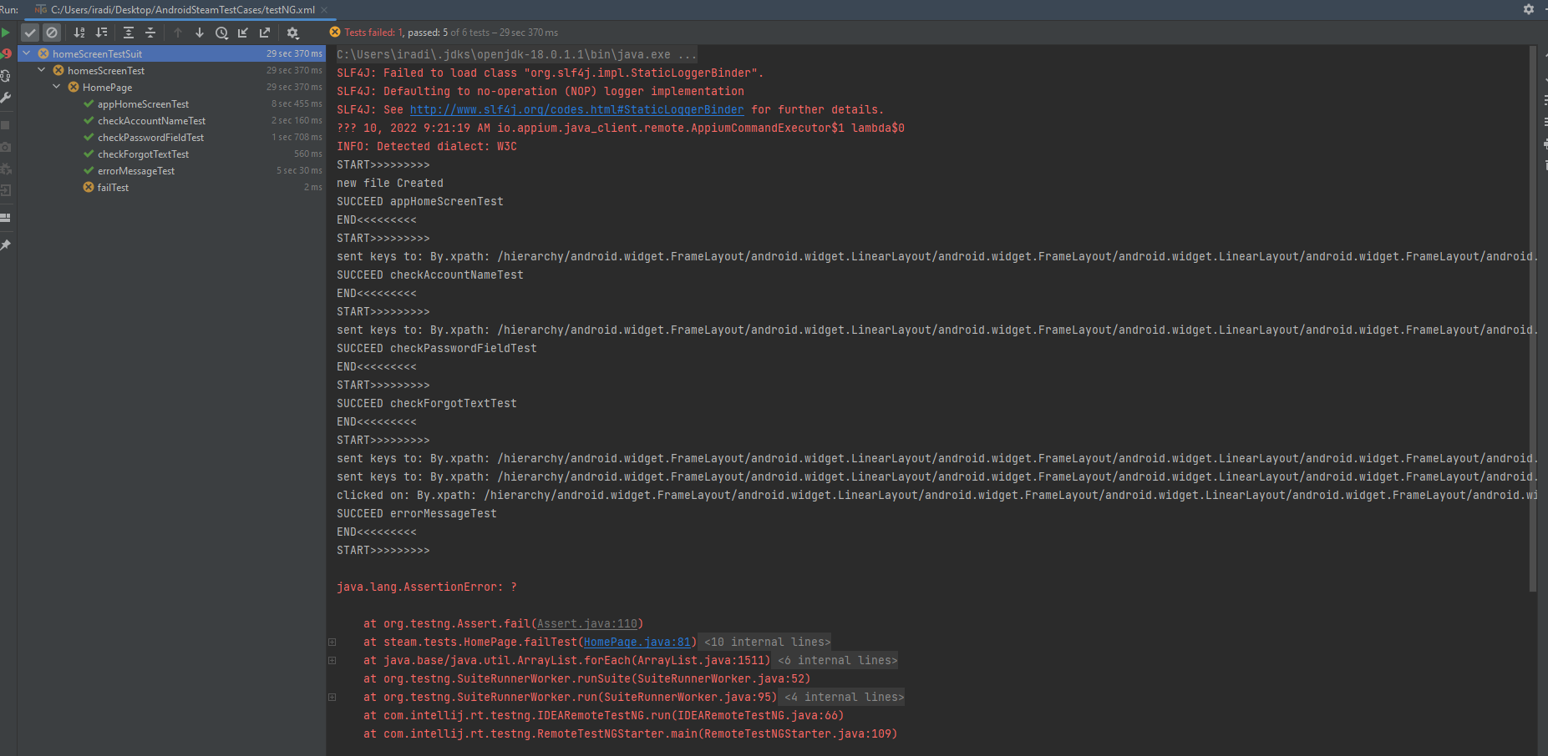

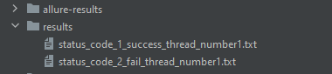

Allure results is used in most cases, but simple result files created by test listeners are also useful.

Short test descriptions:

check sign in is present and has exact text

check that account name field is visible and can be written

check that password field is visible and can be written

check that forgot text is visible

check that wrong password or account name error is visible

fail test

Appium server:

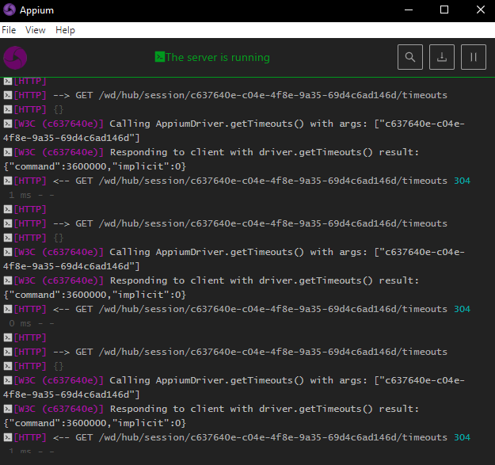

Appium inspector for elements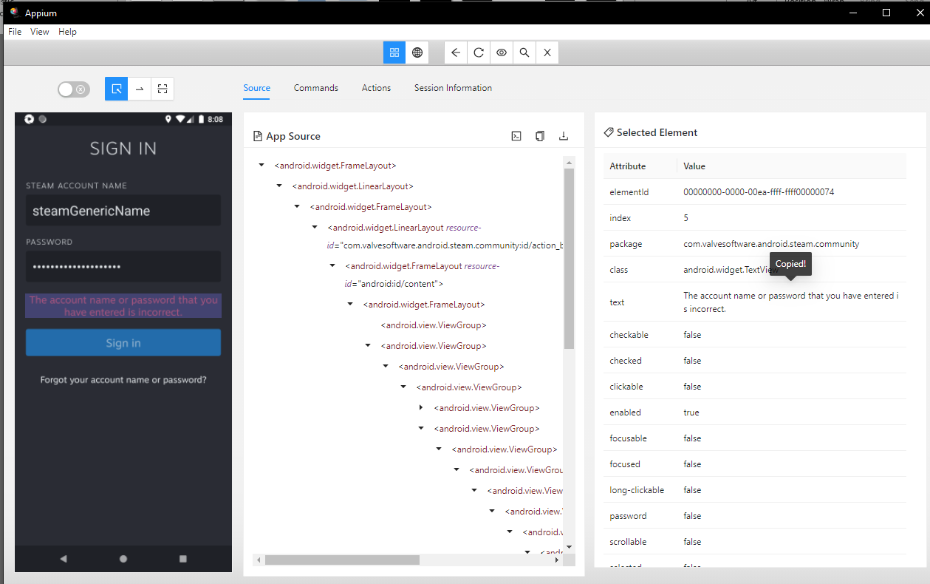

Android emulation:

