|  |  |  |
| --- | --- | --- |
| PDB ID: 5EE7  Complex or Apo-form: apo |  | Curator name: Toni Giorgino1,2, Elisa Fagnani2  Email: toni.giorgino@cnr.it  Affiliation:  1 Consiglio Nazionale delle Ricerche, Italy (CNR-IBF)  2 Dip. Bioscienze, Università degli Studi di Milano  Date: Mon Dec 7 10:28:59 2020 |
| We value your expert knowledge for your target structures. Make any refinement that is needed to satisfy your criteria of a correct receptor model. | | |

**STEP 1. Revision/refinement of modeled sections**. Refined structures are obtained with the automated refinement pipeline of GPCRdb (see relevant details in the anexo on the last page). In order to check for the quality of the refined structures, please superpose the original X-ray structure with the PDBID_apo.pdb and PDBID_complex.pdb.

1.1 Are you satisfied with the outcome of the modelling pipeline from GPCRdb?

Yes

1.2 Did you have to refine/remodel a section? If yes, please provide a detailed protocol for your refinement.

No

**STEP 2. Water placement** has been done with the HOMOLWAT server. Are there water molecules that have been wrongly placed (clashes, etc.) or are missing?

2.1 Please indicate water residue IDs that you had to delete or add into the PDBID_apo.pdb and PDBID_complex.pdb

Added waters: None

Deleted waters: None

**STEP 3. Sodium ion placement at the allosteric site D2.50**. Sodium ions have been placed by the HOMOLWAT server. The general rule is that a sodium ion is always placed in apo forms with a conserved D/E2.50. It is also placed in GPCRs in complex with an antagonist (inactive state). Sodium ions are not placed in structures that are in complex with a partial or full agonist (active state).

3.1 Is the sodium ion correctly placed according to the rules? If not, which modification did you need to carry out?

Na++ removed because binding is dubious for Class B receptors. The site is different, the residence time shorter. Not seen in any crystal structure so far [10.1002/anie.201708889, 10.1124/pr.119.017863].

**STEP 4. Assignment of protonation/tautomeric states**. The protonation/tautomeric states have been assigned using PROPKA.

Importantly, take special care of the (de)protonation state of residue D/E2.50:

* D/E2.50 should be deprotonated in the apo form and the antagonist-GPCR complex
* D/E2.50 should be protonated in the agonist-GPCR complex!

4.1 Based on your expert knowledge, please indicate if you would assign a different protonation/tautomeric state to a specific residue using the following nomenclature. Please change it in the PDBID_apo.pdb and PDBID_complex.pdb as well as indicated in the table below. Note: No hydrogens need to be added by curators. It is enough to assign the protonation states by renaming ASP to ASH or GLU to GLH in the structure.

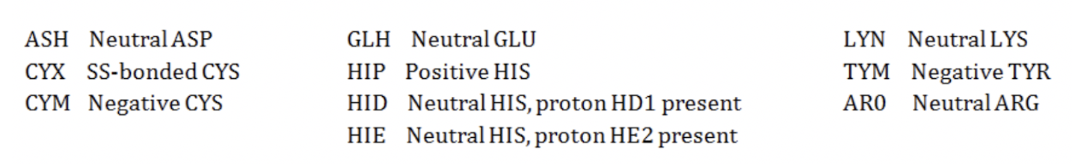

|  |  |
| --- | --- |
| Residue to be changed  (e.g. ASP81) | Newly assigned residue state  (e.g. ASH81) |
|  |  |
|  |  |

No change

**STEP 5. Assignment of disulfide bridges.** Please revise assigned disulfide bridges. Involved cysteine are indicated with CYX in the PDB file.

5.1 Please list missing disulfide bridges in the table below and rename corresponding cysteine in the PDBID_apo.pdb and PDBID_complex.pdb

None

|  |  |
| --- | --- |
| cystein 1  (e.g. CYX88) | cystein 2  (e.g. CYX200) |
|  |  |

**STEP 6. Chemical structure of ligand.** Ensure that the chemical structure of the complexed ligand is correct (Yes/No):

No ligand

**STEP 7. Additional curation and refinement steps.** In case you had to carry out additional refinement steps which are not covered by previous sections, please document them here.

nan

*Further notes by curators*:

nan

**STEP 8. File upload**. Please upload your curated structures and filled curation forms [here](https://drive.google.com/drive/folders/1zLWyjJQN2fbxevzqblETeGlsXSPTsBNc?usp=sharing). Use the following naming format for the PDB files: PDBID_apo_curated.pdb/PDBID_complex_curated.pdb and preserve the form’s original filename.

The final folder structure should look like this:

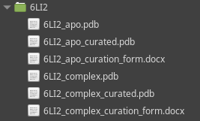

**ANEXO**

**Details about Refinement Pipeline via GPCRdb**

1. Receptor regions are partially remodeled despite having crystal structure coordinates: Distortions in the crystal packing or fused proteins can cause too short or too long TM1-7 and H8 starts and ends. For example, in several structures the intracellular ends of TM3 and TM4 have been corrected in length. This entails that also the ICL2 has been remodeled and deviates from the original crystal structure coordinates. More information about the protocol that yielded curated structures is found at "GPCRdb Homology Models - Less Model & More Crystal” (goo.gl/Qx2MNK).
2. ICL3 is not fused: If the ICL3 is not completely solved, ends will not be fused according to our elaborated standard protocol for GPCR MDs (Section 1, point 6 of the community standard protocol, goo.gl/45PIqC). Curators do not need to cap ends. This will be done later during system preparation.
3. N-terminal capping. Curators do not need to cap the N- and C-terminus. This will be done later during system preparation (Section 3, point 3 of the standard protocol, goo.gl/45PIqC).
4. Disulfide bridges. We ask the curators to assign disulfide bridges (CYS to CYX). We assume that in most cases disulfide bridges are correctly modelled based on available templates. However, in the case of a missing disulfide bridge, the curators are asked to model the disulfide bridge and the loop region around it.