For the special issue we would like to expand/update some of the study.

For latest versions of GPT 5, Gemini, Claude:
- Write out a text prompt which contains: software requirements, user stories, instructions to build the tetris game
- Run it with 1 try in each and see what the results are like

The results can be found at: https://github.com/giorgioamasanti/JSS_run_1

The Prompt
“””
You are to create a version of the game tetris in python. I will provide a brief description of the game, a list of requirements, and a set of user stories (which emphasise the requirements set out by different stakeholders).
Brief description
This will be an emulation of the classic computer game Tetris, written in python. It will feature a grid-based playing field and allow the player to control falling tetromino pieces (the classic ones in the game) with keyboard inputs. I will emphasise the importance of modularity and clear software architecture design, such that future features can be added. You should plan out the architecture and return the final result to me as a folder of .py files which I can download and run.
Functional requirements
- Game space: separate window, showing a 10x20 grid with square pieces able to occupy spaces in the grid
- Game functionality: tetromino pieces occupy spaces, and able to be moved and rotated by keyboard inputs
- Game loop: tetromino pieces fall, new pieces generated randomly when a piece is solidified
- Collision detection: pieces can't pass through each other, pieces stop and solidify when they collide with something below them
- Game over: when the spawned in tetromino is colliding with a solidified piece
- Row clearing functionality: when a row is full it is cleared, the score counter is incremented, and all solidified pieces move down by 1
- Score keeping and high score table
- Randomiser: the same piece is not generated 3 times consecutively

Non-functional (quality) requirements
- Able to work on a 1GHz CPU (i.e. run smoothly and efficiently)
- Take up no more than 200 MB of memory

User stories

As a developer, I want a plan outlining the entire system software architecture, so that I can see the whole project and know exactly how to start writing code for each section.
Completion criteria: When I have an overall plan which outlines how the entire software will operate and broken into modules which I can generate code for.

As a developer, I want a module which manages the grid for the tetris game, will render it and contain functionality for piece placement and row clearing, so that the user can see the gamespace.
Completion criteria: When a module exists which can initialize the tetris grid and contain functionality for the described functionality

As a developer, I want a module to manage the tetromino pieces (initiate them, control their attributes and behaviour), so that the user can see and interact with pieces on the screen.
Completion criteria: When the user can visualise the pieces on the screen

As a user, I want my keyboard inputs to be mapped to the control of the game piece, so that I can interact with the game.
Completion criteria: When the user can interact with the pieces on the screen

As a user, I want to be able to see the game screen, so that I can play the game.

As a user, I want there to be a control panel always on the screen showing start, pause, reset controls for the game as well as current score and current game state, so that I can have greater control and knowledge of what's going on in the game.

As a user I want to be able to see the current score based on the number of rows cleared, so that I can track my progress throughout the game.

As a user, I want all these functionalities implemented so far to be tied into a game I can actually play
Completion criteria: when the game is able to run in its own window
“””

Results
Speed
All 3 were extremely quick, orders of magnitude quicker than previous methods used for the paper.
 | Time to generate plan | Time to generate code | Time to get code downloaded correctly
ChatGPT 5.2 | 0:50 | 1:30 | 3:40
Claude Sonnet 4.5 | 0:20 | 2:00 | 2:56
Gemini 3 Pro | 0:20 | 1:00 | Unable to download a zip file directly but provided python script to create files: 3:20

Functionality
All 3 produced a fully-working game first try, in huge contrast to previous methods for the paper.
All 3 varied in functionality slightly. ChatGPT achieved the bare minimum of what was asked in the requirements. Claude was probably the best result, with extra features and better graphics and control features (smother movement). Gemini also had features not asked for (high score, game state display, next tetris piece display, controls display, pause/reset.
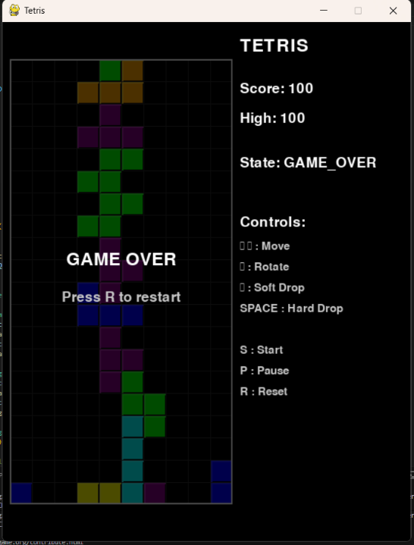
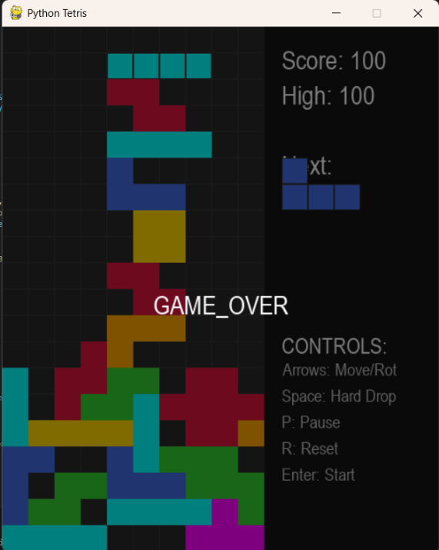
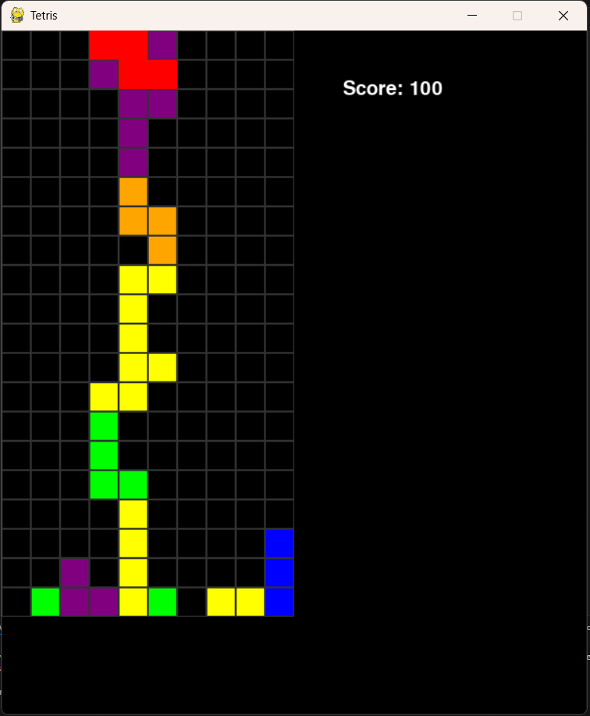
Gemini 3 Pro
ChatGPT 5.2
Claude Sonnet 4.5
Architecture
I asked each of the AI’s to give me a ½ page summary of the architecture:

ChatGPT
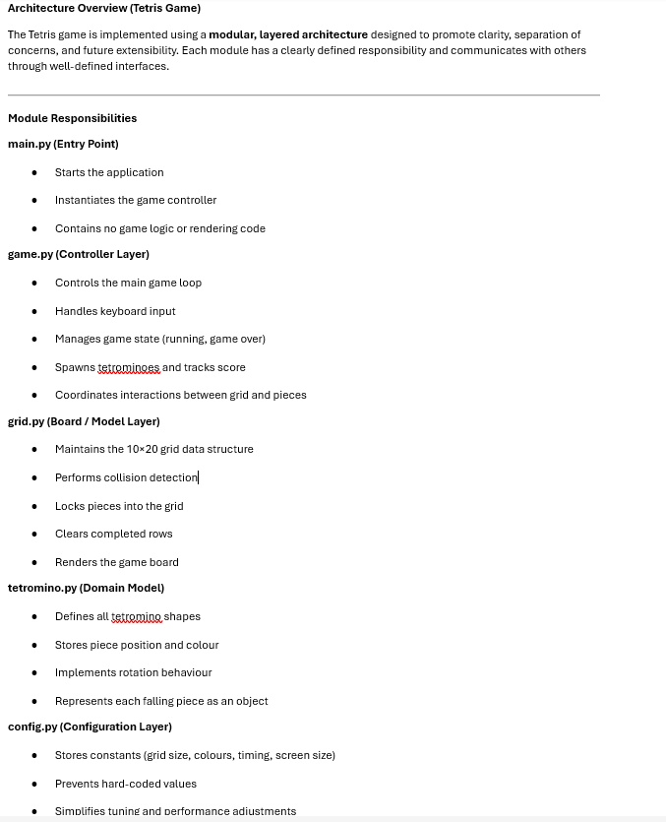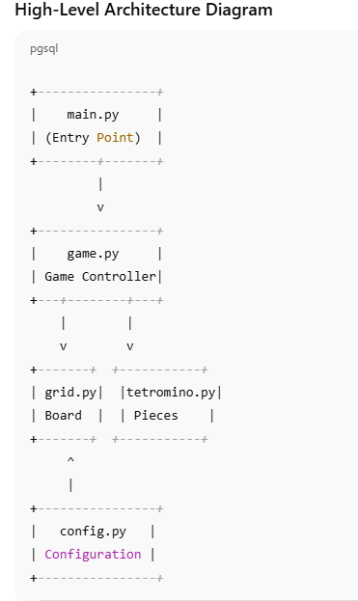

Claude
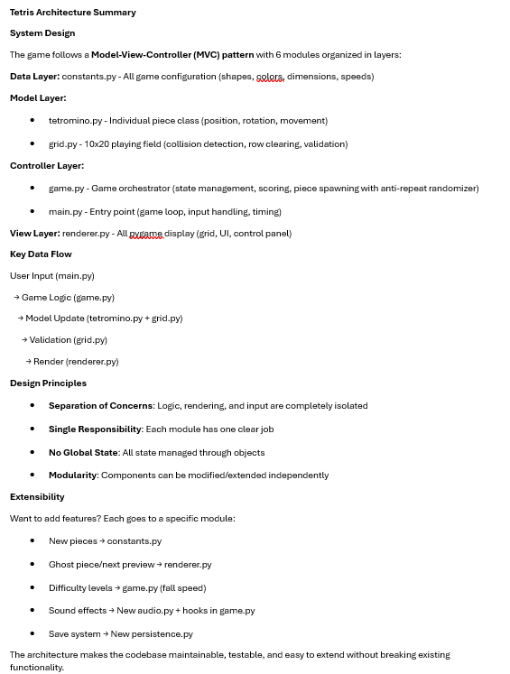

Gemini
